E-Commerce Report

Report Statistics
Total Records: 1000
Unique Customers: 205
Unique Orders: 438
Unique Products: 98

Shipping Status Distribution
- In Transit: 216
- Shipped: 213
- Cancelled: 213
- Pending: 185
- Delivered: 173

Data Visualizations

1. Shipping Status Distribution
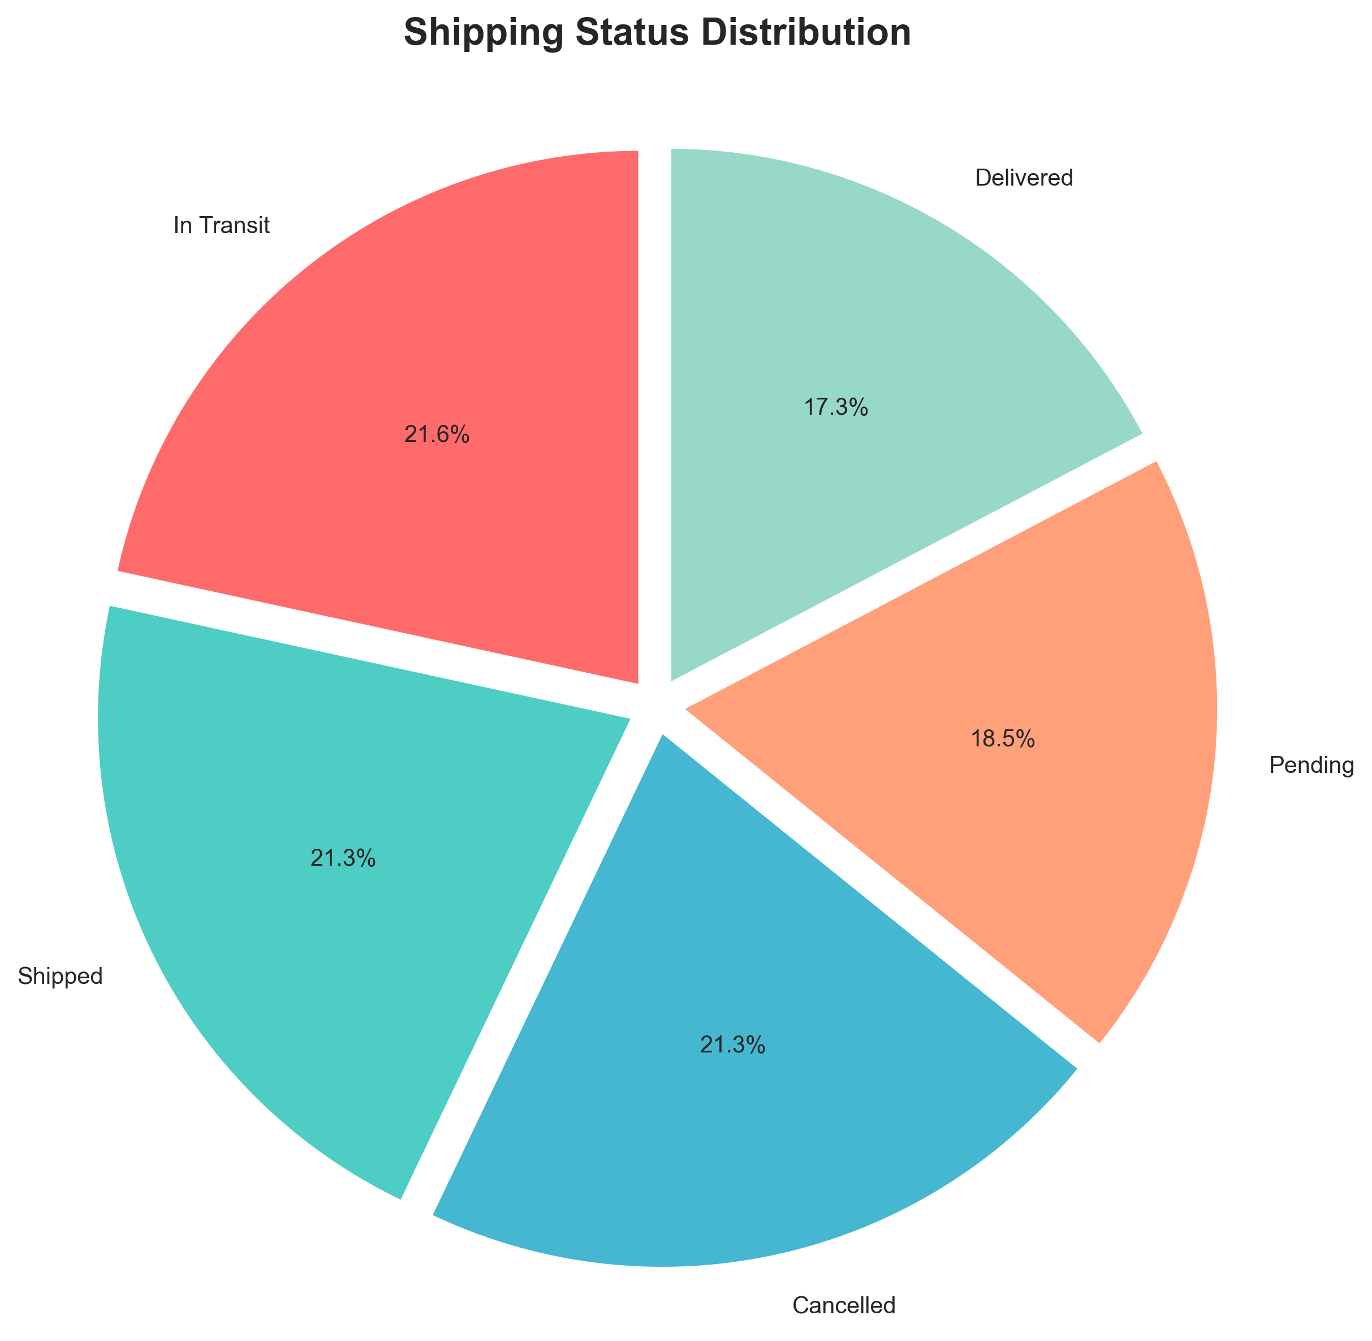

2. Top 10 Products by Revenue
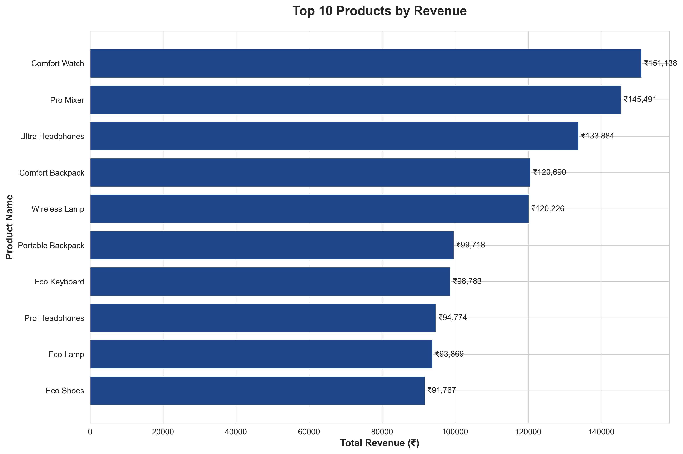

Sample Data (First 50 Records)
Customer Name | City | Order ID | Order Date | Product Name | Quantity | Item Price | Total Amount | Shipping Status | Delivery Date
Deepak Yadav | Lucknow | 1 | 2024-03-31 | Digital Backpack | 3 | ₹1532.57 | ₹94457.52 | Shipped | 2024-04-04
Deepak Yadav | Lucknow | 1 | 2024-03-31 | Smart Headphones | 3 | ₹9563.77 | ₹94457.52 | Shipped | 2024-04-04
Deepak Yadav | Lucknow | 1 | 2024-03-31 | Digital Book | 5 | ₹5596.48 | ₹94457.52 | Shipped | 2024-04-04
Deepak Yadav | Lucknow | 1 | 2024-03-31 | Smart Keyboard | 5 | ₹6637.22 | ₹94457.52 | Shipped | 2024-04-04
Vikram Chopra | Hyderabad | 2 | 2024-01-21 | Comfort Shoes | 5 | ₹3208.16 | ₹25846.54 | Pending | 2024-01-31
Vikram Chopra | Hyderabad | 2 | 2024-01-21 | Wireless Watch | 2 | ₹4902.87 | ₹25846.54 | Pending | 2024-01-31
Kavya Shetty | Pune | 3 | 2024-02-01 | Pro Mixer | 4 | ₹4619.85 | ₹19836.92 | Cancelled | 2024-02-05
Kavya Shetty | Pune | 3 | 2024-02-01 | Smart Watch | 2 | ₹678.76 | ₹19836.92 | Cancelled | 2024-02-05
Kavya Das | Lucknow | 4 | 2024-12-14 | Eco Shoes | 5 | ₹8366.16 | ₹41830.80 | Cancelled | 2024-12-21
Meera Singh | Jaipur | 5 | 2024-04-18 | Premium Headphones | 1 | ₹7479.76 | ₹23819.38 | Delivered | 2024-04-23
Meera Singh | Jaipur | 5 | 2024-04-18 | Premium Lamp | 1 | ₹2806.06 | ₹23819.38 | Delivered | 2024-04-23
Meera Singh | Jaipur | 5 | 2024-04-18 | Comfort Shoes | 4 | ₹3383.39 | ₹23819.38 | Delivered | 2024-04-23
Vikram Verma | Bengaluru | 6 | 2023-07-17 | Wireless Lamp | 4 | ₹9105.33 | ₹52415.59 | Delivered | 2023-07-19
Vikram Verma | Bengaluru | 6 | 2023-07-17 | Digital Headphones | 5 | ₹1575.57 | ₹52415.59 | Delivered | 2023-07-19
Vikram Verma | Bengaluru | 6 | 2023-07-17 | Portable Book | 2 | ₹4058.21 | ₹52415.59 | Delivered | 2023-07-19
Ritu Ghosh | Kolkata | 7 | 2023-08-15 | Comfort Book | 1 | ₹1938.34 | ₹30363.54 | Cancelled | 2023-08-19
Ritu Ghosh | Kolkata | 7 | 2023-08-15 | Digital Backpack | 4 | ₹3746.05 | ₹30363.54 | Cancelled | 2023-08-19
Ritu Ghosh | Kolkata | 7 | 2023-08-15 | Comfort Headphones | 2 | ₹1560.35 | ₹30363.54 | Cancelled | 2023-08-19
Ritu Ghosh | Kolkata | 7 | 2023-08-15 | Digital Headphones | 3 | ₹3440.10 | ₹30363.54 | Cancelled | 2023-08-19
Sneha Reddy | Hyderabad | 8 | 2023-10-15 | Portable Mixer | 3 | ₹2282.35 | ₹6847.05 | In Transit | 2023-10-22
Anita Patel | Hyderabad | 9 | 2023-04-03 | Comfort Bottle | 4 | ₹2467.32 | ₹46410.73 | In Transit | 2023-04-09
Anita Patel | Hyderabad | 9 | 2023-04-03 | Comfort Backpack | 4 | ₹5370.46 | ₹46410.73 | In Transit | 2023-04-09
Anita Patel | Hyderabad | 9 | 2023-04-03 | Ultra Bottle | 3 | ₹5019.87 | ₹46410.73 | In Transit | 2023-04-09
Rahul Chopra | Ahmedabad | 11 | 2024-05-20 | Ultra Mixer | 2 | ₹3803.42 | ₹41002.72 | In Transit | 2024-05-27
Rahul Chopra | Ahmedabad | 11 | 2024-05-20 | Portable Book | 4 | ₹8348.97 | ₹41002.72 | In Transit | 2024-05-27
Sneha Khan | Chennai | 12 | 2023-10-15 | Portable Shoes | 1 | ₹9215.84 | ₹12082.16 | Pending | 2023-10-19
Sneha Khan | Chennai | 12 | 2023-10-15 | Portable T-Shirt | 3 | ₹955.44 | ₹12082.16 | Pending | 2023-10-19
Rohan Reddy | Lucknow | 13 | 2024-12-21 | Premium Shoes | 2 | ₹5910.37 | ₹13002.56 | Shipped | 2024-12-27
Rohan Reddy | Lucknow | 13 | 2024-12-21 | Eco Mixer | 1 | ₹224.58 | ₹13002.56 | Shipped | 2024-12-27
Rohan Reddy | Lucknow | 13 | 2024-12-21 | Premium Backpack | 2 | ₹478.62 | ₹13002.56 | Shipped | 2024-12-27
Pooja Naidu | Mumbai | 14 | 2023-01-08 | Eco Headphones | 4 | ₹3230.57 | ₹40303.92 | Shipped | 2023-01-11
Pooja Naidu | Mumbai | 14 | 2023-01-08 | Digital Book | 3 | ₹5555.78 | ₹40303.92 | Shipped | 2023-01-11
Pooja Naidu | Mumbai | 14 | 2023-01-08 | Premium Keyboard | 2 | ₹5357.15 | ₹40303.92 | Shipped | 2023-01-11
Meera Shetty | Mumbai | 15 | 2024-10-15 | Comfort Backpack | 5 | ₹7245.43 | ₹36227.15 | In Transit | 2024-10-22
Arjun Iyer | Mumbai | 16 | 2023-10-12 | Portable Book | 1 | ₹2815.41 | ₹10067.95 | Cancelled | 2023-10-20
Arjun Iyer | Mumbai | 16 | 2023-10-12 | Eco Keyboard | 2 | ₹3626.27 | ₹10067.95 | Cancelled | 2023-10-20
Tanvi Shetty | Jaipur | 17 | 2024-05-20 | Portable Bottle | 4 | ₹6747.54 | ₹70832.29 | Pending | 2024-05-25
Tanvi Shetty | Jaipur | 17 | 2024-05-20 | Comfort Watch | 4 | ₹7631.50 | ₹70832.29 | Pending | 2024-05-25
Tanvi Shetty | Jaipur | 17 | 2024-05-20 | Eco T-Shirt | 3 | ₹4438.71 | ₹70832.29 | Pending | 2024-05-25
Rahul Verma | Chennai | 18 | 2023-07-18 | Pro Mixer | 1 | ₹6604.68 | ₹77402.27 | Shipped | 2023-07-22
Rahul Verma | Chennai | 18 | 2023-07-18 | Eco Keyboard | 5 | ₹7081.51 | ₹77402.27 | Shipped | 2023-07-22
Rahul Verma | Chennai | 18 | 2023-07-18 | Smart Mixer | 4 | ₹8847.51 | ₹77402.27 | Shipped | 2023-07-22
Sanjay Iyer | Kolkata | 19 | 2024-11-29 | Portable Headphones | 4 | ₹2665.26 | ₹39699.40 | Cancelled | 2024-12-04
Sanjay Iyer | Kolkata | 19 | 2024-11-29 | Eco Keyboard | 1 | ₹5519.61 | ₹39699.40 | Cancelled | 2024-12-04
Sanjay Iyer | Kolkata | 19 | 2024-11-29 | Wireless Backpack | 5 | ₹4703.75 | ₹39699.40 | Cancelled | 2024-12-04
Isha Shetty | Hyderabad | 20 | 2023-06-29 | Ultra Mixer | 2 | ₹2405.23 | ₹25032.33 | In Transit | 2023-07-08
Isha Shetty | Hyderabad | 20 | 2023-06-29 | Comfort Book | 5 | ₹2681.96 | ₹25032.33 | In Transit | 2023-07-08
Isha Shetty | Hyderabad | 20 | 2023-06-29 | Wireless Backpack | 1 | ₹1084.00 | ₹25032.33 | In Transit | 2023-07-08
Isha Shetty | Hyderabad | 20 | 2023-06-29 | Premium Keyboard | 1 | ₹5728.07 | ₹25032.33 | In Transit | 2023-07-08
Ritu Verma | Jaipur | 22 | 2023-09-23 | Ultra Backpack | 4 | ₹7630.37 | ₹35211.04 | Pending | 2023-09-28

