**Problem Statement : Ticket Tracker ApplicatioN**

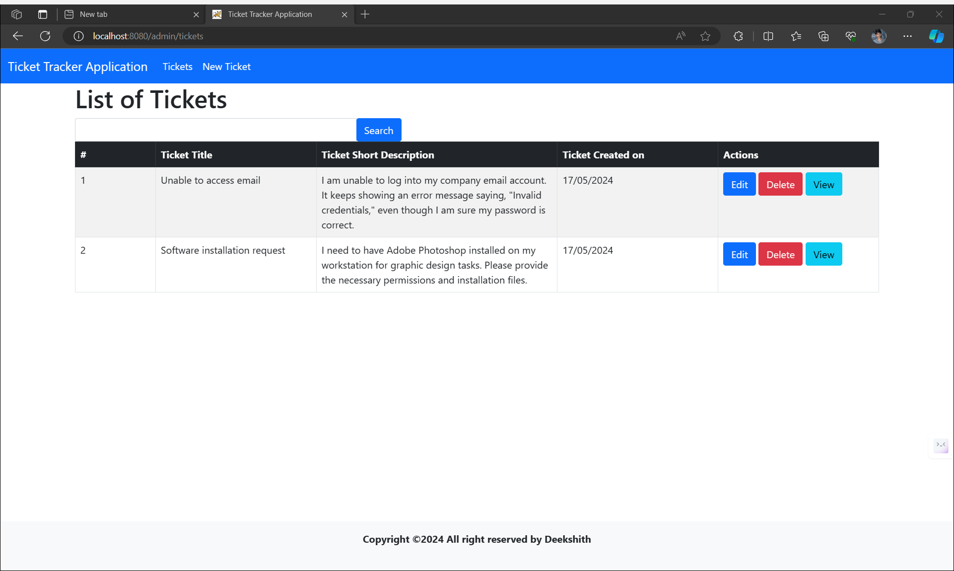**1) Home Screen with data and action buttons (New Ticket, Edit, Delete, View)**

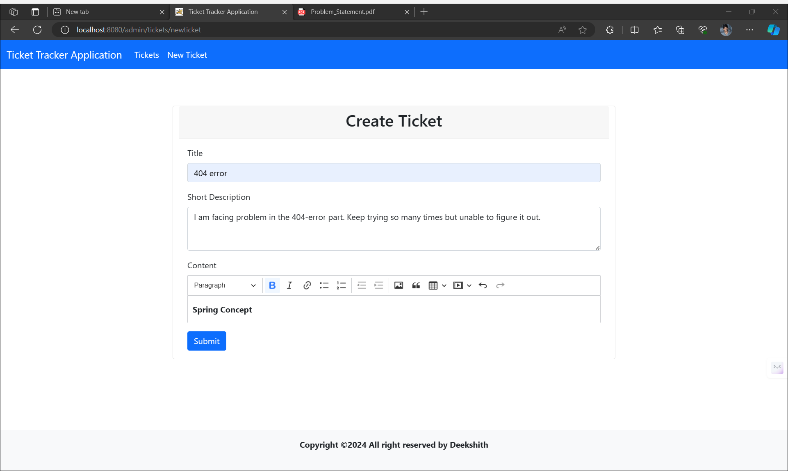 **2) Create Ticket page**

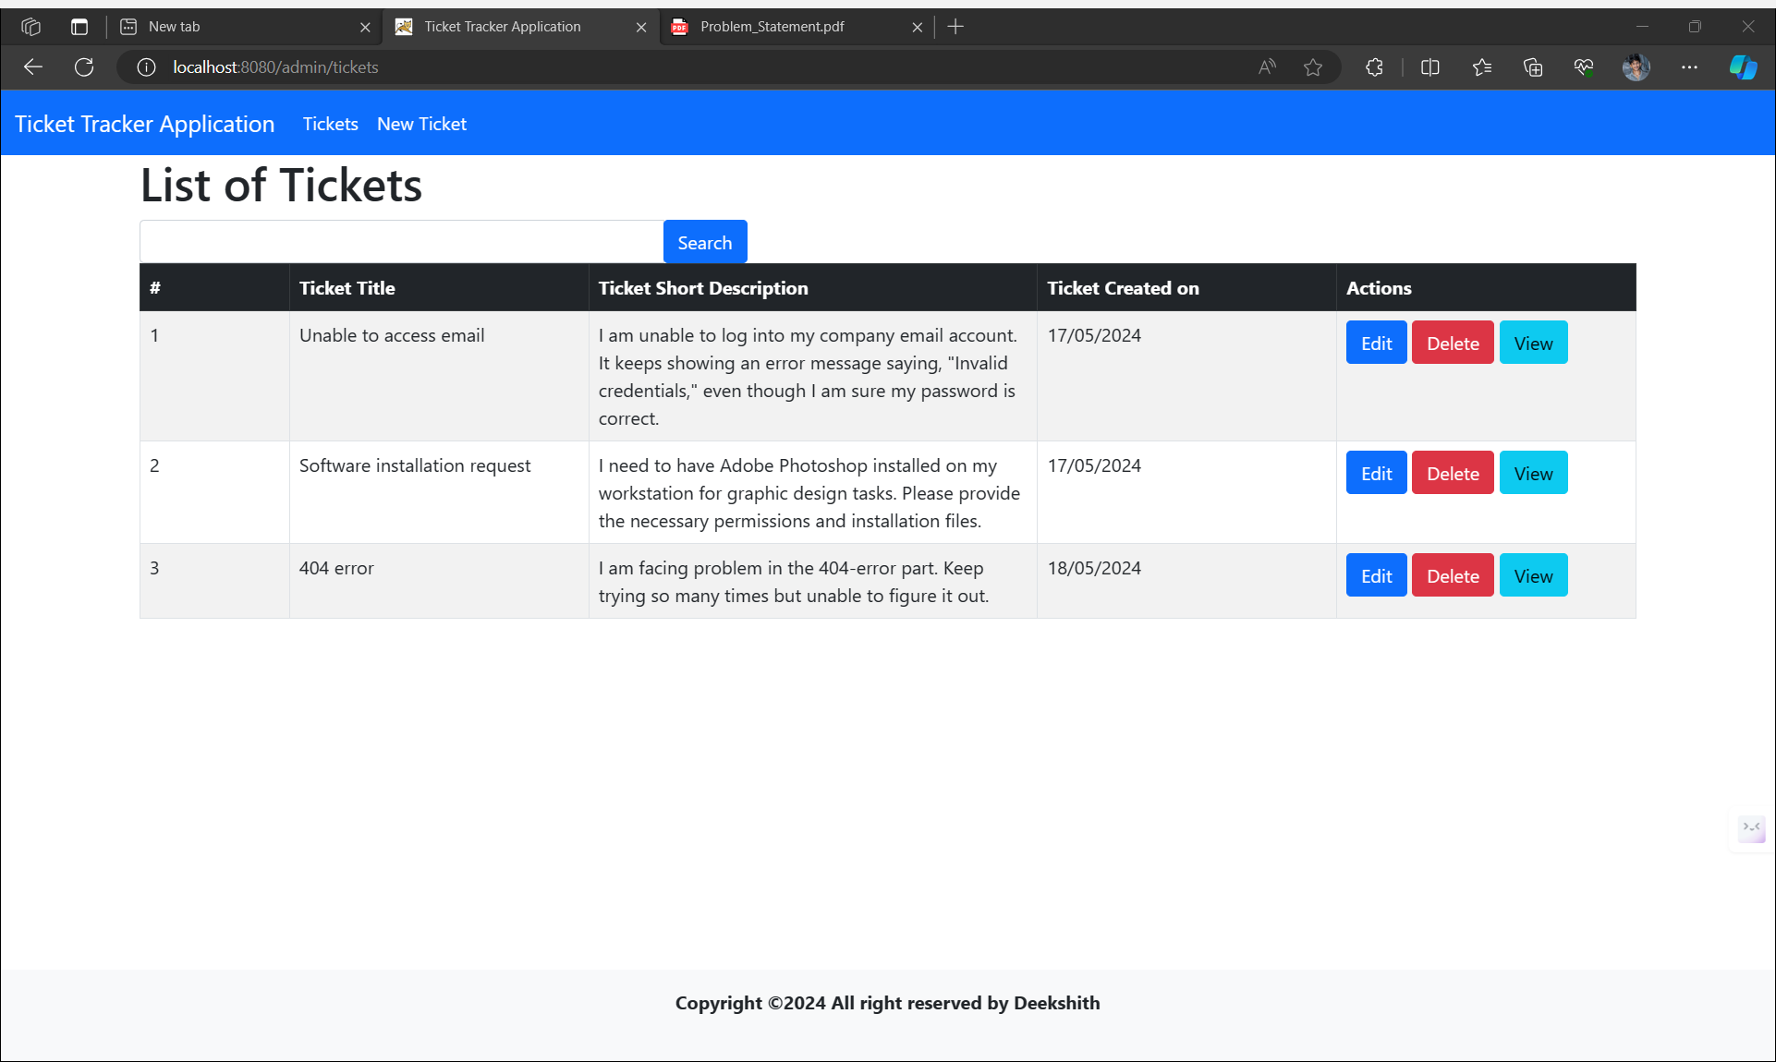**3) After Adding a New Ticket**

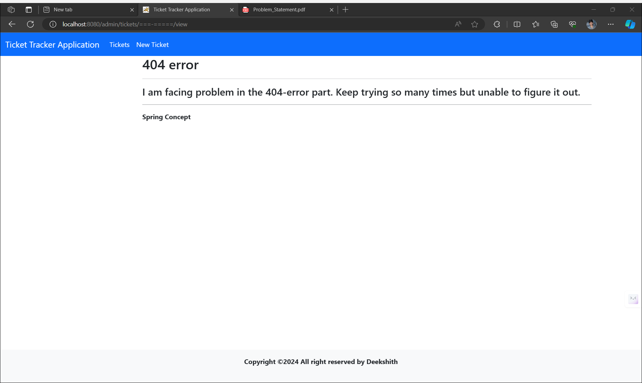**4)Brief View Of a Ticket**

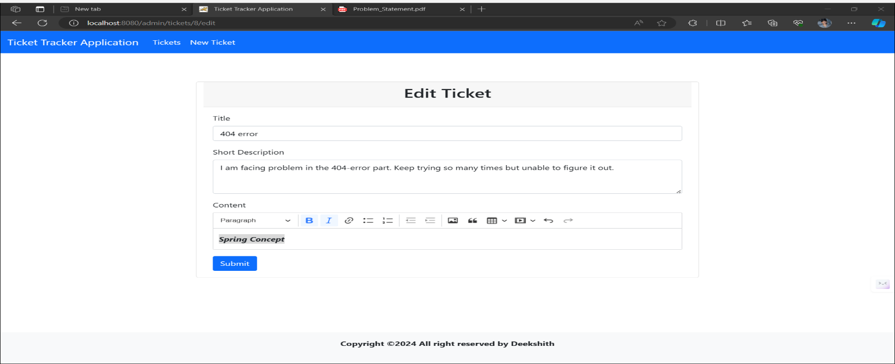**5) Edit a Ticket**

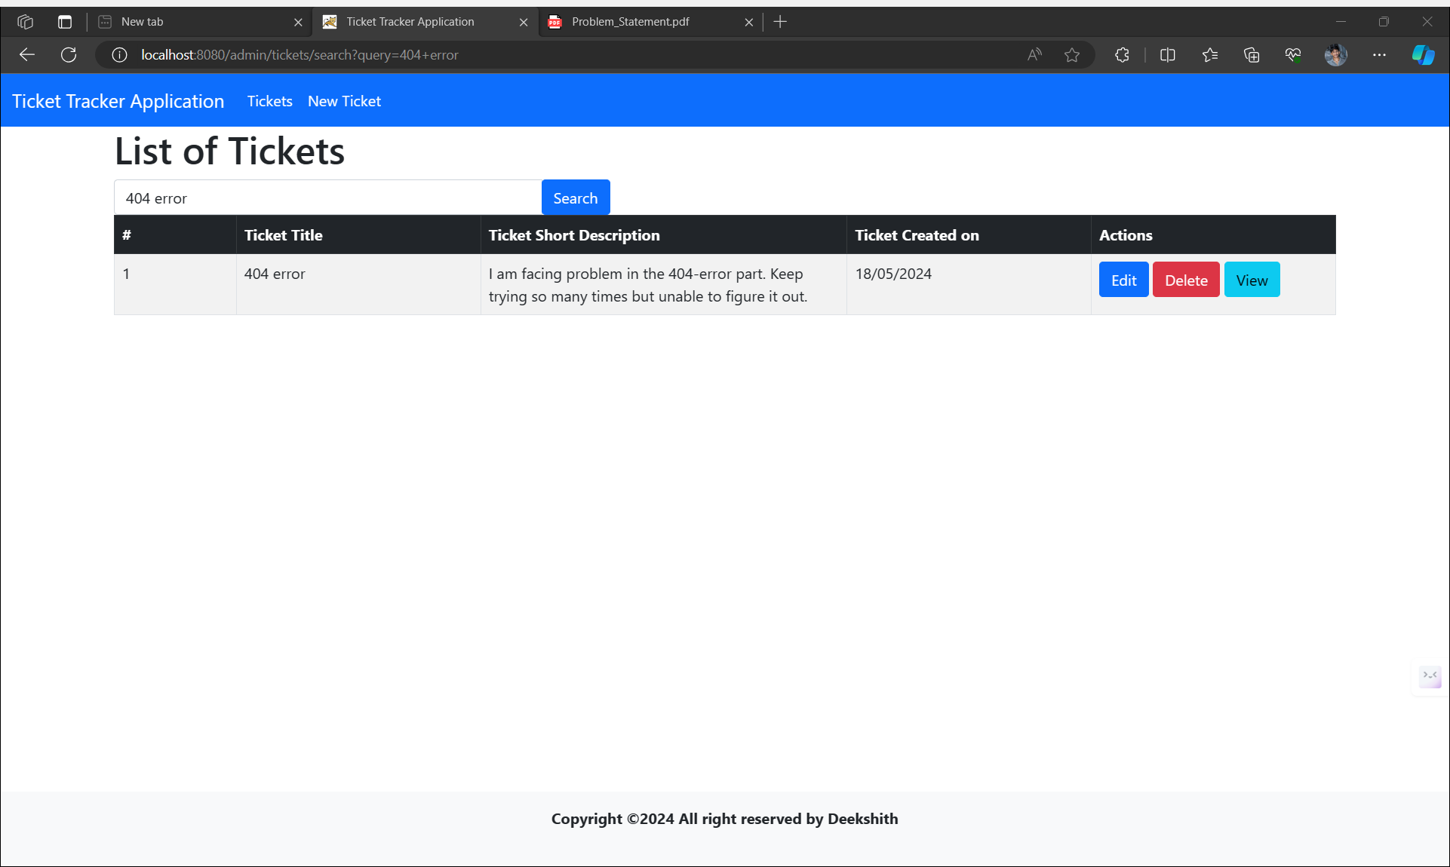**6)** **Search Functionality (search query over Title and short description)**

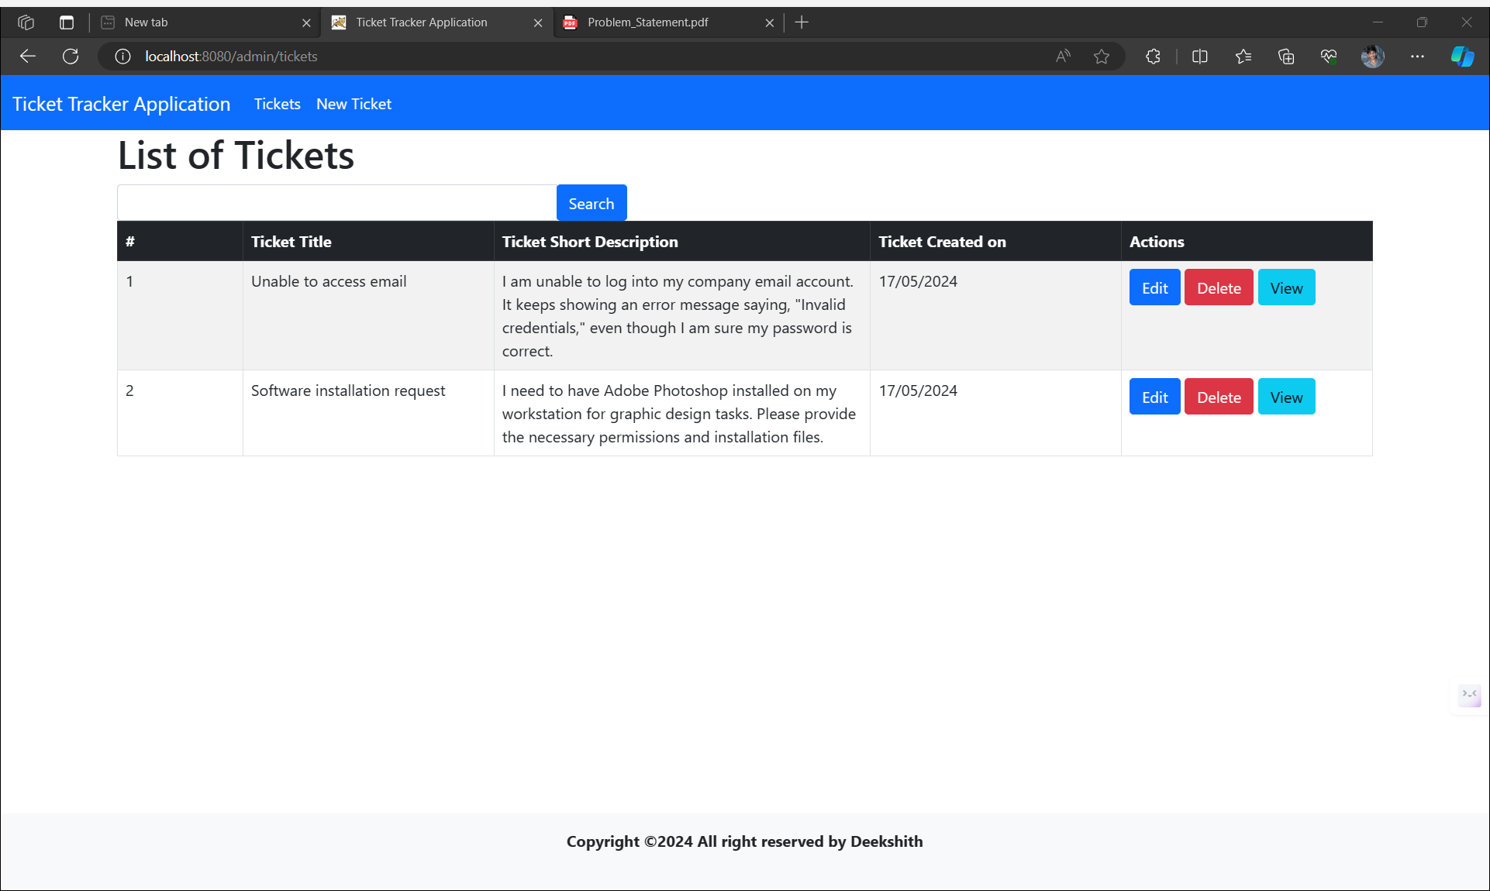**7) After Deleting a Ticket**

Thank you