# SINA Mobility Task Submission

Question: Consider a situation, where a vehicle is at the origin. A ball is falling from 10 metres in -ve y-direction. The length of the vehicle is 1 metre & the distance from the starting point of the vehicle to the position where ball would be falling (on x- axis) is 10 metres. Following are the components attached on the vehicle:

* one 84 wh battery (12v, 7ah)
* two 5v, 1a dc motor attached on each of the front wheels.
* two 12v, 1a dc motor attached on each of the rear wheels.
* Arduino Mega

Once switched on, the power from the battery goes to all the motors. The vehicle can move only on x-axis. The vehicle has to catch the ball before the ball hits the x-axis (The ball should be falling on the vehicle). When the ball starts to fall, the vehicle starts to move in +ve x direction (as shown in image). The movement of the ball & vehicle starts as soon as the button, connected wirelessly to the remote, is pressed. Kindly refer below image for better visualisation.

**Following are the task that has to be done:**

1. Develop a program to run the vehicle to catch the ball.
2. Simulate the move situation in Matlab & if possible, depict the animation in Matlab.
3. Designing a circuit board & DC-DC converter board, if required.

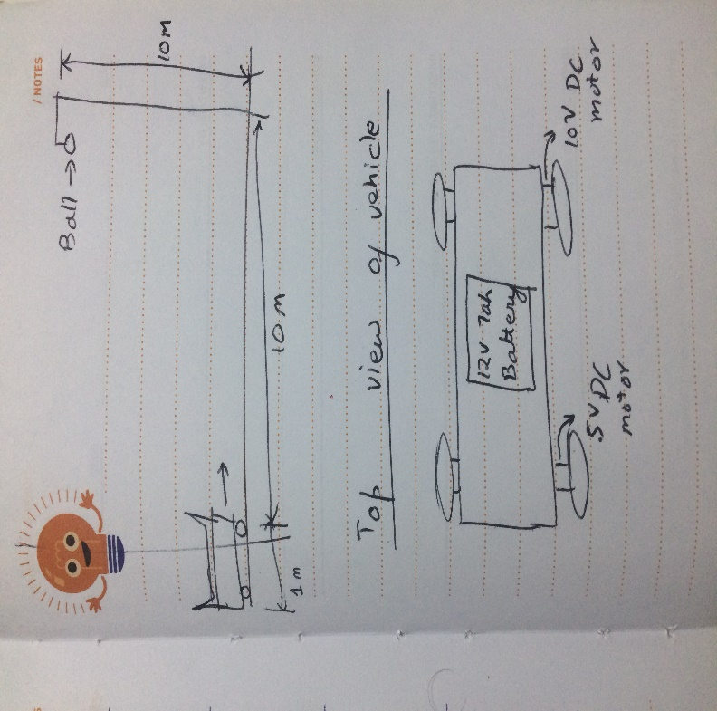

## Solution:

Free Fall Explanation:

Total distance the ball will be travelling = 10m

Using the second equation of motion:

S = u*t + 0.5 *a*t^2

Since u=0, g=9.8ms/sec^2, S=10m and solving for t, we get

t = 1.42 seconds.

This is the amount of time the ball takes to reach the ground. But, it needs to be interrupted before it hits the ground, by the robot.

Robot Movement explanation and required rpm calculations:

At initial position the robot’s center is situated at (-0.5, 0).

The final position of the robot should be at (10, 0).

Therefore, the total distance the robot has to cover is 10.5 meters in less than 1.42 seconds, let’s say 1.3 seconds, because the height of the robot is unknown.

So, the distance the robot has to cover is 10.5m which is 1050 cm.

Total time in which it has to cover = 1.3 seconds

Therefore, total distance that it has to cover in one second = 1050/1.3 = 807.69 cm

Assume radius of wheel including the rubber= 7 cm i.e. diameter = 14 cm

Hence, the distance covered per revolution = pi*d

= 44cm

Hence, the minimum revolutions required per sec = 807.69/44

=18.3565 RPS

Converting RPS to RPM we get, minimum required RPM of motor = 18.3565*60

= 1101.39 RPM

Let us assume, we consider a 1500 RPM motor, so that the requirement is satisfied.

Components used:

* Battery: 12V, 7ah
* Motors: Front Wheels (5V, 1a, 1500 RPM, 2 in number) and Back Wheels (12V, 1a, 1500RPM, 2 in number). Also, it is assumed that the motors are pre-attached with optical wheel encoders as shown.

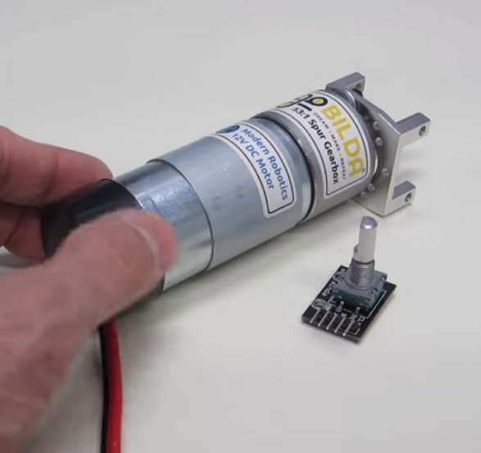 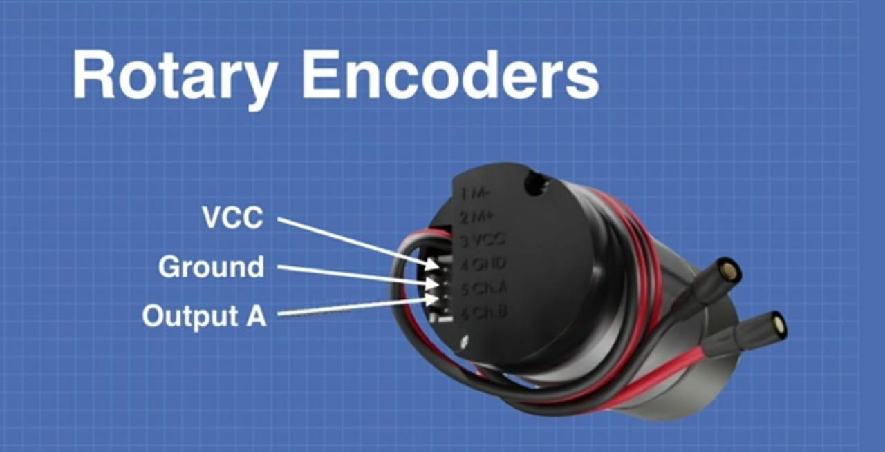

* Robot chassis
* DC-DC converter or Chopper: 12V to 5V
* Connecting wires
* L298 2a H-bridge
* Arduino Uno

Circuit Diagram:

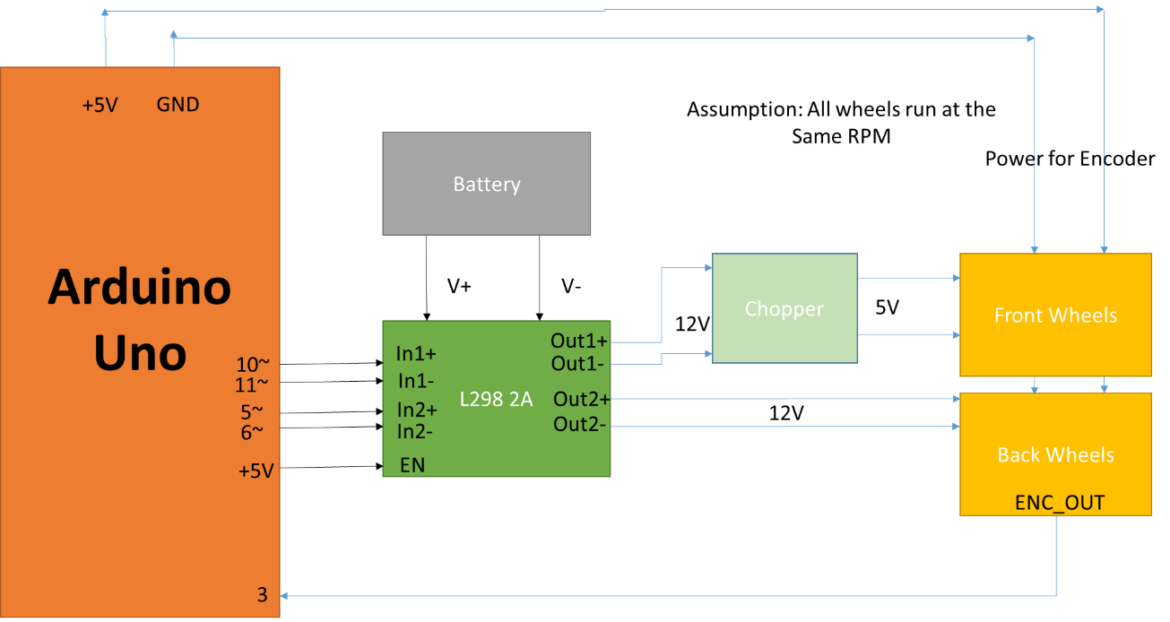

Chopper Design:

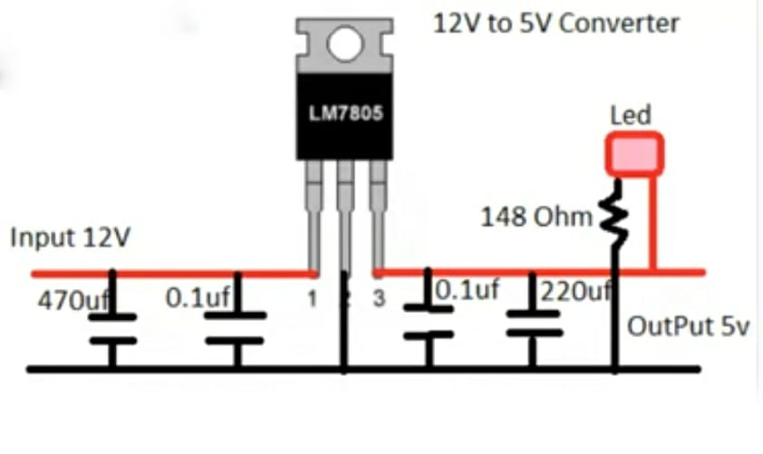

Other formulas used in the code:

Total Distance Travelled (in cm) = 44 * Total number of motor revolutions

Remaining Time = 1300 – Current time in milliseconds

Remaining Distance = 1050 – Total Distance Travelled

Therefore required RPM = (Remaining Distance/ (Remaining Time * 44)) * 60