Smart Water Monitoring System
ESP32, MQTT Broker, Node-RED and Live Dashboard Documentation
Prepared for: T.Deekshith Kumar

1. Project Overview
This project monitors and controls a smart water tank system using an ESP32, an MQTT broker, Node-RED, and a Flask web dashboard. The ESP32 connects to WiFi, publishes tank and device status to MQTT topics, receives dashboard commands, and prints all test actions in the Arduino Serial Monitor. The dashboard displays live tank level, pump, light, fan, ESP32 status, team sharing links, and safety/error messages.

2. System Architecture
The following diagram shows how data moves between ESP32, MQTT broker, Node-RED, and the web dashboard.
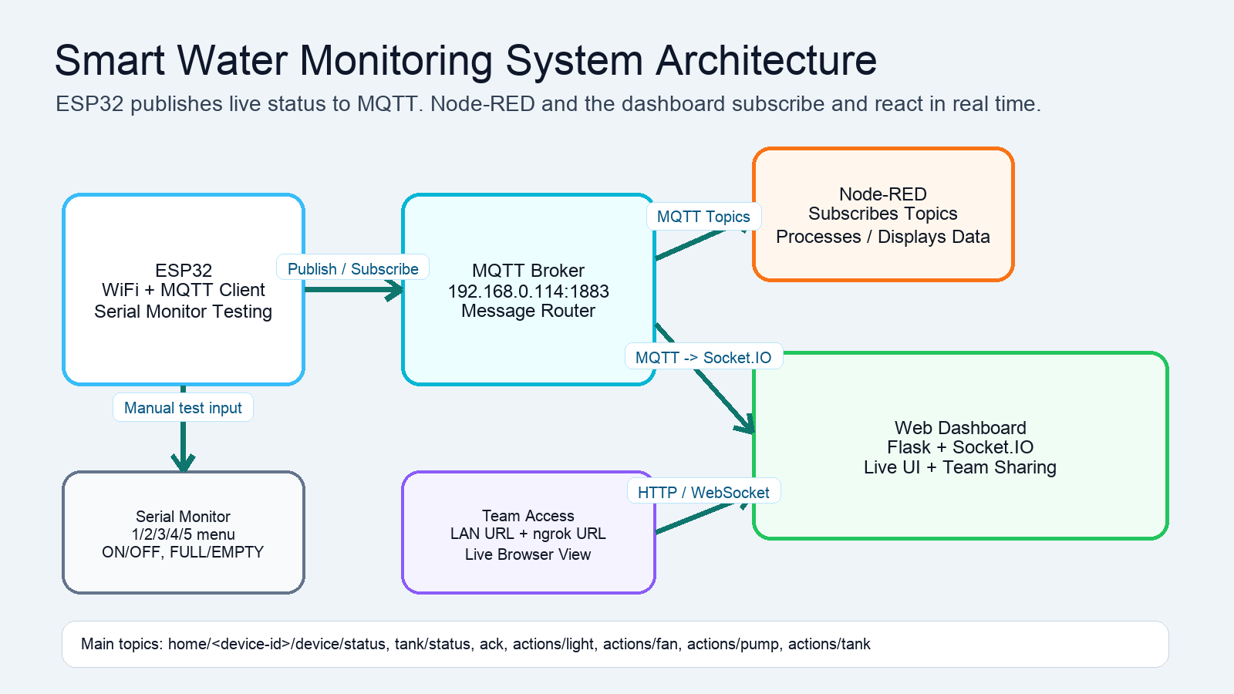

3. What the ESP32 Is Doing
- Connects to the WiFi network using SSID Deekshith.
- Connects to the MQTT broker at 192.168.0.114 on port 1883.
- Creates MQTT topics using its MAC address as the device ID, for example home/6C:C8:40:4E:96:10/device/status.
- Publishes ONLINE status every 5 seconds as a heartbeat so the dashboard can detect whether the ESP32 is connected.
- Publishes tank status as FULL or EMPTY.
- Receives commands from the dashboard for light, fan, pump, and tank empty/full actions.
- Prints dashboard commands in Serial Monitor for testing instead of depending on relays.
- Blocks pump ON when the tank is already FULL and publishes an error acknowledgement.

4. Serial Monitor Testing
The current ESP32 code is designed for testing with Arduino Serial Monitor. You can type numbers to select a device and then type the command.
Input | Meaning | Next Command
1 | Select Light | ON or OFF
2 | Select Fan | ON or OFF
3 | Select Pump | ON or OFF
4 | Select Tank | FULL or EMPTY
5 | Print WiFi, MQTT, tank, light, fan and pump status | No extra command

5. MQTT Broker and Topics
MQTT is the message router. The ESP32 publishes messages to the broker and also subscribes to command topics. Node-RED and the dashboard can subscribe to these same topics to receive live data.
Topic Pattern | Direction | Purpose
home/<device-id>/device/status | ESP32 -> Broker | Publishes ONLINE / OFFLINE status
home/<device-id>/tank/status | ESP32 -> Broker | Publishes tank status FULL or EMPTY
home/<device-id>/ack | ESP32 -> Broker | Acknowledges commands such as PUMP ON or PUMP BLOCKED
home/<device-id>/actions/light | Dashboard -> Broker -> ESP32 | Dashboard sends ON / OFF for light
home/<device-id>/actions/fan | Dashboard -> Broker -> ESP32 | Dashboard sends ON / OFF for fan
home/<device-id>/actions/pump | Dashboard -> Broker -> ESP32 | Dashboard sends ON / OFF for pump
home/<device-id>/actions/tank | Dashboard -> Broker -> ESP32 | Dashboard sends EMPTY or FULL tank command

6. How Node-RED Fits In
Node-RED receives the same MQTT messages by using MQTT-in nodes. It can display values, log them, trigger flows, or forward them to other services. In this project, Node-RED acts as a live data processing layer between the MQTT broker and any extra automations you want to build.
- MQTT-in node subscribes to home/+/device/status to know whether ESP32 is online.
- MQTT-in node subscribes to home/+/tank/status for tank FULL / EMPTY state.
- MQTT-in node subscribes to home/+/ack to receive command acknowledgements and error messages.
- Optional MQTT-out nodes can send commands to home/<device-id>/actions/... topics.

7. Dashboard Operation
The dashboard is a Flask + Socket.IO web application. The backend subscribes to MQTT topics, normalizes incoming data, and sends updates to connected browsers instantly. The frontend shows water level, pump/light/fan state, tank state, ESP32 status, warning messages, and team sharing links.
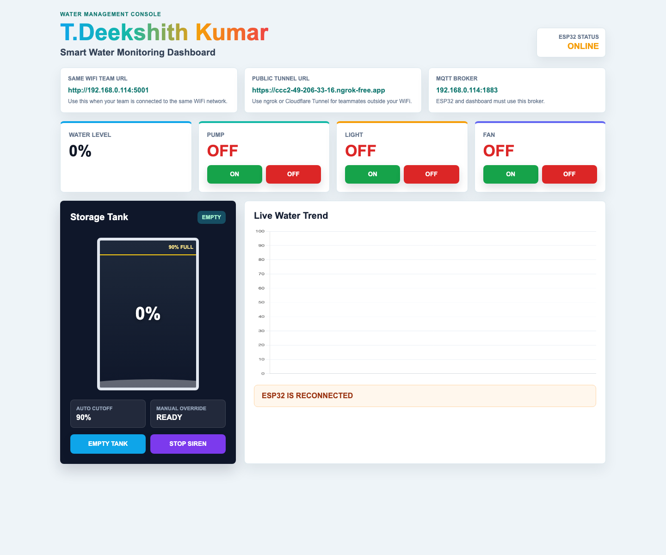
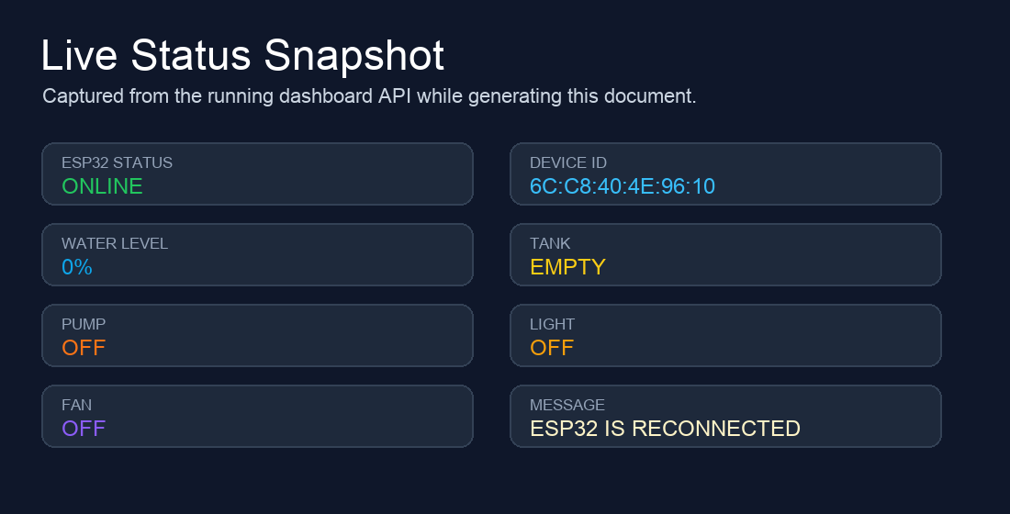

9. Safety and Error Handling
- The dashboard label ESP32 Status refers to the real ESP32 heartbeat, not just the dashboard server.
- If ESP32 is disconnected, the dashboard changes to OFFLINE after the heartbeat timeout.
- When ESP32 is offline, Pump, Light, Fan and Empty Tank commands are blocked and an error message is shown.
- If the tank becomes FULL or reaches 90%, the pump is forced OFF.
- The dashboard siren starts when the tank is full and stays on until the STOP SIREN button is pressed.
- The EMPTY TANK button resets the tank display to 0% and sends an EMPTY command to ESP32.

10. Team Access
The dashboard can be viewed by team members in two ways:
- Same WiFi URL: http://192.168.0.114:5001
- Public ngrok URL: https://ccc2-49-206-33-16.ngrok-free.app
Keep the laptop, Flask dashboard, MQTT broker, ngrok tunnel, and ESP32 running while the team is watching live data.

11. Summary
The ESP32 is the field device. MQTT is the communication broker. Node-RED can process and visualize MQTT messages. The dashboard is the live control and monitoring interface for users and team members. Together, these parts create a real-time smart water monitoring and control system.

