KnowledgeBot
High-Level Design (HLD) Document
AI-Powered Document Chatbot · Retrieval-Augmented Generation (RAG) Architecture

Project Name | KnowledgeBot
Project Type | AI / NLP Chatbot — Retrieval-Augmented Generation (RAG)
Document | High-Level Design (HLD) — Version 1.0
Date | June 2026
Prepared By | Deekshitha Kamme
Mentor / Lead | Jaya Rohra & Vemuri Sree Lalitha
Status | Pending Lead Sign-off
Classification | Confidential — Internal Project Use Only

Table of Contents
Table of Contents 1
1. Introduction 1
1.1 Purpose 1
1.2 Scope & Objectives 1
1.3 Intended Audience 1
2. System Overview 1
3. Functional Requirements 1
4. Architecture Overview 1
4.1 Architecture Style 1
4.2 System Architecture Diagram 1
4.3 Layer Summary 1
5. Component Design 1
6. Data Flow 1
6.1 Document Ingestion Flow 1
6.2 Query & Answer Flow 1
7. External Interfaces 1
8. Technology Stack 1
9. Non-Functional Requirements & Design Decisions 1
9.1 Key Design Decisions 1
10. Assumptions & Dependencies 1
10.1 Assumptions 1
10.2 Dependencies 1
11. Risks and Mitigations 1
12. Conclusion 1
13. Appendices 1
Appendix A — Out of Scope (v1.0) 1
Appendix B — Glossary 1
Appendix C — Revision History 1
Appendix D — Sign-off 1

1. Introduction

1.1 Purpose
This High-Level Design (HLD) document describes the overall architecture, major components, data flow, and key design decisions for KnowledgeBot, an AI-powered document chatbot built on a Retrieval-Augmented Generation (RAG) pattern. It translates the requirements captured in the KnowledgeBot Business Requirement Document (BRD v3) into a structured technical design that will guide the Low-Level Design (LLD) and subsequent development phases.

1.2 Scope & Objectives
KnowledgeBot allows users to upload documents to a private repository and ask natural-language questions about their contents. The system retrieves the most relevant passages using semantic search, generates a grounded answer with a Large Language Model (LLM), and returns the answer together with source citations, a confidence score, and a fact-validation check. The design objectives for this phase are to:
- Automate manual document search by allowing natural-language querying.
- Ensure accuracy by grounding every generated answer strictly in retrieved source content.
- Provide transparency through source citations and confidence scoring on every answer.
- Improve reliability by flagging potential misinformation through fact validation.

1.3 Intended Audience
This document is intended for the KnowledgeBot development team, the project mentor/lead (Jaya Rohra and Vemuri Sree Lalitha) responsible for design sign-off, and any reviewer who needs a technical understanding of the system architecture before the Low-Level Design and implementation phases begin.

2. System Overview
KnowledgeBot is a chatbot that answers questions from a private document repository using Retrieval-Augmented Generation. Rather than relying purely on an LLM's internal knowledge, the system first retrieves the most semantically relevant chunks of text from the user's own documents and passes them to the LLM as grounding context, which significantly reduces hallucination and keeps answers traceable to a source.
The system accepts a broad range of document formats — PDF, TXT, PPT/PPTX, DOCX, XLSX, JSON, ZIP/folder archives, and image screenshots (PNG, JPG) — so that users are not restricted to a single file type. Every answer is returned with a clickable source citation, a colour-coded confidence score, and an optional fact-validation warning if the generated answer appears inconsistent with the retrieved source text.
At the highest level, a user interacts with KnowledgeBot entirely through a web-based React interface; the backend orchestrates parsing, embedding, retrieval, LLM generation, and validation, and externally calls an LLM provider and an embedding model. The full architectural breakdown, including the context of how the system interacts with these external services, is presented in Section 4 (Architecture Overview).

3. Functional Requirements
The functional requirements below summarise the core capabilities KnowledgeBot must deliver, as defined in the BRD. Each requirement follows a UI-first convention: the user-facing interaction is specified before the corresponding backend processing step.
ID | Feature / Module | Requirement Summary | Priority
FR-UI | App Launch & Navigation | Landing page with nav bar, hero section, and upload / chat CTAs; client-side routing. | Must Have
FR-01 | Document Repository | Store uploaded documents across all supported formats (PDF, TXT, PPT, DOCX, XLSX, JSON, ZIP, PNG/JPG). | Must Have
FR-02 | Document Upload (UI) | Drag-and-drop zone with Browse button, file preview, and upload progress indicator. | Must Have
FR-03 | Document Chunking | Split uploaded documents into overlapping ~500-token chunks for embedding. | Must Have
FR-04 | Text Embedding | Convert text chunks into vector embeddings via sentence-transformers / NVIDIA model. | Must Have
FR-05 | Semantic Search | Retrieve top-K relevant chunks from the Vector DB based on query meaning. | Must Have
FR-06 | Natural Language Query (UI) | Chat input box with Ask button; disabled with spinner while awaiting a response. | Must Have
FR-07 | LLM Answer Generation | Generate a grounded answer from retrieved chunks + query via the LLM API. | Must Have
FR-08 | Chatbot Interface (UI) | Two-column chat view with timestamps, auto-scroll, and full session history. | Must Have
FR-09 | Source Citation (UI) | Clickable citation badge on every answer opening a side panel with the source snippet. | Must Have
FR-10 | Confidence Score (UI) | Colour-coded confidence badge (green / yellow / red) based on retrieval similarity. | Should Have
FR-11 | Fact Validation | Cross-validate generated answers against retrieved chunks; flag mismatches. | Should Have
FR-12 | Incorrect Info Detection | Detect and flag suspicious or inconsistent content during ingestion or query time. | Should Have
FR-13 | Corrected Answer Suggestion (UI) | Show a source-grounded corrected answer when fact validation fails. | Could Have
FR-14 | Suspicious Content Flag (Admin UI) | Admin panel listing flagged chunks with dismiss / mark-reviewed actions. | Should Have
FR-15 | Concurrent User Access | Support ≥10 concurrent users without session conflict or performance loss. | Must Have
FR-16 | Session Continuation (UI) | Post-answer prompt, idle-timeout modal, and token-limit toast notification. | Must Have

4. Architecture Overview

4.1 Architecture Style
KnowledgeBot follows a layered (n-tier) client-server architecture composed of a Presentation Layer, an API Gateway Layer, a Business Logic Layer, and a Data Layer. The Business Logic Layer additionally integrates with a set of external AI services for embeddings, vector search, and LLM-based answer generation. This separation keeps the frontend, request handling, RAG orchestration, and storage independently maintainable and testable.

4.2 System Architecture Diagram
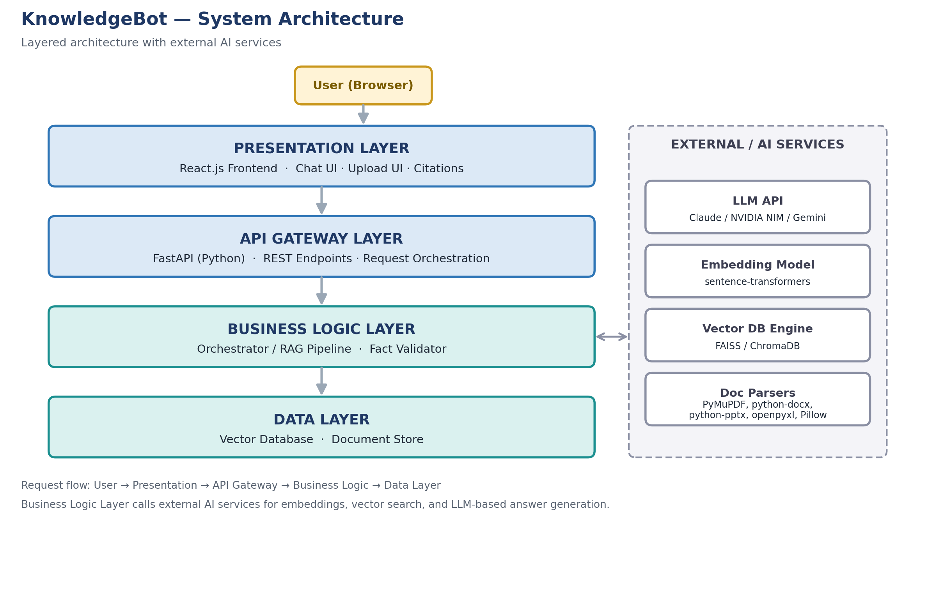
Figure 1 — KnowledgeBot layered system architecture with external AI services.

4.3 Layer Summary
- Presentation Layer — React.js single-page application providing the chat interface, document upload UI, and citation/confidence display.
- API Gateway Layer — FastAPI (Python) REST endpoints for upload, query, and validation; entry point for all client requests.
- Business Logic Layer — the Orchestrator / RAG pipeline that coordinates parsing, embedding, retrieval, LLM calls, and the Fact Validator.
- Data Layer — the Vector Database and document store that persist embeddings, metadata, and uploaded source files.
- External / AI Services — the LLM API, embedding model, vector database engine, and document parsers consumed by the Business Logic Layer.

5. Component Design
This section details the purpose, inputs/outputs, and key responsibilities of each major KnowledgeBot component, mapped to the layers introduced in Section 4.
Component | Overview | Key Functions / Interactions
React Frontend | Single-page application delivering the chat UI, document upload form, and answer display with citations. | Renders chat UI, upload form, confidence meter; calls FastAPI REST endpoints; displays citations and validation warnings.
FastAPI Backend | REST API layer that exposes upload, query, and validation endpoints and orchestrates the RAG pipeline. | Routes requests to ingestion, search, and LLM services; assembles the final response payload returned to the UI.
Document Ingestion | Parses uploaded files and prepares them for semantic indexing. | Parses PDF/DOCX/PPT/XLSX/TXT/JSON/ZIP/image files; splits text into 500-token overlapping chunks; generates embeddings.
Vector Store | Persists embeddings and performs similarity search. | FAISS (local, in-memory) or ChromaDB (hosted) stores embeddings and metadata; returns top-K most similar chunks per query.
LLM Service | Generates the final natural-language answer from retrieved context. | Sends retrieved chunks + user query to Claude / NVIDIA NIM / Gemini API; returns a context-grounded answer.
Fact Validator | Cross-checks generated answers against source chunks before they reach the user. | Compares the LLM answer to retrieved chunks; flags contradictions; can surface a corrected, source-grounded answer.

6. Data Flow

6.1 Document Ingestion Flow
When a user uploads a document, KnowledgeBot processes it through a five-step pipeline before it becomes searchable.
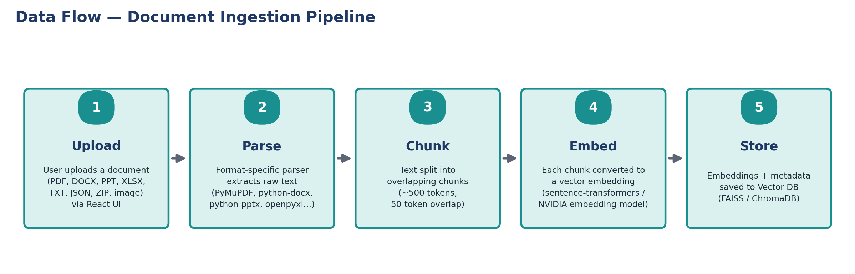
Figure 2 — Document ingestion pipeline, from upload to vector storage.
Outcome: the document is fully indexed and ready for semantic search, with each chunk stored alongside metadata identifying its source file, chunk index, and page number.

6.2 Query & Answer Flow
When a user asks a question, KnowledgeBot processes the request through a six-step pipeline to produce a grounded, cited answer.
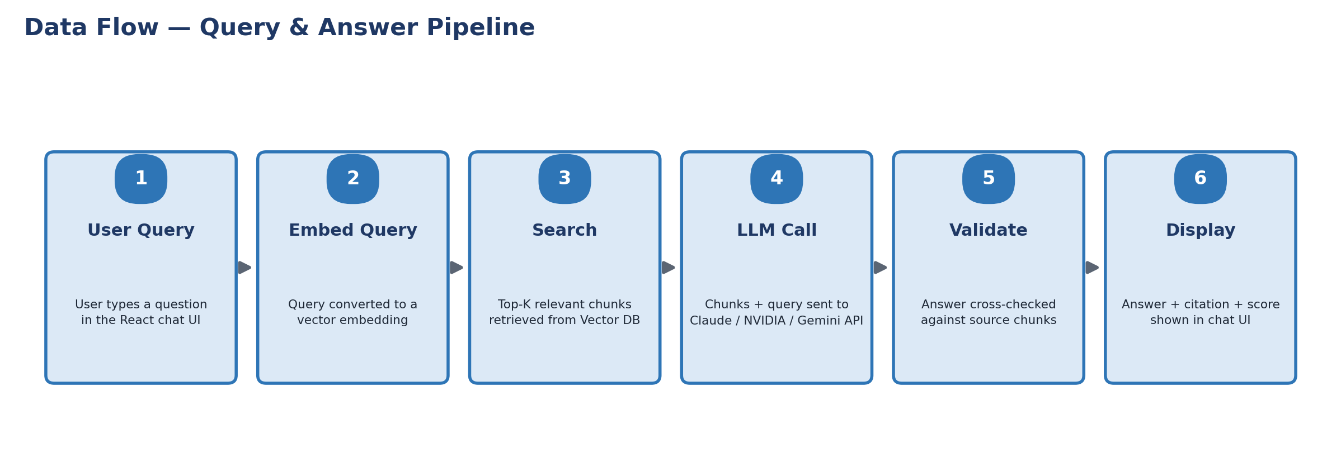
Figure 3 — Query and answer pipeline, from user question to validated, cited response.

7. External Interfaces
KnowledgeBot's Business Logic Layer integrates with the following external systems and libraries. All client-to-backend traffic, and backend-to-LLM traffic, uses REST over HTTPS; document parsing and FAISS-based vector search run in-process within the backend.
External System | Interface Type | Protocol | Purpose
LLM API | Outbound REST API call | HTTPS / REST (JSON) | Generates the grounded natural-language answer from the user query and retrieved context chunks. Provider: Claude API, NVIDIA NIM, or Gemini API.
Embedding Model | Library call / outbound API | In-process (sentence-transformers) or HTTPS / REST (NVIDIA) | Converts document chunks and user queries into vector embeddings for semantic comparison.
Vector Database | In-process library or hosted service | In-process (FAISS) or HTTPS / REST (ChromaDB) | Stores chunk embeddings and metadata; serves top-K similarity search results.
Document Parsers | In-process library calls | Local file I/O | PyMuPDF/pdfplumber, python-docx, python-pptx, openpyxl, json, zipfile, and Pillow + pytesseract extract text/content from each supported file type.
GitHub | Version control integration | HTTPS / Git | Source code collaboration, milestone tracking, and issue management throughout development.

8. Technology Stack
Layer / Component | Technology / Tool | Purpose / Role
Frontend (UI) | React.js | Chatbot interface, document upload, real-time answer display
Backend API | Python + FastAPI | REST API layer, request orchestration, RAG pipeline control
LLM / AI | Claude API / NVIDIA NIM / Gemini API | Natural-language answer generation from retrieved context
Embeddings | sentence-transformers / NVIDIA embedding model | Convert text chunks and queries into semantic vectors
Vector Database | FAISS (local) / ChromaDB (hosted) | Store and perform top-K semantic similarity search
Document Parsing | PyMuPDF, pdfplumber, python-docx, python-pptx, openpyxl, Pillow + pytesseract | Extract and clean text/content from all supported document formats
Fact Validation | Custom Python module + LLM | Cross-check generated answers vs. source chunks; flag discrepancies
Version Control | GitHub | Source code collaboration and milestone tracking
Environment | Python 3.10+, Node.js | Development and runtime environments

9. Non-Functional Requirements & Design Decisions
ID | Category | Requirement | Priority
NFR-01 | Performance | Respond to user queries within 5 seconds under normal load. | Must Have
NFR-02 | Scalability | Support a document repository of up to 500 documents in v1.0. | Should Have
NFR-03 | Usability | React UI usable without training; first query within 2 minutes. | Must Have
NFR-04 | Reliability | 99% uptime during demo and evaluation periods. | Must Have
NFR-05 | Security | Uploaded documents inaccessible to unauthorised users. | Should Have
NFR-06 | Maintainability | Modular codebase with clear separation of concerns. | Must Have
NFR-07 | Portability | Runs on Windows, macOS, and Linux development environments. | Should Have
NFR-08 | Accuracy | LLM answers grounded strictly in retrieved document context. | Must Have

9.1 Key Design Decisions
- Performance — asynchronous FastAPI endpoints; FAISS in-memory search returns top-K results in under 500ms; LLM call target under 4 seconds.
- Scalability — the API is stateless, and the vector store can be swapped from local FAISS to hosted ChromaDB as the document repository grows.
- Reliability — every LLM call is wrapped in try/catch with a fallback message on timeout and basic retry logic (maximum 2 retries).
- Security — all API endpoints validate input, no raw file execution is permitted, and uploaded documents are stored in an isolated directory.
- Accuracy — the LLM system prompt instructs the model to answer only from supplied context; the Fact Validator provides a second line of defence against hallucination.
- Maintainability — a modular folder structure (api/, ingestion/, search/, llm/, frontend/) paired with a clear README and GitHub Issues for tracking.

10. Assumptions & Dependencies

10.1 Assumptions
- Documents may be in PDF, TXT, PPT/PPTX, DOCX, XLSX, JSON, ZIP/folder archive, or image (PNG/JPG screenshot) format — the system is not restricted to a single fixed format.
- Claude API, NVIDIA NIM, or Gemini API credentials are available to the team for the duration of the project.
- FAISS will be used as the primary local vector store, with ChromaDB available as a hosted fallback for larger repositories.
- Each uploaded document is ≤50 MB, and the total repository is ≤500 documents for v1.0.
- Users interact with the system entirely through the React UI; no direct backend access is expected.
- Internet connectivity is available for outbound calls to the LLM and embedding APIs.
- Concurrent user access is expected; the system must handle multiple simultaneous sessions without degradation.
- After each answered query, the system prompts the user to continue or end the session to help manage LLM token consumption.

10.2 Dependencies
- Active API access to the chosen LLM provider (Claude / NVIDIA NIM / Gemini).
- GitHub repository set up and accessible to all three team members.
- Lead sign-off on this HLD before the Low-Level Design (LLD) phase begins.
- Python 3.10+ and Node.js development environments configured on all team machines.

11. Risks and Mitigations
Risk | Potential Impact | Mitigation Strategy
Aggressive 13-working-day timeline may compress testing. | Reduced test coverage; late defect discovery. | Phased milestones with mandatory sign-off at BRD, HLD, LLD, and Demo stages to catch issues early.
LLM API rate limits, latency, or downtime. | Failed or delayed answer generation. | Try/catch with retry (max 2 attempts), graceful fallback message, and support for switching between Claude / NVIDIA NIM / Gemini.
LLM hallucination or ungrounded answers. | Loss of user trust in answer accuracy. | Strict “answer only from context” system prompt combined with the Fact Validator's cross-check against source chunks.
Broad file-format support (8+ types) increases parsing complexity for a 3-person team. | Slipped schedule on lower-priority formats. | Prioritise PDF, TXT, and DOCX as Must Have; phase in PPT, XLSX, JSON, ZIP, and image OCR support incrementally.
Concurrent session load (≥10 users) impacting performance. | Slower responses or session conflicts. | Stateless FastAPI design, async endpoints, and in-memory FAISS search to keep retrieval fast under load.
Small team size (3 members) spread across frontend, backend, and AI work. | Bottlenecks on critical-path tasks. | Modular folder structure, clear ownership per milestone, and GitHub Issues for workload tracking.

12. Conclusion
This High-Level Design establishes a layered RAG architecture for KnowledgeBot: a React frontend, a FastAPI orchestration layer, a vector-search-driven retrieval pipeline, and an LLM-based answer generator backed by source citation and fact validation. The design directly supports the functional and non-functional requirements defined in the BRD while keeping the system modular enough for a three-person team to deliver within a 2.5-week timeline.
Next steps: with Lead sign-off on this HLD, the team will proceed to the Low-Level Design (LLD) — covering the database schema, detailed API endpoint specifications, and component wireframes — followed by backend and frontend development, integration testing, and the final mentor demo.

13. Appendices

Appendix A — Out of Scope (v1.0)
ID | Item | Note
OOS-01 | Real-time web browsing | The chatbot answers only from uploaded documents; no live internet search.
OOS-02 | Multi-language support | v1.0 supports English only; additional languages may follow in a future version.
OOS-03 | Voice input / output | Text-only interface in v1.0.
OOS-04 | User authentication system | No login/signup flow in v1.0; may be added as a future enhancement.
OOS-05 | Mobile application | Web-based React UI only; no native Android/iOS app.
OOS-06 | Document editing / management | Users can upload but not edit, rename, or delete documents via the UI in v1.0.

Appendix B — Glossary
Term | Definition
RAG | Retrieval-Augmented Generation — retrieving relevant context before generating an answer.
LLM | Large Language Model used to generate natural-language responses (e.g., Claude, Gemini).
Semantic Search | Search based on meaning rather than exact keyword matching.
Vector Embedding | Numerical representation of text capturing semantic meaning for similarity comparison.
FAISS | Facebook AI Similarity Search — library for efficient vector similarity search.
ChromaDB | Open-source vector database used to store and query document embeddings.
Chunking | Splitting large documents into smaller overlapping text segments for embedding.
Confidence Score | A 0–100% value indicating how certain the system is about a generated answer.
Fact Validation | Comparing a generated answer against source content to detect contradictions.
FastAPI | High-performance Python web framework used to build the backend REST API.
Token Limit | The maximum tokens processable in a single LLM session before a new session is required.
Concurrent Users | Multiple users accessing the system simultaneously without conflict.

Appendix C — Revision History
Version | Date | Description | Author
1.0 | June 2026 | Initial High-Level Design, derived from BRD v3 and approved scope. | Shashank Anand Gedela

Appendix D — Sign-off
This HLD must be reviewed and approved by the Lead/Mentor before the Low-Level Design and development phases begin.
Role | Name | Signature / Date | Status
HLD Author | Shashank Anand Gedela |  | Pending
Reviewer | Team Members (2 & 3) |  | Pending
Lead / Mentor | Jaya Rohra & Vemuri Sree Lalitha |  | Pending

