Intelligent Crime Anomaly Detection in Smart Cities using Deep Learning
In propose paper author employing combination of deep CNN & RNN algorithm to detect crime anomaly (abnormal) activities in smart cities. CNN algorithm will be utilized to identify objects and RNN (LSTM) algorithm is used to identify object facial behaviour. So by identifying objects and its facial behaviour we can predict or forecast his future activity as Assault/fighting, theft/burglary, accident and many more.
Here author combining deep CNN and RNN so it’s called as hybrid algorithm. To train propose algorithm author has used video dataset but not released on internet so we downloaded abnormal activities videos from KAGGLE website but this dataset won’t have bounding boxes information so we cannot plot bounding box across identifies objects but we can predict object and his behaviour.
In KAGGLE we have following crime videos dataset
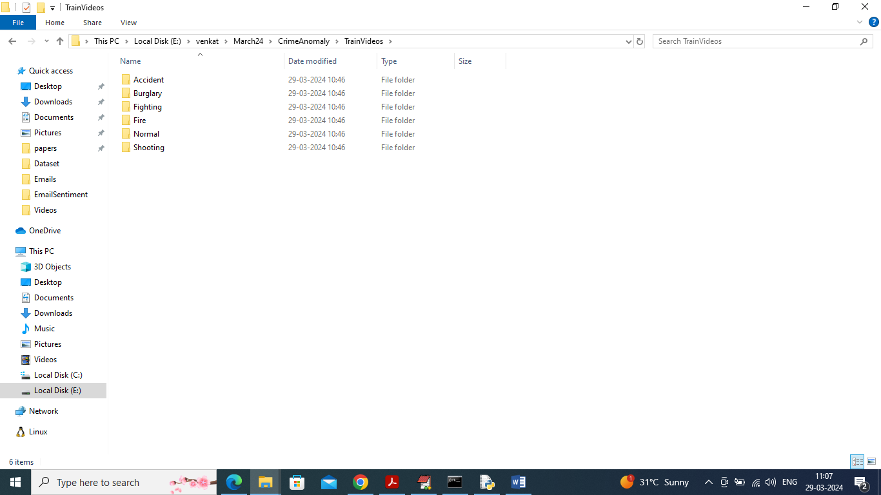
In above dataset screen each folder contains videos of crime anomaly activities and by using above videos will train and test propose hybrid algorithm. To evaluate performance of propose algorithm author utilize various metrics such as accuracy, precision, MSE (mean square error. MSE refers to error difference between predicted and true values so the lower the error the better is the algorithm).
To implement this project we have designed following modules
- Admin Login: admin can login to system using username and password as admin and admin
- Train Hybrid DCNN & RNN Algorithm: using this module admin will train propose algorithm which will be used to predict anomaly activity
- Crime Anomaly Detection: using this module admin will upload test video and then system will detect anomaly activity.
SCREEN SHOTS
To run project double click on ‘run.bat’ file to start python server and get below page
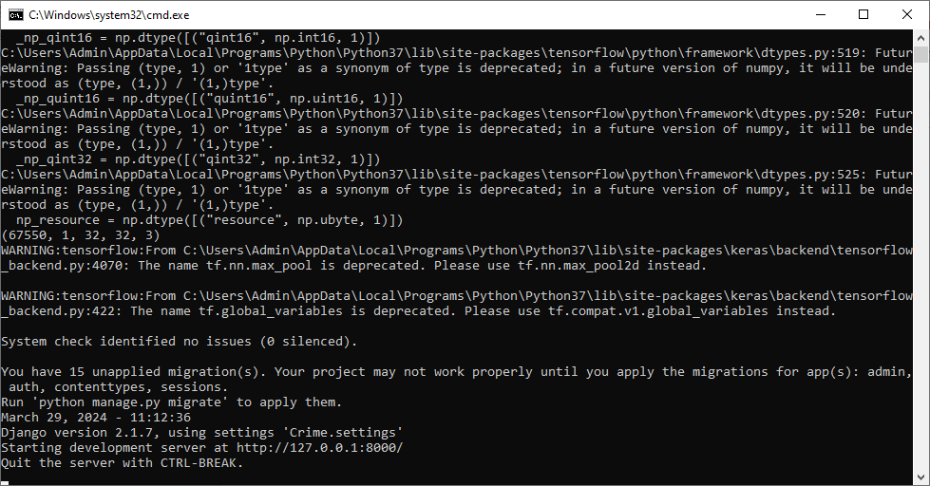
In above screen python web server started and now open browser and enter URL as http://127.0.0.1:8000/index.html and press enter key to get below page
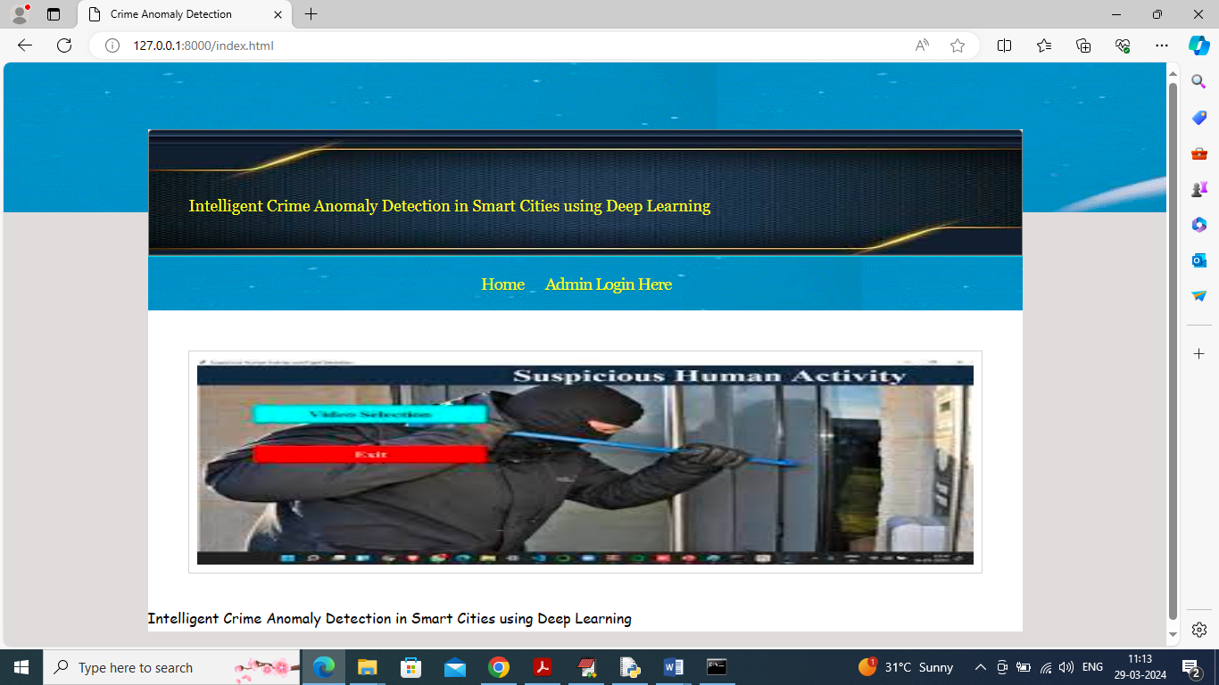
In above screen click on ‘Admin Login’ link to get below login page
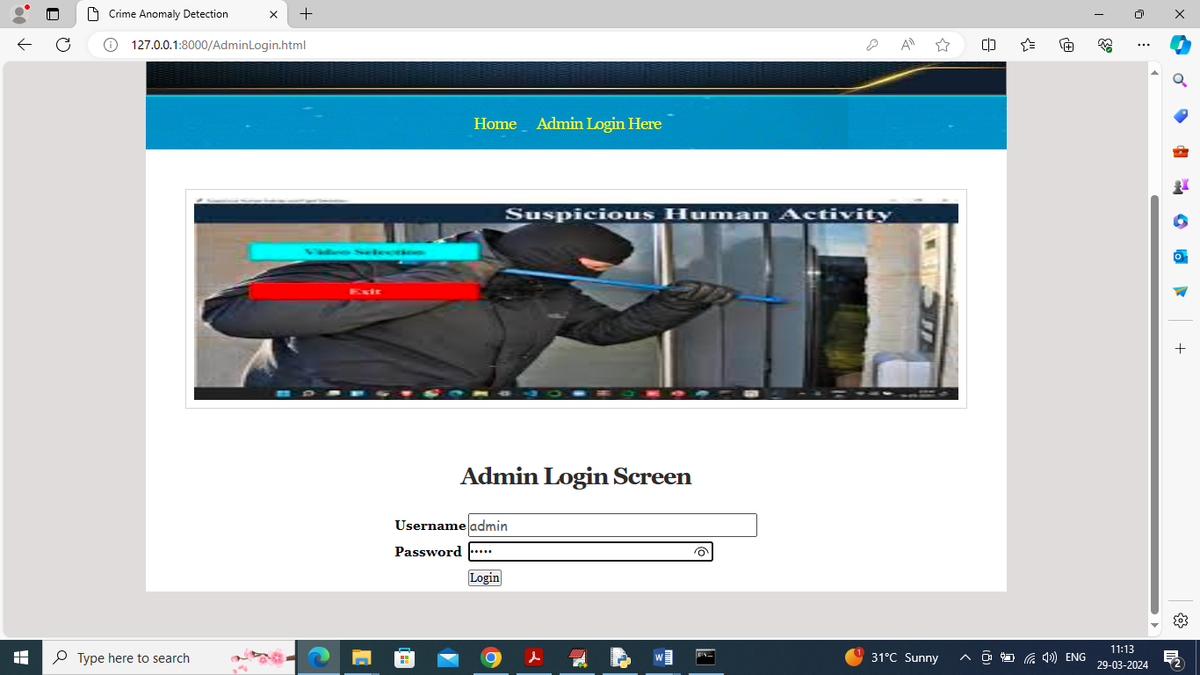
In above screen admin can login to system using username and password as ‘admin’ and after login will get below page
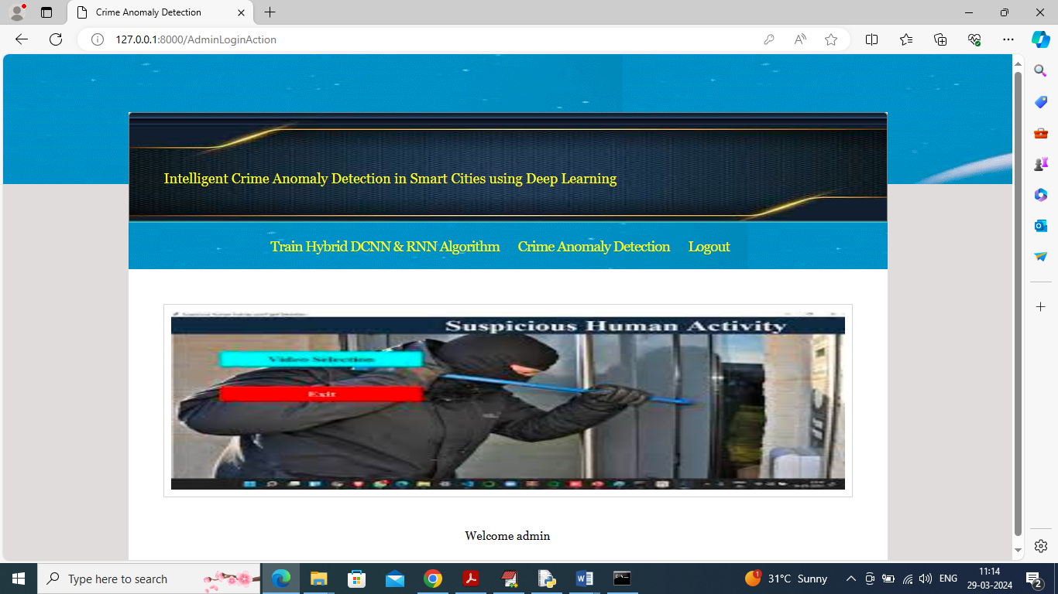
In above screen click on ‘Train Hybrid DCNN & RNN Algorithm’ link to train model and get below page
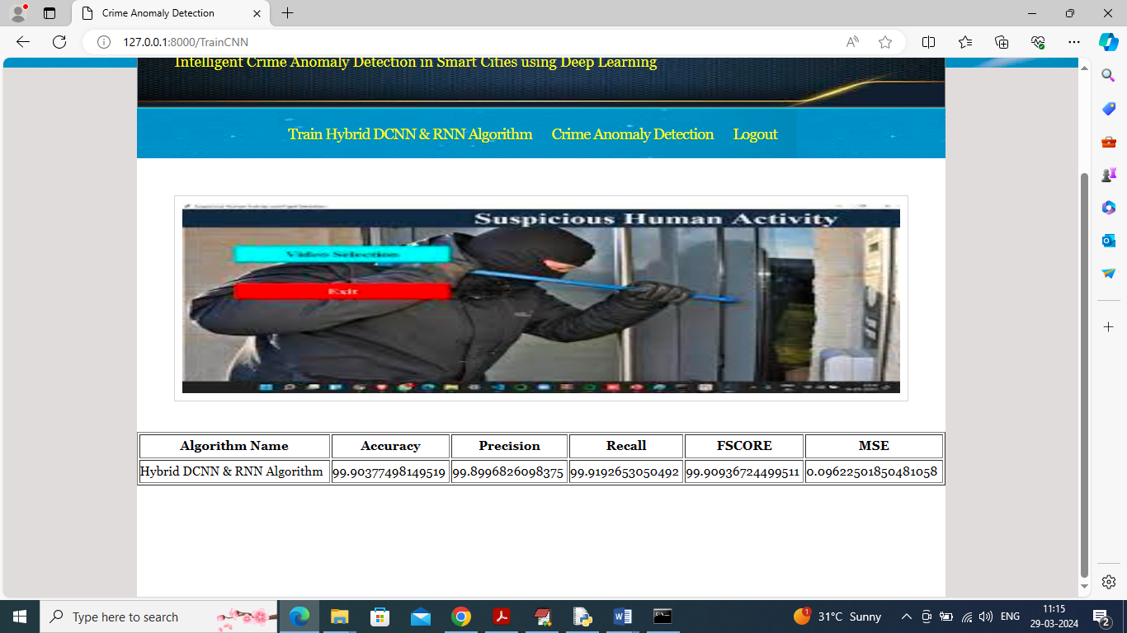
In above screen deep CNN training completed and it got 99% accuracy and can see other metrics like precision, recall, FSCORE and MSE. Now click on ‘Crime Anomaly Detection’ link to get below page
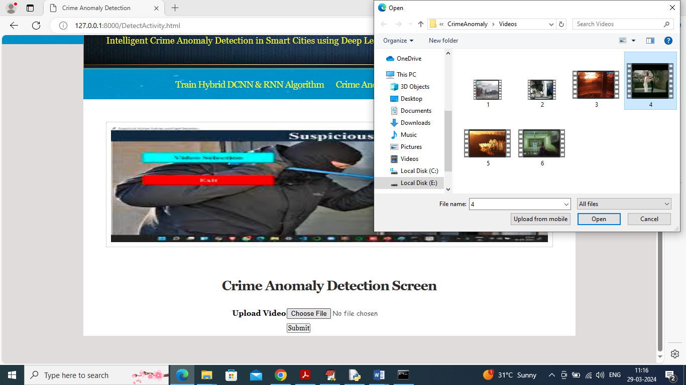
In above screen upload any video and then click on ‘Open’ and ‘Submit’ button to play video with detection
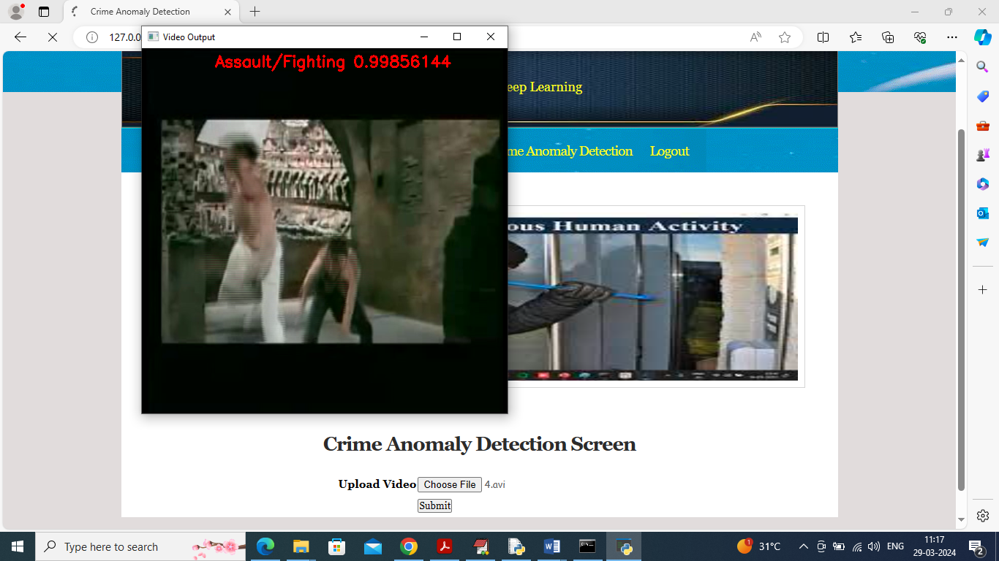
In above screen in playing video Fighting detected and similarly you can upload and test other videos
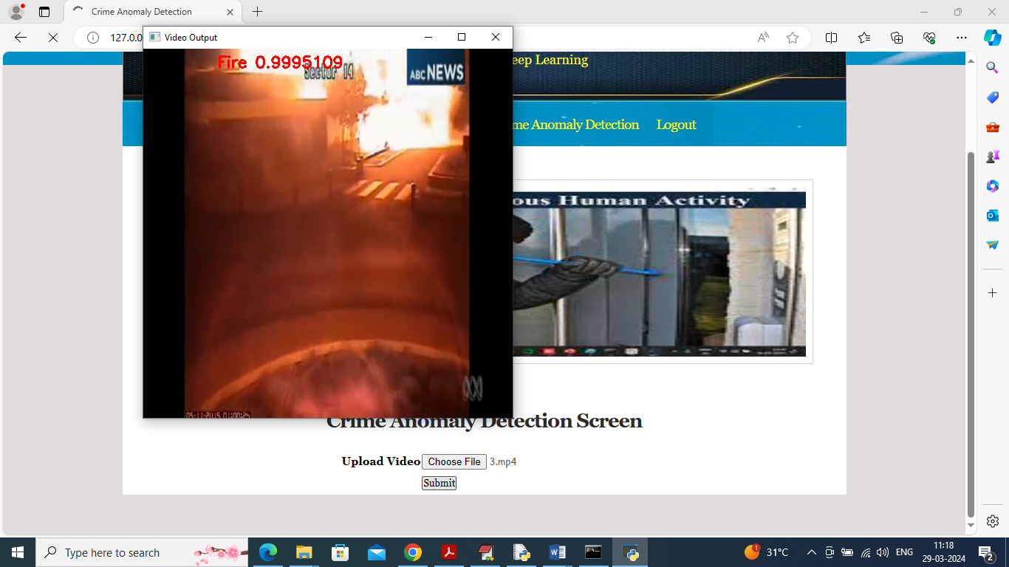
In above screen Fire detected and while playing video you can press ‘Q’ key by taking cursor on video to close the video
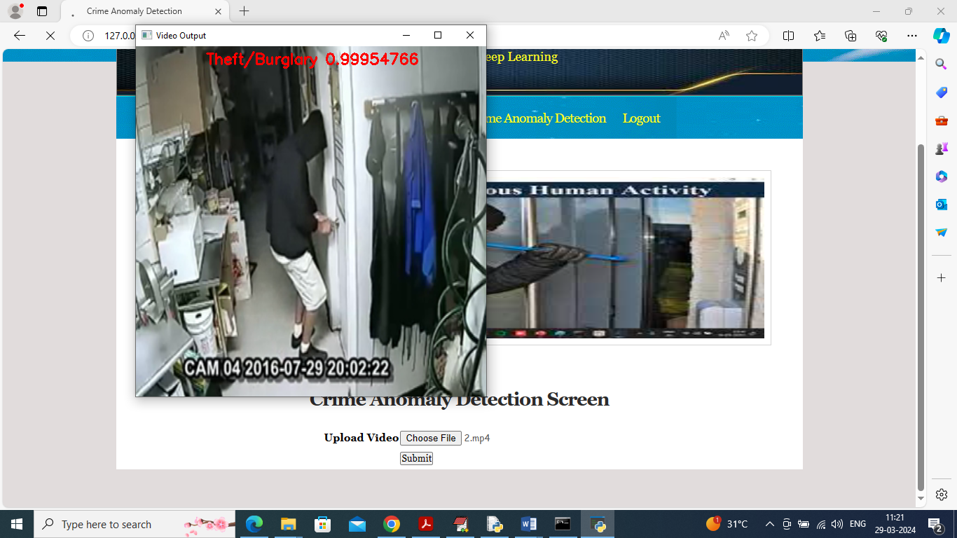
In above screen Theft/Burglary detected and similarly you can upload and test other videos and while video playing you can press ‘q’ to terminate playing and upload other videos.
Below testing video we have downloaded from net
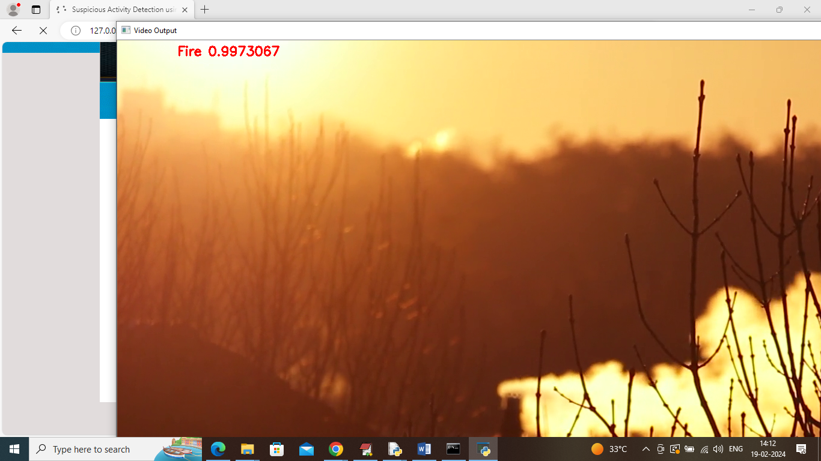
It was downloaded from below Google page

Fire video downloaded and testing from above page and Shooting video downloading from below Google page

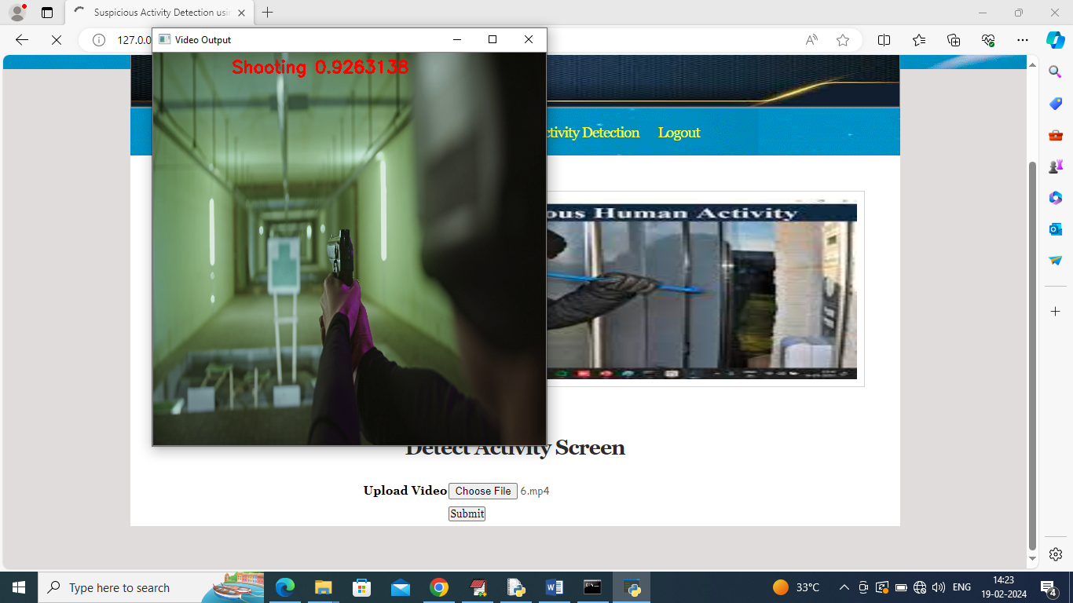
In above video shooting is detected

