# Chapter 2: Analysis

2.1 Introduction to analysis:

Analysis is the process of studying something in an organized way to learn more about it. It is the process of evaluating data or information, by breaking it into different part and understanding its cause-effect relationship. Analysis is important for any kind of project because, it helps to set certain goals and objectives for what a project planner is trying to do and why he/she is trying to do and if they are trying to solve the problem, analysis can also help on deciding how can they solve them? The purpose of analysis in this project is to identify:

1. Description of Problems related to real state buying, selling and rental faced by local people.
2. Performance requirement for the development of online real estate website, which provide ease to property buying, selling and rental.
3. Hardware requirement for development of the project
4. The need of users and the study the market to meet user's expectation.
5. Functions to be included in project for proper user interface.

2.2 Analysis Methodology:

Analysis methodology is an analysis technique to be undertaken for the development of project. Analysis methodology provides a certain framework for how analysis can be undertaken for development of the project.

I have chosen Soft approach analysis methodologies for this project. This approach is more people focused which considers that user interaction is as important as technical consideration. As my project is focused on people living in certain area, Soft approach methodology helps when user, social, political and cultural issues is to be considered. I must satisfy user expectation which can only be done with the help of Soft approach analysis methodology.

Steps taken while following Soft approach analysis methodologies are:

1. **Understanding a problematic situation**: Problem of real estate market was discovered by research, interviewing the real estate professionals, local people, studying real estate market concept and self-experience while renting apartment in Kathmandu valley. Problem seen by following this step are:

* Real estate agents are the main actor in inflation of property.
* Property buyer/rental have to pay large amount of money to agent.
* No availability of centralized market place for real estate business.
* No actual valuation of property.

1. **Describing the problematic situation**: Most of the people living in Kathmandu valley are outsiders (People from different villages, cities and even foreigner). Most of these people struggle searching for room/flat/apartment/house inside the valley. They do not have direct contact with house owner, they have to go through agents which takes a large amount of money from them. Based on problem gathered in step 1, problem situation is properly defined and described with the help of Rich picture.

Rich picture is a diagrammatic tool for problem solving. I have developed rich picture for this project to visually represent the problem. Rich picture of my project is shown below:

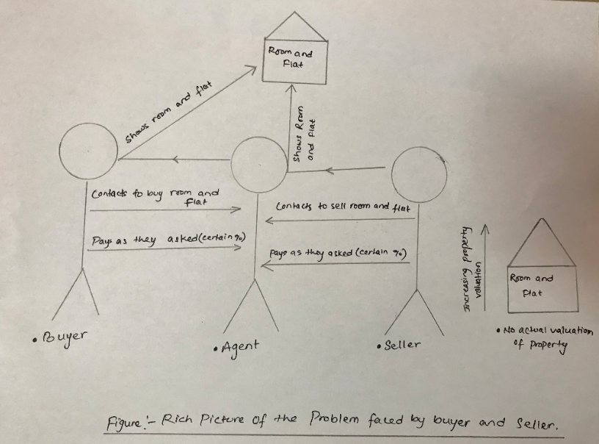

Figure Rich picture of problems

1. **Root definition through CATWOE analysis**: Root definition is the process of naming a system, which describes the aims and functions of the system. They are of two types of root definition which are:

* Primary task root definition: It focuses on Process of system to be developed.
* Issue based Root definition: It focuses on Problem system is trying to solve.

**Input/output diagram:** Clarifying what system is to achieve or change, using input/output transformation diagrams. Some input/output diagram of a system are shown below:

Seller posts

Seller contacting agent for property sale.

Seller does not have to contact agent to sell property.

property online

Result: Seller does not have to pay to agent. Hence can be profited.

Creates centralized

Buyer searching and buying property though agents.

Buyer can search and buy from home.

online Market place.

Result: Buyer can view all available property online and buy through online without extra fee to agents.

Property valuation

Reasonable Property Value.

No actual valuation of property.

can be compared

Result: Buyer can compare and understand proper valuation of specific area and buy for reasonable price.

The special importance on defining a problem lies on describing its functionality. I have tried to describe functionality with the help of **CATWOE** elements. **CATWOE** is an acronym that stands for customer, actor, transformation, world view, Owners and Environment. It's is simple checklist to find solution to a problem.

**Customer**: Real estate buyer/seller and rental.

**Actors**: Real estate owner/seller/buyer

**Transformation**: Allows direct trade between real estate owner/seller and buyer/rental.

**Worldview**: Ease for property buying/selling and marketing.

**Owners**: Project Investor/Developers. (For this project I am the owner)

**Environmental Constraints**:

1. **Composing Conceptual Model:** A conceptual model is a representation of a system that uses concept and ideas to represent a concept of project. it is the process of describing physical and social aspect of project in an abstract way. (REFERENCES HERE).Conceptual Model has been created and shown below:

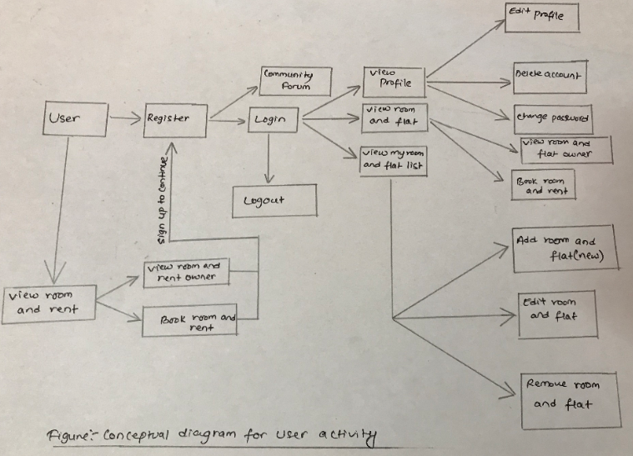

Figure Conceptual diagram for user activity

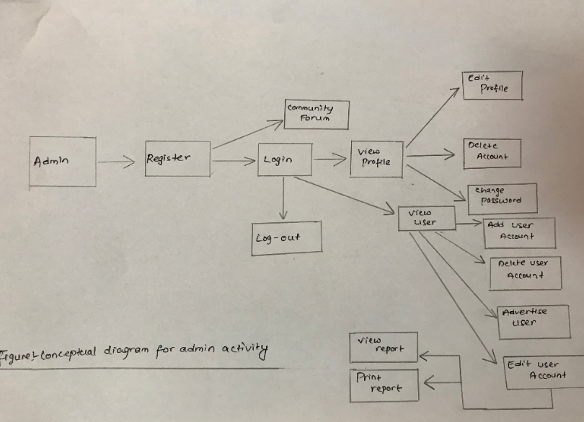

Figure Conceptual diagram for Admin activity

1. **Comparing model and reality**: Comparing model and reality helps to identify that not everything we be pitched as per conceptual model in reality. Comparison of conceptual model analysis with real world analysis are shown below:

|  |  |
| --- | --- |
| Conceptual model | Real world model. |
| All User can add product. | Real estate users only deal with property rather than users from another field. |
| All user can sign up and look for website. | It only uploads certain field, so user looking for another field may find boring. |

1. **Selecting desired and feasible interventions:** The selection of model requires discussion among stakeholders to view and extent possibilities. This process ends making certain possible changes. Some possible changes for this project can be:
   * + Community forum can be linked to all users and admin.
     + User from another field may find boring, so they can be informed before registration.

**2.3 Feasibility study:**

Feasibility study is the study performed in order to evaluate whether an action taken for the project's succession make sense or not, from an economic and operational point of view. Feasibility study is not similar to business plan because it provides investigation to planning function and provides reason for being viable or not. Feasibility study is mostly performed to minimize the cost, while working on new decision. The type of feasibility I have performed for this project are:

1. **Technical/Resource Feasibility:**

**As I am introducing new project, technical feasibility will help me to determine whether my project is technically viable or not. There are many other similar projects in market but none of them have provided customer satisfaction. So, I will try to satisfy customer by developing my product with new functionality which require a correct kind of technical support.**

1. **Market Feasibility: Market feasibility will help to understand the market need and study whether users will accept or not. This project will be beneficial mostly to people living in Kathmandu valley searching for room/flat buying/rental. Gathering a correct information from user and sending the final project with good marketing strategy will help my project grow.**
2. **Scheduled feasibility:** Scheduled feasibility will help to allocate the time resources to undertake the project, it studies whether or not project will be completed in time. For this I have scheduled my project in different time frame. I have created WBS, Gantt charts and milestones for allocating certain time for phase of project which will help me to develop my project in time.
3. **Operational feasibility:** Operational feasibility will help me understand ability to solve problems and take advantage of opportunities. I have seen the problem in real estate business so I can take advantage in it by solving the problem. for which i require the proper understanding of real estate stakeholders.

**2.4 Requirement analysis**

**2.4.1 Functional requirement:** Functional requirement is the step-in project development which includes functionality of hardware/software, methods and technical features required for development of project. List of functional requirements is given below:

|  |  |  |  |  |
| --- | --- | --- | --- | --- |
| ID | Title | Description | Rational | Dependencies |
| Ex1 | Registration of User | Register user data and create user account. | To create a user account in a system. | n/a |
| Ex2 | Login | Access registered account. | To gain access to account and view property/insert update. | Ex1 |
| Ex3 | Logout | Logout users account. | To provide security to user account. | Ex2 |
| Ex4 | Edit profile | Makes changes in existing user data. | Users might have changes in personal data to update such. | Ex1 and Ex2 and Ex5 |
| Ex5 | View Profile | Allows users to view other details/profile. | Buyer may have a doubt in seller. so as to maintain belief with identifying seller. | Ex1 and Ex2 |
| Ex6 | Upload | Uploads pictures/photos to user's profile. | So, Buyer/seller can view property virtually. | Ex1 and Ex2 |
| Ex7 | Review and rating. | Gather user's satisfaction/dissatisfaction. | To find Popular and most loved property. | Ex1 and Ex2 |
| Ex8 | Message | Handles client's queries. | To create direct conversation between buyer and seller. | Ex1 and Ex2 |
| Ex9 | View Uploads | Allows client to view uploads. | So, client can virtually view properties. | Ex1 and Ex2 |
| Ex10 | Delete account. | Allows users to delete account and personal data. | If users don't want to use the website anymore. | Ex1 and Ex2 |
| Ex11 | Community Forum | It allows to create community between users. | It allows every user to be part of a system. | n/a |
| Ex12 | Change Password | Allows user to change login key. | If user fells unsecure due to various login. They can change their login key. | Ex1/Ex2/Ex3/Ex4 and Ex5 |
| Ex13 | View Report | Allows user to view properties detail report. | To allow user to follow property valuation. | Ex1 and Ex2 |
| Ex14 | Print Report | Allows user to print properties details report. | To allow user to follow property valuation. | Ex1/Ex2 and Ex13 |
| Ex15 | Online Book | Allow user to book property. | To show user is interested in a property. | Ex1/Ex2/ and Ex9 |
| Ex16 | Create new password. | Allow user to change the password incase they forget. | To recover the account if user forgets password. | EX1. |
| Ex17 | View room and flat (Product) | Allow user to view all room and flat(product) | To view all available room and flat. | n/a |
| Ex18 | View My room and flat (Product) | Allow user to view own room and flat (Product) | To view Own room and rent(product). | Ex1, Ex2, Ex5 |
| Ex19 | Post query. | Allow user to post query. | To post query in interested room and flat(product) | Ex1, Ex2, Ex17 |
|  |  |  |  |  |
|  |  |  |  |  |

**2.4.2 Non-Functional requirements:** Non-functional requirement determines the quality attributes of the project rather than specific function. Non-functional requirement does not necessary should be included in a system but helps the project to be standard and secure. List of non-functional requirements for this project is listed below:

|  |  |  |  |  |
| --- | --- | --- | --- | --- |
| ID | Title | Description | Rational | Dependencies |
| Ba1 | Performance | System should function properly every time. | To provide smooth and efficient performance to user. | n/a |
| Ba2 | Data Secrecy | System should be secure to provide security to user data. | To protect user's data. | Ex1 |
| Ba3 | Capability | System should function equally to every user. | user should be allowed to access from any kind of devices. | n/a |
| Ba3 | Marketing strategy | It will increase the involvement of user. | To introduce system to users. | n/a |
| Ba4 | Availability | Data should be available when required. | To maintain availability of data any time. | n/a |
| Ba5 | Confidentiality | User data should have access to authorized person only. | To maintain data access authority. | n/a |
| Ba6 | Maintainability | System should be maintained from time to time. | To find and fix the bug in a system. | n/a |
| Ba7 | Integrity | Data should not be modified by unauthorized. | To maintain data integrity. | n/a |
| Ba8 | Legal clearance | System should be legal clear to make use. | For smooth use without interfere of government. | n/a |
| Ba9 | Reliability | System should be reliable for use | For robust use of system. | n/a |
| Ba10 | Recoverability | Recoverable system is required. | To prevent from hardware/software crash and data loss. | n/a |
| Ba11 |  |  |  |  |
| Ba12 |  |  |  |  |

**2.4.3 MoSCoW Prioritization:** MoSCoW is a prioritization technique which helps to understand and manage priorities. MoSCoW stands for Must have, should have, could have, won't have this time. Prioritization can be applied to requirements, acceptance criteria. MoSCoW prioritization for my project are listed below:

**MoSCoW Prioritization of function requirement:**

|  |  |  |  |
| --- | --- | --- | --- |
| ID | Title | MoSCoW | Remarks |
| Ex1 | Registration of User | Must |  |
| Ex2 | Login | Must |  |
| Ex3 | Logout | Must |  |
| Ex4 | Edit profile | Must |  |
| Ex5 | View Profile | Should |  |
| Ex6 | Upload | Must |  |
| Ex6 | Review | Must |  |
| Ex7 | Message | Should |  |
| Ex8 | View Uploads | Should |  |
| Ex9 | Delete account. | Must |  |
| Ex10 | Community Forum | Should |  |
| Ex11 | Change Password | Must |  |
| Ex12 | View Report | Must |  |
| Ex13 | Update Report | should |  |
| Ex14 | Print Report | Should |  |
| Ex15 | Create new password. | Must |  |
| Ex16 | View Room and flat (Product) | Must |  |
| Ex17 | View My Room and Flat (My product) | Must |  |
| Ex18 | Post query | Should |  |
|  |  |  |  |
|  |  |  |  |

**MoSCoW Prioritization of Non-functional requirement:**

|  |  |  |  |
| --- | --- | --- | --- |
| ID | Title | MoSCoW | Description (Why) |
| Ba1 | Performance | Must |  |
| Ba2 | Data Secrecy | Must |  |
| Ba3 | Capability | Should |  |
| Ba4 | Marketing strategy | Could have |  |
| Ba5 | Availability | Should have |  |
| Ba6 | Confidentiality | Should have |  |
| Ba7 | Maintainability | Should have |  |
| Ba8 | Integrity | Should have |  |
| Ba9 | Legal | Must have |  |
| Ba10 | Reliability | Could have |  |
|  |  |  |  |
|  |  |  |  |

**2.4.4 System Requirement specification:** System requirement specification is a document that includes the details of features and functionality of a system to be developed.

**Hardware and software specification:** Hardware and software that is used for development and hardware/software that are to be used after development of this project are listed below:

* Pre-project requirement: The hardware/software i used for development of project are:
  + - * + Operating system 64 bit (Windows 10 pro)
        + Atom (text editor)
        + XAMPP (web server)
        + Google chrome (Browser)
        + Star UML (UML tool)
        + Microsoft office 365.
        + Project libre.
        + PCs with I5 processor, 8 GB and 265 GB hard drive.
        + MySQL (Database software).
* Post-project requirement: The minimum hardware/software required for best use of the project by users are:
  + PCs: Any PCs or Smart phones with 4 GB RAM and 1.70 Ghz processor
  + Browsers: Google chrome/Firefox etc.
  + Router: For Internet connection.
  + OS: Windows 7,8,10/Linux/iOS etc.

**2.5 Use case diagram:** Use case diagram is the representation of user's interaction with a system that shows the relation between user and different use cases in which user is involved. It is the primary form of system requirement for new software under developed. Use case diagram is often drawn to identify use cases of a system, method system uses and to identify how and where a system can be developed.

The use case diagram of my project is given below:

1. **user login system:** 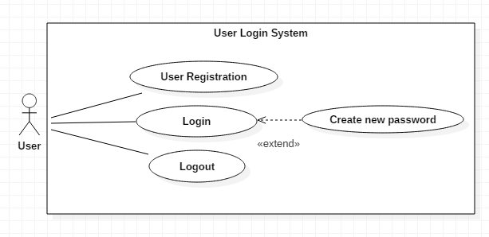

Figure User login system use case

New user must register with their details to create an account and get access to the website. After they register with their details they can login and view all information inside the website, they can logout to get out of the website anytime. In case a user forgets their password, they can create a new password with certain authentication.

1. **Admin login system:**

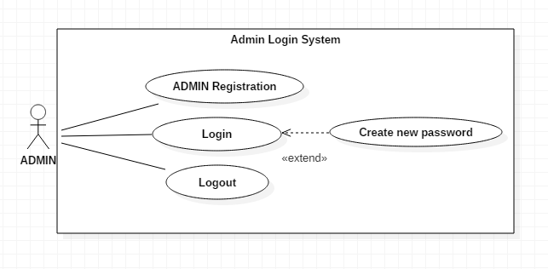

Figure Admin login system use case

Admin must register with their details to create an account and get access to the website. After they register with their details they can login and view all information inside the website, they can logout to get out of the website anytime. In case an admin forgets their password, they can create a new password with certain authentication

1. **Admin and user Profile:** 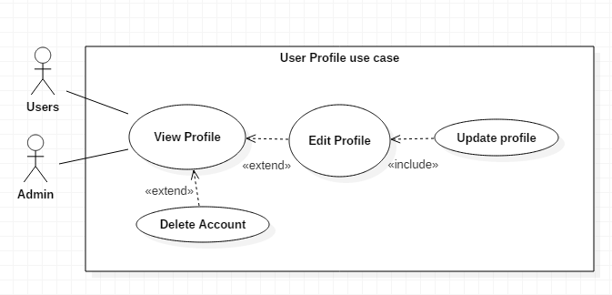

Figure Admin and user profile use case

User and Admin can view their profile in which they have access to all their information. They can edit profile and update their profile. They can even delete their account whenever they want to delete.

1. **Admin functionality:** 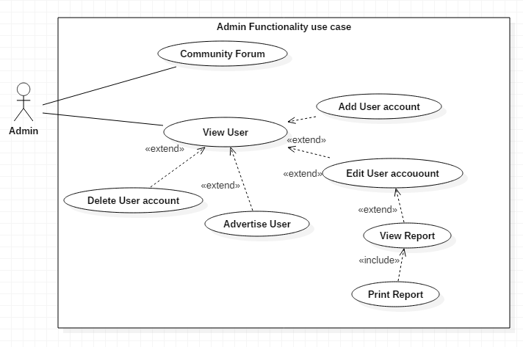

Figure Admin functionality use case

Admin can have various functionality in which View users is one of them. Admin have an ability to advertise user, add user account, edit user account and delete user account in required condition. Admin can even view and print report. They can be involved in community forum to have discussion among users.

1. **Product handling:** 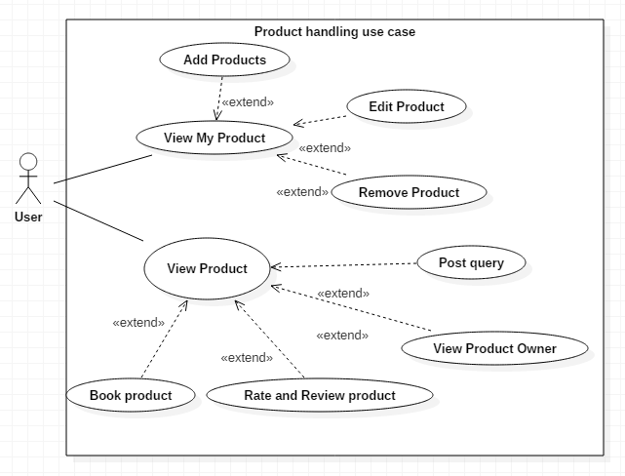

Figure Room and flat handling use case

Product for this project is Room and flat. User have an ability to add product, view others product and view My product list in a system. User can edit and remove their product anytime they want. They can even Post query, view product owner, book product and rate and review others product**.**

1. **Book product:** 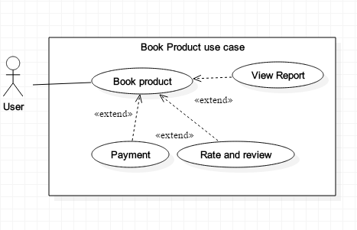

Figure Book product use case

User can book product they are interested in, after they have booked the product they can view product by visiting the site. After they visit the site they can rate and review product for other help. User can also view report of product. Online payment is not available for now in this project so the can click payment and pay in real time.

**2.6 Natural Language Analysis:** The field of study, focusing on interaction between computers and human language is known as natural language analysis or NLA in short. It helps computer to understand, manipulate and interpret human language. Natural language can be processed by breaking down into shorter element such as Noun, verb and adjectives. There are many other ways for natural language analysis. In this breaking, down process Noun can be used as candidate class, adjective can be used as candidate attributes and verb can be used as candidate method to write a program. Short scenario for my project is written below:

Real estate is a project focused on creating a centralized market place for Property buying/selling and rental in Kathmandu valley. Finding property such as room/flat/apartment/house in desired location is a difficult task in Kathmandu valley. I am creating a website where buyer and seller can meet and advertise their product.

This website will allow user (buyer and seller) and admin to create an account with their personal details. User are required to enter their personal details for registration and login. Admin will also be allowed to add users in critical situation. User/Admins can change their password and create new password in case they forget. User/Admin can edit their profile, update and delete profile any time they want. Once user get registered, they can login, add new room and flat (product), view their room and flat(product) list, remove their room and flat(product) any time they want. After users add room and flat (product) with all description of product, it will be appeared in "view all room and flat" of all users. Then, all user can book the room and flat (product), post queries, rate and review (room and flat) product, view room and flat (product) owner profile. User/Admin can participate in online community forum where they can share (room and flat) product's view and opinions. Admin can view all user profile, advertise user and delete user account but user can only manipulate their room and flat (product). User must provide personal details such as name, address, date of birth, location, email etc. for registration. And before uploading any room and flat (product) they must submit the description of the product such as product type, product available date, product quality, price of product etc.

From the above text, NLA can be carried out by:

* Selection of noun for potential candidate class.
* Selection of adjectives for potential candidate attributes.
* Selection of verbs for potential candidate methods.

Selection of candidate class, attributes and method from above text are listed below:

|  |  |  |  |
| --- | --- | --- | --- |
| Candidate Class. | Candidate Attributes. | Candidate Methods. | |
| User.  Admin.  Room and Flat  Location. | Name  Email  Date of Birth.  Phone number.  Room and Flat type.  Room and Flat available date.  Room and Flat quality.  Room and Flat price. | | Add user.  Edit user.  Delete profile.  Edit user profile.  Add room and flat.  Edit room and flat.  Delete room and flat. |

**Initial Class Diagram:**

Class diagram is static structure diagram used to describe structure of a system by showing system's class, attributes and operation. The purpose of class diagram is to show the model types designed within a system. Most of the initial class diagram includes Class, an interface, a data type and a component. Class can be represented in a rectangle box containing three compartments stacked vertically with attributes and methods in it. Class diagram is designed to help developer and other team members to write a program.

Initial class diagram for my system is shown below:

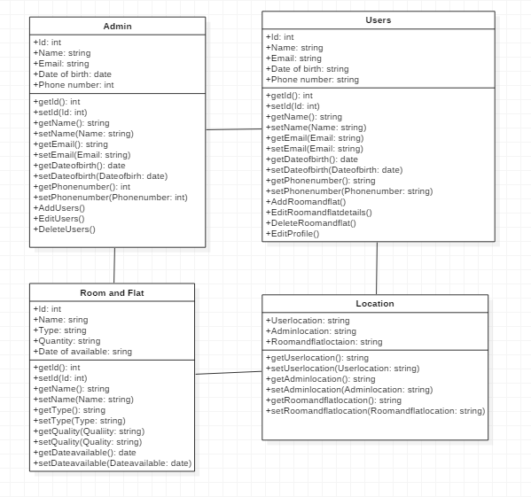

Figure Initial Class diagram