Guessing random number



**In this game, the computer will generate a random number and the user will try to figure out that number**

**The roles:**

**1- You will guess a number between 1-10**

**2-You have only 5 chances**

**3-You will start with 10 points with each incorrect guessing you will lose 2 points**

**4-Running out chances or points , means you lost**



العنود التويجري 421202025

جود العليان 421202232

سيرا الهطلاني 421202162

ديم الغرير 411202095

دانه الكغيل 421202150

IT214 -Section 1260

Word file made by alanoud

package project;

public class Player{

private int points=10;

private String name;

public Player(String n){

setName(n);

}//end method

public void setName(String name){

this.name = name;

}//end method

public void setPoints(int points){

this.points = (points > 0) ? points : 0;

}//end method

public String getName(){

return name;

}//end method

public int getPoints(){

return points;

}//end method

public void subPoints() {

setPoints(getPoints()-2);

}//end method

public String toString(){

return String.format("The name is %s\nThe points are %d\n", getName(), getPoints() );

}//end method

} // end of class player

package project;

import java.util.Random;

import java.util.Scanner;

public class Game{

private Player p;

private static final int numberOfChances=5;

private static final int max=10;

private int currentChance;

private int computerNum ;

private Scanner input ;

private int []allGuesses=new int[numberOfChances];

public Game() {

input = new Scanner(System.in);

System.out.println("Please enter your name: ");

p= new Player(input.nextLine());

welcomeMassege();

} //end method

private void setCoumputerNum() {

Random rand= new Random();

computerNum= 1+rand.nextInt(getMax());

} //end method

public int getNumberOfChances() {

return numberOfChances ;

} //end method

private int getMax() {

return max ;

} //end method

public int getCurrentChance() {

return currentChance;

} //end method

public int getComputerNum() {

return computerNum;

} //end method

public void incrementCurrentChance() {

currentChance++;

} //end method

public void guessing() {

setAllGuesses();

setCoumputerNum();

p.setPoints(10);

System.out.println("Please enter your guess: ");

for ( currentChance=0; getCurrentChance() < numberOfChances; ) {

try {

int userGuess =input.nextInt();

checkingValityOfTheGuess(userGuess);

int check = compare(userGuess);

allGuesses[currentChance]=userGuess;

incrementCurrentChance();

if (check == -1)

break;}// end try

catch(IllegalArgumentException a) {

System.out.println(a.getMessage());

}// end catch

}//end for

lossingCheck();

} //end method

private void setAllGuesses() {

for (int i=0;i<allGuesses.length;i++)

allGuesses[i]=0;

}

public void checkingValityOfTheGuess(int userGuess) {

if (userGuess>getMax()||userGuess<1) {

throw new IllegalArgumentException("you entered an invalid number");}

} //end method

private int compare(int userGuess) {

if (userGuess < getComputerNum()) {

lessThanComputerNum() ;

return 0; }

else if (userGuess > getComputerNum()) {

higherThanComputerNum();

return 0; }

else {

equalComputerNum();

return -1; }

} //end method

private void lessThanComputerNum() {

System.out.printf("TOOO LOWWWW!!!!!, your left chances are %d\n ",getNumberOfChances()-(getCurrentChance()+1));

p.subPoints();

}//end method

private void higherThanComputerNum(){

System.out.printf("TOOO FARRRR!!! your left chances %d\n ",getNumberOfChances()-(getCurrentChance()+1));

p.subPoints();

}//end method

private void equalComputerNum() {

System.out.printf("you won at attempt %d your points are %d\n ",getCurrentChance()+1,p.getPoints());

}//end method

private void lossingCheck() {

if (getCurrentChance()==numberOfChances&&getComputerNum()!=allGuesses[numberOfChances-1]) {

System.out.printf("you lost and your points = %d\n",p.getPoints());

System.out.printf("Computer guess was %d\n",getComputerNum() );}

} //end method

private void welcomeMassege() {

System.out.println();

System.out.printf("Guess the inetger between 1-10 \nyou have only %d chances",this.getNumberOfChances());

System.out.println();

System.out.println("your current points are 10 for each wrong quess you'll lose 2 points");

}//end method

public void Print_AllGuesses() {

for(int i=0; i<allGuesses.length;i++)

if (allGuesses[i]!=0)

System.out.printf("Guess %d is %d\n",i+1,allGuesses[i]);

}

public String toString() {

System.out.println("------Report-------\n");

System.out.printf("%s\nyour guesses are:\n", p);

Print_AllGuesses();

return String.format("Computer guess is %d\n",getComputerNum() );

}

}//end of class Game

package project;

public class Test {

public static void main(String[]args){

Game A =new Game();

A.guessing();//first Game

System.out.println(A);

A.guessing();//second Game for the same player

System.out.println(A);

}

}//end class Test

OUTPUT:

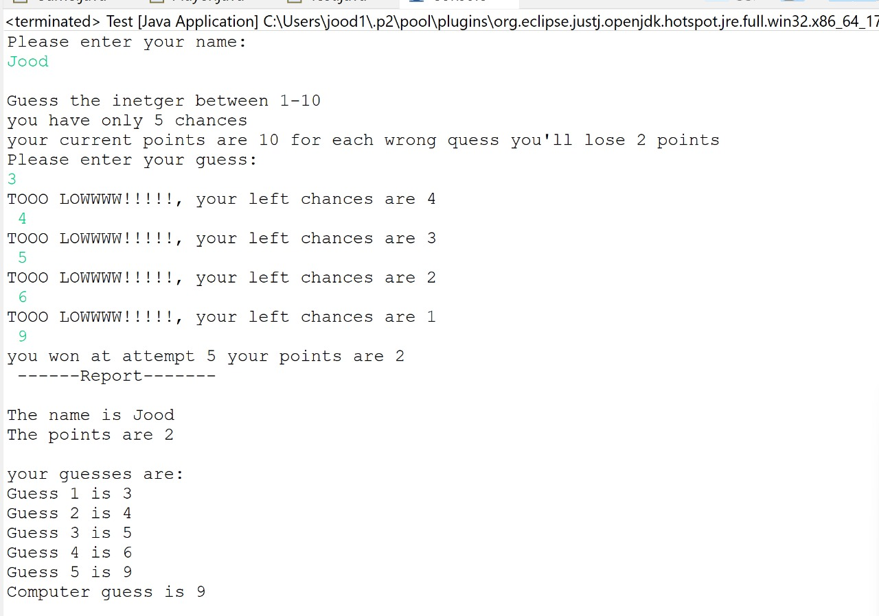

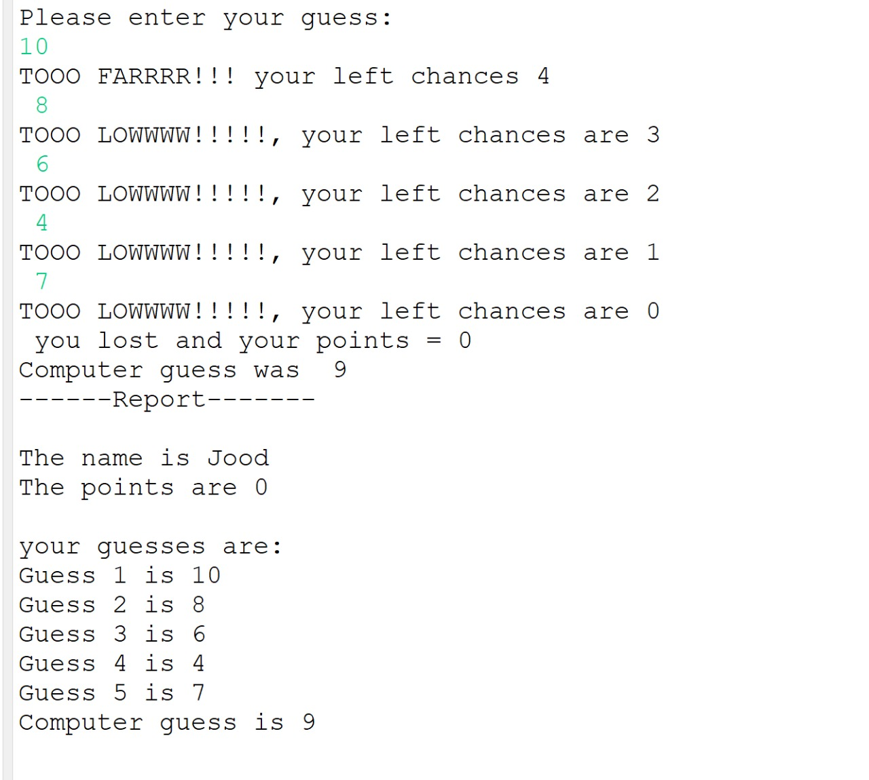

In case that the user entered a number that out of range during the game

