|  |  |
| --- | --- |
| AUTHORS | |
| 1 | Nadeem |
| 2 | Azaria |
| 3 | Vivash |

|  |  |  |
| --- | --- | --- |
| DEVELOPER NAMES | PROJECT ROLE | ASSIGNED WORKFLOW |
| Nadeem | Lead project manager | Index.php / upload.php |
| Azaria | Database administrator | Login.php / update-credentials.php |
| Vivash | User interface design | Admin.php / pptx presentation |

|  |  |
| --- | --- |
| 3rd Party Software | |
| Web hosting services | Google Firebase |
| Database Services | Google Firebase / phpMyAdmin |
| Workflow management | GitHub |

# System Functionality

End Users

Developers

President

System security

Mitigation for Unauthorized access

To ensure the integrity of the book club platform and safeguard against unauthorized access, a stringent authentication mechanism has been implemented. Only individuals with a valid Richfield student number can gain access to the main page or register page. This measure is enforced by granting exclusive authorization to the book club president or designated developers to enter student numbers into the database. Upon receiving a request to join the book club, the president or developers will verify the student's credentials and subsequently add their student number to the database.

During the login process, the system will validate the entered student number against the database. If the student number is recognized, the user will be redirected to the 'Update User Information' page where they can personalize their account by creating a custom username and modifying the default password. Conversely, if an invalid student number is entered, the system will immediately restrict access, preventing unauthorized individuals from gaining entry.

This multi-layered approach effectively safeguards the book club platform from unauthorized access, ensuring that only verified Richfield students can participate in the club's activities.

System theme

**5**

**4**

**3**

**2**

**1**

|  |  |
| --- | --- |
| HEX INDEX | |
| 1 | 00A6FB |
| 2 | 0582CA |
| 3 | 006494 |
| 4 | 003554 |
| 5 | 051923 |

FONTS

Using css normalization stylesheet: normalize.css

html {

    /* Improve consistency of default fonts in all browsers.

    font-family:

        system-ui,

        'Segoe UI',

        Roboto,

        Helvetica,

        Arial,

        sans-serif,

        'Apple Color Emoji',

        'Segoe UI Emoji';

    line-height: 1.15; /* 1. Correct the line height in all browsers. */

    -webkit-text-size-adjust: 100%; /* 2. Prevent adjustments of font size after orientation changes in iOS. */

    -moz-tab-size: 4; /* 3. Use a more readable tab size (opinionated). */

    tab-size: 4; /* 3 */

}

User interface

Login page (login.php)

Assigned developer: Azaria

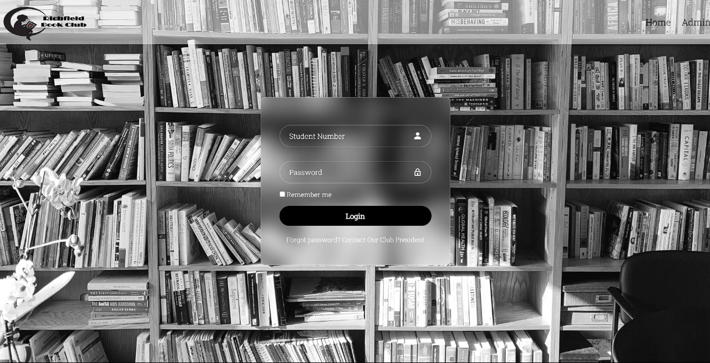

Page functionality

Serving as a gateway for registered students, the main login page streamlines access to the Richfield Online Book Club. Upon entering their student number and the default password (**R1chField@2023**). To ensure a secure and organized environment, the club president must first add students through the administrator page, granting them authorized access. Following a successful login and completion of the student number authorization step, students will be seamlessly redirected to the UpdateCredentials.php page.

Button “Login” – Verifies student number exist within the database and verifies correct password has been entered.

Update Credentials page (update-credentials.php)

Assigned developer: Azaria

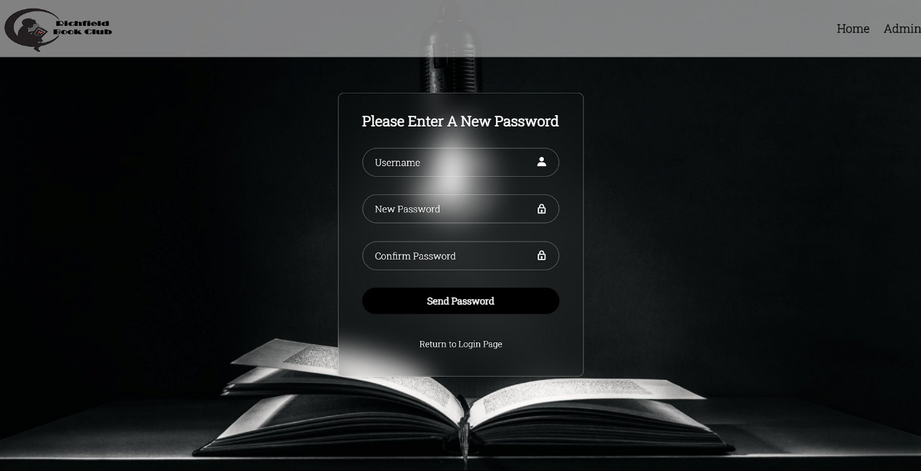

This page only be available to student numbers that have been recognized by the database. They will be asked to change their password and create a username. Once done the php script will update the database fields for username and password accordingly.

Button “Send Password” – php script executes updating default password to the users prescribed password and updated username.