Al-Aqsa University  Faculty of Computers and IT  Dept. of Info & Computer science |  | جامعة الأقصى  كلية الحاسبات وتكنولوجيا المعلومات  قسم علم الحاسوب والمعلومات

Advanced Database

Assignment 3

Presented to: Eng. Maha AL-Atteli

Student name: Deema Mohammed AL-Maqadma
Student number:2320230766

Semester: First Semester 2025/2026

Question 1 : Write a function that print out the maximum and minimum salary of employees in a specific job. )

The Function:

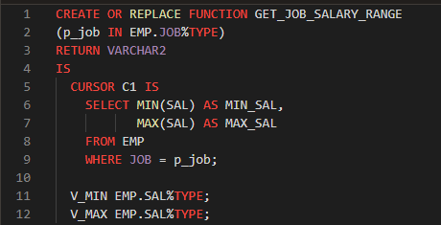
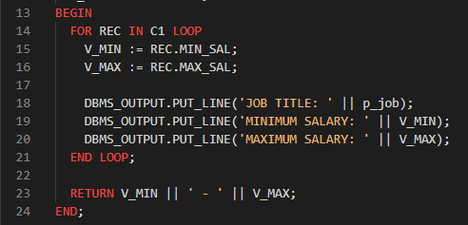

The Result:

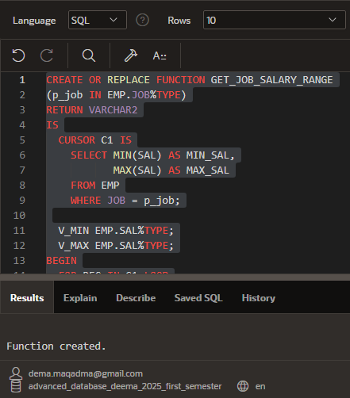

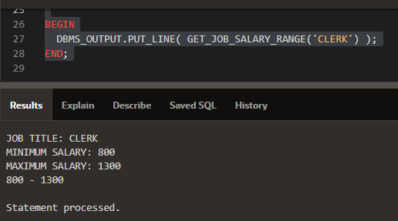

Question 2 : Create procedure that print out how many employees and average salary exist in a specific department

The Procedure:

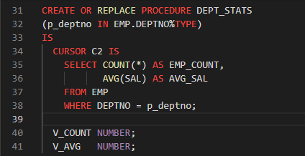
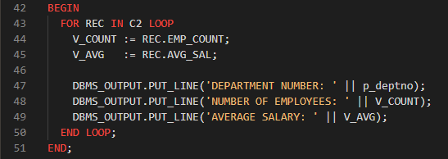

The Rresult:

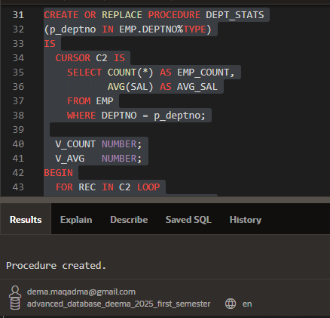

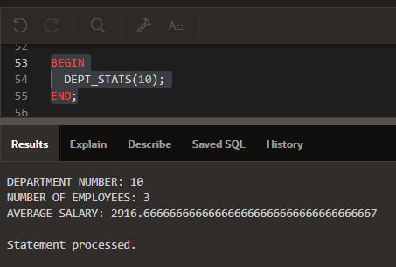

Conclusion:

In this assignment, I applied the main PL/SQL concepts learned this week by creating
a function and a procedure that work with the EMP table. The function returned the
minimum and maximum salary for a specific job, while the procedure printed the number
of employees and the average salary for a selected department. I used parameters,
%TYPE, cursors, loops, and DBMS_OUTPUT to process and display the results. This work
helped me understand how PL/SQL programs interact with database tables and how to
execute stored programs inside Oracle APEX.

" واخر دعواهم ان الحمد لله رب العالمين "

