Al-Aqsa University  Faculty of Computers and IT  Dept. of Info & Computer science |  | جامعة الأقصى  كلية الحاسبات وتكنولوجيا المعلومات  قسم علم الحاسوب والمعلومات

Advanced Database Systems

Final Project

Presented to: Eng. Maha AL-Attili

Student name: Deema Mohammed AL-Maqadma
Student number:2320230766

Semester: First Semester 2025/2026

1. Create CONTACTS Table

We created the CONTACTS table to store contact information. It will serve as the source for saving and managing fields such as Name, Phone, Email, and Category.

CREATE TABLE CONTACTS (
CONTACT_ID NUMBER GENERATED BY DEFAULT AS IDENTITY PRIMARY KEY,
NAME VARCHAR2(100) NOT NULL,
PHONE VARCHAR2(20),
EMAIL VARCHAR2(100),
CATEGORY VARCHAR2(50)
);

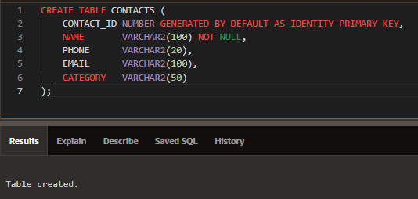

2. Insert Sample Records

We inserted two sample records into the CONTACTS table to test the data storage and ensure the table works correctly.

INSERT INTO CONTACTS (NAME, PHONE, EMAIL, CATEGORY)
VALUES ('Deema AL-Maqadma', '0599123456', deema.almaqadma@example.com', 'Friend');

INSERT INTO CONTACTS (NAME, PHONE, EMAIL, CATEGORY)
VALUES ('Omar Khaled', '0599876543', 'omar.khaled@example.com', 'Colleague');

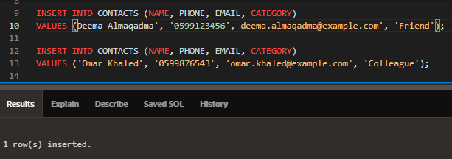

3. Create VALIDATE_EMAIL Function

We created the VALIDATE_EMAIL function to check if an email address has a valid format. It returns 'Y' for valid emails and 'N' for invalid ones.

CREATE OR REPLACE FUNCTION VALIDATE_EMAIL(p_email IN VARCHAR2)
RETURN CHAR
IS
BEGIN
-- Check if email contains '@' and '.'
IF INSTR(p_email, '@') > 1 AND INSTR(p_email, '.', INSTR(p_email, '@')) > 0 THEN
RETURN 'Y';
ELSE
RETURN 'N';
END IF;
END;
/

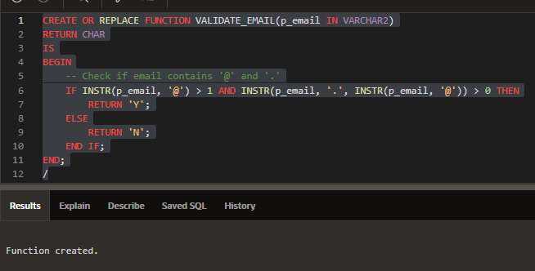

4. Create ADD_CONTACT Procedure

We created the ADD_CONTACT procedure to insert new contact records into the CONTACTS table using input parameters for Name, Phone, Email, and Category.

CREATE OR REPLACE PROCEDURE ADD_CONTACT(
p_name IN VARCHAR2,
p_phone IN VARCHAR2,
p_email IN VARCHAR2,
p_category IN VARCHAR2
)
IS
BEGIN
INSERT INTO CONTACTS (NAME, PHONE, EMAIL, CATEGORY)
VALUES (p_name, p_phone, p_email, p_category);

COMMIT;
END;
/

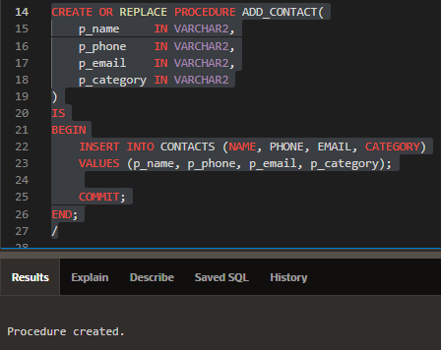

5. Create Application in App Builder

We started building the Contact Management application in Oracle APEX using App Builder. This application will include pages for listing contacts, adding new contacts, and viewing contact details.
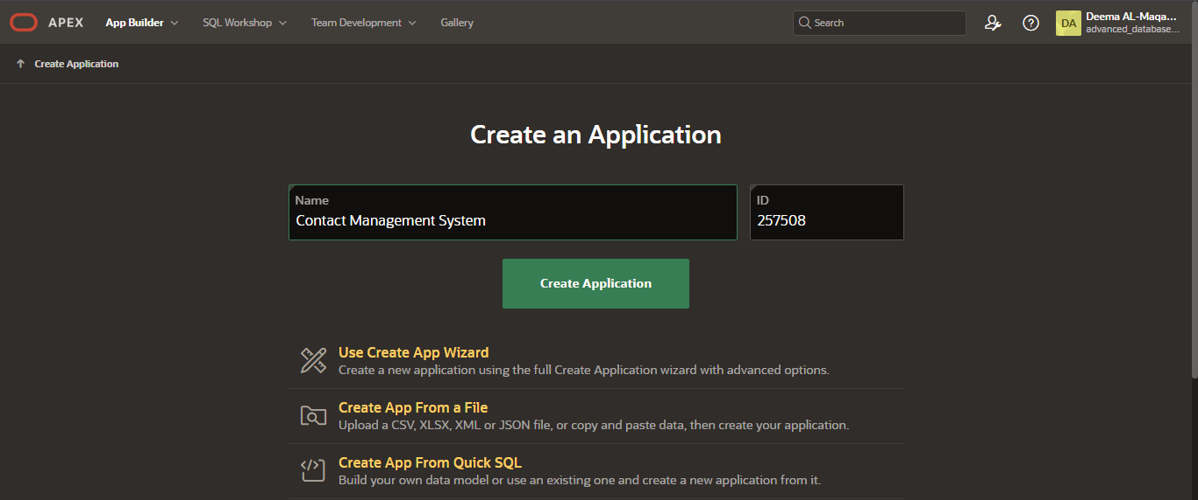
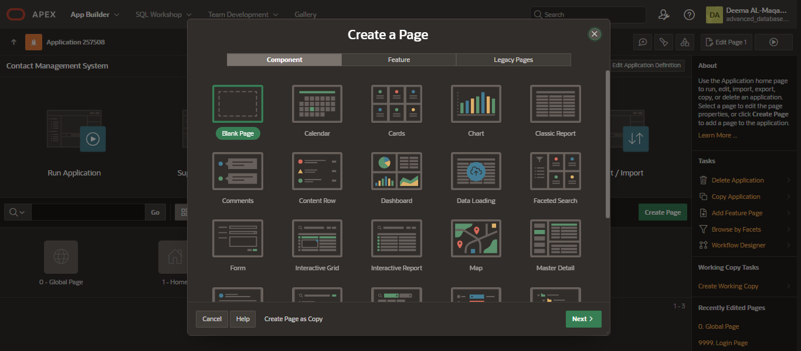

6. Create Contacts List Page

We created the first page of the application using an Interactive Report linked to the CONTACTS table. This page displays all contacts, shows the total number of records, and makes each contact name clickable for viewing details.

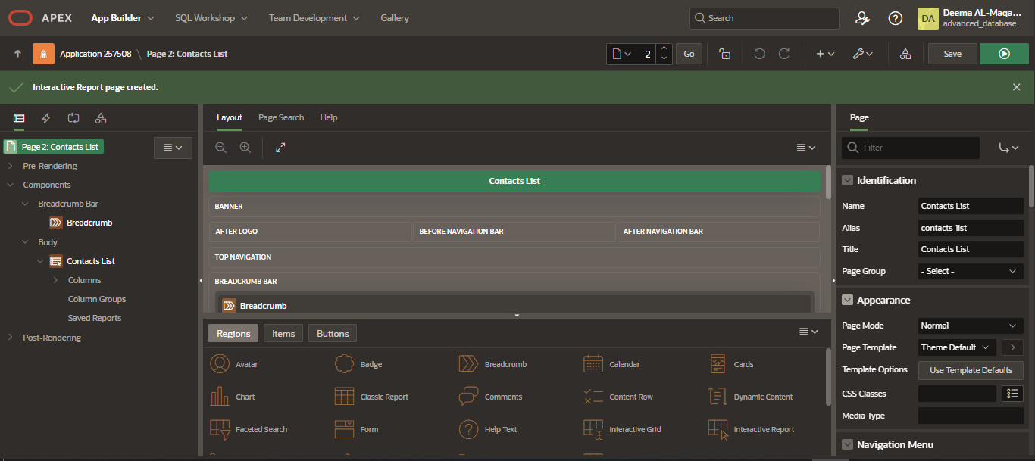
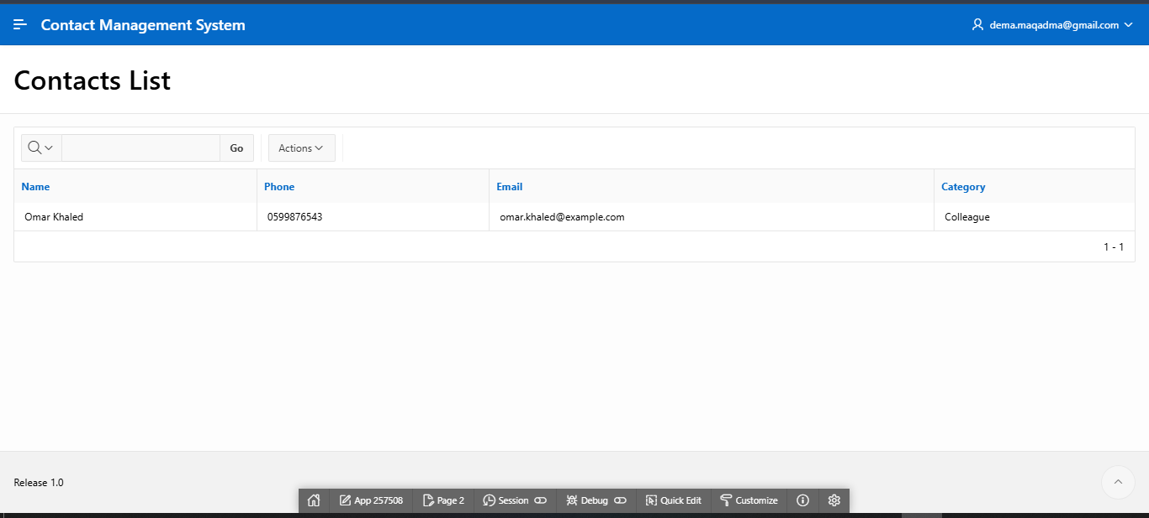

7. Add Contact Page Buttons and Fields

The Add Contact page automatically displays the fields from the CONTACTS table (Name, Phone, Email, Category). We added two buttons: Add (to save the new contact) and Cancel (to return to the Contacts List page).

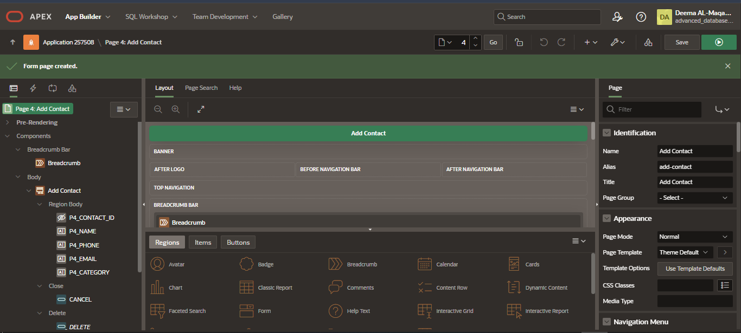
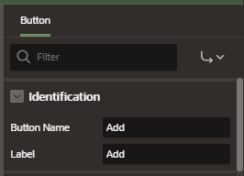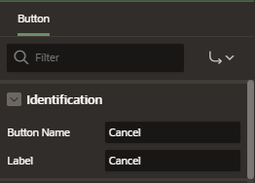
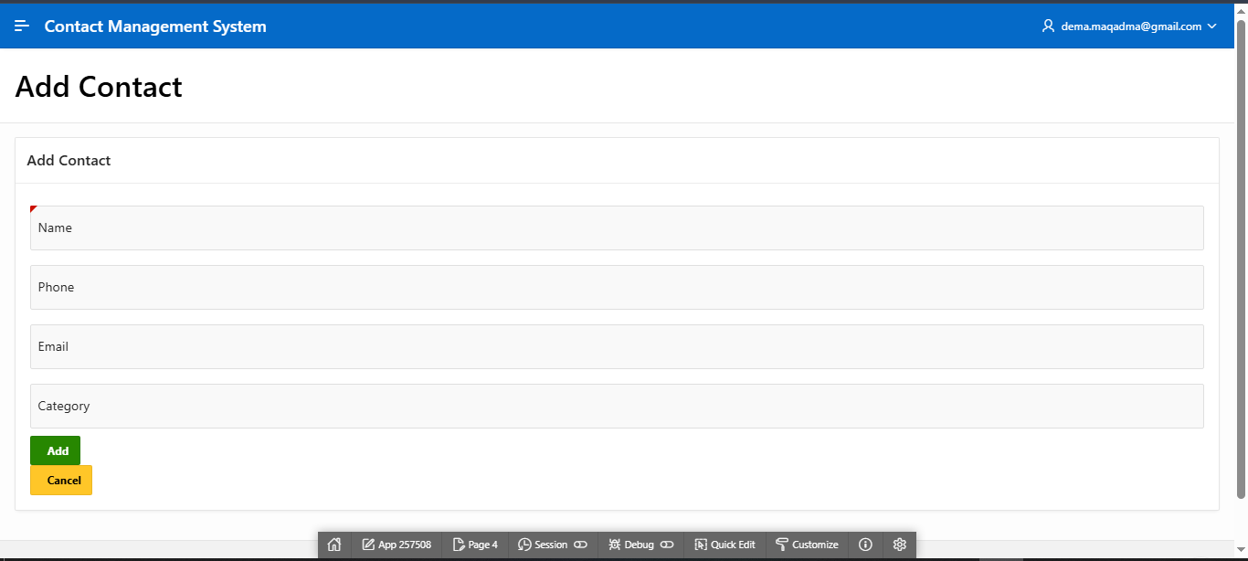

8. Link Contact Name to Details Page

We configured the Name column in the Contacts List page to open the Contact Details page. The CONTACT_ID value is passed through the column link using the Set Items and With Values options, allowing the details page to display the selected contact's full information.

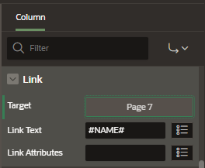
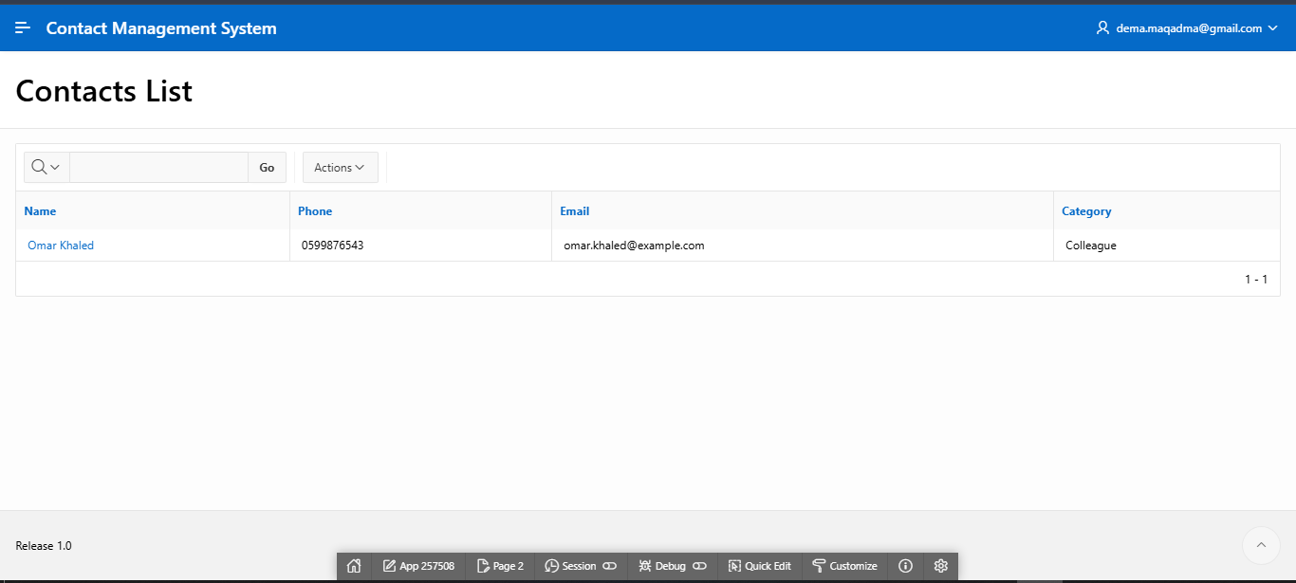
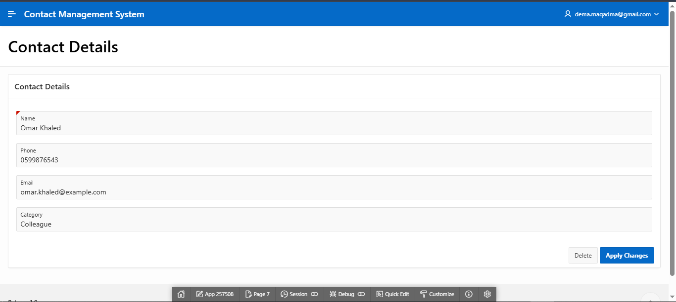

9. Deadlocks

A deadlock occurs when two or more transactions wait indefinitely for each other to release locks.
Techniques:
- Prevention: Avoid conditions that lead to deadlocks.
- Detection: Identify deadlocks when they occur.
- Avoidance: Use algorithms to ensure the system never enters a deadlock state.
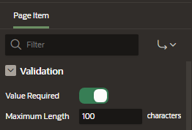
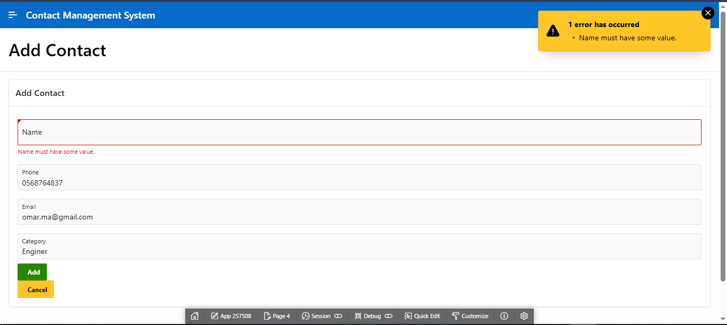

10. RT 4.1 – Validations

We added two validations to the Add Contact page. First, we marked the Name field as required to ensure users cannot submit an empty name. Second, we created a PL/SQL validation that calls the VALIDATE_EMAIL function to verify the email format. If the function returns 'N', an error message is displayed to the user.

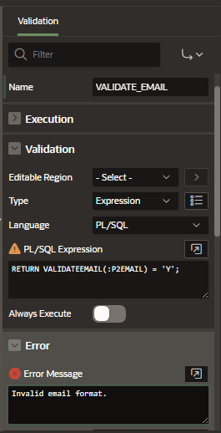
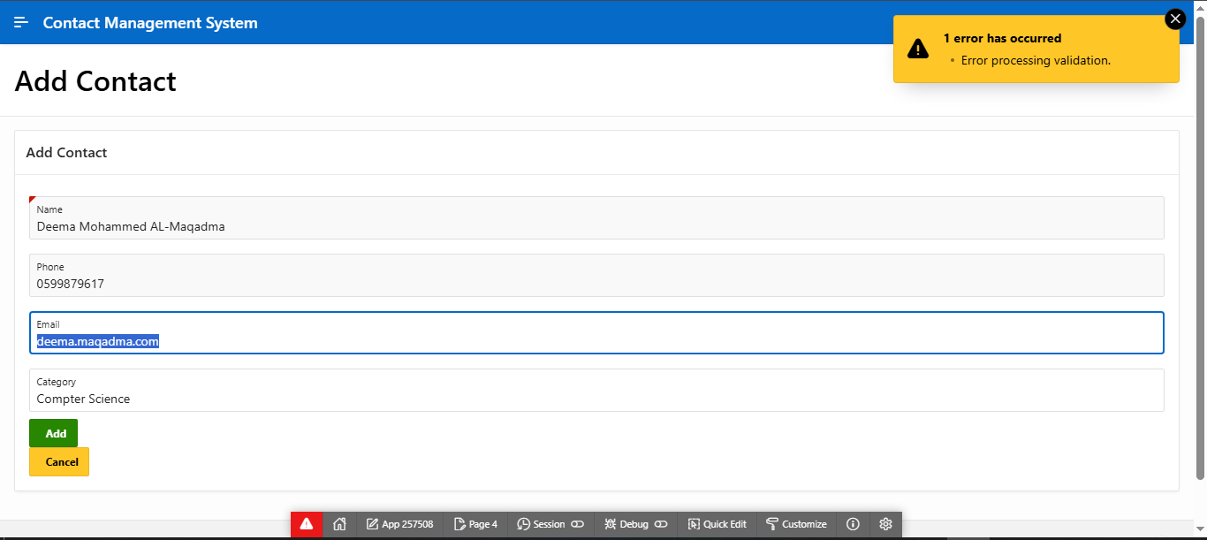

11. RT 4.2 – Dynamic Action

We created a Dynamic Action on the Contacts List page. When the user clicks on a contact name, the system navigates to the Contact Details page and passes the CONTACT_ID, allowing the full details of the selected contact to be displayed.

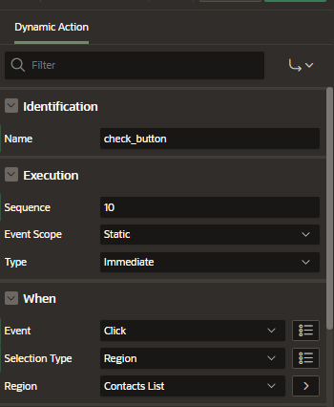

11. RT 4.3 – Authorization

We created an Authorization Scheme in Shared Components using a PL/SQL function that allows only the ADMIN user to access the Add Contact page. The scheme was then applied to the page’s security settings to restrict access for other users.

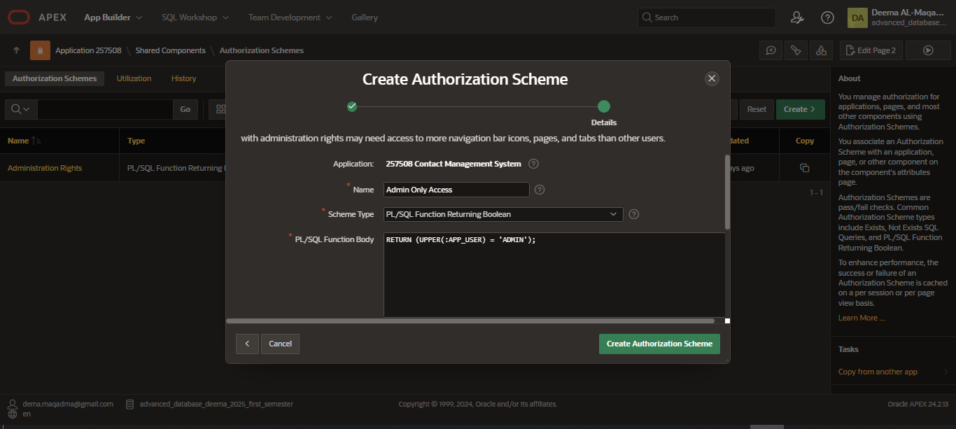
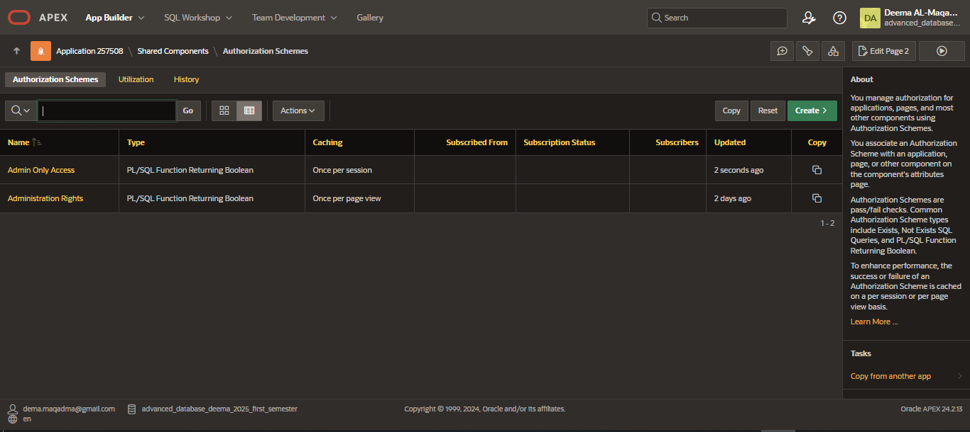
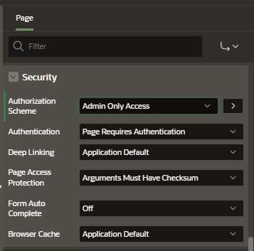

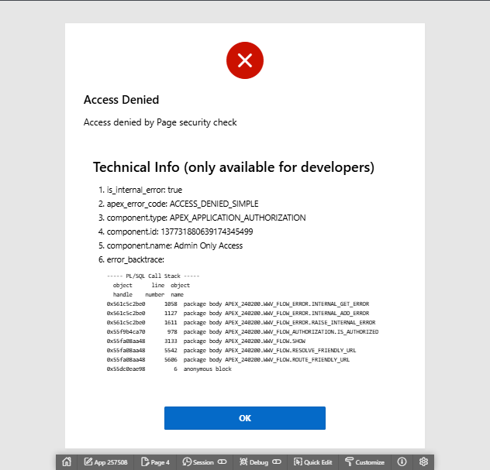`
" واخر دعواهم ان الحمد لله رب العالمين "

