Al-Aqsa University  Faculty of Computers and IT  Dept. of Info & Computer science |  | جامعة الأقصى  كلية الحاسبات وتكنولوجيا المعلومات  قسم علم الحاسوب والمعلومات

( ITNM3319 )

Data & System Security

Final Project

Presented to: Eng. Baraa Sahmoud

Student name: Deema Mohammed AL-Maqadma
Student number:2320230766

Semester: Secound Semester 2025/2026

- Self-Assessment Table

Fill in the table with honest examples about your current digital habits.

Topic | My Current Practice
Password Management | I use Google Password Manager with strong passwords containing numbers, letters, and symbols.
Two-Factor Authentication | I enable two-factor authentication on most accounts like GitHub and banking.
File Encryption | I rarely encrypt files, but sometimes protect important folders with a password.
Suspicious Link Detection | I am cautious with links and scan suspicious URLs using VirusTotal.
Hashing Awareness | I know hashing well and applied it in backend projects for password storage.
Software Updates | I regularly update my devices when prompted, sometimes delaying on my laptop.
Cloud Storage Security | I use Google Drive linked to Gmail but have not applied extra security settings.
Wi-Fi Security | I connect to shared networks and do not focus much on changing Wi-Fi settings.
Antivirus Use | I rely on Windows Defender and occasionally use free antivirus apps on my phone.
Password Storage | I store my passwords securely in Google Password Manager.
Social Media Privacy | My accounts are private, I only add people I know, and avoid sharing personal info.
App Permissions | I grant app permissions only when needed and disable them afterward for security.

- Your Personal Security Plan

- Category: 🔐 Encryption & Hashing

Tool/Website Name: CyberChef

Website: https://gchq.github.io/CyberChef

What it is used for: CyberChef is an online tool for encryption, decryption, hashing, and data conversion.

Why I chose it: I selected CyberChef because it allows me to practice encryption and hashing directly in the browser. It is new compared to the tools we used in class and gives me clear before/after results for text or files.

Note: I applied CyberChef by encrypting a sample text and generating a SHA-256 hash, then captured screenshots before and after.

- Category: 🔑 Password Manager

Tool/Website Name: Bitwarden Web Vault

Website: https://bitwarden.com/

What it is used for: Bitwarden is a password manager that securely stores and generates strong passwords.

Why I chose it: Bitwarden is a password manager that securely stores and generates strong passwords.

Note: Bitwarden is a password manager that securely stores and generates strong passwords.

- Category: 🔑 🔗 Suspicious Link Analysis

Tool/Website Name: PhishTank

Website: https://www.phishtank.com

What it is used for: PhishTank is an online platform to check or submit suspicious websites and detect phishing attempts.

Why I chose it: PhishTank is an online platform to check or submit suspicious websites and detect phishing attempts.

Note: PhishTank is an online platform to check or submit suspicious websites and detect phishing attempts.

- Category: 🛰️ Information Gathering

Tool/Website Name: Censys

Website: https://censys.io

What it is used for: Censys is an online search engine that discovers and analyzes devices and services connected to the internet.

Why I chose it: I selected Censys because it helps with information gathering in a practical way, allowing me to understand how exposed systems can be found online. It is new to me and works directly in the browser, making it easy to test and screenshot.

Note: I applied Censys by searching for a domain and captured the results to connect it with my self-assessment on information gathering.

- Tool Testing & Screenshots

- Tool Testing: CyberChef
Website: https://gchq.github.io/CyberChef
Category: Encryption & Hashing

Steps I applied:
1. I opened CyberChef in my browser.
2. I typed a sample text "Hello Security".
3. I encrypted the text using AES with a simple key and captured screenshots before and after encryption.

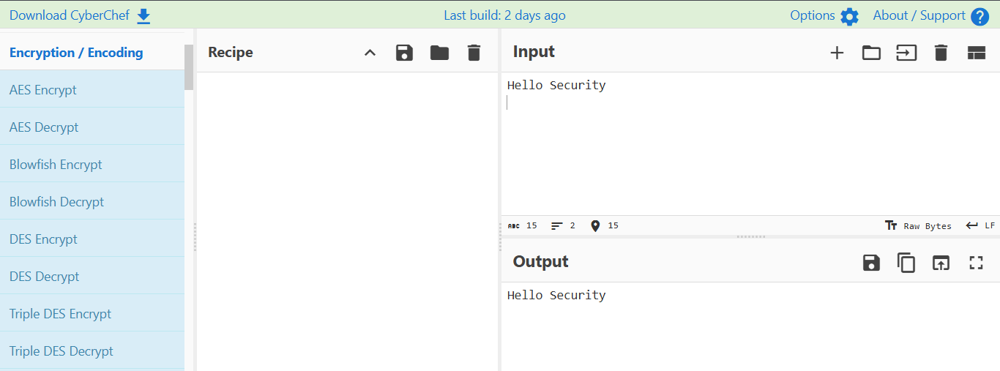

4. I generated a SHA-256 hash of the same text and captured screenshots before and after hashing.

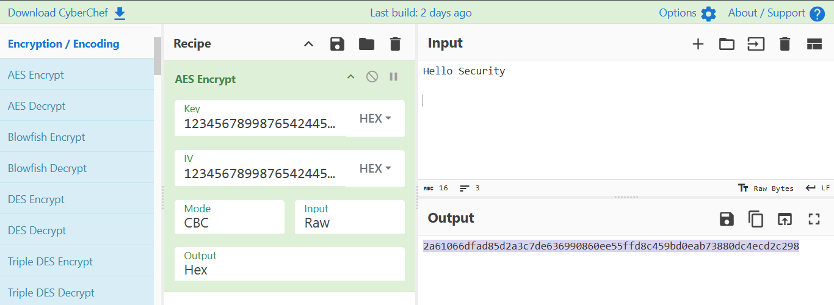

Note: After testing, I observed how encryption changes readable text into ciphertext and how hashing produces a fixed value that cannot be reversed. This helped me connect the tool to my self-assessment on hashing awareness.

- Tool Testing: Censys
Website: https://censys.io
Category: Information Gathering

Steps I applied:
1. I opened Censys in my browser.
2. I typed a domain "microsoft.com" into the search bar.
3. I clicked search to gather information about the domain.
4. I captured a screenshot showing the input domain before scanning.

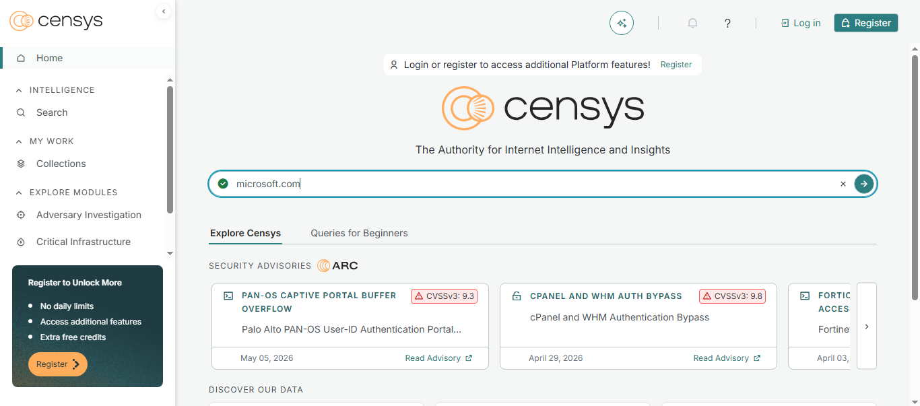
5. I captured another screenshot showing the results (metadata, certificates, services).
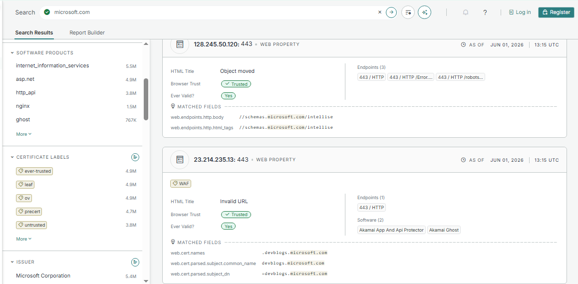

Note: After testing, I observed how Censys provides detailed information about domains and services. This helped me connect the tool to my self-assessment on information gathering and understand how exposed systems can be discovered online.
Conclusion:

From my experience in the course "Data and Computer Systems Security," I learned many important concepts such as password management, two-factor authentication, encryption, hashing, suspicious link detection, software updates, and privacy awareness. These topics gave me a strong foundation in understanding how to protect my digital identity.

In the final project, I applied these concepts by completing the self-assessment table, choosing four new tools from different categories, and testing two of them directly in the browser. I used CyberChef to practice encryption and hashing, and Censys to explore information gathering. I captured screenshots before and after each test to show the practical results.

Through this project, I realized how theoretical knowledge can be turned into real practice. I learned simple but powerful skills such as creating strong passwords, verifying suspicious links, and understanding how information about systems can be collected online.

Overall, this course increased my awareness of the importance of security and protection. It taught me that privacy and safety are essential in the digital world, and that we must protect our devices and ourselves from surrounding threats by taking the right precautions and acting carefully and responsibly.

" واخر دعواهم ان الحمد لله رب العالمين "

