Al-Aqsa University  Faculty of Computers and IT  Dept. of Info & Computer science |  | جامعة الأقصى  كلية الحاسبات وتكنولوجيا المعلومات  قسم علم الحاسوب والمعلومات

( ITNM3319 )

Data & System Security

Assignment 1

Presented to: Eng. Baraa Sahmoud

Student name: Deema Mohammed AL-Maqadma
Student number:2320230766

Semester: Secound Semester 2025/2026

1) Navigate to Desktop
Command: cd Desktop
Definition: Move into the Desktop directory.

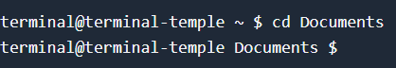

2) Create test_folder
Command: mkdir test_folder
Definition: Make a new folder named test_folder.

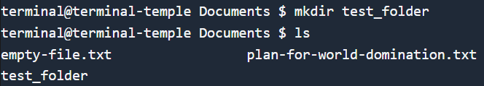

3) Enter test_folder
Command: cd test_folder
Definition: Go inside the test_folder directory.

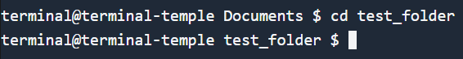

4) Create info.txt
Command: touch info.txt
Definition: Create an empty text file.

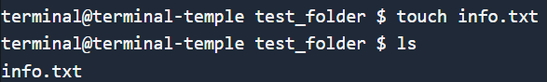

5) Write text into info.txt
Command: echo "Hello from Kali!" > info.txt
Definition: Add text to the file.

6) View file content
Command: cat info.txt
Definition: Show what is inside the file.

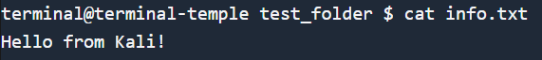

7) Show current path
Command: pwd
Definition: Display your current directory path.

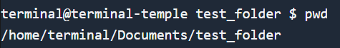

8) Create backup_folder on Desktop
Command: cd .. && mkdir backup_folder
Definition: Go back to Desktop and create backup_folder.

9) Copy info.txt to backup_folder
Command: cp test_folder/info.txt backup_folder/
Definition: Copy the file into the backup folder.

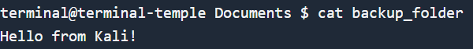

Conclusion:
In this assignment, we practiced basic Linux commands: moving between folders, creating files, writing text, viewing content, checking our path, and copying files. These steps build the foundation for working in Kali Linux.

" واخر دعواهم ان الحمد لله رب العالمين "

