Al-Aqsa University  Faculty of Computers and IT  Dept. of Info & Computer science |  | جامعة الأقصى  كلية الحاسبات وتكنولوجيا المعلومات  قسم علم الحاسوب والمعلومات

Operating Systems for Intelligent Systems (ENGS2306)

Assignment 4
Process Exploration & Management

Presented to : Eng. Mohammed AL-Hams

Student name: Deema Mohammed AL-Maqadma
Student number: : 2320230766

Semester: Second Semester 2024/2025

1. Explore :
htop
Explanation: Shows a live, colorful dashboard of running processes.
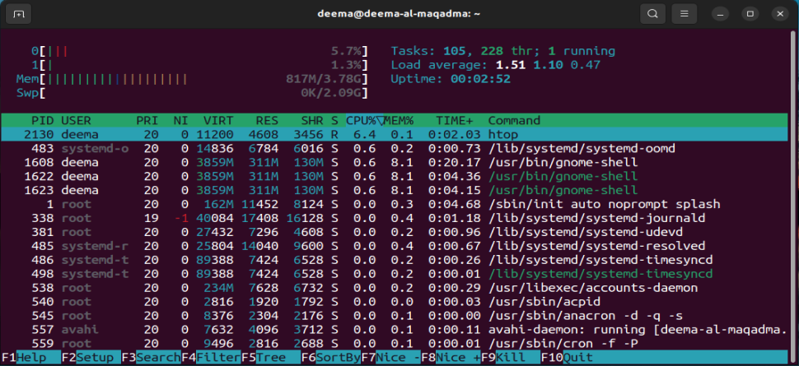

2. Create & Identify: Start a process that sleeps for 5 minutes (300seconds) in the background:
sleep 300 &
Explanation:
Runs a sleep process in the background. The terminal prints its PID.
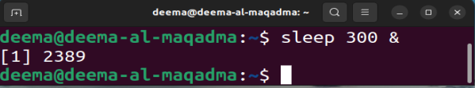
3. Find the Process PID
ps -ef | grep sleep
Explanation:
Searches for the sleep process and retrieves its PID.
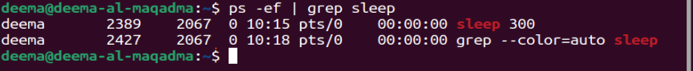
4. Change its Priority
renice 12 -p <PID>
Explanation:
Lowers its priority by setting a niceness of 12 (higher number = lower priority).

5. Verify Niceness
ps -o pid,ni,comm -p <PID>
Explanation:
Displays the process PID, its niceness level, and command name for confirmation.
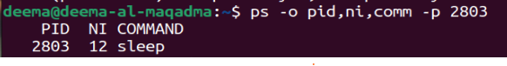
6. Terminate the Process
kill <PID>
Explanation:
Politely asks the process to terminate using SIGTERM.

7. Verify It's Gone
ps -ef | grep sleep
Explanation:
Confirms that the sleep process has been successfully terminated.

9. Report Explanation :

Option 1: SIGTERM vs SIGKILL \
- SIGTERM (15): A graceful exit signal. The process is asked to finish cleanly—saving data and releasing resources.
- SIGKILL (9): A forced termination signal. No cleanup—used when a process is frozen or refusing to exit.
Real scenario: You try to end a sensor-logging process with kill. If it doesn't respond, use kill -9.

Option 2: What is a Zombie Process?
A zombie process is a completed process that still exists in the process table because its parent didn't collect its exit status (via wait()). It doesn’t consume resources but indicates poor process management.
System cleanup: The parent should clean it up. If not, the system eventually reassigns it to init, which will.

" واخر دعواهم ان الحمد لله رب العالمين ".

