Al-Aqsa University  Faculty of Computers and IT  Dept. of Info & Computer science |  | جامعة الأقصى  كلية الحاسبات وتكنولوجيا المعلومات  قسم علم الحاسوب والمعلومات

Operating Systems for Intelligent Systems (ENGS2306)

Assignment 6
Advanced Bash Scripting

Presented to : Eng. Mohammed AL-Hams

Student name: Deema Mohammed AL-Maqadma
Student number: : 2320230766

Semester: Second Semester 2024/2025

1. Explore Commandes:
1. Function: reusable block of code
2. Calling Function: Call the function
3. Parameters: Pass arguments to function
4. Local Variable: Scoped variable inside function
5. Return Value: Output from function
6. Array: A list of values
7. Looping Array: Iterate through array
8. set -e: Exit script on error
9. systemctl: Check service status

*The complete code of your system_reporter.sh
script (copy-paste as text):

system_reporter.sh

bash

!/bin/bash
set -e

Define services to check
SERVICES=("ssh" "cron" "ufw")

Function to check service status
checkservicestatus() {
local service=$1
if systemctl is-active --quiet "$service"; then
echo -e "[ OK ] $service is active."
else
echo -e "[FAIL] $service is not active."
fi
}

Main script logic
echo "System Health Report for $(hostname) as of $(date)"
echo "---------------------------------------------"

for service in "${SERVICES[@]}"; do
checkservicestatus "$service"
done

echo "------------- End of Report -----------------"

* A screenshot showing the script running successfully :
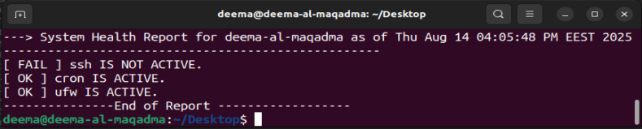

• A second screenshot showing the :
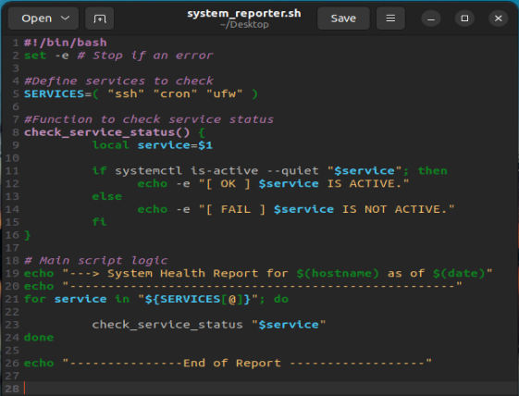

9. Report Explanation :

> Using a function like checkservicestatus() improves code readability and maintainability. Instead of repeating the same logic inside the loop, the function encapsulates it, making the script cleaner and easier to update if needed.

> Benefits of Using a function:
- Readability: The main script logic becomes clean.
- Reusability: check_service() can be reused in other scripts.
- Maintenance: Fix errors in one place.

" واخر دعواهم ان الحمد لله رب العالمين ".

