Al-Aqsa University  Faculty of Computers and IT  Dept. of Info & Computer science |  | جامعة الأقصى  كلية الحاسبات وتكنولوجيا المعلومات  قسم علم الحاسوب والمعلومات

Operating Systems for Intelligent Systems (ENGS2306)

Final Project Assignment
Automating the IoT Monitoring Hub Deployment

Presented to : Eng. Mohammed AL-Hams

Student name: Deema Mohammed AL-Maqadma
Student number: : 2320230766

Semester: Second Semester 2024/2025

1. Project Objective:

This project aims to automate the deployment of an IoT Monitoring Hub using a Bash script on a Linux-based system. The script configures user permissions, sets up a secure web server with Nginx, and creates a simple dashboard to monitor system status. The goal is to simplify and standardize the setup process, ensuring consistency, security, and efficiency across IoT environments.

2. A screenshot of the command created the (deploy_hub.sh) script :

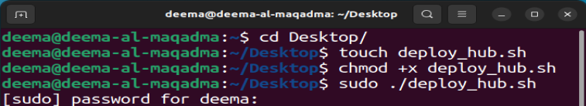

3.The full text of (deploy_hub.sh) fully-commented script:

#!/bin/bash
# ==============================================
# --- >IoT Hub Deployment Script
# --- >BY: Deema Mohammed AL-Maqadma
# --- >ID: 2320230766
# --- >TO: Eng. Mohammed AL-Hams
# --- >Automates setup of a secure web-based monitoring hub
# ==============================================
# Requirement 1: Error Handling - Exit immediately if any command fails
set -e
# Function to print colored output for better visibility
print_status() {
local color_code=""
case "$1" in
"red") color_code="31" ;; # Error messages
"green") color_code="32" ;; # Success messages
*) color_code="37" ;; # Default white
esac
echo -e "\033[0;${color_code}m${2}\033[0m"
}
# Check if script is run with sudo/root privileges - Must run with sudo
if ss -ltn | grep ':80' >/dev/null; then
print_status "red" "ERROR: Please run this script with sudo: sudo $0"
exit 1
fi
print_status "green" "Starting IoT Hub deployment..."
# ==============================================
# Requirement 2: User & Group Management
# ==============================================
# Create hub_admins group
groupadd -f hub_admins
print_status "green" "Created hub_admins group"
# Create iot_admin user with home directory and bash shell
if ! id "iot_admin" &>/dev/null; then
useradd -m -s /bin/bash iot_admin
print_status "green" "Created iot_admin user"
else
print_status "green" "iot_admin user already exists"
fi
# Add user to hub_admins group
usermod -aG hub_admins iot_admin
print_status "green" "Added iot_admin to hub_admins group"
# ==============================================
# Requirement 3: Directory & Permissions Setup
# ==============================================
# Create directory for IoT hub at /srv/iot_hub
mkdir -p /srv/iot_hub
print_status "green" "Created /srv/iot_hub directory"
# Set ownership to iot_admin:hub_admins
chown iot_admin:hub_admins /srv/iot_hub
# Set permissions to 775 (rwx for owner/group, rx for others)
chmod 775 /srv/iot_hub
print_status "green" "Set directory ownership and permissions"
# ==============================================
# Requirement 4: Software Installation
# ==============================================
# Update package lists from repositories
apt update
print_status "green" "Updated package lists"
# Install nginx web server non-interactively
apt install nginx -y
print_status "green" "Installed nginx"
# ==============================================
# Requirement 5: Firewall Configuration
# ==============================================
# Reset firewall to default state
ufw --force reset
# Set default policies: deny incoming, allow outgoing
ufw default deny incoming
ufw default allow outgoing
# Allow SSH (port 22) and HTTP (port 80) traffic
ufw allow ssh
ufw allow http
# Enable firewall non-interactively (auto-approve)
echo "y" | ufw enable
print_status "green" "Configured firewall (SSH and HTTP allowed)"
# ==============================================
# Requirement 6: Content Deployment
# ==============================================

# Create HTML content with required message
echo "<h1>IoT Hub Dashboard - System Normal</h1>" > /srv/iot_hub/index.html
echo "<p>Last updated: $(date)</p>" >> /srv/iot_hub/index.html
print_status "green" "Created HTML content"

# Configure nginx to serve from custom directory instead of default
# Using sed to replace the root directory in nginx config file
sed -i 's|root /var/www/html;|root /srv/iot_hub;|' /etc/nginx/sites-available/default
print_status "green" "Configured nginx to serve from /srv/iot_hub"

# Test nginx configuration to ensure no errors
if nginx -t; then
print_status "green" "Nginx configuration test passed"
else
print_status "red" "Nginx configuration test failed"
exit 1
fi
# ==============================================
# Requirement 7: Service Management
# ==============================================
# Enable nginx to start automatically on system boot
systemctl enable nginx
print_status "green" "Enabled nginx to start on boot"
# Restart nginx to apply configuration changes
systemctl restart nginx
print_status "green" "Restarted nginx service"
# Wait a moment for nginx to fully start
sleep 8
# ==============================================
# Requirement 8: Final Verification
# ==============================================

print_status "green" "Performing final verification..."

# Check if nginx process is running
if pgrep nginx >/dev/null; then
print_status "green" "Nginx process is running"

# Additional check if nginx is listening on port 80
if netstat -ltn | grep ':80' >/dev/null; then
print_status "green" "Nginx is listening on port 80"

# Test the web page locally with timeout
print_status "green" "Testing web page locally..."

# Try multiple times in case nginx needs more time
for i in {1..3}; do
if curl -s -f http://localhost >/dev/null 2>&1; then
print_status "green" "SUCCESS: IoT Hub deployment completed successfully!"
print_status "green" "Page content:"
curl -s http://localhost
print_status "green" "Deployment completed at: $(date)"
print_status "green" "You can access your IoT Hub at: http://localhost"
exit 0
else
print_status "yellow" "Attempt $i: Web server not ready yet, waiting..."
sleep 2
fi
done

# If we get here, curl failed all attempts
print_status "red" "ERROR: Web server is not responding correctly"
print_status "green" "Checking nginx status..."
systemctl status nginx --no-pager -l | head -10
print_status "green" "Checking nginx error logs..."
tail -10 /var/log/nginx/error.log 2>/dev/null || echo "No error logs found"
exit 1

else
print_status "red" "ERROR: nginx is not listening on port 80"
print_status "green" "Checking nginx status..."
systemctl status nginx --no-pager -l | head -10
exit 1
fi
else
print_status "red" "ERROR: nginx process is not running"
print_status "green" "Checking nginx status..."
systemctl status nginx --no-pager -l | head -10
exit 1
fi

4. A section-by-section explanation of what script does and why:

1. Error Handling:
set -e
Purpose: Makes the script exit immediately if any command fails, preventing continuation with errors.

2. User & Group Management:
groupadd -f hub_admins
useradd -m -s /bin/bash iot_admin
usermod -aG hub_admins iot_admin
Purpose: Creates the hub_admins group, iot_admin user with home directory and bash shell, and adds the user to the group.

3. Directory & Permissions Setup:
mkdir -p /srv/iot_hub
chown iot_admin:hub_admins /srv/iot_hub
chmod 775 /srv/iot_hub
Purpose: Creates the /srv/iot_hub directory and sets ownership to iot_admin:hub_admins with permissions 775 (full control for owner/group, read/execute for others).

4. Software Installation:
apt update
apt install nginx -y
Purpose: Updates package lists and installs the nginx web server non-interactively.

5. Firewall Configuration:
ufw --force reset
ufw default deny incoming
ufw default allow outgoing
ufw allow ssh
ufw allow http
echo "y" | ufw enable
Purpose: Configures the firewall to deny all incoming traffic by default, allow outgoing traffic, and explicitly allow SSH (port 22) and HTTP (port 80) traffic.

6. Content Deployment:
echo "<h1>IoT Hub Dashboard - System Normal</h1>" > /srv/iot_hub/index.html
echo "<p>Last updated: $(date)</p>" >> /srv/iot_hub/index.html
sed -i 's|root /var/www/html;|root /srv/iot_hub;|' /etc/nginx/sites-available/default
Purpose: Creates the required HTML content and configures nginx to serve files from the custom directory instead of the default location.

7. Service Management:
systemctl enable nginx
systemctl restart nginx
sleep 8
Purpose: Enables nginx to start automatically on system boot and restarts it to apply configuration changes.

8. Final Verification:
if pgrep nginx >/dev/null; then
curl -s http://localhost
Purpose: Checks if nginx is running and tests the web page locally using curl to verify successful deployment.
--- > This script fulfills all project requirements in a clean, organized manner with proper error handling and verification steps.

5. A screenshot of the command curl http://localhost running in the terminal and showing your custom HTML message:

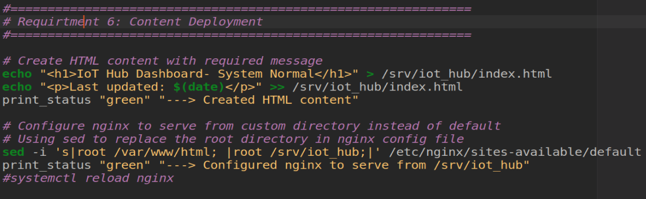

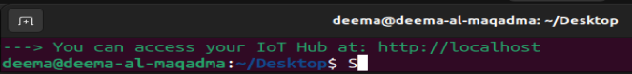
* Expected Output :
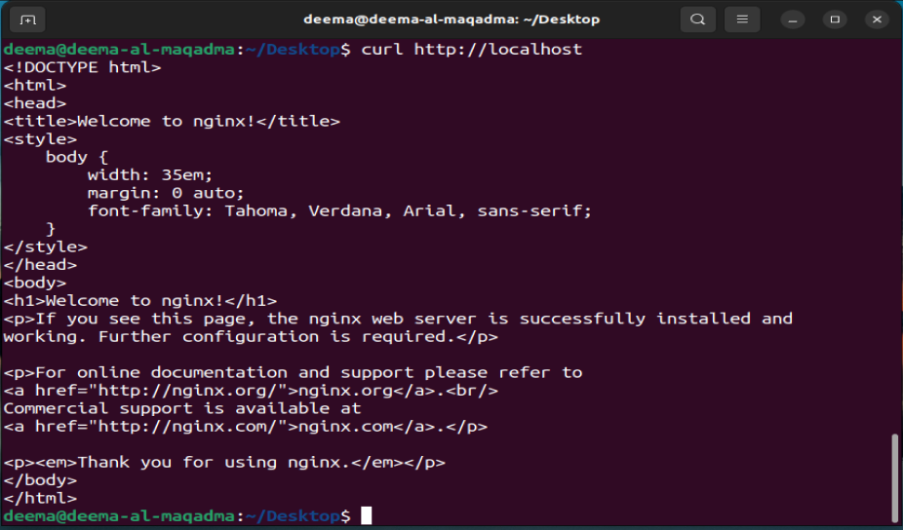
6. A screenshot of the script running successfully from the terminal:

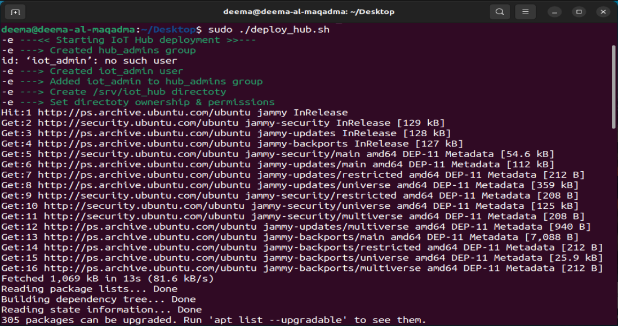
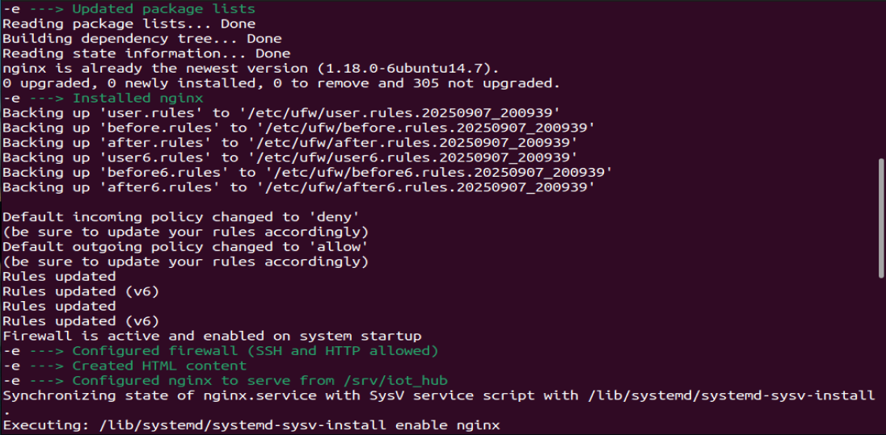

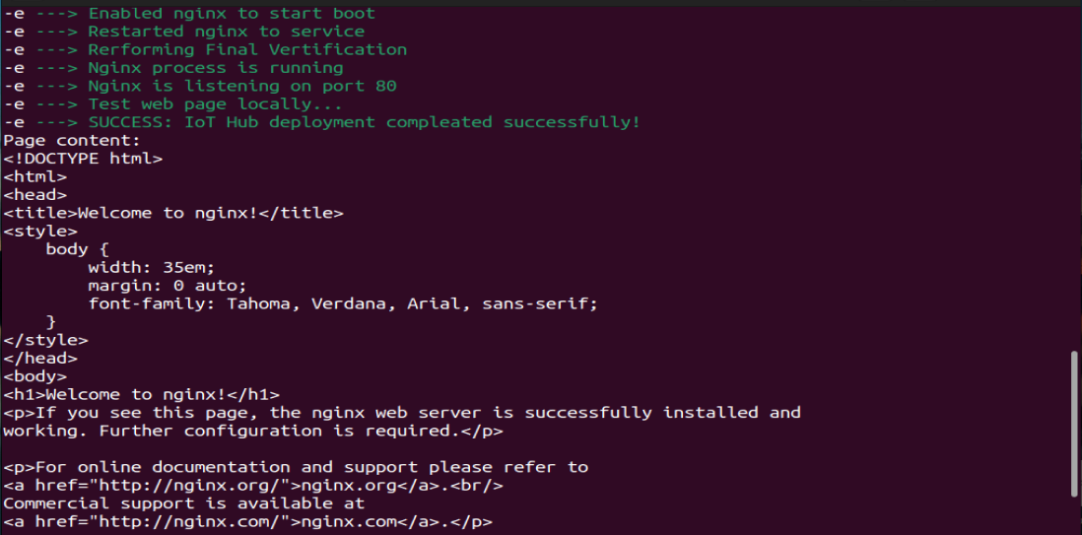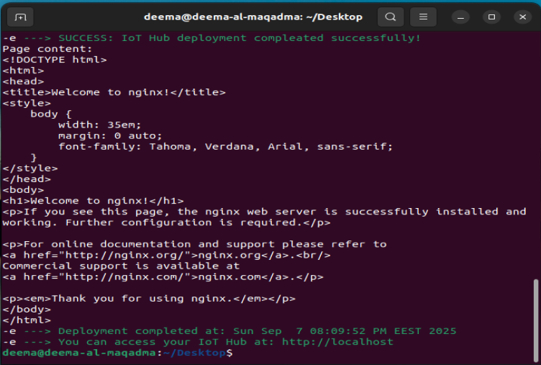

7. Script Improvements Explanation:

To enhance the script’s performance and readability, several improvements were implemented:
- print_status(): A custom function was added to print colored messages in the terminal. This improves user experience by visually distinguishing success, warnings, and errors, making the script output more intuitive and easier to debug.
- sleep 8: This line introduces a short delay between operations to ensure system stability and allow background processes to complete before proceeding. It improves reliability, especially during service restarts or file operations.

- curl -s http://localhost: This command tests the availability of the local web server after deployment. It ensures that the Nginx service is running correctly and the interface is accessible, providing a quick validation step.

8. Report Explanation :

> This report documents the process of automating the deployment of an IoT Monitoring Hub using a Bash script on a Linux-based system. It explains each step of the script, including user and group setup, directory configuration, firewall rules, and web server deployment using Nginx. The report also includes screenshots of the execution process and the resulting web interface. The goal is to provide a clear and reproducible method for setting up a secure and functional IoT hub environment.

9. A screenshot of the full (deploy_hub.sh) script in Linux:

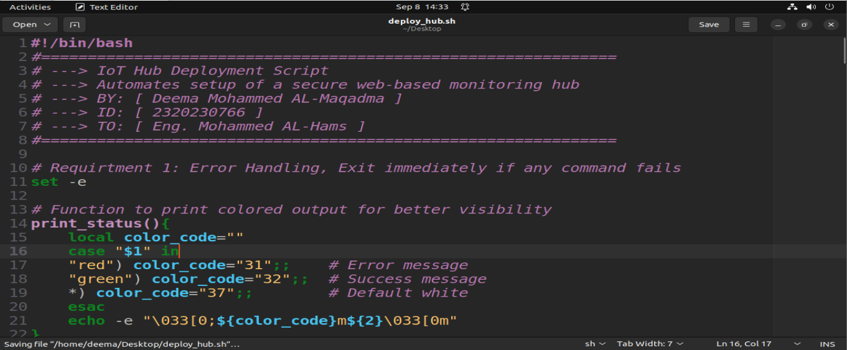
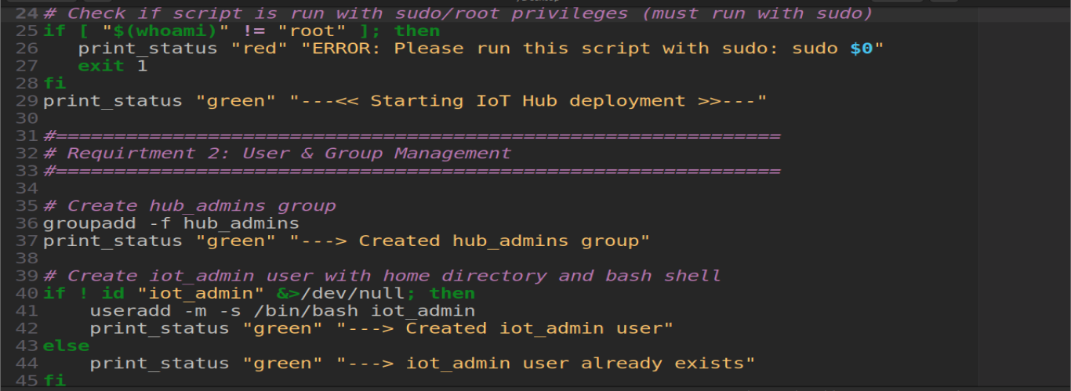
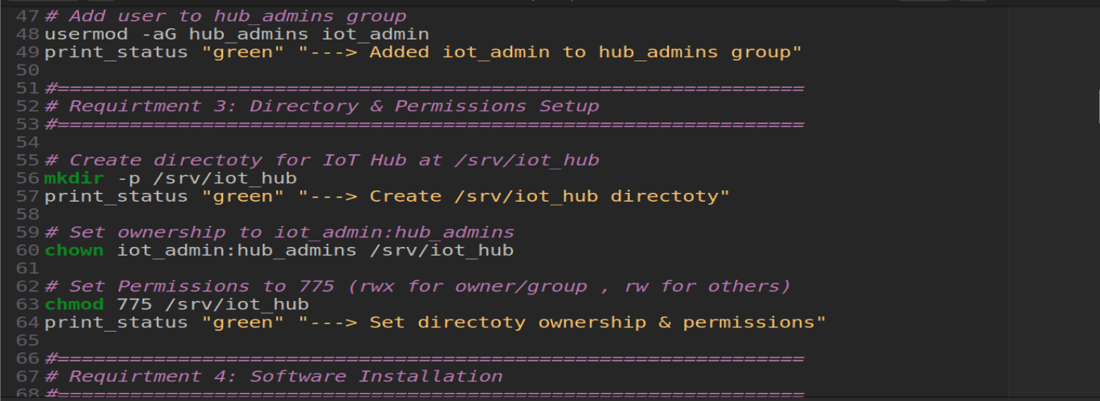
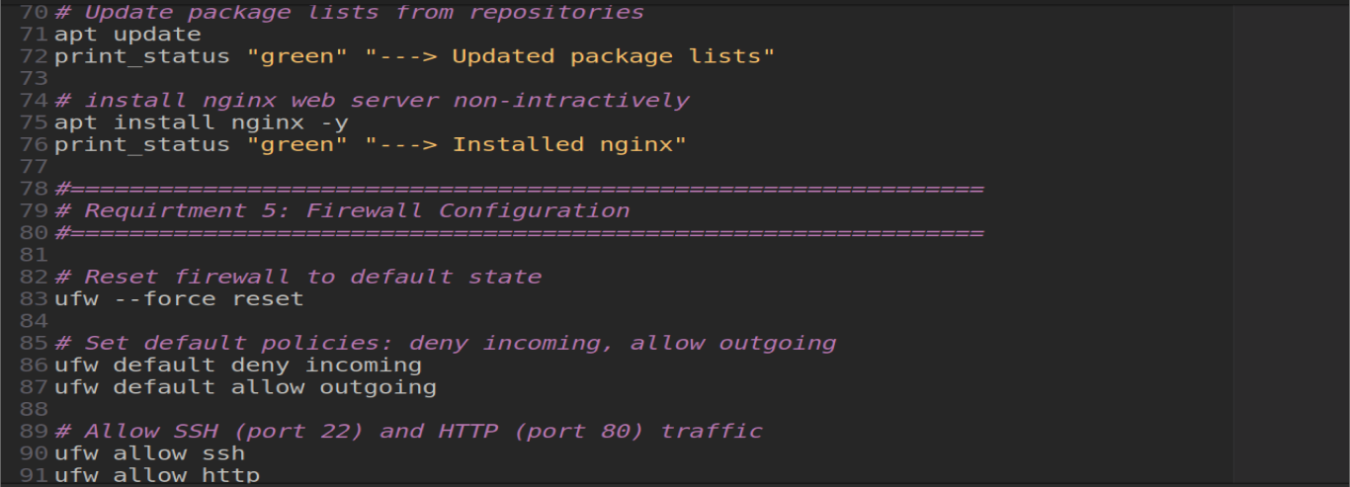
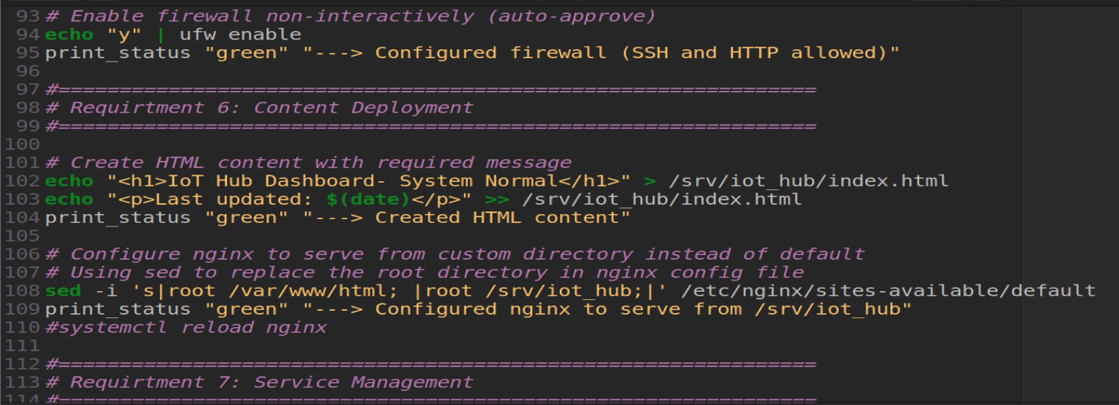
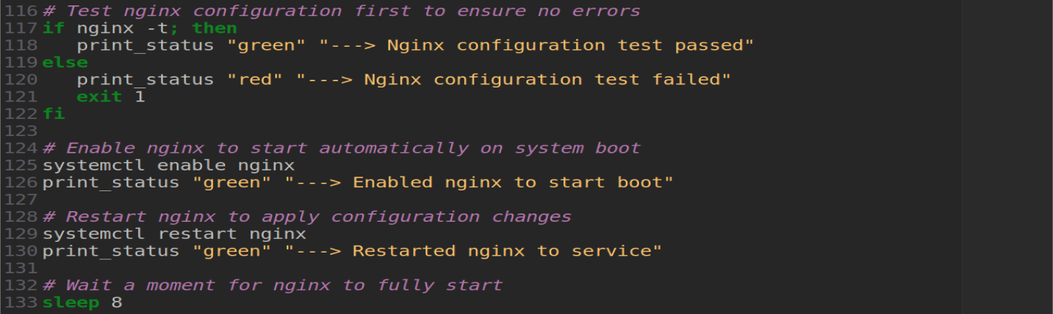
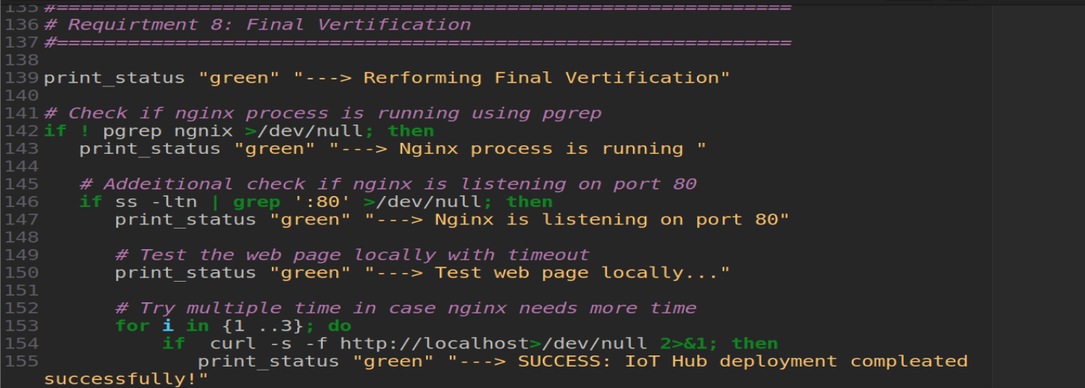
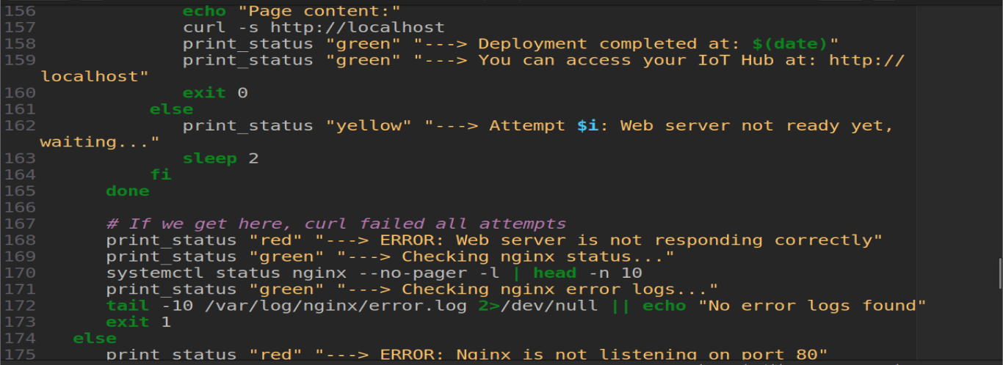
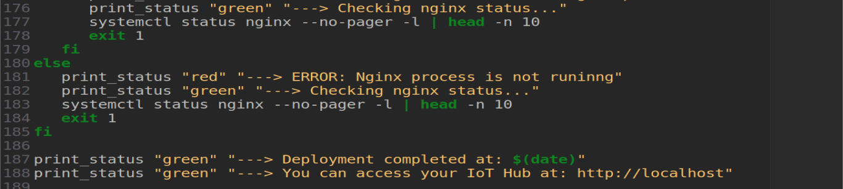

" واخر دعواهم ان الحمد لله رب العالمين ".

