Al-Aqsa University  Faculty of Computers and IT  Dept. of Info & Computer science |  | جامعة الأقصى  كلية الحاسبات وتكنولوجيا المعلومات  قسم علم الحاسوب والمعلومات

Software Engineering

Assignment 1: Answers Of Chapters (1,2,3)

Presented to: Eng. Abdulfattah AL-Farra

Student name: Deema Mohammed AL-Maqadma
Student number:2320230766

Semester: Second Semester 2024/2025

Chapter1

1. What four components does the IEEE include in its definition of software, and why is each important?

According to the IEEE definition, software includes:

1. Computer Programs (Code):
These are essential as they execute the desired operations on the computer system.

2. Procedures:
They define the schedule, method of execution, and responsibility for applying the software effectively.

3. Documentation:
It supports development, usage, and maintenance. Development docs aid team collaboration, while user manuals guide end-users.

4. Data:
It customizes software for specific users and includes parameters, configuration, and test data essential for functionality.

2. Compare and contrast Generic software with Custom software in terms of development cost, time to market, and fit to user needs.

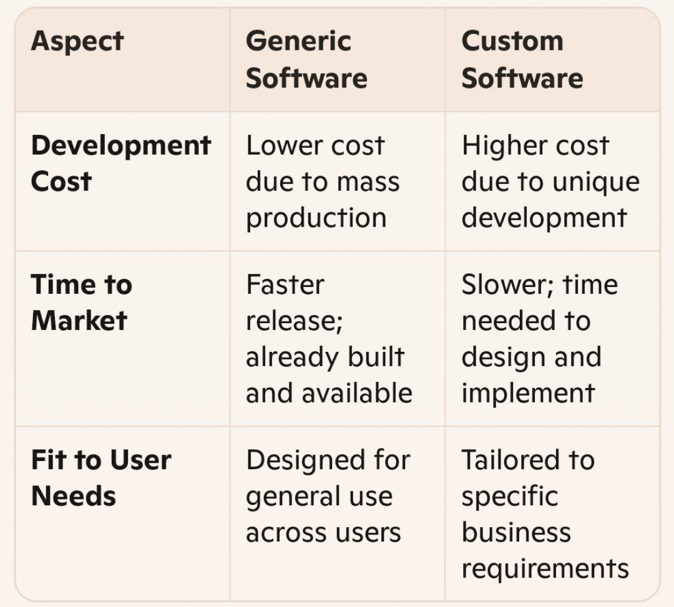
3. How does Student Software differ from Professional (industrial-strength) Software regarding reliability, maintenance, and expected lifespan?

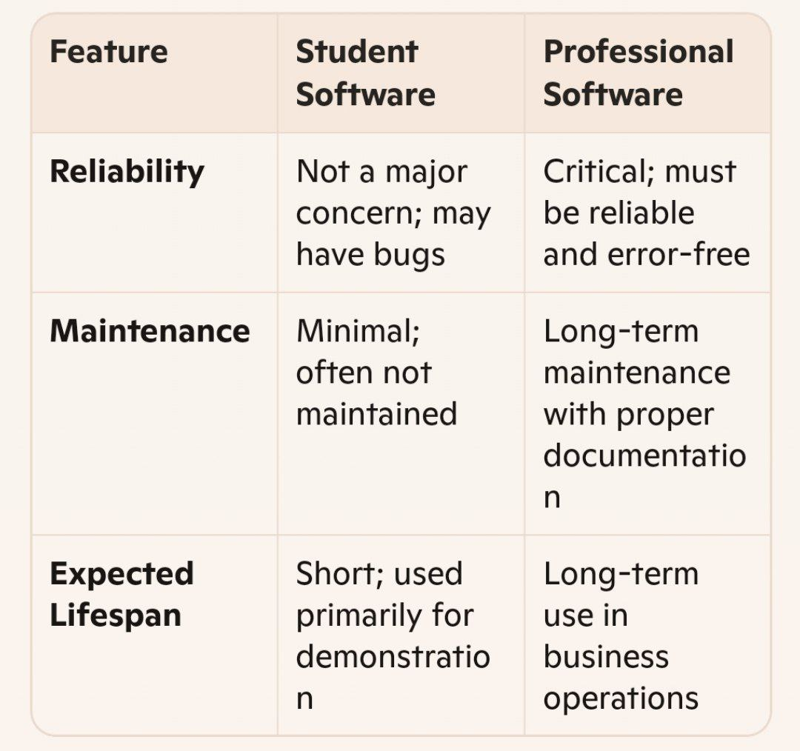

4. Identify and explain the “Four P’s” (People, Process, Product, Project) that influence software engineering success.
- People:
Roles such as analysts, architects, programmers, testers, and managers. Their collaboration and skills are crucial.
- Process:
Activities include specification, development, validation, and evolution. A structured process ensures efficiency and quality.
- Product:
The deliverables—code, documents, and data—must meet user requirements and quality standards.
- Project:
Involves planning, scheduling, staffing, and controlling development. Proper project management ensures goals are met on time and within budget.

5. What factors should an organization weigh in the Build-or-Buy decision, and what are the main pros and cons of each option?

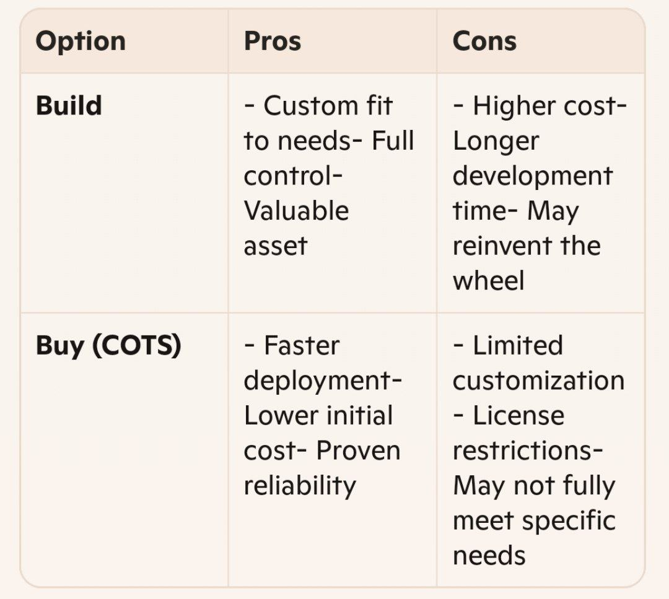
Chapter 2

1.Define “software methodology” and list its key elements (e.g. roles, activities, work products).
A software methodology is a formalized set of practices, techniques, and rules used to plan, develop, and manage software projects effectively. It guides teams through each stage of software creation.
Key Elements:
- Roles: People involved (e.g., Project Manager, Designer, Developer, Tester).
- Activities: Tasks performed (e.g., Planning, Coding, Testing).
- Work Products: Deliverables such as use cases, source code, documentation.
- Techniques: Procedures (e.g., UML modeling, JAD sessions).
- Process: Flow and connection of activities.
- Milestones: Events marking progress (e.g., document published, code delivered).
- Tools: Software used (e.g., Microsoft Project, UML tools).
- Skills: Required proficiencies for each role.
- Personality: Traits suited to roles (e.g., abstraction skills for designers).- Standards: Coding, drawing, and decision policies.
- Team Values: Beliefs guiding decision-making and behavior.

2. Outline the main phases of the software process life cycle (Definition, Analysis, Design, Implementation, Testing, Support) and state the goal of each.
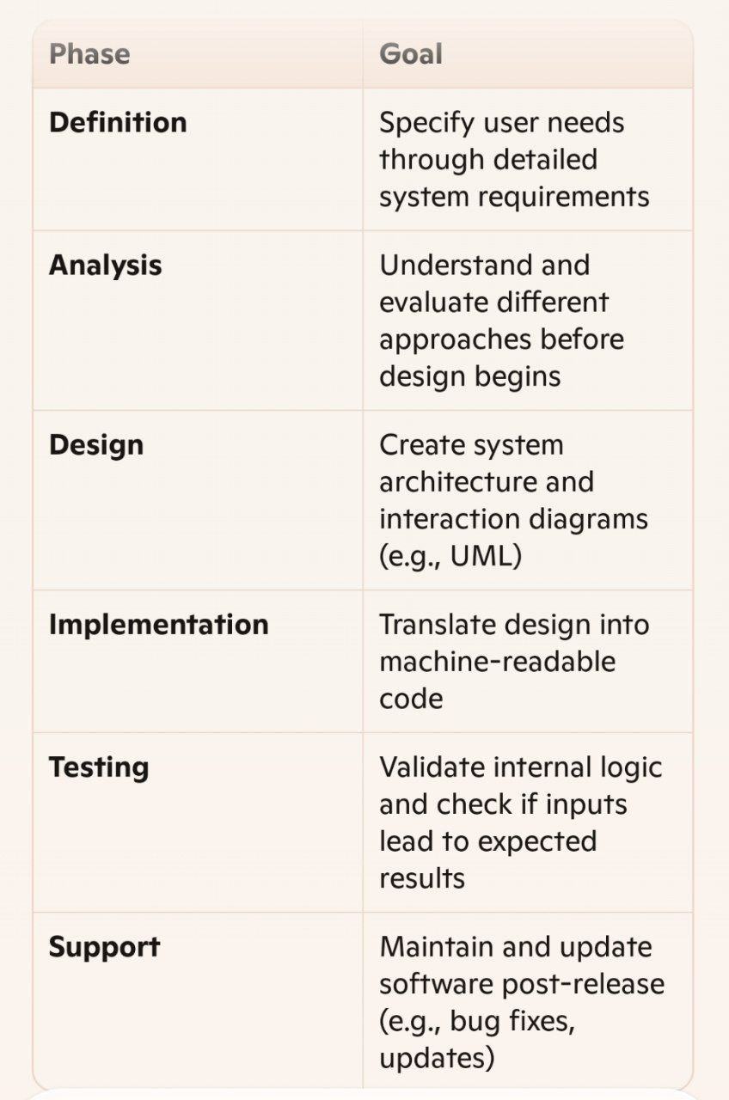

3. Compare the Waterfall model with the Incremental model in terms of adaptability to changing requirements and delivery cadence.

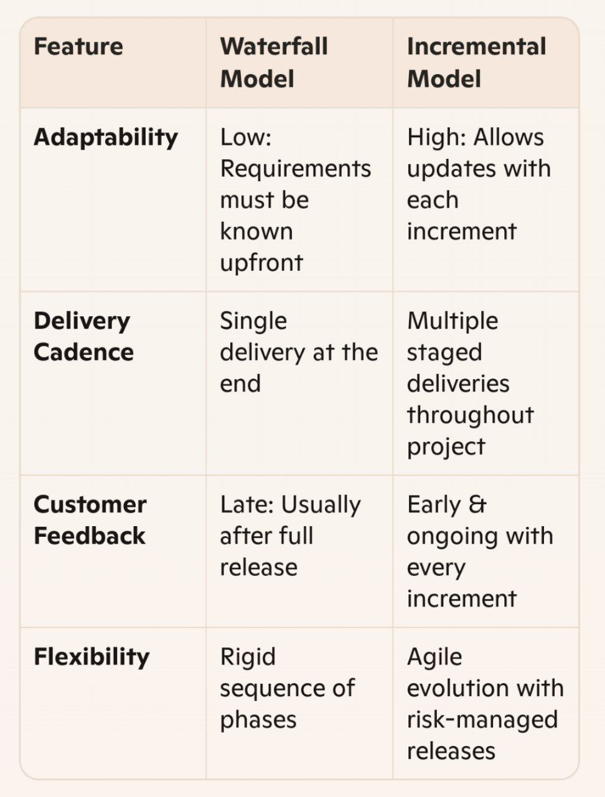
4. Choose two values from the Agile Manifesto and explain how each contrasts with traditional, document-driven approaches.
- “Working software over comprehensive documentation”:
Agile emphasizes functionality and delivering usable software frequently, while traditional methods often focus heavily on lengthy specs before any usable code appears.
- “Responding to change over following a plan”:
Agile allows for late-stage requirement changes to meet evolving needs, unlike traditional approaches which resist change once the plan is set.

5. Describe three core Extreme Programming (XP) practices and discuss their benefits.
- Test-Driven Development (TDD):
Tests are written before the feature.
Benefits: Fewer bugs, clearer expectations, easier refactoring.
- Pair Programming:
Two programmers work together—one codes, the other reviews.
Benefits: Higher code quality, knowledge sharing, fewer defects.
- Continuous Integration (CI):
Code is merged and tested daily.
Benefits: Faster detection of errors, smoother integration, consistent quality.

- Chapter 3

1.What is the goal of the requirements gathering (Specification) phase, and why is clear requirements capture crucial to project success?
The goal of the specification phase is to clearly define what the software must do, based on user needs and stakeholder expectations. Clear requirements are crucial because they:
- Provide a shared understanding among stakeholders.
- Reduce ambiguity and misinterpretation.
- Serve as a baseline for design, development, and testing.
- Help manage scope and avoid costly changes later.
- Ensure the final product meets user expectations.

2. Explain the standard User Story template: As a [role] I want [goal] so I can [reason] and describe the purpose of each part.
This format helps capture user needs from their perspective:
- As a [role]:
Specifies who the user is (e.g., customer, admin). Clarifies context.
- I want [goal]:
Describes what they want to achieve. Focuses on the action or functionality.
- So I can [reason]:
Explains why it matters to them. Adds motivation and purpose.
This helps development teams understand requirements in a human-centered way and prioritize features based on user value.

3. Compare and contrast the two estimation techniques: estimate by analogy versus Planning Poker. When might you choose one over the other?

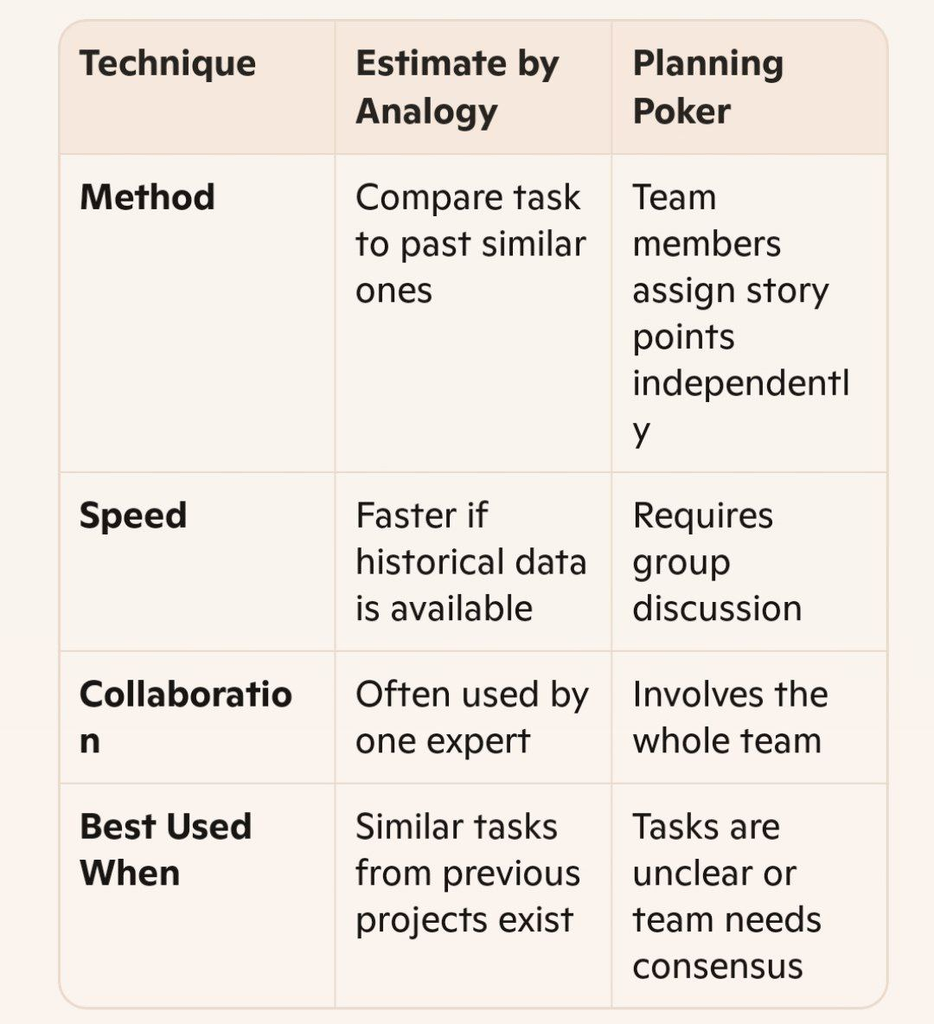
4. List the “Definition of Ready” criteria that a User Story should satisfy before a team commits to implementation.
A User Story should meet these criteria:
- Clearly written and understandable
- Acceptance criteria are defined
- Dependencies are resolved
- Story is small enough to be completed in a sprint
- Team has the necessary skills and resources
- Testable with available tools and methods
- Business value is identified
Meeting these ensures the story is actionable and reduces the risk of delays during development.

5. Describe the Given–When–Then format in Behavior-Driven Development (BDD) and explain how it helps bridge the gap between requirements and automated acceptance tests.
The Given–When–Then format structures test scenarios:
- Given: The initial context or setup (e.g., "Given a user is logged in").
- When: The action taken (e.g., "When the user clicks Submit").
- Then: The expected result (e.g., "Then the confirmation message appears").
This format helps by:
- Making requirements precise and executable.
- Allowing collaboration between developers, testers, and business stakeholders.
- Serving as both documentation and automated test specification.
It ensures that development aligns with intended behavior and reduces misunderstandings between teams.

" واخر دعواهم ان الحمد لله رب العالمين "

