Ghana's Waste Crisis: A Reflection on a Nation’s Contradictions
Walking through the streets of Ghana—whether in bustling cities or quiet towns—one thing consistently breaks my heart and fills me with both sadness and rage: the sheer amount of filth strewn across our public spaces. Plastic bottles, sachet wrappers, and polythene bags are everywhere. The question I keep asking myself is, how did we get here?
A Young Nation, Yet an Old Problem
According to the 2021 Population and Housing Census, Ghana is a predominantly youthful country. Over 56% of the population is under the age of 25, with the largest demographic groups falling between 5 and 24 years old. This should, in theory, position us for transformation—young populations are often associated with innovation, energy, and change. Yet, when it comes to something as basic and essential as environmental hygiene and waste disposal, the evidence on our streets tells a different story.
Is This a Failure of Waste Management?
In a country where a majority of people are young, educated, and presumably aware of the environmental and health impacts of littering, it is troubling that this behavior persists. Have we failed as a nation in the domain of waste management? Have our institutions—educational, civic, and governmental—let us down?
I struggle to believe this is purely a matter of ignorance. I am a product of the same educational system. I was never explicitly taught to hoard my waste until I find a bin, but something about respect for public space, discipline, and civic responsibility was ingrained in me. Even when there are no trash bins in sight, I keep waste in my bag or hands until I can dispose of it properly. So if the knowledge exists, what then is missing?
The Role of Infrastructure and Planning
Perhaps the issue lies not with the people, but with the system—or rather, its absence. In Germany, where I have lived for the past seven years, public waste bins are everywhere: in parks, at bus stops, in nature reserves, even along hiking trails. And they are not just present; they are regularly emptied, preventing overflow and promoting responsible disposal.
By contrast, in Ghana, such infrastructure is severely lacking. In many public places—markets, parks, beaches, bus terminals—dustbins are either absent or neglected. If we fail to provide people with the means to dispose of their waste correctly, are we not inadvertently encouraging bad behavior?
A Nation of Contradictions
Ghana is a country where personal hygiene is taken seriously. It is common—and culturally expected—for people to bathe twice a day, change clothes frequently, and present themselves with dignity. Yet, this personal cleanliness is not reflected in our shared environment. Our streets and gutters are clogged with filth, a stark contradiction to our obsession with personal grooming.
The irony is painful. In a nation with open drainage systems, improperly managed waste often ends up in gutters and canals, contributing directly to the severe flooding events that plague our cities every rainy season. The filth we discard returns to haunt us—through floods, disease, and environmental degradation.
Where Are the Planners and Enforcers?
More than 65 years after independence, why have we not figured out effective systems for town planning and waste disposal? Where are our civil engineers and urban planners? What are the local governments doing? Who is responsible for enforcing planning laws and ensuring basic civic amenities like waste bins and regular waste collection?
Is it the failure of central government? Is it the negligence of municipal authorities? Or is it the apathy of the citizenry? Most likely, it's a combination of all three. But assigning blame alone won’t clean our streets. What we need is leadership with vision, systems with accountability, and citizens with a sense of collective ownership.

The Way Forward
To solve this, we must:
- Invest in basic public waste infrastructure in all urban and semi-urban areas.
- Ensure frequent waste collection and management at the local government level.
- Incorporate civic responsibility and environmental education more actively in school curricula and national campaigns.
- Enforce penalties for littering while rewarding clean communities and public spaces.
- Encourage public-private partnerships for waste management and recycling innovation.
Ghana deserves better. Our children deserve cleaner streets. Our cities deserve to reflect the pride we claim in our culture, in our appearance, and in our identity as a nation.
It’s time to stop tolerating the filth and start demanding more—from our leaders, from our systems, and from ourselves.
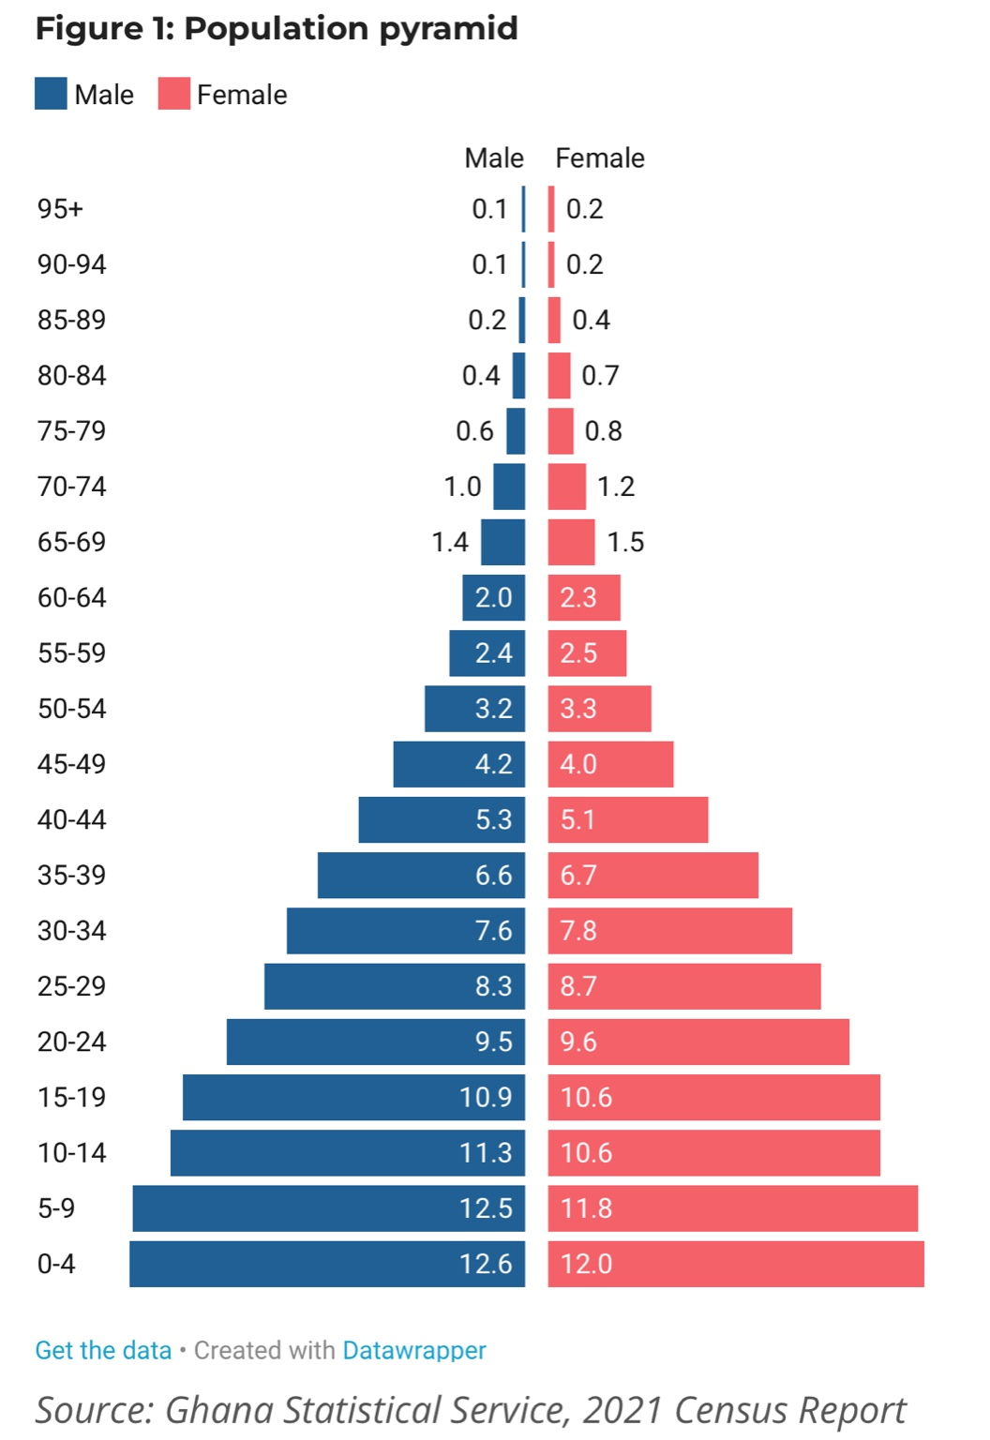
Figure 1: Ghana's Population Pyramid (Source: Ghana Statistical Service, 2021 Census Report)

