1. Type the following commands at the MATLAB command line and try to determine what each command does.
x = 3:7
x(1)
x(2:4)
x = 7:-1:-5
y = [2 i 4]
y = [2 i 4];
size(y);
y
disp(y);
z1 = y';
z2 = transpose(y);

Use the command summary at the end of this document to answer the following questions:
- What does the semicolon at the end of the line do?
- What is the difference between y' and transpose(y)?
- What mathematical operation occurs when you type x*z1? (Take x to be a array, eg. x = [1 2 3].)
- What mathematical operation occurs when you type x.*y?
- Now define A=[1 2; 3 4] and v=[1;2;3;4]. What do the semicolons do?
- Which of the following operations are valid? Why or why not?
- x*y x.*y x.*transpose(y)
- A*v A*v(2:3) transpose(v(1:2))*A
- What do you get if you type B=[A A]? How about C=[A;A]?
2. A variable in MATLAB is an array. An array has dimensions N×M, Where N and M are in Naturals. N is the number of rows and M is the number of columns. If N=M=1, the variable is a scaler. If N=1and M>1, then the variable is a row vector. If N>1 and M=1, then the variable is a column vector. If both N and M are greater than one, then the variable is a matrix, if N=M, then the variable is a square matrix. The coefficients of an array are real or complex numbers.
(a) Each of the following is an assignment of a value to a variable called array. For each, identify the dimensions of the array (M and N), and identify whether the variable is a scaler, row vector, column vector, or matrix.
array = [1 2 3 4 5]
array = [1:5]
array = 1:5
array = [1:1:5 ]
array = [1:-1:-5 ]
array = [ 1 2;3 4]
(b) Create a 2×3 matrix containing arbitrary data. Explore using the MATLAB functions zeros, ones, eye and rand to create the matrix. Find a way to use the square matrix eye (2) as part of your 2×3 matrix. Verify the sizes of your arrays using size.
(c) Use the MATLAB commands size and length to determine the length of the arrays given by 1:0.3:10 and 1:1:-1. Consider more generally the array constructor pattern
array = start : step : stop
Where start, step and stop are scalar variables or real numbers. How many elements are there in array?

3. (a) Using MATLAB to compute

,
Use a loop (try help for) to specify each individual addition in the summation.
(b) Write a MATLAB program to add all the even numbers from 0 to 100.
(c) Add all the terms in the series
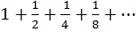
Until the sum exceeds 1.995.
4. Create the following Matrices
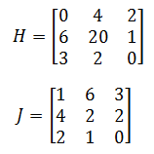
- Find the Matrix H+J
- Find the Matrix H * J
- Multiply H by J, element-by-element
5. Let A = [1 2; 3 4], B = [0 1; -1 0]; C = [0 -i; i 0]. We can write the matrix multiply of A and B in terms of for loops. Matlab has a built-in editor which you can use to create programs (it is under the ``Start'' icon in the lower left corner of the Matlab window). Create a file called some_filename.m containing the following code:
% Multiply two matrices together
A = [1 2; 3 4], B = [0 1; -1 0], C = [0 -i; i 0]
D = zeros(2,2); % Initialise the matrix D
for i1 = 1:2
for i2 = 1:2
for i3 = 1:2
D(i1,i2) = D(i1,i2) + A(i1,i3)*B(i3,i2);
end;
end;
end;
disp('D=');
disp(D);
You can run this code by typing some_filename (without the .m) on the command line, or by clicking ``Save and Run'' in the editor.
- Verify that this gives the same answer as D=A*B.
- Write a program to find E=A*B*C using for loops.
- Write a program to find F=A.*B using for loops.
- Write a program to find G=A*transpose(B) using for loops.
6. Given
A= [2 0 2; 1 0 1]
And
B= [4 4 4; 9 9 9]
Calculate the following operations using MATLAB:
- A+B
- A*3
- A. *3
- A. ^3
- (A+B) ./B
- (A+B) ./A

7. Use the MATLAB command rref to determine which of the following matrices are row equivalent to
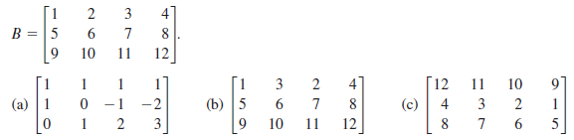

8. Let A be the coefficient matrix, and B the right-hand side of the linear system of equations
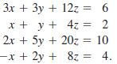
Enter the matrices A and B, and form the augmented matrix C for this system by using the
MATLAB command C=[A B]. Solve the system using rref.

9. The MATLAB command polyfit allows you to fit a polynomial of degree to a set of n data
points in the plane
Find the fourth-degree polynomial that fits the five data points of matrix A
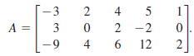
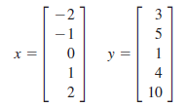
and entering the MATLAB command polyfit(x,y,4).
10. Find the second-degree polynomial that fits the points (1, -2), (2, 4), (-4, -6)
11. Find the sixth-degree polynomial that fits the points (0,0), (-1, 4.5), (-2, 133), (-3, 1225.5), (1, -0.5), (2, 3), (3, 250.5)
12. The following table gives the revenues (in billions of dollars) for General Dynamics Corporation
from 2005 through 2009.
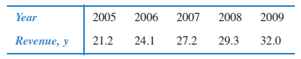
Use p=polyfit(x, y, 4) to fit the fourth-degree polynomial to these data. Let x, represent the year,
With x=5 corresponding to 2005. Then use f=polyval(p,10) to estimate the revenue in 2010.
(The actual revenue in 2010 was $32.5 billion)
13. Create a variable, rows, which is a random integer in the range from 1 to 5. Create a variable, cols, which is a random integer in the range from 1 to 5. Create a matrix of all zeros with the dimensions given by the values of rows and cols.

14. Create a 4 × 2 matrix of all zeros and store it in a variable. Then, replace the second row in the matrix with a 3 and a 6.

15. Create a y vector that stores random integers in the range from 1 to 100. Create an x vector that iterates from 1 to the length of the y vector. Experiment with the plot function using different colors, line types, and plot symbols.

16. The lump sum S to be paid when interest on a loan is compounded annually is given by S = P(1 + i) ^{n}, where P is the principal invested, i is the interest rate, and n is the number of years. Write a program that will plot the amount S as it increases through the years from 1 to n. The main script will call a function to prompt the user for the number of years (and error-check to make sure that the user enters a positive integer). The script will then call a function that will plot S for years 1 through n. It will use 0.05 for the interest rate and $10,000 for P.

17. Let array
A= [1 0 1 0
0 2 0 2
3 1 3 1]
Write the commands that will perform each of the following operations on array A:
- Return the second column of A.
- Return the first and third rows of A.
- Delete the first and second columns of A.
- Append the column vector [7; 8; 9] to A.
Re-create array A again before each problem. Check your answer by using MATLAB.

18. Given vectors
A= [2 -3 4 0]
B= [4; -12; 4; -12]
C= [2 12 0 0]
Compute the following operations using MATLAB:
- A*B
- A*C
- B*C
- C*B
19. Given the square matrices
A= [2 0; 1 -5]
B= [3 -2 0; 4 1 5; 0 -3 4]
Compute the following operations using MATLAB:
- A’
- det(A)
- B’
- det(B)
Compute the following with MATLAB:
- A^2
- inv(A)
- inv(B)
- A^-2

20. Consider the linear system
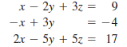

(a) Use the MATLAB command rref to solve the system.
(b) Let A be the coefficient matrix, and B be the right-hand side of the system.
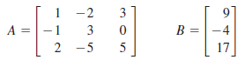
Use the MATLAB command A\B to solve the system.
21. Enter the matrix
Use the MATLAB command rref to find the reduced row-echelon form of A. What is the
solution to the linear system represented by the augmented matrix A?
22. Solve the linear system
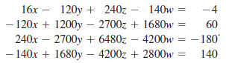
You can display more significant digits of the answer by entering format long before solving the
system. Return to the standard format by entering format short.
23. Enter the matrices
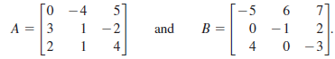
Use MATLAB to find
24. Write the following system of linear equations in the form AX=B and use the MATLAB
Command A\B to solve the system.
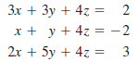 Check your answer using rref.
25. Enter the matrices
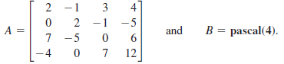
(a) Use the MATLAB command trace to find the traces of A, B, and A+B. What do you
observe?
(b) What is the relationship between the trace of AB and the trace of BA?
26. Use the MATLAB command diag to form the 5 × 5 diagonal matrix D with diagonal entries 0, -1, -2, -3, and -4. Find the product =DDDD.If D is an n×n diagonal matrix, describe how to find the product D^{k} for any positive integer k.
27. Let
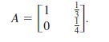
Compute A², A³, and A⁸. Describe the matrix A^{n} for large n.
28. Enter the three matrices
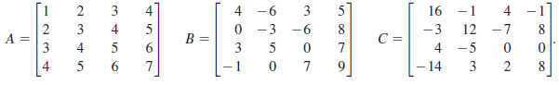
(a) Calculate AB – AC and A (B-C).What do you observe?
(b) Calculate 3(AC), A(3C) and (3A)C. What do you observe?

29. In this exercise, you will use MATLAB to find the least squares regression line for the set of data
and from matrix A and B
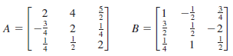
(a) Form the following matrices.
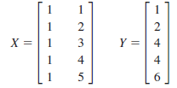
(b) Let A=(X^{T} X)⁻¹ X^{T} Y.
(d) Plot the data using the following MATLAB commands
t=(0: 0.1: 6);
plot(X1, Y, ‘+’)
(e) Plot the least suares line for the data by using the following MATLAB commands
t=(0: 0.1: 6);
p=polyfit(X1, Y, 1);
f=polyval(p, t);
plot(t, f, ‘*’)
(f) You can combine the previous plots by using the following MATLAB command.
plot(X1, Y, ‘+’, t, f, ‘*’)
30. Create a variable ftemp to store a temperature in degrees Fahrenheit (F). Convert this to degrees Celsius and store the result in a variable ctemp. The conversion factor is C = (F – 32) * 5/9.

31. Using the colon operator and the transpose operator, create a column vector that has the values –1 to 1 in steps of 0.2.

32. Create a vector x with values ranging from 1 to 100 in steps of 5. Create a vector y that is the square root of each value in x. Plot these points. Now, use the bar function instead of plot to get a bar chart instead.

33. Create a 4 × 6 matrix of random integers, each in the range from –5 to 5; store it in a variable. Create another matrix that stores for each element the absolute value of the corresponding element in the original matrix.

