Regularization Methods Effect on Transfer Learning Performance

Introduction

Motivation
In the field of Deep Learning, Transfer Learning has become the standard technique for achieving high performance on small datasets. However, the quality of the feature representations learned during pretraining can be insufficient.
Traditional classifiers focus on minimizing cross entropy loss only and are only encouraged to learn the minimum features necessary to distinguish between training classes. The network can converge to a state in which all feature vectors for the same class are very similar, and the model might ignore useful but non-essential features. This is unwanted behavior for the downstream task as it might need to distinguish between more fine-grained details. For example, if the original classifier is trained to distinguish between different animals but the downstream task is distinguishing between different breeds of a specific animal, then we might observe bad performance for the downstream task. In addition, downstream domain might be very different than the pretrained one, which demands learning good and robust representation in the latent feature space of the model.
We propose that integrating SSL-inspired constraints will mitigate these issues by forcing the model CNN latent features to follow some desired characteristic and therefore also learn the fine-grained details of the dataset and achieve more robustness to domain shifts.

Project’s Goals
Our primary objective is to evaluate the impact of different loss regularization techniques applied to the final features of a known CNN model (pre-FC layer) on transfer learning performance on various datasets.
We will examine the influence of the next regularization methods added to the cross-entropy (CE) loss: Isotropic Gaussian Spread (SIGReg), Variance-Invariance-Covariance regularization (VICReg) and Cosine Similarity Regularization compared to a baseline of training without regularization (normal CE loss). We would like to examine if these regularization techniques lead to better transfer-learning performance on small-scale and domain-specific datasets and evaluate their influence when reducing the downstream datasets sizes.

Methods

Explanation of The Loss and Regularization Methods
Our Loss will consist of Cross Entropy loss and added regularization as follows:
$$L=L_{CE}+λ⋅R_{Regularization}$$
We will examine the effects of three different SSL inspired regularizations.
Each Regularization method will enforce different constraints on the CNN’s latent features:
- Cosine Similarity – minimize the cosine of the angle between vectors in the batch. forces orthogonality between samples features and might lead to better spread features space.
- VICReg - an objective that forces the model’s feature vector to have three good qualities for each batch:
  - Invariance – similar inputs lead to similar feature vectors.
    - Represented by the term $MSE\left(Z, Z^{'}\right)$ which penalize each pair of augmentations based on the mean squared error between their feature vectors.
  - Variance – promotes variance above threshold $1$ on each dimension of the feature vector.
    - Represented by the term $\left[v\left(Z\right)+ v\left(Z^{'}\right)\right]$ where $v\left(Z\right)$ applies a linear penalty for each embedding dimension that has standard deviation below a threshold of 1 (based on the distance from std of 1).
  - Covariance – penalizes correlation between different dimensions. Forcing each dimension to learn different representations (features) of the input.
    - Represented by the term $[c(Z) + c(Z')]$ which is a quadratic penalty of the off-diagonal components of the covariance matrix of each feature.
The total loss for each pair of augmentations is given by the formula:
$$L(Z, Z') = λ·MSE(Z, Z') + μ·[v(Z) + v(Z')] + ν·[c(Z) + c(Z')]$$
We have used the recommended hyperparameters as given in the attached paper:
$λ=25, μ=25, ν=1$.
In total this regularization eliminates informational redundancy by decorrelating feature dimensions, avoids representation collapse by maintaining variance above threshold per dimension and brings similar samples closer. Therefore, should learn efficient and reliable representation of the features space.
- SIGReg – Encourages Isotropic Gaussian distribution of the features of each batch (works efficiently by projecting the data on M random vectors each step). Based on the paper attached this normalization should be optimal on worst case for all possible downstream classification tasks because it should achieve minimal variation for the learned classifier, as can be seen in the illustration below.
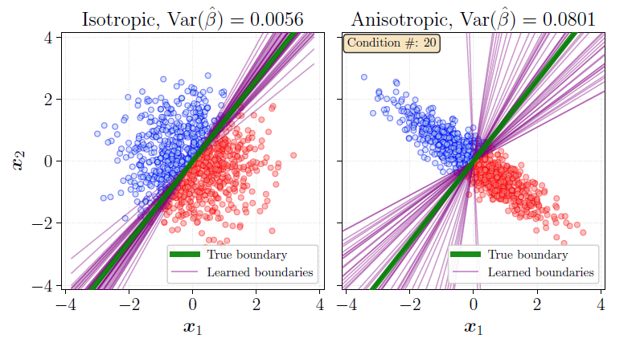
Figure 1: illustration taken from the attached paper. Shows anisotropic embeddings (right diagram) lead to higher variance on learned estimator compared to isotropic embeddings (left diagram).

Explanation of The Algorithm
First, we have performed hyperparameters tuning to find well performing regularization weights for each loss: $L=L_{CE}+λ⋅R_{Regularization}$
For each regularization weight $λ∈\left\{0.01, 0.1, 1, 10\right\}$ of each regularization method, we have trained the ResNet50 model for 20 epochs. We have compared the validation accuracy for each regularization method and chose to fully train only models which achieved high results.
We have used augmentations to improve training results and to satisfy VICReg requirements for the Invariance term which helps it to output similar feature vectors for each augmentation pair.
We have fully trained ResNet-50 classifier model on ImageNet100 for 100 epochs with 4 different losses. First, CE loss without regularization and then trained with CE loss combined with each of the regularization methods explained above.
For reducing the training process time, we have implemented AMP (Automatic Mixed Precision) as learned in class in both full and transfer learning training.
Then, we performed transfer learning. We have used the learned model’s backbone (CNN part) as frozen weights and trained only the FC layer.
For each model, we have trained its FC layer for 50 epochs on each of the downstream datasets, which are detailed in the following section. Transfer learning was trained with CE loss and did not include augmentations.
In addition, we have trained ResNet18 and ResNet50 from scratch for 50 epochs on each of these datasets for comparison purposes.
Afterwards we trimmed each dataset to different samples per class $s∈\{10 , 50, 100\}$ to evaluate the influence of the regularization techniques on smaller datasets compared to the full ones.
Information about Hyperparameters Used
For the pretraining process on ImageNet100, we used a batch size of 128, and for the transfer learning phase, we used a batch size of 32. In both stages, we used an SGD optimizer (Learning Rate: 0.01, Momentum: 0.9, Weight Decay: 1e-4) and a Cosine Annealing scheduler.

Explanation of The Datasets
For the full training dataset, we have decided to use ImageNet100 which consists of 100 selected classes from the ImageNet-1K dataset. We have chosen to use this dataset because it has a big diversity, captures natural images and retains high resolution of the samples. This ensures the model learns robust features that have high enough quality for effective transfer learning. It contains about 130,000 images compared to 1.2 million of ImageNet-1K which allows much faster training, much less memory and less massive GPU resources which fit our relatively lean resources.
The Transfer Learning datasets were chosen as representatives of different downstream classification tasks:
- CIFAR10 – Benchmark
  - CIFAR-10 is a known benchmark for transfer learning and has big similarity to the pretraining ImageNet100 dataset as both contain many animals classes.
- DTD, EuroSat – Domain Shifts
  - DTD includes texture images, which mostly aren’t real images but illustrations. This can examine if our features representations have been trained to distinguish different patterns and textures in the sample.
  - EuroSat contains satellite images of big areas that should be classified by type (Forest, Residential etc.). This is a big domain shift compared to the original dataset and task which might be a good indicator on how much the model can deal with big domain shifts.
- Flowers102 – Fine-Grainded Details
  - Flowers102 contains 102 classes of different types of flowers, which means the model must distinguish between much smaller features in the input images. This can examine how well the learned CNN features representations can capture fine-grained details.

Experiments We Performed to Validate Our Method
- Comparison with Unbiased Baseline: We compared all regularization techniques against a baseline ResNet-50 trained only with Cross-Entropy loss to evaluate the impact of feature space constraints relative to an unbiased model.
- Training from Scratch: We have compared transfer learning results to ResNet-50 and ResNet-18 trained from scratch. We have included ResNet-18 to ensure a meaningful comparison against a model suited for small datasets, rather than relying solely on ResNet-50 which might get poor results due to overfitting.
- Evaluation on Diverse Datasets: We validated performance across four distinct datasets (CIFAR-10, DTD, EuroSat, Flowers-102) rather than a single benchmark to ensure the reliability of our results.
- Augmentation: We verified data augmentation outputs to ensure transformations weren’t too aggressive and preserved major semantic features necessary for classification.
- Hyperparameter Optimization: We performed a grid search for regularization weights $λ∈ \{0.01, 0.1, 1, 10\}$ over 20 epochs to ensure each method was compared at its optimal configuration.

Experiments and Results

Hyperparameters Tuning
The table below summarizes the validation accuracy of each regularization method after 20 epochs with different regularization weights $λ$. In bold are the chosen hyperparameters for full training (for Cosine similarity and VICReg two hyperparameters were chosen because both led to relatively good accuracy).
Hyperparameter Tuning - validation accuracy for each regularization weight
Regularization Weight | Cosine | SIGReg | VICReg
0.01 | 59.14 | 55.02 | 58.88
0.1 | 58.93 | 25.14 | 48.79
1 | 50.93 | 4.83 | 16.72
10 | 3.04 | 2.52 | 0.98
Below is SIGReg full accuracy and loss graphs. As can be seen, $λ=0.01$ achieves much better accuracy and the most stable training.
$$λ=0.01$$ | $$λ=0.1$$
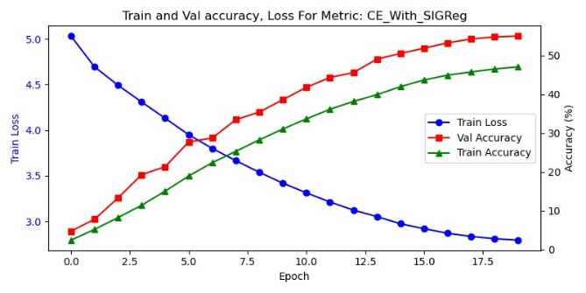 | 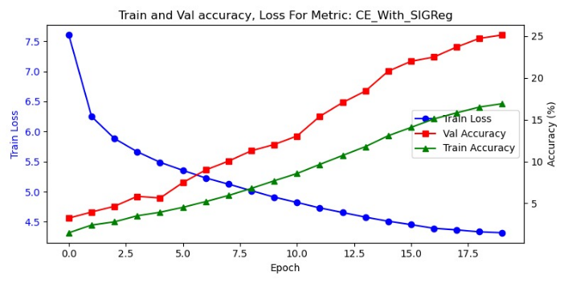
$$λ=1$$ | $$λ=10$$
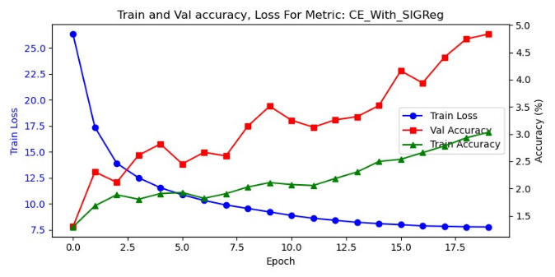 | 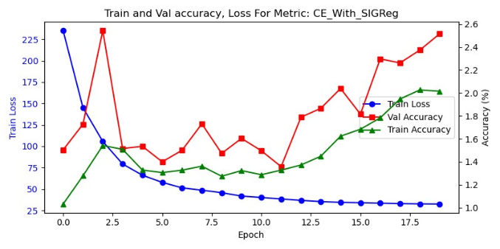
Figure 2: Validation accuracy for different regularization weights for SIGReg. Same graphs were produced and compared for all other regularization methods.

Full Pretraining for Selected Hyperparameters
These are the test accuracies of each regularization method after training for 100 epochs. As can be seen, Cosine Similarity regularization achieves the best results.
Test Accuracy after training for 100 epochs
Dataset | CE | Cosine |  | SIGReg | VICReg
Reg weight | - | 0.1 | 1.0 | 0.01 | 0.01 | 0.1
Test accuracy | 71.28 | 73.42 | 75.36 | 74.6 | 70.14 | 61.48
Surprisingly, all of these regulation methods except VICReg seem to improve test accuracy on the ImageNet dataset.

Transfer Learning Results
The Tables below show test accuracy results for each dataset. First, without trimming the dataset. Afterwards, when trimming the datasets to reducing number of samples per class $100, 50, 10$. We will note Flowers102 train dataset has about 10 samples per class to begin with and therefore is not shown on the trimmed tables. DTD train dataset contains about 40 samples per class therefore produces similar results when trimming to 100 and 50 samples per class. Highlighted in bold, the accuracy of the best performing regularization.
Transfer Learning Test Accuracy Without Trimming
Dataset | CE | Cosine |  | SIGReg | VICReg |  | ResNet18  From Scratch | ResNet50  From Scratch
Reg weight | - | 0.1 | 1.0 | 0.01 | 0.01 | 0.1 | ResNet18  From Scratch | ResNet50  From Scratch
Cifar10 | 79.94 | 78.16 | 71.46 | 76.31 | 81.09 | 78.1 | 85.23 | 83.81
DTD | 39.68 | 37.87 | 33.78 | 36.06 | 39.41 | 35.21 | 23.46 | 17.87
EuroSat | 92.07 | 90.76 | 82.81 | 89.85 | 94.15 | 91.48 | 98.59 | 98.19
Flowers102 | 58.82 | 56.71 | 40.66 | 46.56 | 59.96 | 53.07 | 34.98 | 29.22

Test Accuracy Trimming Datasets to 100 samples per class
Dataset | CE | Cosine |  | SIGReg | VICReg |  | ResNet18  From Scratch | ResNet50  From Scratch
Reg weight | - | 0.1 | 1.0 | 0.01 | 0.01 | 0.1 | ResNet18  From Scratch | ResNet50  From Scratch
Cifar10 | 67.2 | 63.38 | 57.93 | 62.08 | 66.81 | 64.54 | 44.65 | 38.94
DTD | 39.47 | 38.46 | 33.83 | 35.9 | 40.85 | 34.1 | 22.5 | 17.34
EuroSat | 85.69 | 83.43 | 75.28 | 83.54 | 87.3 | 83.52 | 82.56 | 81.43

Test Accuracy Trimming Datasets to 50 samples per class
Dataset | CE | Cosine |  | SIGReg | VICReg |  | ResNet18  From Scratch | ResNet50  From Scratch
Reg weight | - | 0.1 | 1.0 | 0.01 | 0.01 | 0.1 | ResNet18  From Scratch | ResNet50  From Scratch
Cifar10 | 61.55 | 59.02 | 53.08 | 57.49 | 62.67 | 58.32 | 37.32 | 32.39
DTD | 38.56 | 38.62 | 33.24 | 35.9 | 40.96 | 33.62 | 23.56 | 17.55
EuroSat | 83.72 | 80.48 | 71.72 | 79.48 | 86.09 | 83.46 | 75.69 | 75.02

Test Accuracy Trimming Datasets to 10 samples per class
Dataset | CE | Cosine |  | SIGReg | VICReg |  | ResNet18  From Scratch | ResNet50  From Scratch
Reg weight | - | 0.1 | 1.0 | 0.01 | 0.01 | 0.1 | ResNet18  From Scratch | ResNet50  From Scratch
Cifar10 | 49.73 | 44.85 | 39.44 | 39.62 | 49.95 | 45.03 | 25.57 | 20.01
DTD | 30.85 | 29.84 | 26.01 | 28.14 | 32.07 | 26.6 | 13.62 | 10.74
EuroSat | 71.56 | 68.98 | 59.15 | 64.33 | 73.44 | 71.13 | 53.06 | 39.06

Conclusions
Our main observation is that adding regularization to latent CNN features can positively influence transfer learning performance. Among the methods tested, VICReg was the only one to consistently surpass the Cross-Entropy baseline across the various datasets, though often by a small margin. In addition, for big enough datasets (more than 1000 samples per class e.g. CIFAR10, EuroSat), training from scratch have produced better results than all our pre-trained models (also on these VICReg surpass normal CE loss), which suggests the pretraining might be further improved.
Furthermore, most regularization methods improved the test accuracy during the pretraining phase on the ImageNet100 dataset. This might indicate that these constraints successfully helped the model learn more effective representations for the original classification task.
In addition, we have noticed an inverse correlation between the pretraining accuracy and transfer learning effectiveness. While SIGReg and Cosine Similarity improved accuracy on the source ImageNet100 dataset, they failed to enhance transfer learning performance. In contrast, VICReg achieved lower pretraining accuracy but consistently outperformed the baseline.

Future Work
Future research should aim to improve learned representations by: pretraining on larger and more diverse datasets, such as ImageNet-1K, to address the limitation of ImageNet100 containing primarily animal classes and examine a broader range of SSL regularization techniques.
As conclusion from VICReg pretraining accuracy, we would like to examine Cosine Similarity and SIGReg with increased regularization weight in a way that may slightly reduce source test accuracy but could lead to better fit feature space for downstream tasks. Additionally, we want to validate these findings across different network architectures and datasets to confirm the universality of these results.
Finally, given that some constraints improved source performance, these regularizations should be evaluated as a general method for boosting test accuracy in supervised learning.

Ethics Statement
1. Introduction-
- Student names: Nufar Cohen & Ori Fridman
- Project Title: Evaluating Regularization Methods Effect on Transfer Learning Performance
- Project Description: Our project evaluates how adding the CE loss different regularization techniques from SSL domain applied to the features of the last CNN layer while training a classifier model, influence the accuracy of downstream transfer learning tasks. It aims to examine if we can use these methods to improve transfer learning performance focusing on small-scale and domain-specific datasets.
2. LLM Analysis - Gemini responses for the questions given:
- The three types of stakeholders affected by this project are:
  - Deep Learning Researchers and Developers: Interested in improving model performance and finding efficient ways to train on small datasets.
  - Industry Data Scientists: Those working with niche or small-scale domain-specific datasets (e.g., satellite imagery or medical diagnostics) where full-scale training is not feasible.
  - Cloud Service and GPU Providers: Affected by the computational efficiency and resource requirements of different training and regularization methods.
- Explanations would focus on how integrating Self-Supervised Learning (SSL) inspired regularization—specifically VICReg—can improve the quality of learned "feature libraries" in CNN backbones. For researchers, the focus is on the theoretical benefit of capturing fine-grained details beyond simple class discrimination. For industry practitioners, the explanation emphasizes that these methods allow for higher accuracy even when the target dataset size is significantly reduced (down to 10 samples per class) or when a significant domain shift occurs.
- The project lead or lead data scientist (in this case, the authors Nufar Cohen and Ori Fridman) is responsible for communicating these findings. They must ensure technical accuracy when explaining hyperparameters like $λ$ to researchers, while focusing on the cost-benefit analysis of improved accuracy versus training time for industry stakeholders and resource managers.
3. Reflection - In order to make the explanation of the generative AI more ethical, the generative AI response should also state that if our project might influence other stakeholders’ autonomy, we, the leaders of the project, are responsible for making our AI models explainable or avoid using them for these cases. Meaning, the stakeholders that their autonomy might be influenced by our project, has the right to know how the AI models concluded their output in order for the stakeholders to navigate their environment and understand why and how decision that influences them been decided. If there is no explainable option, then the project’s authors are responsible for preventing its usage in the cases where other people are strongly affected by it.

References
Loss Regularization:
    - VIC regularization - VICReg: Variance-Invariance-Covariance Regularization for Self-Supervised Learning; authors: Adrien Bardes, Jean Ponce, Yann LeCun; link.
    - SIG regularization - LeJEPA: Provable and Scalable Self-Supervised Learning Without the Heuristics; authors: Randall Balestriero, Yann LeCun; link.
Datasets:
    - ImageNet100 - https://www.kaggle.com/datasets/ambityga/imagenet100
    - Describable Textures Dataset (DTD) – https://www.robots.ox.ac.uk/~vgg/data/dtd/
    - EuroSat dataset - https://www.kaggle.com/datasets/apollo2506/eurosat-dataset
    - Flowers102 - https://www.kaggle.com/datasets/nunenuh/pytorch-challange-flower-dataset

See References section - “LeJEPA: Provable and Scalable Self-Supervised Learning Without the Heuristics”

