**Doc 1: Employee using Oracle 11g**

**CREATE TABLE statement**

create table Employee (

1. empno varchar2(8) constraint empnoNotnull not null,
2. empname varchar2(50) constraint empnameNotnull not null,
3. department varchar2(20) constraint departmentNotnull not null,
4. email varchar2(50) constraint emailNotnull not null,
5. phone varchar2(10) constraint empphoneNotnull not null,
6. constraint EmployeePK primary key (empno)

);

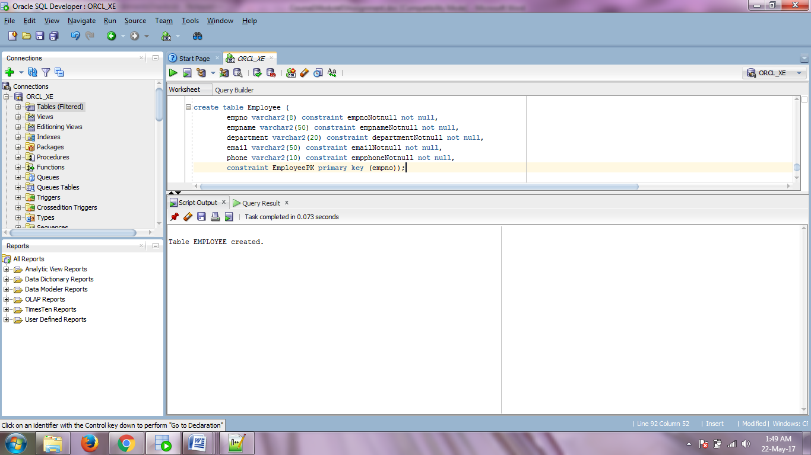

**Screenshot 1: CREATE TABLE execution**

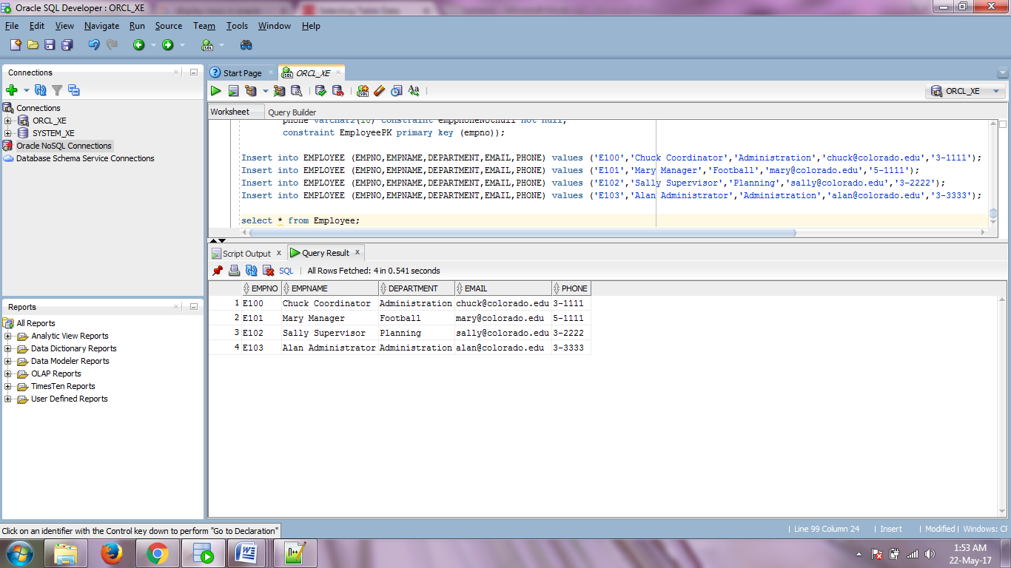

**Screenshot 2: Populated Table**