**Doc 2: ResourceTbl using Oracle 11g**

**CREATE TABLE statement**

create table ResourceTbl (

1. resno varchar2(8) constraint resnoNotnull not null,
2. resname varchar2(20) constraint resnameNotnull not null,
3. rate integer constraint rateNotnull not null,
4. constraint ResourceTblPK primary key (resno),
5. constraint rateCheck check (rate>0)

);

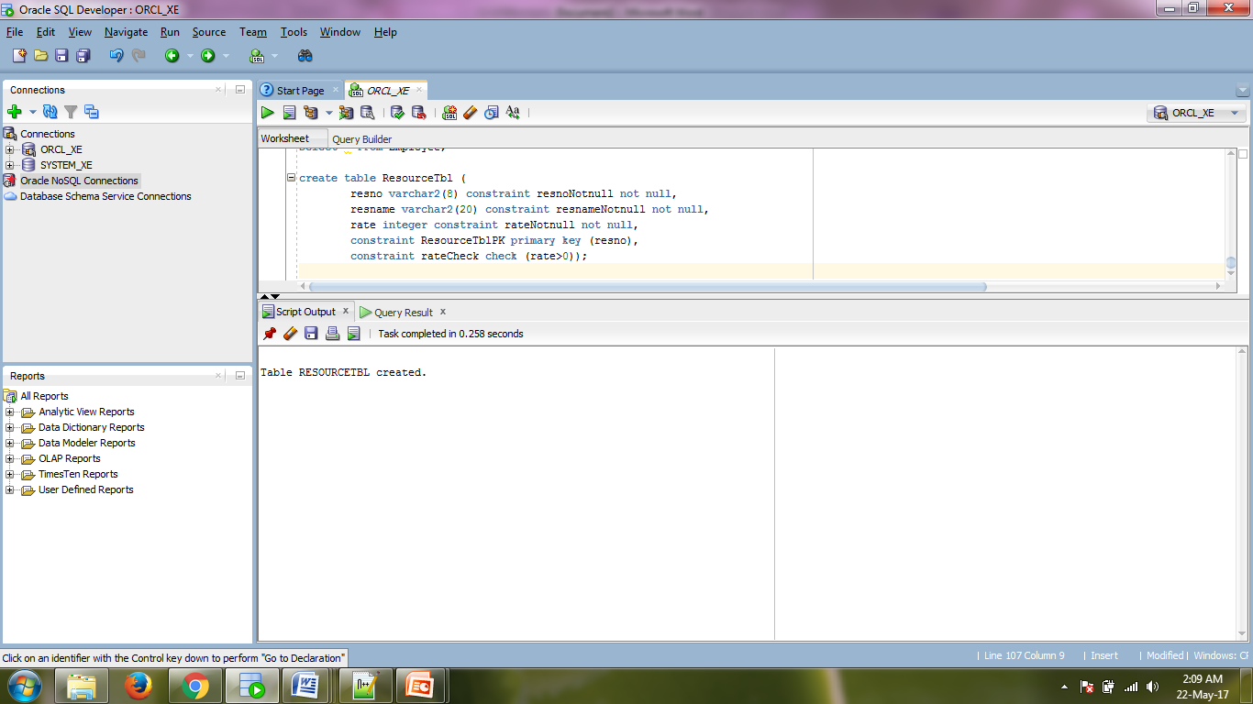

**Screenshot 1: CREATE TABLE execution**

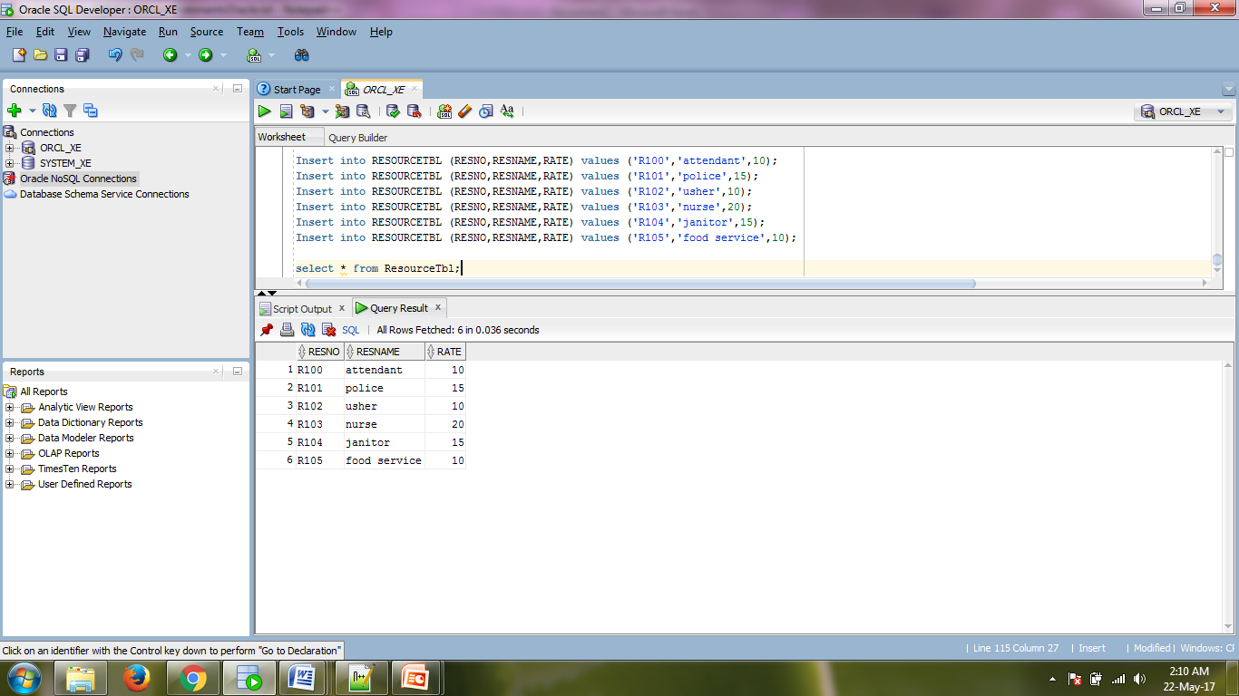

**Screenshot 2: Populated Table**