**Doc 3: EventRequest using Oracle 11g**

**CREATE TABLE statement**

create table EventRequest (

1. eventno varchar2(8) constraint eventnoNotnull not null,
2. Dateheld date constraint DateheldNotnull not null,
3. datereq date constraint datereqNotnull not null,
4. facno varchar2(8) constraint EventRequestfacnoNotnull not null,
5. custno varchar2(8) constraint EventRequestcustnoNotnull not null,
6. dateauth date,
7. status varchar2(10) constraint statusNotnull not null,
8. estcost integer constraint estcostNotnull not null,
9. estaudience integer constraint estaudienceNotnull not null,
10. budno varchar2(10),
11. constraint EventRequestPK primary key (eventno),
12. constraint EventRequestfacnoFK foreign key (facno)

references Facility(facno),

1. constraint EventRequestcustnoFK foreign key (custno)

references Customer(custno),

1. constraint statusCheck check (status in ('Pending','Denied','Approved')),
2. constraint estaudienceCheck check (estaudience > 0)

);

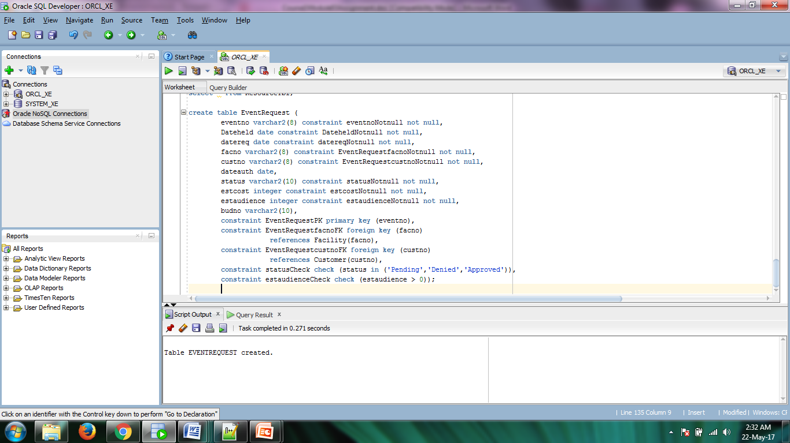

**Screenshot 1: CREATE TABLE execution**

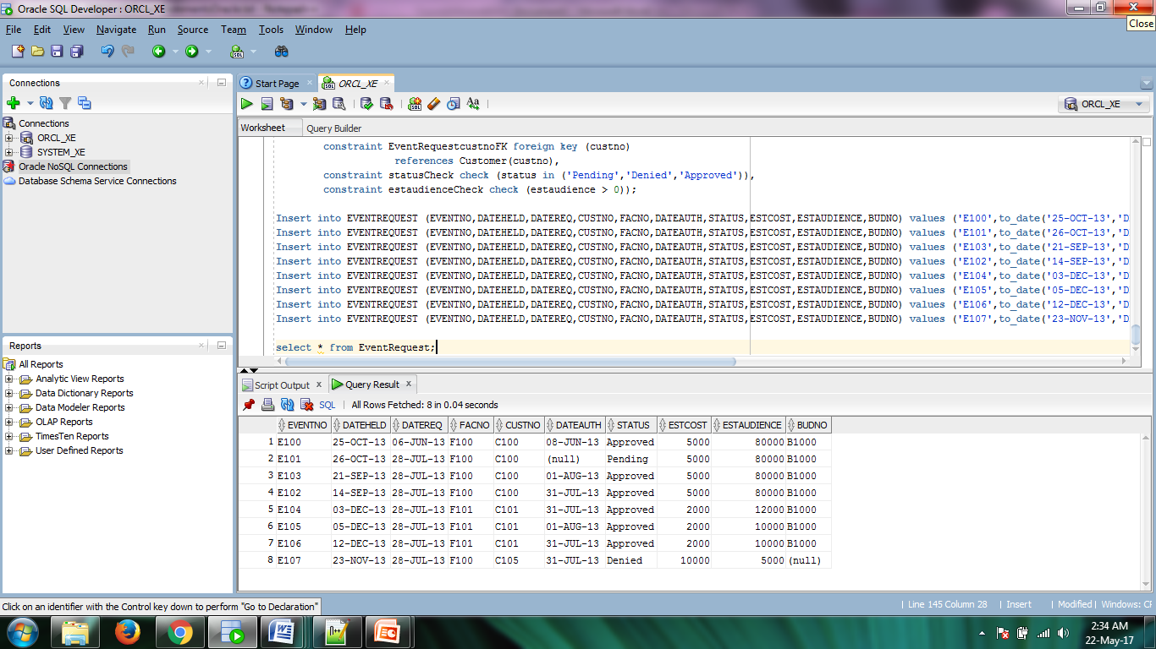

**Screenshot 2: Populated Table**