**Doc 4: EventPlan using Oracle 11g**

**CREATE TABLE statement**

create table EventPlan (

1. planno varchar2(8) constraint plannoNotnull not null,
2. Eventno varchar2(8) constraint EventPlanEventnoNotnull not null,
3. workdate date constraint workdateNotnull not null,
4. notes varchar2(80),
5. activity varchar2(15) constraint activityNotnull not null,
6. empno varchar2(8),
7. constraint EventPlanPK primary key (planno),
8. constraint EventPlanEventnoFK foreign key (Eventno)

references EventRequest(eventno),

1. constraint EventPlanempnoFK foreign key (empno)

references Employee(empno)

);

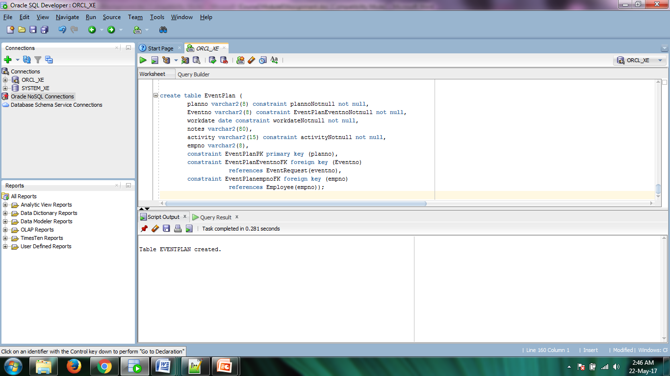

**Screenshot 1: CREATE TABLE execution**

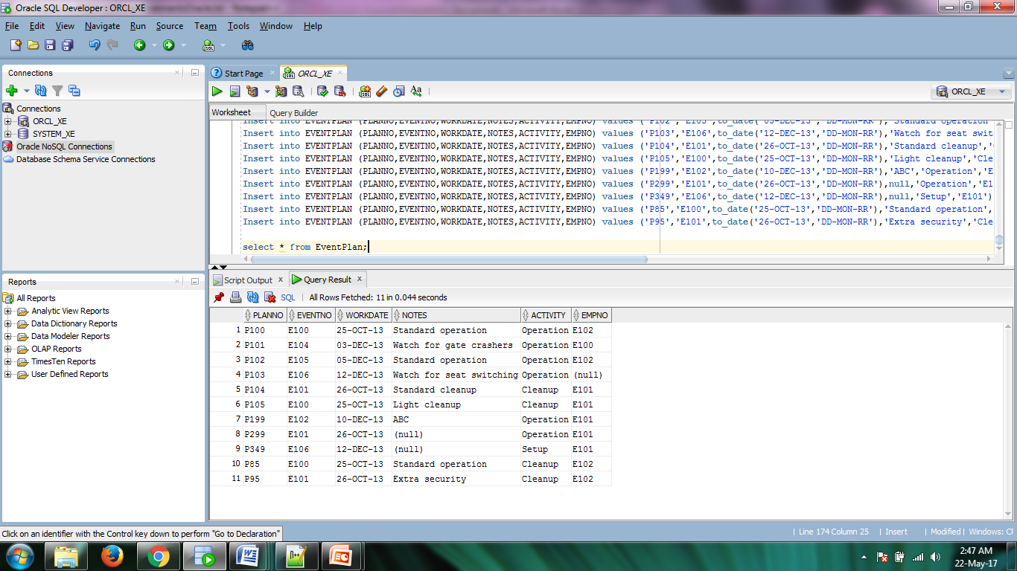

**Screenshot 2: Populated Table**