**Doc 5: EventPlanLine using Oracle 11g**

**CREATE TABLE statement**

create table EventPlanLine (

1. planno varchar2(8) constraint EventPlanLineplannoNotnull not null,
2. lineno integer constraint linenoNotnull not null,
3. timestart timestamp constraint timestartNotnull not null,
4. timeend timestamp constraint timeendNotnull not null,
5. numberfld integer constraint numberfldNotnull not null,
6. locno varchar2(8) constraint EventPlanLinelocnoNotnull not null,
7. resno varchar2(8) constraint EventPlanLineresnoNotnull not null,
8. constraint EventPlanLinePK primary key (planno,lineno),
9. constraint EventPlanLineplannoFK foreign key (planno)

references EventPlan(planno),

1. constraint EventPlanlocnoFK foreign key (locno)

references Location(locno),

1. constraint EventPlanresnoFK foreign key (resno)

references ResourceTbl(resno),

1. constraint StartEndCheck check (timestart < timeend)

);

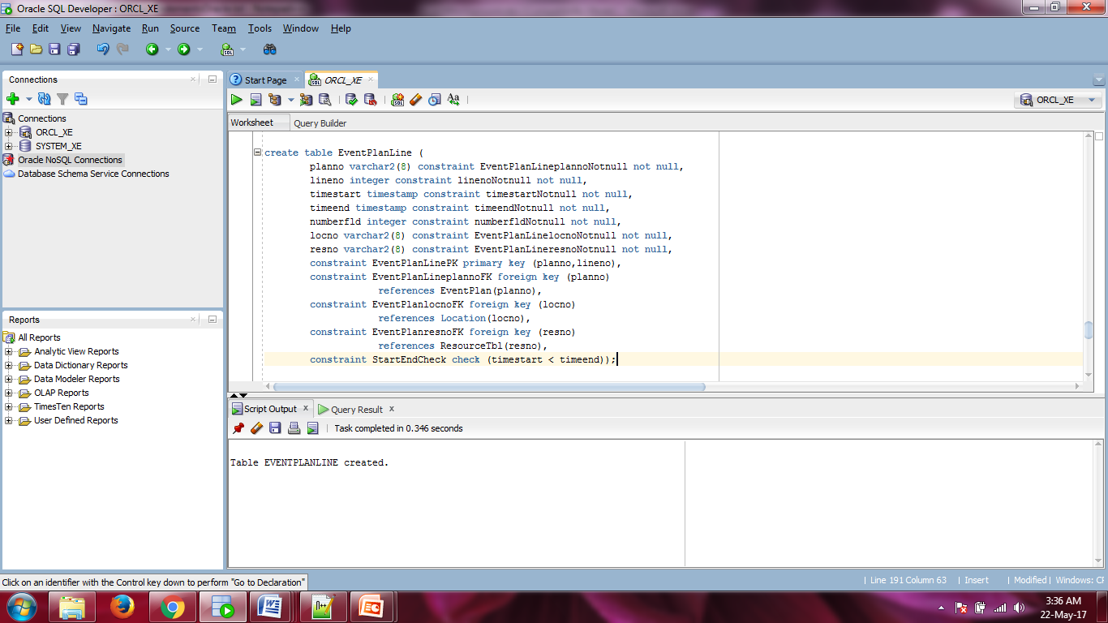

**Screenshot 1: CREATE TABLE execution**

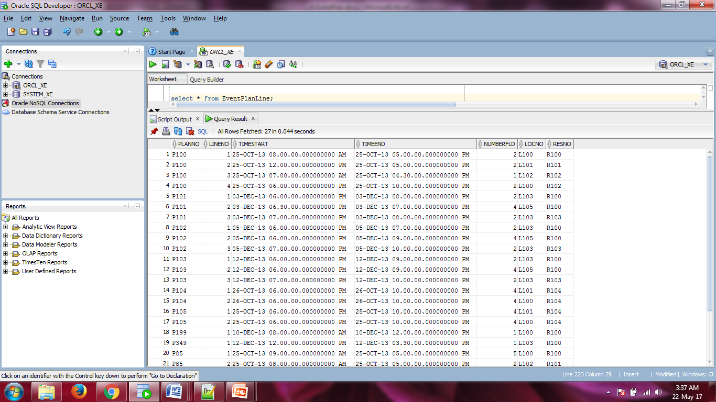

**Screenshot 2: Populated Table**