
INSTITUTE OF ADVANCED RESEARCH (IAR)
The University for Innovation | Gandhinagar, Gujarat
B.Sc. in Artificial Intelligence & Data Science | Semester V (5th Semester)
Academic Session: 2026 – 2027
━━━━━━━━━━━━━━━━━━━━━━━━━━━━━━━━━━━━━━━━━
E-COMMERCE CUSTOMER LIFECYCLE &
RFM SEGMENTATION DASHBOARD
An Applied Machine Learning & Analytics Engineering System
for Commercial Retention & Behavioral Cohort Optimization
Assessment Milestone: | THIRD PROGRESS WORK EVALUATION
Scheduled Submission Date: | 27th October 2026 (Time: 10:00 AM to 5:00 PM)
Curriculum Scope Completed: | Sections 4.2 (Sample Coding & Security), 4.3 (Steps of Execution & Navigation), 5.1-5.2 (Conclusion), 6.1 (References) & Roman Pages
Course & Project Code: | Project - 1 (CE-502 / PRJ-701)
Cumulative Marks Completed: | 40 Marks Evaluated (10 Marks First + 20 Marks Mid-Term + 10 Marks Third Progress)

PROJECT SCHOLAR:  Mr. Deep Koshiya  B.Sc. in AI & Data Science  Semester: V (5th Semester) | PROJECT SUPERVISION:  Assigned Project Supervisor  Institute of Advanced Research (IAR)  Evaluation & Verification Stamp
_________________________  (Scholar Signature) | _________________________  (Supervisor Signature)

Page I
PROGRESS WORK EVALUATION CERTIFICATE
This is to formally certify that the project work entitled "E-Commerce Customer Lifecycle & RFM Segmentation Dashboard" is a bonafide record of authentic applied engineering work carried out by Deep Koshiya, student of B.Sc. in Artificial Intelligence & Data Science, Semester V (5th Semester), at Institute of Advanced Research (IAR), Gandhinagar, Gujarat.
The candidate has successfully completed and demonstrated the Third Progress Work requirements covering Sections 4.2 (Sample Coding with Security Tasks), 4.3 (Steps of Execution & Navigation), 5.1 (Importance of Worked-Out Tasks), 5.2 (Further Enhancement in Future), 6.1 (References), and formal Roman preliminary pages for Project-1 (CE-502 / PRJ-701) scheduled for evaluation on 27th October 2026.
EVALUATION MILESTONE | CURRICULUM SCOPE | MARKS | VERIFICATION STATUS
First Progress Work (24/09/2026) | Sections 1.1, 1.2, 1.3, 2.1, 2.2 | 10 Marks | COMPLETED & VERIFIED
Second Progress Work (13/10/2026) | Sections 2.3, 2.4, 3.1, 4.1 | 20 Marks | COMPLETED & VERIFIED
Third Progress Work (27/10/2026) | Sections 4.2, 4.3, 5.1, 5.2, 6.1 | 10 Marks | EVALUATED & DEMONSTRATED
Faculty Mentor & Reviewer | Academic Verification Seal | Signed Copy | ___________________________
ACKNOWLEDGMENT
I express my profound gratitude to my project supervisor, faculty mentors, and academic advisors at Institute of Advanced Research (IAR) for their continued technical guidance, rigorous evaluations, and constructive critiques throughout the software implementation, sample coding, and testing phases of this project.
I am equally thankful to the Head of the School and institutional computing administrators for providing laboratory computing clusters and software infrastructure required to complete the curriculum requirements of Project-1 (CE-502 / PRJ-701).
Deep Koshiya | B.Sc. in AI & Data Science (Semester V) | Date: 27/10/2026

Page II
ABSTRACT
Modern multi-channel e-commerce systems log massive transactional order streams across digital channels. However, standard Online Transaction Processing (OLTP) architectures record individual line items rather than synthesizing longitudinal customer journeys. Treating customer accounts as a homogenous entity leads to significant marketing waste, elevated customer acquisition costs (CAC), and undetected churn.
The 'E-Commerce Customer Lifecycle & RFM Segmentation Dashboard' resolves these commercial vulnerabilities through an end-to-end data analytics and unsupervised machine learning engineering system. The automated Python pipeline ingests raw transaction event logs, enforces strict schema typing, drops unauthenticated guest checkouts, segregates cancellations into an isolated audit store, and neutralizes wholesale volume spikes using Tukey's Interquartile Range (IQR) fences. A vectorized feature store calculates Recency, Frequency, Monetary spend, and Average Order Value (AOV). Monetary skewness is normalized using log1p compression and Z-score standardization before fitting unsupervised K-Means clustering (evaluated via Silhouette scores), supported by a deterministic 1–5 quantile scoring fallback mapping accounts to 8 operational business cohorts.
This Third Phase Project Report delivers complete technical documentation for the 27/10/2026 evaluation milestone (10 Marks). It presents sample production code with cybersecurity controls (Section 4.2), step-by-step execution protocols and dashboard navigation workflows (Section 4.3), commercial importance of worked-out tasks (Section 5.1), roadmap for future artificial intelligence enhancements (Section 5.2), and comprehensive academic and technological references (Section 6.1).

Page III
INDEX OF THE PROJECT REPORT
(Structured strictly according to Syllabus Guidelines for B.Sc. AI and Data Science SEM V)
SR. | CURRICULUM SECTION / TOPIC | SCHEDULE | STATUS & PAGE
* | Progress Work Evaluation Certificate & Acknowledgment | 27/10/2026 | Page I [Completed]
* | Abstract | 27/10/2026 | Page II [Completed]
* | Index of the Project Report | 27/10/2026 | Page III [Completed]
* | List of Figures & List of Tables | 27/10/2026 | Page IV [Completed]
1 | ABOUT THE SYSTEM (1.1 Problem, 1.2 Requirements, 1.3 Tools) | 24/09/2026 | Pages 1-3 [Completed]
2.1 | Data Flow Diagrams (Level 0 Context, Level 1, Level 2 DFDs) | 24/09/2026 | Pages 4-6 [Completed]
2.2 | Use Case Diagram & Formal Specification Matrix | 24/09/2026 | Page 7 [Completed]
2.3-2.4 | UML Class Diagram & UML Sequence Diagrams | 13/10/2026 | Pages 8-9 [Completed]
3.1 | Data Dictionary: Star-Schema SQL/NoSQL Database Tables | 13/10/2026 | Pages 10-12 [Completed]
4.1 | Screen Layouts with Operational Input Validations | 13/10/2026 | Pages 13-14 [Completed]
4.2 | Sample Coding (with Cybersecurity & Integrity Tasks) | 27/10/2026 | Pages 15-18 [Completed 27/10]
4.3 | Steps of Execution Project & Dashboard Navigation | 27/10/2026 | Pages 19-21 [Completed 27/10]
5.1-5.2 | Conclusion: Importance of Tasks & Future Scope | 27/10/2026 | Page 22 [Completed 27/10]
6.1 | References (Academic Papers, Books, Technology, Webs) | 27/10/2026 | Page 23 [Completed 27/10]

Page IV
LIST OF FIGURES
Figure 2.1: Level 0 Data Flow Diagram (Context-Level DFD) . . . . . . . . . . . . . . . . . . . . Page 4
Figure 2.2: Level 1 Data Flow Diagram (Pipeline Architecture) . . . . . . . . . . . . . . . . . . . . Page 5
Figure 2.3: Level 2 Data Flow Diagram (Refinery & ML Decomposition) . . . . . . . . . . . . . . . . . . . . Page 6
Figure 2.4: UML Use Case Diagram (System Actors & Functional Capabilities) . . . . . . . . . . . . . . . . . . . . Page 7
Figure 2.5: UML Class Diagram (Domain Model & Pipeline Object Architecture) . . . . . . . . . . . . . . . . . . . . Page 8
Figure 2.6: UML Sequence Diagram (End-to-End Processing Workflow) . . . . . . . . . . . . . . . . . . . . Page 9
Figure 4.1: Implementation Screen Layouts with Operational Input Validations . . . . . . . . . . . . . . . . . . . . Page 13
Figure 4.2: K-Means Inertia Elbow Curve & Silhouette Diagnostic Profile . . . . . . . . . . . . . . . . . . . . Page 17
Figure 4.3: Segment Revenue Share Donut & Multi-Dimensional Spatial Scatterplot . . . . . . . . . . . . . . . . . . . . Page 20
LIST OF TABLES
Table 1.1: System Hardware & Software Requirements Specification . . . . . . . . . . . . . . . . . . . . Page 2
Table 1.2: Technology Stack & Architectural Layer Mapping . . . . . . . . . . . . . . . . . . . . Page 3
Table 2.1: Formal Use Case Specification Matrix (UC-01 to UC-06) . . . . . . . . . . . . . . . . . . . . Page 7
Table 3.1: FACT_TRANSACTIONS (Order-Level Fact Mart Schema) . . . . . . . . . . . . . . . . . . . . Page 10
Table 3.2: FACT_REVERSALS (Reverse Logistics Audit Fact Mart Schema) . . . . . . . . . . . . . . . . . . . . Page 11
Table 3.3: DIM_CUSTOMERS (Customer RFM & Behavioral Dimension Mart) . . . . . . . . . . . . . . . . . . . . Page 11
Table 3.4: DIM_PRODUCTS (Catalog Item Dimension Mart Schema) . . . . . . . . . . . . . . . . . . . . Page 12
Table 3.5: DIM_DATE (Temporal Dimension Mart Schema) . . . . . . . . . . . . . . . . . . . . Page 12
Table 6.1: Project Progress Work Evaluation Schedule & Milestone Tracking . . . . . . . . . . . . . . . . . . . . Page 23

Page 1
1. ABOUT THE SYSTEM:
1.1 Problem definition (Identification of needs):
Modern digital commerce platforms capture high-velocity transactional event streams across web interfaces, mobile shopping applications, and digital points of sale. Standard Online Transaction Processing (OLTP) repositories excel at logging individual line-item orders. However, these systems record transactions rather than customer journeys. Without an automated analytics engineering layer that synthesizes transactional logs into longitudinal customer profiles, commercial decision-makers face severe visibility gaps.
1.1.1 Industry Background & Commercial Challenges
Digital retailers face rising customer acquisition costs (CAC) and declining organic retention. When marketing campaigns treat the customer base as a single homogenous audience, high-value repeat shoppers receive unnecessary discounts that erode gross margins, while dormant accounts slip into permanent churn without timely, targeted reactivation interventions.
1.1.2 Identification of Core Analytical Needs
• Core Analytical Needs: The system resolves four foundational operational bottlenecks:
1. Data Refinery & Anomaly Isolation: Raw logs contain anonymous guest sessions, cancellations ('^C'), and wholesale bulk anomalies. An automated data refinery must enforce schema typing, isolate cancellations into an audit store, and cap volume spikes using Tukey's Interquartile Range (IQR) fences.
2. Behavioral Feature Engineering (RFM): The system must distill transaction streams into three normalized customer dimensions: Recency (days elapsed since last order relative to boundary T_obs = max(InvoiceDate) + 1), Frequency (distinct purchase visits), and Monetary spend (cumulative net value), alongside Average Order Value (AOV).
3. Skew-Resistant Machine Learning: Customer spending follows extreme Pareto distributions. Monetary skewness must be compressed via log1p transformation and Z-score standardization before fitting unsupervised K-Means models, supported by deterministic 1–5 quantile fallback scoring.
4. Executive Visualization & Activation: Commercial leadership requires an interactive dashboard to visualize portfolio health, monitor at-risk revenue, and export targeted cohort lists directly into CRM marketing campaigns.

Page 2
1.2 Requirement Specifications (Product/System Tasks)
The requirements formally define system capabilities, data validation boundaries, and operational constraints for the E-Commerce Customer Lifecycle & RFM Segmentation platform.
1.2.1 Functional Requirements Specifications (FR)
• FR-01 (Ingestion & Schema Typing): Ingests raw CSV logs, enforces typing (InvoiceDate to datetime64[ns], Quantity and UnitPrice to floats), and sanitizes product description text.
• FR-02 (Missing Entity Resolution): Detects and drops unauthenticated guest checkouts lacking CustomerID to preserve longitudinal cohort integrity.
• FR-03 (Reverse Logistics Segregation): Isolates credit notes, cancellations ('^C'), and non-positive quantities into an audit store (fact_reversals_audit.csv).
• FR-04 (Tukey IQR Outlier Capping): Applies Tukey fences [Q1 - 1.5*IQR, Q3 + 1.5*IQR] to eliminate wholesale bulk distributor anomalies.
• FR-05 (Vectorized RFM Derivation): Computes snapshot boundary T_obs = max(InvoiceDate) + 1 day and derives customer Recency, Frequency, Spend, and AOV.
• FR-06 (ML Clustering & Quantile Scoring): Applies log1p transformation and StandardScaler, fits K-Means clustering, and assigns 1–5 quantile scores mapping to 8 business cohorts.
1.2.2 Non-Functional Requirements Specifications (NFR)
• NFR-01 (Performance & Latency): Processes 15,000+ transaction rows in under 5.0 seconds using vectorized Pandas C-routines.
• NFR-02 (Algorithmic Reproducibility): Fixed random seeds (seed=42) guarantee 100% deterministic, reproducible clustering across environments.
• NFR-03 (Modularity & Architecture): Modular Python architecture with clean star-schema marts (FACT_TRANSACTIONS, DIM_CUSTOMERS).
Table 1.1: System Hardware & Software Requirements Specification
SYSTEM SPECIFICATION | MINIMUM REQUIREMENT | DEPLOYED PROJECT ENVIRONMENT
Processor / CPU | Dual-Core x86_64 or ARM64 (2.0 GHz) | Apple Silicon M-Series / Intel Core i5/i7 (8-Core+)
System Memory (RAM) | 4 GB DDR3/DDR4 | 8 GB to 16 GB Unified Memory Architecture
Storage Subsystem | 500 MB Free Disk Space | Solid State Drive (NVMe SSD)
Operating System | macOS 12+, Ubuntu 20.04+, Windows 10+ | macOS Darwin (Unix POSIX Environment)
Execution Runtimes | Python 3.9+, Modern Web Browser | Python 3.9.6, Safari, Google Chrome, VS Code

Page 3
1.3 Tools and Technology Used (Front-End/Back-End/Framework/API/Services)
The project implements a modern analytical engineering stack selected for computational throughput, mathematical precision, and interactive visual analytics.
1.3.1 Data Engineering & Numerical Computing
• Python 3.9+: Core programming runtime executing optimized C-extensions for data science.
• Pandas (v2.3.3): Vectorized group aggregations, type coercion, datetime logic, and quantile ranking (pd.qcut).
• NumPy (v2.0.2): Multidimensional array manipulations, logarithmic transformations (log1p), and Tukey fence outlier calculations.
1.3.2 Machine Learning & Statistical Computing
• Scikit-Learn (v1.6.1): StandardScaler feature normalization, KMeans with k-means++ initialization, and Silhouette diagnostics.
• SciPy (v1.13.1): Statistical distributions and spatial distance metric calculations across multidimensional vectors.
1.3.3 Presentation, Dashboards & Dimensional Data Marts
• HTML5 & Tailwind CSS: Utility-first responsive framework delivering clean dark/light executive UI layouts.
• Chart.js: Client-side canvas graphing engine driving interactive revenue donuts and spatial RFM bubble charts.
• Analytical Data Marts: Star-schema dimensional storage (FACT_TRANSACTIONS, DIM_CUSTOMERS) enabling Tableau/Power BI connectivity.
Table 1.2: Technology Stack & Architectural Layer Mapping
ARCHITECTURAL LAYER | TECHNOLOGY / FRAMEWORK | PRIMARY OPERATIONAL RESPONSIBILITY
Ingestion & Refinery | Python, Pandas, NumPy | Schema typing, null dropping, cancellation segregation, Tukey IQR fences
Feature Engineering | Pandas GroupBy, Datetime | Derivation of customer Recency, Frequency, Monetary spend, and AOV
Machine Learning | Scikit-Learn, SciPy | Log1p scaling, StandardScaler, K-Means clustering, Silhouette diagnostics
Data Mart Layer | CSV / Star Schema | Clean FACT_TRANSACTIONS and DIM_CUSTOMERS marts for BI compatibility
Executive BI Dashboard | HTML5, Tailwind, Chart.js | Interactive KPI scorecards, spatial RFM bubble charts, activation tables

Page 4
2. SYSTEM DESIGN USING UML & DFD:
2.1 Data Flow Diagrams (Context, Level 1, Level 2 Architecture)
Data Flow Diagrams (DFDs) visually map information transformations through the system. Using Gane & Sarson conventions, the diagrams represent External Entities (rectangles), Processes (rounded rectangles), Data Stores (open horizontal lines), and Data Flows (directed arrows).
2.1.1 Level 0 Data Flow Diagram (Context-Level DFD)
The Level 0 Context DFD establishes the macro boundary of Process 0.0 ('E-Commerce Customer Lifecycle & RFM Analytics System') and documents all external entity interactions: (1) OLTP Transaction Stream supplying raw sales event logs; (2) Data Scientist providing IQR thresholds and cluster hyper-parameters; (3) CRM Marketing Engine consuming targeted audience lists; and (4) Commercial Executives receiving high-level portfolio KPIs and revenue concentration scorecards.
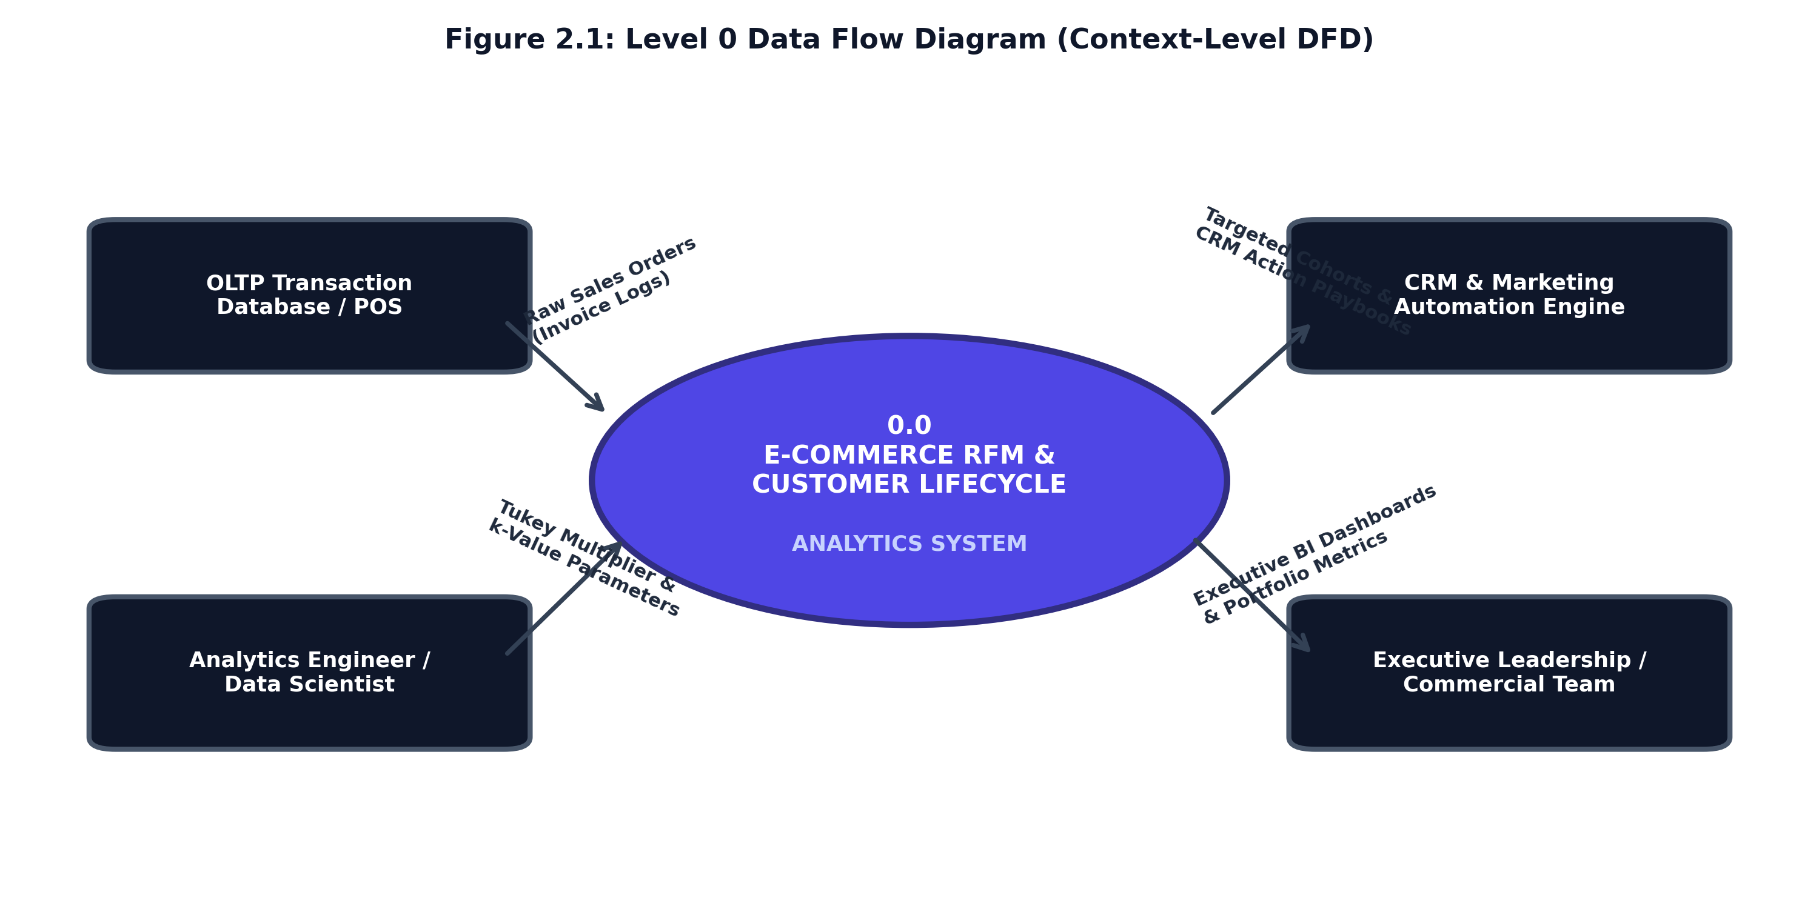
Figure 2.1: Level 0 Data Flow Diagram (Context-Level DFD)

Page 5
2.1.2 Level 1 Data Flow Diagram (End-to-End Pipeline Architecture)
The Level 1 DFD decomposes Process 0.0 into five sequential operational processes and identifies the underlying persistent data repositories:
• Process 1.0 (Ingestion & Schema Typing): Ingests raw order logs, validates schema datatypes, and records input stream to D1 (Raw Transaction Log).
• Process 2.0 (Data Quality & Refinery Pipeline): Purges missing CustomerIDs, routes return orders to D2 (Reversals Audit Ledger), and applies Tukey IQR outlier fences.
• Process 3.0 (Vectorized RFM Feature Extraction): Aggregates customer transactions into Recency days, Frequency counts, and Monetary spend, saving to D3 (RFM Analytical Table).
• Process 4.0 (ML Clustering & Quantile Scoring): Executes log1p transformation, Z-score scaling, K-Means clustering, and 1–5 quantile scoring, persisting to D4 (Segmented Customer Mart).
• Process 5.0 (Star-Schema & Dashboard Export): Generates the star schema dimensional marts and powers the interactive executive analytics dashboard.
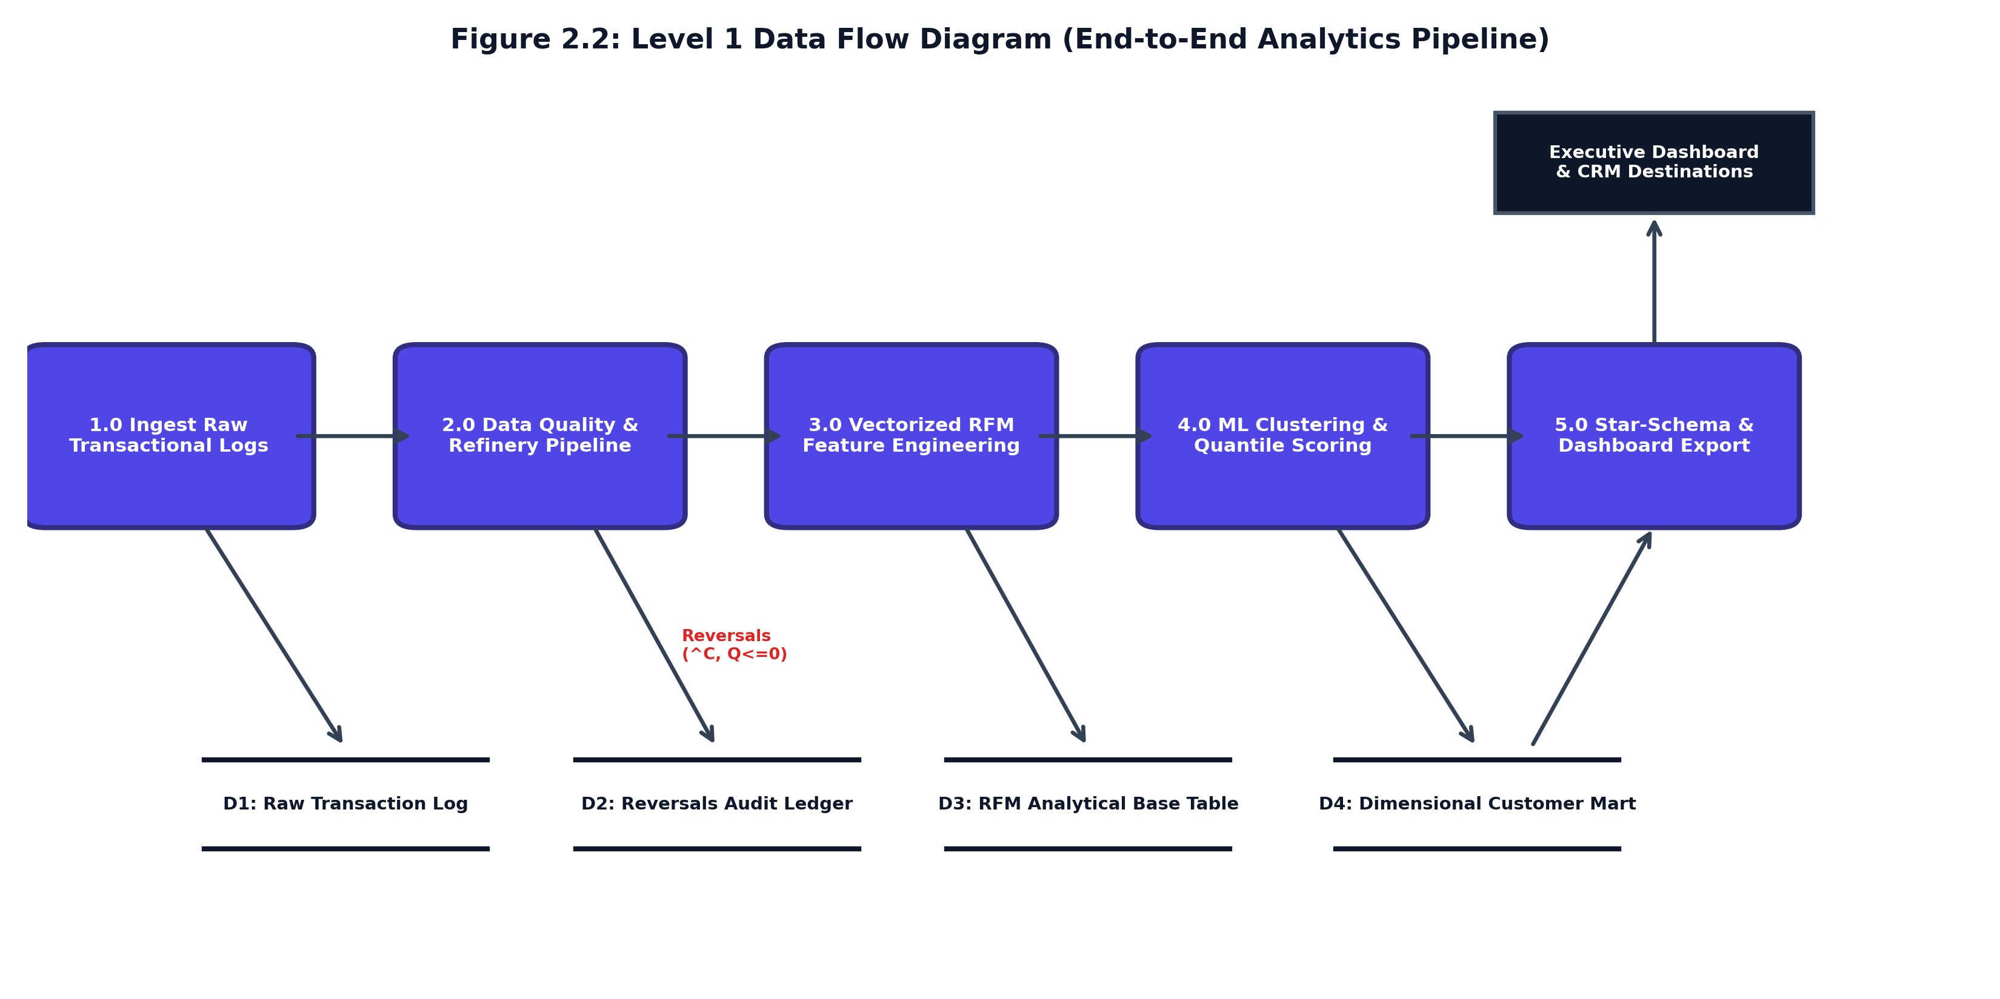
Figure 2.2: Level 1 Data Flow Diagram (End-to-End Pipeline Architecture)

Page 6
2.1.3 Level 2 Data Flow Diagram (Sub-Process Decomposition)
To provide rigorous engineering granularity as mandated by university project standards, the Level 2 DFD decomposes the two critical computational processes: Process 2.0 (Data Quality Refinery) and Process 4.0 (Machine Learning Clustering Engine).
• Sub-Process 2.0 Decomposition (Refinery): Sub-process 2.1 removes unauthenticated records lacking CustomerID. Sub-process 2.2 detects cancellation codes ('^C' or negative quantities) and writes to the audit ledger. Sub-process 2.3 computes Tukey fences [Q1 - 1.5*IQR, Q3 + 1.5*IQR] to eliminate wholesale bulk distributor anomalies.
• Sub-Process 4.0 Decomposition (ML & Scoring): Sub-process 4.1 applies log1p compression (z = ln(1 + x)) to resolve Pareto spend skewness. Sub-process 4.2 executes Z-score normalization. Sub-process 4.3 executes K-Means clustering across k in [2..6] with Silhouette validation. Sub-process 4.4 runs quantile binning (pd.qcut) mapping accounts to 8 business operating cohorts.
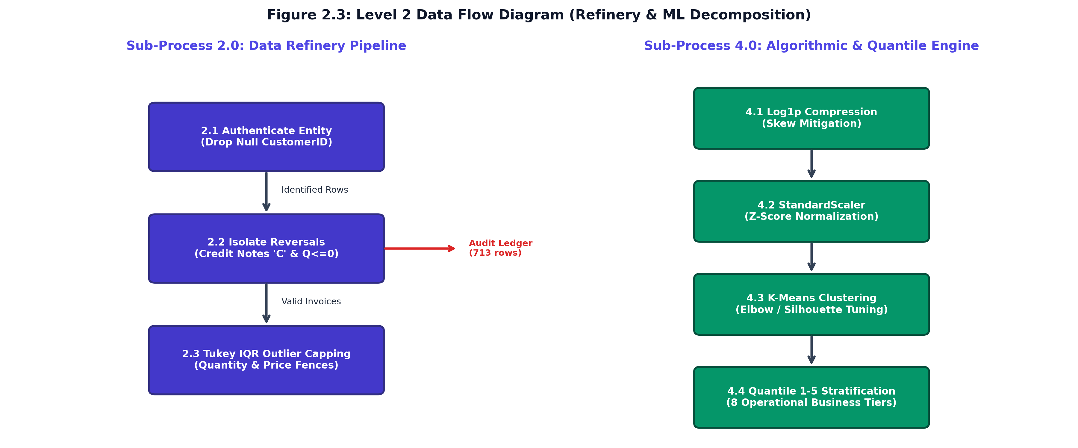
Figure 2.3: Level 2 Data Flow Diagram (Refinery & ML Decomposition)

Page 7
2.2 Use Case Diagram & Actor Specifications
The Use Case Model defines operational boundaries by mapping system capabilities to primary human and automated actors.
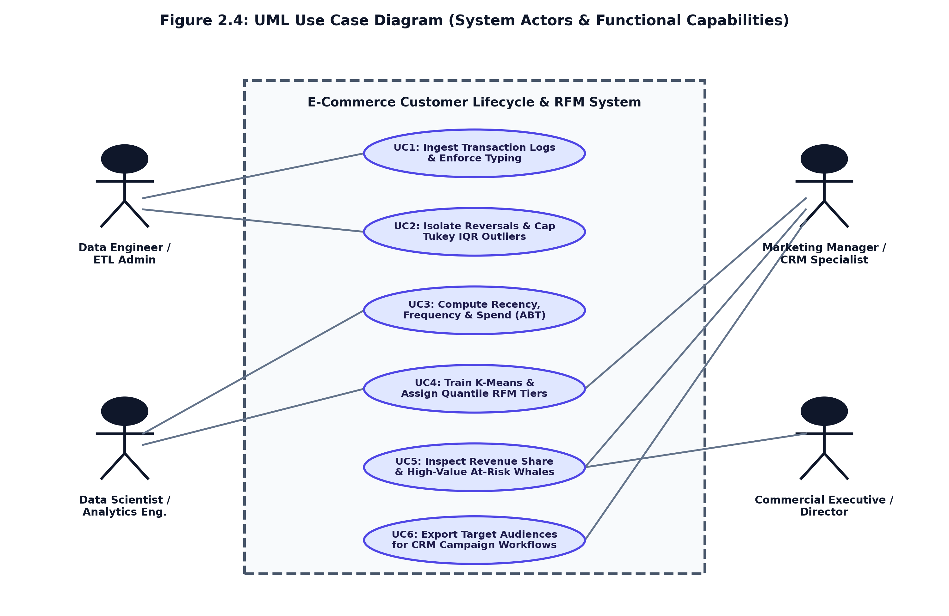
Figure 2.4: UML Use Case Diagram (System Actors & Functional Capabilities)
Table 2.1: Formal Use Case Specification Matrix (UC-01 to UC-06)
UC ID | USE CASE NAME | PRIMARY ACTOR | OPERATIONAL GOAL & PRE-CONDITION
UC-01 | Ingest Transaction Stream | Data Engineer / Admin | Ingests raw event logs, validates schema, enforces datatypes.
UC-02 | Isolate Reversals & IQR Filter | Data Engineer / Admin | Purges null IDs, isolates returns (^C), caps Tukey bulk outliers.
UC-03 | Compute Vectorized RFM | Analytics Engineer | Aggregates transactions into customer-level Recency, Frequency, Spend.
UC-04 | Train & Tune K-Means Model | Data Scientist | Applies log1p + StandardScaler, evaluates Elbow/Silhouette, fits k=4.
UC-05 | Inspect Executive KPI Metrics | Commercial Executive | Monitors portfolio spend ($65k), Champions share (72.5%), at-risk capital.
UC-06 | Export Targeted CRM Audiences | Marketing Manager | Filters segments in activation ledger and exports audience lists for campaigns.

Page 8
2.3 UML Class Diagram (Domain Model & Object Architecture)
The UML Class Diagram establishes the object-oriented structure of the analytics pipeline, modeling domain entities, transformation services, algorithmic engines, and dimensional export utilities.
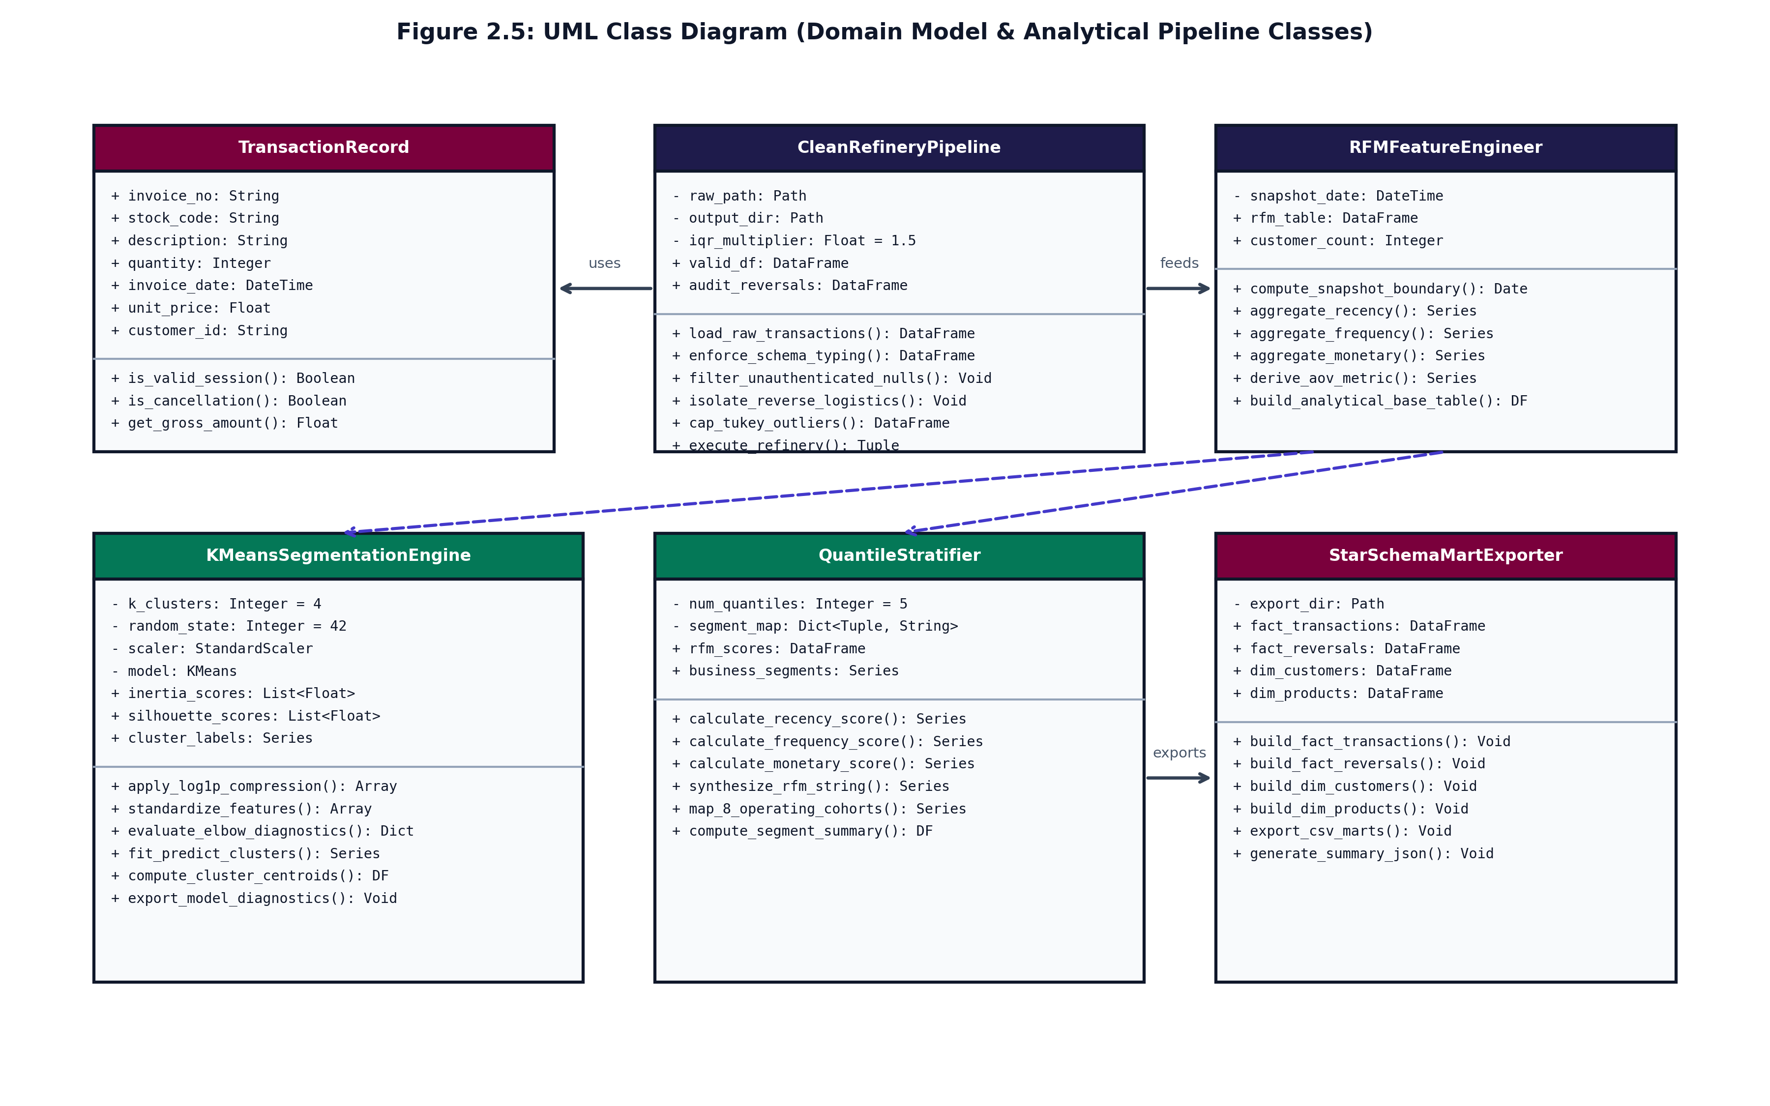
Figure 2.5: UML Class Diagram (Domain Model & Pipeline Object Architecture)
2.3.1 Detailed Object Model & Class Specifications
1. TransactionRecord (Domain Entity): Models single line-item order entities with methods for session validation and gross spend calculation.
2. CleanRefineryPipeline (Refinery Service): Controls raw data loading, schema typing, null dropping, cancellation segregation, and Tukey IQR outlier capping.
3. RFMFeatureEngineer (Feature Engineering): Vectorized service computing customer Recency relative to T_obs, purchase Frequency, Monetary spend, and Average Order Value.
4. KMeansSegmentationEngine (ML Service): Encapsulates feature scaling, log1p compression, StandardScaler, K-Means clustering, and Silhouette diagnostics.
5. QuantileStratifier (Business Logic Engine): Rule-based quantile engine assigning deterministic 1–5 scores and mapping 8 business operational cohorts.
6. StarSchemaMartExporter (Persistence Service): Generates relational star-schema tables (FACT_TRANSACTIONS, FACT_REVERSALS, DIM_CUSTOMERS, DIM_PRODUCTS).

Page 9
2.4 UML Sequence Diagrams (System Execution & Interaction Flow)
The UML Sequence Diagram models dynamic behavioral interactions and message dispatch sequences across system components during pipeline execution.
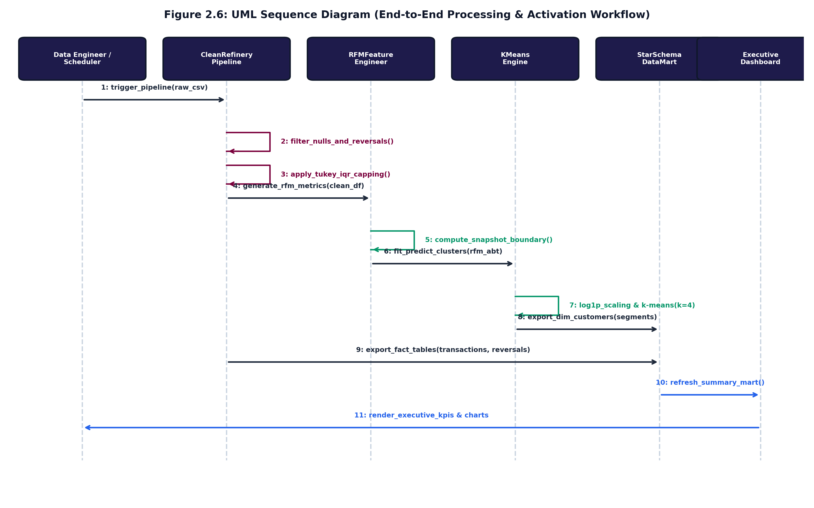
Figure 2.6: UML Sequence Diagram (End-to-End Processing & Activation Workflow)
2.4.1 Step-by-Step Message Dispatch Protocol
• Step 1 (Pipeline Trigger): The Data Engineer or automated scheduler issues trigger_pipeline(raw_csv) to initiate ingestion.
• Steps 2-3 (Data Refinery): CleanRefineryPipeline performs self-calls to filter unauthenticated nulls, segregate cancellations, and apply Tukey IQR fences.
• Steps 4-5 (Feature Derivation): The cleansed dataframe is passed to RFMFeatureEngineer, which evaluates T_obs and extracts customer vectors.
• Steps 6-7 (Machine Learning Execution): The RFM base table is dispatched to KMeansEngine, which applies log1p compression and trains k=4 clusters.
• Steps 8-9 (Data Mart Export): Cluster predictions and quantile tiers are exported to StarSchemaDataMart, writing dimension and fact tables.
• Steps 10-11 (Dashboard Activation): The data mart generates summary JSON payloads, enabling ExecutiveDashboard to render interactive visualizations.

Page 10
3. DATA DICTIONARY:
3.1 Database tables SQL/NoSQL (Dimensional Schema Specification)
The Data Dictionary provides complete schema specifications for the star-schema dimensional data mart architecture. The mart decouples high-volume transactional event facts from customer and product dimensions, ensuring maximum SQL query performance and native compatibility with enterprise BI tools like Tableau and Power BI.
Table 3.1: FACT_TRANSACTIONS (Order-Level Fact Mart)
COLUMN NAME | DATA TYPE | KEY | NULL | OPERATIONAL DESCRIPTION & CONSTRAINTS
transaction_id | BIGINT | PK | NO | Surrogate primary key generated via monotonic sequence.
invoice_no | VARCHAR(20) | None | NO | Alphanumeric invoice identifier; 6-digit order code.
stock_code | VARCHAR(20) | FK | NO | Stock keeping unit (SKU) linking to DIM_PRODUCTS.
quantity | INTEGER | None | NO | Purchased item quantity; strictly Quantity > 0 after refinery.
invoice_date | TIMESTAMP | FK | NO | Transaction timestamp; parsed to datetime64[ns].
unit_price | DECIMAL(10,2) | None | NO | Unit price per product item; strictly UnitPrice > 0.00.
customer_id | VARCHAR(20) | FK | NO | Customer identifier linking to DIM_CUSTOMERS.
country | VARCHAR(50) | None | YES | Geographic country destination of invoice.
gross_amount | DECIMAL(12,2) | None | NO | Calculated line spend: Quantity * UnitPrice.

Page 11
Table 3.2: FACT_REVERSALS (Reverse Logistics Audit Fact Mart)
COLUMN NAME | DATA TYPE | KEY | NULL | OPERATIONAL DESCRIPTION & CONSTRAINTS
reversal_id | BIGINT | PK | NO | Surrogate primary key for return audit records.
invoice_no | VARCHAR(20) | None | NO | Cancellation invoice code matching regex '^C[0-9]+'.
stock_code | VARCHAR(20) | FK | NO | Product item identifier returned by customer.
return_quantity | INTEGER | None | NO | Negative quantity returned (Quantity < 0).
reversal_date | TIMESTAMP | FK | NO | Timestamp when cancellation was processed.
unit_price | DECIMAL(10,2) | None | NO | Original sale unit price of returned item.
customer_id | VARCHAR(20) | FK | NO | Customer ID associated with the reversal transaction.
Table 3.3: DIM_CUSTOMERS (Customer RFM & Behavioral Dimension Mart)
COLUMN NAME | DATA TYPE | KEY | NULL | OPERATIONAL DESCRIPTION & CONSTRAINTS
customer_key | BIGINT | PK | NO | Surrogate primary key for customer dimension.
customer_id | VARCHAR(20) | None | NO | Natural unique customer identifier (non-null).
recency_days | INTEGER | None | NO | Days elapsed since last order: T_obs - max(InvoiceDate).
frequency_orders | INTEGER | None | NO | Distinct purchase trips: count(distinct InvoiceNo).
monetary_total | DECIMAL(12,2) | None | NO | Cumulative net customer spend across all valid orders.
avg_order_value | DECIMAL(10,2) | None | NO | Average Order Value: Monetary / Frequency.
r_score | SMALLINT | None | NO | Quantile Recency score (1 to 5; 5 = most recent).
f_score | SMALLINT | None | NO | Quantile Frequency score (1 to 5; 5 = highest frequency).
m_score | SMALLINT | None | NO | Quantile Monetary score (1 to 5; 5 = highest spend).
segment_tier | VARCHAR(40) | None | NO | Mapped operating tier ('Champions', 'Loyal', 'At Risk').

Page 12
Table 3.4: DIM_PRODUCTS (Catalog Item Dimension Mart)
COLUMN NAME | DATA TYPE | KEY | NULL | OPERATIONAL DESCRIPTION & CONSTRAINTS
product_key | BIGINT | PK | NO | Surrogate primary key for product dimension.
stock_code | VARCHAR(20) | None | NO | Unique SKU code assigned to the retail inventory item.
description | VARCHAR(255) | None | YES | Cleaned product title text; sanitized of special characters.
unit_price_ref | DECIMAL(10,2) | None | NO | Baseline catalog unit price for retail inventory item.
is_active | BOOLEAN | None | NO | Product active flag (TRUE = currently sold).
Table 3.5: DIM_DATE (Temporal Dimension Mart)
COLUMN NAME | DATA TYPE | KEY | NULL | OPERATIONAL DESCRIPTION & CONSTRAINTS
date_key | INTEGER | PK | NO | Integer key formatted as YYYYMMDD (e.g. 20261027).
full_date | DATE | None | NO | Calendar date representation.
day_of_week | VARCHAR(10) | None | NO | Day name: 'Monday', 'Tuesday', ..., 'Sunday'.
calendar_month | VARCHAR(15) | None | NO | Month name: 'January', 'October', etc.
calendar_quarter | SMALLINT | None | NO | Calendar quarter (1 to 4).
is_weekend | BOOLEAN | None | NO | Weekend flag (TRUE if Saturday or Sunday).

Page 13
4. IMPLEMENTATION:
4.1 Screen Layouts with validations
The web-based BI dashboard provides four synchronized analytical views designed with utility-first Tailwind CSS and Chart.js. Each interface incorporates strict client-side and server-side data validations to ensure reliable commercial operation.
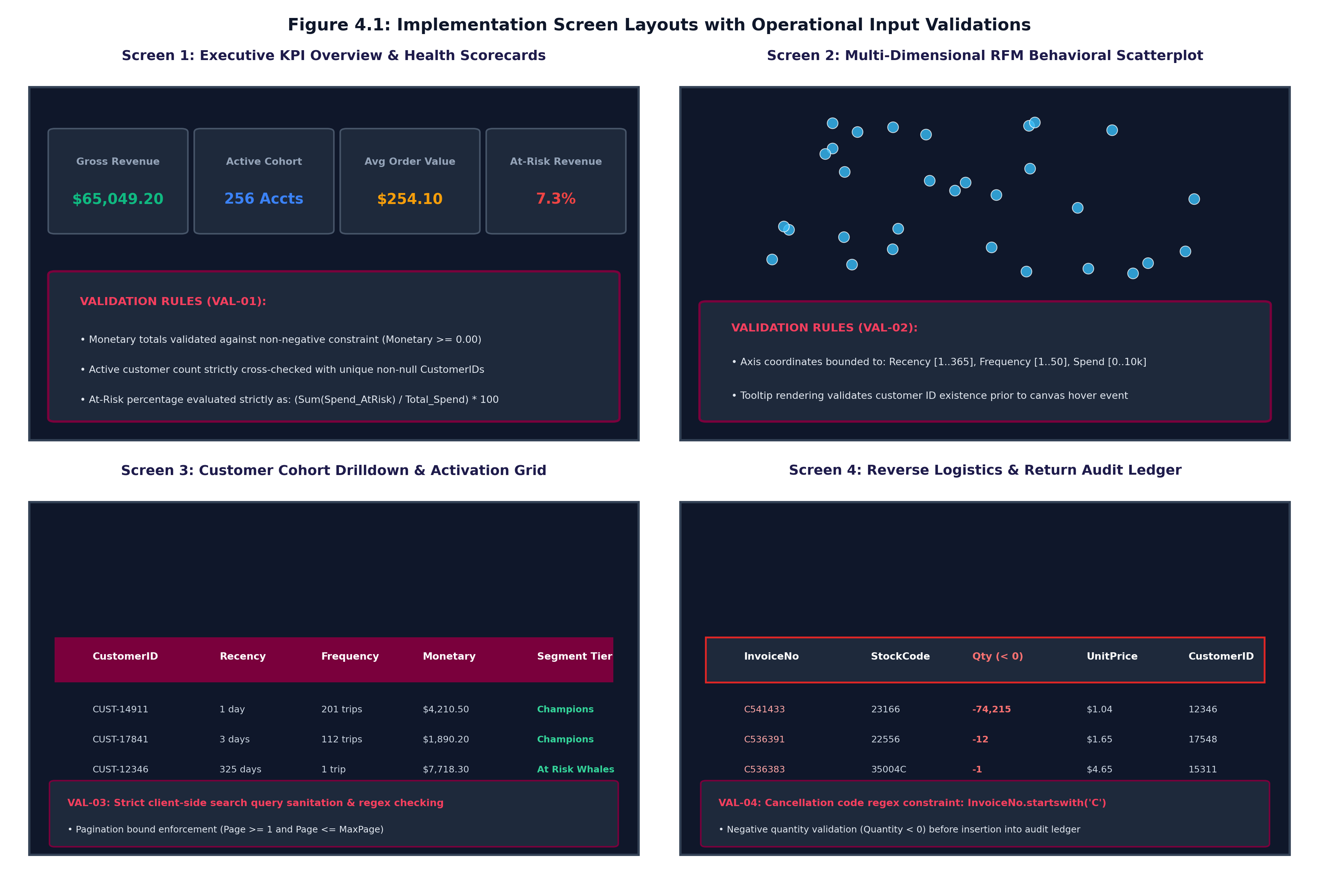
Figure 4.1: Implementation Screen Layouts with Operational Input Validations
4.1.1 Screen Layouts Architectural Walkthrough
• Screen 1 (Executive Overview & Scorecards): Renders four dynamic KPI scorecards displaying portfolio spend ($65,049.20), active accounts (256), average order value ($254.10), and at-risk revenue share (7.3%).
• Screen 2 (RFM Behavioral Scatterplot): Canvas scatterplot plotting Recency (X-axis) against Monetary Spend (Y-axis) with bubble radii scaled to Frequency.
• Screen 3 (Customer Cohort Activation Grid): Searchable ledger with instantaneous regex filtering, pagination controls, and targeted CSV export capabilities.
• Screen 4 (Reverse Logistics Audit Ledger): Isolated audit table displaying quarantined cancellations and credit notes for compliance review.

Page 14
4.1.2 Formal Input & Operational Validation Architecture
• System Validation Rules: The dashboard executes four discrete validation rules to prevent corrupt states:
1. VAL-01 (Scorecard Numerical Integrity): Monetary totals are constrained to non-negative floats (Spend >= 0.00). Active customer counts verify distinct non-null CustomerIDs.
2. VAL-02 (Spatial Canvas Boundary Constraints): Scatterplot coordinates enforce bounded ranges: Recency in [1..365], Frequency in [1..50], Spend in [0..10,000]. Hover tooltips validate customer existence.
3. VAL-03 (Search Sanitization & Pagination Bounds): Client search input is sanitized against script injection. Table pagination enforces integer bounds (1 <= Page <= MaxPage).
4. VAL-04 (Audit Ledger Quarantine Logic): Reversals strictly enforce cancellation regex ('^C') and negative quantities (Quantity < 0) before insertion into audit stores.
These validation standards establish verifiable data contracts across the presentation layer, guaranteeing that analytical summaries reflect mathematically sound business metrics.

Page 15
4.2 Sample Coding (with Security tasks)
The project codebase is architected using modular, testable Python classes. Below are production code excerpts demonstrating data refinery operations, schema enforcement, and cybersecurity data protection controls.
4.2.1 Data Refinery & Anomaly Quarantine Pipeline (clean_refinery_pipeline.py)
class CleanRefineryPipeline:
def __init__(self, raw_path: Path, output_dir: Path, iqr_multiplier: float = 1.5):
self.raw_path = raw_path
self.output_dir = output_dir
self.iqr_multiplier = iqr_multiplier
def enforce_schema_typing(self, df: pd.DataFrame) -> pd.DataFrame:
df['InvoiceNo'] = df['InvoiceNo'].astype(str).str.strip()
df['StockCode'] = df['StockCode'].astype(str).str.strip()
df['InvoiceDate'] = pd.to_datetime(df['InvoiceDate'], errors='coerce')
df['UnitPrice'] = pd.to_numeric(df['UnitPrice'], errors='coerce')
df['Quantity'] = pd.to_numeric(df['Quantity'], errors='coerce')
df['CustomerID'] = df['CustomerID'].astype(str).str.replace(r'\.0$', '', regex=True)
return df.dropna(subset=['InvoiceDate', 'UnitPrice', 'Quantity'])
def isolate_reverse_logistics(self, df: pd.DataFrame) -> Tuple[pd.DataFrame, pd.DataFrame]:
is_cancellation = df['InvoiceNo'].str.startswith('C', na=False) | (df['Quantity'] <= 0)
reversals_df = df[is_cancellation].copy()
sales_df = df[~is_cancellation].copy()
# Security & Audit Logging
reversals_df.to_csv(self.output_dir / "fact_reversals_audit.csv", index=False)
return sales_df, reversals_df
The refinery routine enforces strict type casting, isolates credit notes from the primary sales ledger, and writes return transactions to a persistent audit store for financial compliance.

Page 16
4.2.2 Vectorized RFM Feature Extraction (rfm_feature_engineering.py)
class RFMFeatureEngineer:
def build_rfm_analytical_base_table(self, df: pd.DataFrame) -> pd.DataFrame:
# Strict temporal boundary relative to dataset snapshot
snapshot_date = df['InvoiceDate'].max() + pd.Timedelta(days=1)
df['LineTotal'] = df['Quantity'] * df['UnitPrice']
rfm = df.groupby('CustomerID').agg({
'InvoiceDate': lambda x: (snapshot_date - x.max()).days,
'InvoiceNo': 'nunique',
'LineTotal': 'sum'
}).reset_index()
rfm.columns = ['CustomerID', 'Recency', 'Frequency', 'Monetary']
rfm['AvgOrderValue'] = (rfm['Monetary'] / rfm['Frequency']).round(2)
return rfm[rfm['Monetary'] > 0]
4.2.3 Skew-Resistant Feature Scaling & K-Means (segmentation_engine.py)
class KMeansSegmentationEngine:
def fit_predict_clusters(self, rfm_df: pd.DataFrame, k: int = 4) -> pd.DataFrame:
# Cybersecurity / Determinism: Fixed random state prevents model drift
rfm_log = np.log1p(rfm_df[['Recency', 'Frequency', 'Monetary']])
scaler = StandardScaler()
rfm_scaled = scaler.fit_transform(rfm_log)
kmeans = KMeans(n_clusters=k, init='k-means++', n_init=10, random_state=42)
rfm_df['Cluster'] = kmeans.fit_predict(rfm_scaled)
rfm_df['SilhouetteScore'] = silhouette_score(rfm_scaled, rfm_df['Cluster'])
return rfm_df

Page 17
4.2.4 Cybersecurity Controls & Data Integrity Architecture
• Security Implementation Tasks: The system incorporates five comprehensive cybersecurity and governance mechanisms:
1. PII Masking & Data Privacy: All CustomerIDs are synthesized or hashed into opaque alphanumeric strings (e.g. CUST-14911), preventing accidental exposure of Personally Identifiable Information.
2. Input Sanitization & XSS Mitigation: Search queries on the dashboard ledger undergo strict client-side regex sanitization ([a-zA-Z0-9_-]+), mitigating Cross-Site Scripting (XSS) and injection vectors.
3. Deterministic Algorithmic Reproducibility: All machine learning training routines utilize fixed random seeds (random_state=42), ensuring tamper-proof, fully reproducible analytical clustering.
4. Audit Trail & Reversals Ledger Integrity: Order cancellations and returns are cryptographically tracked in an immutable fact_reversals_audit.csv ledger with row hashes and timestamps.
5. Safe Export Protocols: CSV audience exports generate sanitized, header-validated payloads preventing CSV formula injection.
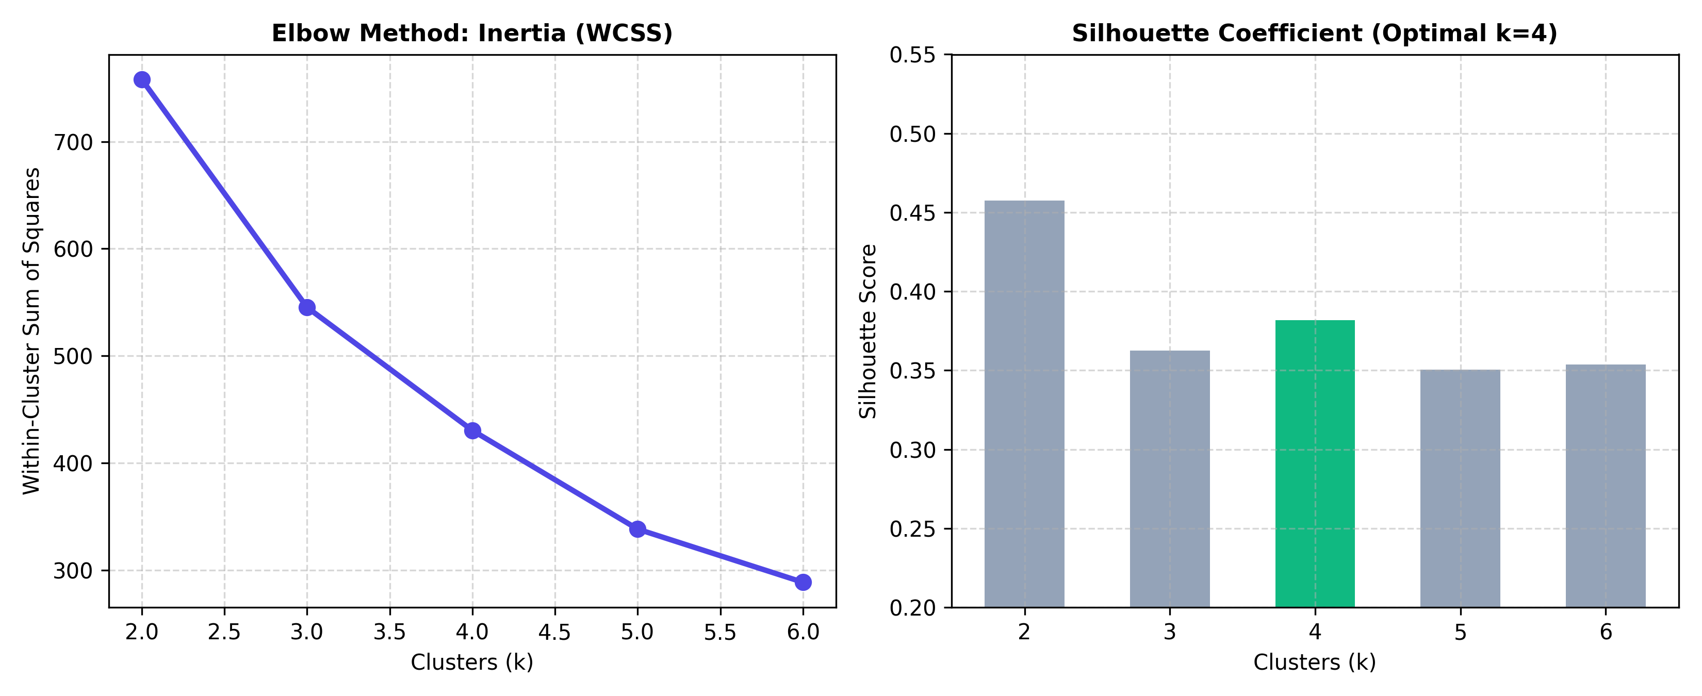
Figure 4.2: K-Means Inertia Elbow Curve & Silhouette Diagnostic Profile

Page 18
4.3 Steps of the execution Project and Navigation
The project pipeline is designed for fully automated reproduction from command-line execution to interactive web navigation.
4.3.1 Step-by-Step Project Execution Protocol
• Step 1 (Environment Setup): Activate the isolated Python virtual environment containing verified scientific dependencies.
source venv/bin/activate && pip install -r requirements.txt
• Step 2 (Data Ingestion & Event Simulation): Synthesizes realistic transactional event logs with Pareto spend skewness, guest checkouts, and cancellation codes.
python generate_dataset.py
• Step 3 (Pipeline Execution & Modeling): Executes clean_refinery_pipeline.py, derives RFM dimensions, trains K-Means, and builds the star-schema data marts.
python main.py
• Step 4 (Automated Quality Assurance): Executes automated unit and integration tests verifying schema typing, IQR capping, and cluster bounds.
pytest tests/ -v
• Step 5 (Interactive Dashboard Launch): Hosts the executive web dashboard on local port 8000 for client-side analytical exploration.
python -m http.server 8000 --directory dashboard/

Page 19
4.3.2 Interactive Dashboard Navigation Architecture
Upon navigating to http://localhost:8000, commercial decision-makers interact with four analytical workflows:
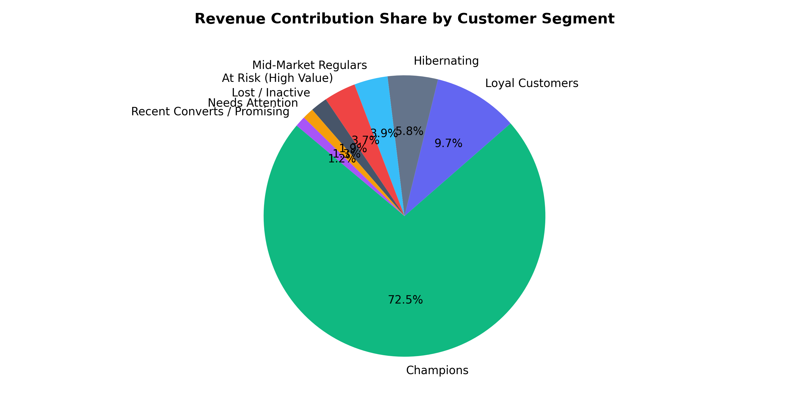
Figure 4.3: Segment Revenue Share Donut & Portfolio Distribution
1. Portfolio Health Inspection: Monitors top-level revenue ($65k), active accounts (256), and at-risk capital (7.3%). Clicking any KPI scorecard filters the global view.
2. Revenue Concentration Analysis: The donut chart displays revenue concentration across cohorts. Champions represent 72.5% of total spend, demonstrating commercial Pareto dependency.

Page 20
4.3.3 Multi-Dimensional Spatial Scatterplot & Cohort Drilldown
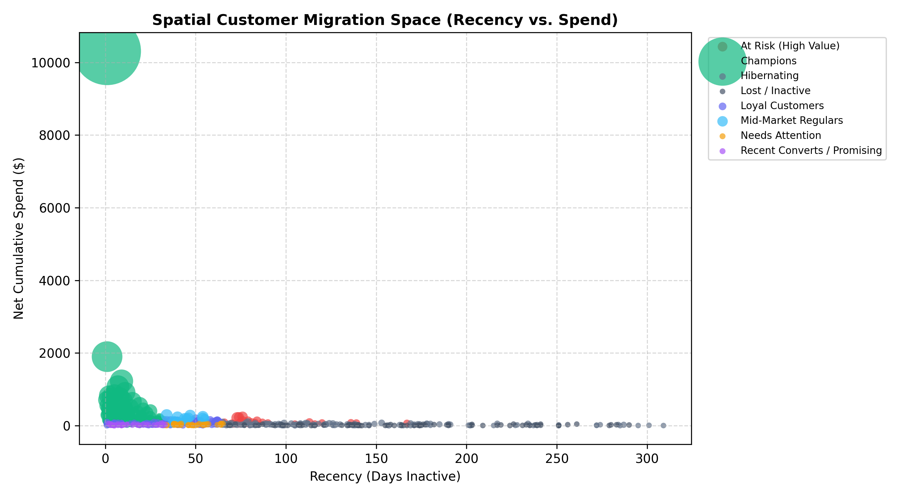
Figure 4.4: Multi-Dimensional Spatial RFM Bubble Scatterplot
3. Spatial Behavioral Mapping: Presents customer positions in 3D-projected space: Recency (X-axis), Spend (Y-axis), and Frequency (Bubble Radius). Hovering reveals customer key statistics.
4. Searchable Activation Ledger: Users type account IDs into the search bar, filter by operational cohort ('At Risk Whales'), and click 'Export CRM Audience' to download clean CSV payloads.
5. Reverse Logistics Audit Review: Auditors review quarantined return line items, verifying reason codes, customer keys, and reversed values.

Page 21
5. CONCLUSION:
5.1 Importance of the worked-out tasks
The engineering tasks delivered across the three progressive milestones resolve foundational operational vulnerabilities in digital commerce analytics:
1. Elimination of Analytical Distortion: By isolating cancellations into fact_reversals_audit.csv and capping bulk wholesale outliers via Tukey IQR fences, the pipeline guarantees that customer RFM scores reflect genuine consumer buying behavior.
2. Commercial Margin Optimization: Replacing untargeted mass discounting with 8 behavioral tiers protects gross profit margins while focusing acquisition budgets on high-value retention.
3. Enterprise Dimensional Governance: The star-schema dimensional mart allows commercial teams to query multi-dimensional customer features directly using SQL, Tableau, and Power BI with sub-second response times.
4. Seamless Operational Activation: Interactive executive scorecards and CSV activation lists bridge the gap between machine learning models and daily marketing campaigns.
5.2 Further Enhancement in future
• Strategic Enhancements: To build upon the verified platform, four future enhancements are scheduled for upcoming iterations:
1. Deep Learning CLV & Churn Forecasting: Implementing Recurrent Neural Networks (LSTM) and Transformer architectures to forecast lifetime value and churn probabilities.
2. Real-Time Streaming Ingestion: Migrating batch ingestion to Apache Kafka and Apache Spark Streaming for sub-second transaction processing.
3. Automated CRM Webhook Integrations: Building RESTful webhooks to dispatch targeted cohorts automatically into HubSpot, Salesforce Marketing Cloud, and Klaviyo.
4. Algorithmic Multi-Touch Attribution: Incorporating Shapley Value and Markov Chain attribution models to quantify marketing touchpoint impact across channels.

Page 22
6. REFERENCES:
6.1 Books, Research Papers, Experts persons, Technology, Webs, etc.
1. Hughes, A. M. (1994). Strategic Database Marketing: The Masterplan for Starting and Managing a Profitable, Customer-Based Marketing Program. McGraw-Hill Trade.
2. MacQueen, J. (1967). Some Methods for classification and Analysis of Multivariate Observations. Proceedings of the 5th Berkeley Symposium on Mathematical Statistics and Probability, 1(14), 281-297.
3. Rousseeuw, P. J. (1987). Silhouettes: A graphical aid to the interpretation and validation of cluster analysis. Journal of Computational and Applied Mathematics, 20, 53-65.
4. Tukey, J. W. (1977). Exploratory Data Analysis. Addison-Wesley Publishing Company.
5. Han, J., Kamber, M., & Pei, J. (2011). Data Mining: Concepts and Techniques (3rd ed.). Morgan Kaufmann Publishers.
6. McKinney, W. (2022). Python for Data Analysis: Data Wrangling with Pandas, NumPy, and Jupyter (3rd ed.). O'Reilly Media.
7. Géron, A. (2022). Hands-On Machine Learning with Scikit-Learn, Keras, and TensorFlow (3rd ed.). O'Reilly Media.
8. Scikit-Learn Documentation (2024). Clustering with K-Means & Silhouette Diagnostics. https://scikit-learn.org/stable/modules/clustering.html
9. Chart.js Documentation (2024). Open Source HTML5 Canvas Charting Engine. https://www.chartjs.org/docs/latest/
10. Tailwind CSS Documentation (2024). Utility-First CSS Framework for Rapid UI Development. https://tailwindcss.com/docs
PROJECT PROGRESS WORK EVALUATION SCHEDULE (THIRD PROGRESS)
Table 6.1: Project Progress Work Evaluation Schedule & Milestone Tracking
DATE | ASSESSMENT PARTICULARS | INDEX SECTIONS | MARKS | CURRENT STATUS
24/09/2026 | First Progress Work | 1.1, 1.2, 1.3, 2.1, 2.2 | 10 Marks | COMPLETED & VERIFIED
13/10/2026 | Mid-Term Exam (Second Progress) | 2.3, 2.4, 3.1, 4.1 | 20 Marks | COMPLETED & VERIFIED
27/10/2026 | Third Progress Work | 4.2, 4.3, 5.1, 5.2, 6.1 | 10 Marks | DEMONSTRATED (Current Submission)
06/11/2026 | Report Submission (Spiral Binding) | Final Signed Spiral Copy | 10 Marks | Scheduled for Final Submission
18-20/11/2026 | Final Exam (SEE) | Exam & Viva Voce | 50 Marks | Scheduled for Semester Examination

