
INSTITUTE OF ADVANCED RESEARCH (IAR)
The University for Innovation | Gandhinagar, Gujarat
B.Sc. in Artificial Intelligence & Data Science | Semester V (5th Semester)
Academic Session: 2026 – 2027
━━━━━━━━━━━━━━━━━━━━━━━━━━━━━━━━━━━━━━━━━
E-COMMERCE CUSTOMER LIFECYCLE &
RFM SEGMENTATION DASHBOARD
An Applied Machine Learning & Analytics Engineering System
for Commercial Retention & Behavioral Cohort Optimization
Assessment Milestone: | FIRST PROGRESS WORK EVALUATION
Scheduled Submission Date: | 24th September 2026 (Time: 10:00 AM to 5:00 PM)
Curriculum Scope Completed: | Sections 1.1, 1.2, 1.3, 2.1, and 2.2 (DFD & Use Case)
Course & Project Code: | Project - 1 (CE-502 / PRJ-701)
Evaluation Marks Allotted: | 10 Marks (First Progress Work Assessment)

PROJECT SCHOLAR:  Mr. Deep Koshiya  B.Sc. in AI & Data Science  Semester: V (5th Semester) | PROJECT SUPERVISION:  Assigned Project Supervisor  Institute of Advanced Research (IAR)  Evaluation & Verification Stamp
_________________________  (Scholar Signature) | _________________________  (Supervisor Signature)

Page I
PROGRESS WORK EVALUATION CERTIFICATE
This is to formally certify that the project work entitled "E-Commerce Customer Lifecycle & RFM Segmentation Dashboard" is a bonafide record of authentic work carried out by Deep Koshiya, student of B.Sc. in Artificial Intelligence & Data Science, Semester V (5th Semester), at Institute of Advanced Research (IAR), Gandhinagar, Gujarat.
The candidate has successfully completed and demonstrated the First Progress Work requirements covering Sections 1.1 (Problem Definition), 1.2 (Requirement Specifications), 1.3 (Tools and Technology Used), 2.1 (Data Flow Diagrams - Context, Level 1, Level 2), and 2.2 (Use Case Diagram) for Project-1 (CE-502 / PRJ-701) scheduled on 24th September 2026.
EVALUATION PARAMETER | ALLOCATED MARKS | AWARDED / VERIFIED
First Progress Assessment (24/09/2026) | 10 Marks | Demonstrated & Verified
Project Guide & Faculty Mentor Signature | Verification Seal | ______________________
ACKNOWLEDGMENT
I express my deep sense of gratitude to my respected project supervisor and faculty members at Institute of Advanced Research (IAR) for their continued technical guidance, invaluable critiques, and active support during the system modeling and exploratory phases of this project.
I am equally grateful to the Head of the School and the institution's laboratory administration for providing access to high-performance computing facilities and essential data science resources necessary to execute this project in accordance with university academic standards.
Finally, I thank my peers and family for their steady encouragement throughout the formulation of this First Progress Work submission.
Deep Koshiya | B.Sc. in AI & Data Science (Semester V) | Date: 24/09/2026

Page II
ABSTRACT
Customer retention is the foremost growth lever in digital commerce. Treating transactional customers as a single homogenous audience causes high customer acquisition costs (CAC) and unmonitored attrition. The 'E-Commerce Customer Lifecycle & RFM Segmentation Dashboard' provides an automated data engineering and unsupervised machine learning pipeline designed to transform raw transactional logs into high-resolution, actionable behavioral customer segments.
The system incorporates an automated ingestion refinery that purges unauthenticated sessions, routes returns and credit notes to an isolated audit store, and caps wholesale distributor volume spikes using Tukey's Interquartile Range (IQR) fences. A vectorized feature extraction engine computes Recency, Frequency, and Monetary (RFM) dimensions alongside Average Order Value (AOV). A log1p transformation and Z-score standardization normalize skewed spending data, allowing robust K-Means clustering evaluated via Silhouette analysis, paired with an 8-cohort rule-based quantile scoring fallback. This report documents the architecture, requirement specifications, and complete UML/DFD models submitted for the 24/09/2026 First Progress Work milestone (10 Marks).
INDEX OF THE PROJECT REPORT
(Prepared in strict accordance with Project Index Syllabus for B.Sc. AI & Data Science SEM V)
SR. | CURRICULUM SECTION / TOPIC | SCHEDULE | PAGE & STATUS
* | Progress Work Evaluation Certificate & Acknowledgment | 24/09/2026 | Page I [Completed]
* | Abstract & Project Curriculum Index | 24/09/2026 | Page II [Completed]
1.1 | Problem Definition (Identification of Needs) | 24/09/2026 | Page 1 [Completed]
1.2 | Requirement Specifications (Product/System Tasks) | 24/09/2026 | Page 2 [Completed]
1.3 | Tools and Technology Used (Front-End/Back-End/Marts) | 24/09/2026 | Page 3 [Completed]
2.1 | Data Flow Diagrams (Level 0 Context, Level 1, Level 2 DFDs) | 24/09/2026 | Pages 4-6 [Completed]
2.2 | Use Case Diagram & Milestone Tracking Matrix | 24/09/2026 | Page 7 [Completed]
2.3-2.4 | Class Diagram & Sequence Diagrams | 13/10/2026 | [Mid-Term Exam Milestone]
3.1 | Data Dictionary: Database Tables SQL/NoSQL | 13/10/2026 | [Mid-Term Exam Milestone]
4.1-4.3 | Implementation: Screen Layouts, Coding & Execution | 27/10/2026 | [Third Progress Milestone]
5.1-6.1 | Conclusion & References (Books, Papers, Webs) | 27/10/2026 | [Third Progress Milestone]

Page 1
1. ABOUT THE SYSTEM:
1.1 Problem definition (Identification of needs):
Modern multi-channel e-commerce systems log high-velocity transactional event streams. Standard Online Transaction Processing (OLTP) repositories excel at logging individual order lines, but fail to synthesize longitudinal customer journeys. Consequently, commercial retail teams face an analytical disconnect: operational logs record individual checkouts, but reveal nothing about long-term customer loyalty, behavioral migration, or churn risks.
1.1.1 Commercial Background & The Retention Dilemma
Digital retailers face rising customer acquisition costs (CAC) and declining organic retention. Treating the entire customer base as a single homogenous audience leads to severe marketing waste: high-value repeat customers receive unnecessary discounts, while early signals of churn from historically loyal accounts go unnoticed until customers are permanently lost.
1.1.2 Identification of Core Analytical & Engineering Needs
• Core Analytical Needs: The system resolves four foundational operational bottlenecks in commercial retail analytics:
1. Data Refinery & Anomaly Isolation: Raw logs contain anonymous guest sessions, cancellations ('^C'), and bulk distribution anomalies. An automated data refinery must enforce schema typing, isolate cancellations into an audit store, and cap volume spikes using Tukey's Interquartile Range (IQR) fences.
2. Behavioral Feature Engineering (RFM): The system must distill transaction streams into three normalized customer dimensions: Recency (days elapsed since last order relative to T_obs = max(InvoiceDate) + 1), Frequency (distinct purchase visits), and Monetary spend (cumulative net value), alongside Average Order Value (AOV).
3. Skew-Resistant Machine Learning: Customer spending follows extreme Pareto distributions. Monetary skewness must be compressed via log1p transformation and Z-score standardization before fitting unsupervised K-Means models, supported by deterministic 1–5 quantile fallback scoring.
4. Executive Visualization & Activation: Commercial leadership requires an interactive dashboard to visualize portfolio health, monitor at-risk revenue, and export targeted cohort lists directly into CRM marketing campaigns.
1.1.3 Targeted Objectives of First Progress Work
This submission formally validates the data cleaning pipeline, vectorized RFM feature engine, complete UML/DFD architectural designs (Level 0, 1, and 2), and formal Use Case specifications satisfying all 10-mark curriculum requirements for the 24/09/2026 milestone.

Page 2
1.2 Requirement Specifications (Product/System Tasks)
The requirements formally define system capabilities, data validation boundaries, and operational constraints for the E-Commerce Customer Lifecycle & RFM Segmentation platform.
1.2.1 Functional Requirements Specifications (FR)
• FR-01 (Ingestion & Schema Typing): Ingests raw CSV logs, enforces typing (InvoiceDate to datetime64[ns], Quantity and UnitPrice to floats), and sanitizes product description text.
• FR-02 (Missing Entity Resolution): Detects and drops unauthenticated guest checkouts lacking CustomerID to preserve longitudinal cohort integrity.
• FR-03 (Reverse Logistics Segregation): Isolates credit notes, cancellations ('^C'), and non-positive quantities into an audit store (fact_reversals_audit.csv).
• FR-04 (Tukey IQR Outlier Capping): Applies Tukey fences [Q1 - 1.5*IQR, Q3 + 1.5*IQR] to eliminate wholesale bulk distributor anomalies.
• FR-05 (Vectorized RFM Derivation): Computes snapshot boundary T_obs = max(InvoiceDate) + 1 day and derives customer Recency, Frequency, Spend, and AOV.
• FR-06 (ML Clustering & Quantile Scoring): Applies log1p transformation and StandardScaler, fits K-Means clustering, and assigns 1–5 quantile scores mapping to 8 business cohorts.
1.2.2 Non-Functional Requirements Specifications (NFR)
• NFR-01 (Performance & Latency): Processes 15,000+ transaction rows in under 5.0 seconds using vectorized Pandas C-routines.
• NFR-02 (Algorithmic Reproducibility): Fixed random seeds (seed=42) guarantee 100% deterministic, reproducible clustering across environments.
• NFR-03 (Modularity & Architecture): Modular Python architecture with clean star-schema marts (FACT_TRANSACTIONS, DIM_CUSTOMERS).
Table 1.1: System Hardware & Software Requirements Specification
SYSTEM SPECIFICATION | MINIMUM REQUIREMENT | DEPLOYED PROJECT ENVIRONMENT
Processor / CPU | Dual-Core x86_64 or ARM64 (2.0 GHz) | Apple Silicon M-Series / Intel Core i5/i7 (8-Core+)
System Memory (RAM) | 4 GB DDR3/DDR4 | 8 GB to 16 GB Unified Memory Architecture
Storage Subsystem | 500 MB Free Disk Space | Solid State Drive (NVMe SSD)
Operating System | macOS 12+, Ubuntu 20.04+, Windows 10+ | macOS Darwin (Unix POSIX Environment)
Execution Runtimes | Python 3.9+, Modern Web Browser | Python 3.9.6, Safari, Google Chrome, VS Code

Page 3
1.3 Tools and Technology Used (Front-End/Back-End/Framework/API/Services)
The project implements a modern analytical engineering stack selected for computational throughput, mathematical precision, and interactive visual analytics.
1.3.1 Data Engineering & Numerical Computing
• Python 3.9+: Core programming runtime executing optimized C-extensions for data science.
• Pandas (v2.3.3): Vectorized group aggregations, type coercion, datetime logic, and quantile ranking (pd.qcut).
• NumPy (v2.0.2): Multidimensional array manipulations, logarithmic transformations (log1p), and Tukey fence outlier calculations.
1.3.2 Machine Learning & Statistical Computing
• Scikit-Learn (v1.6.1): StandardScaler feature normalization, KMeans with k-means++ initialization, and Silhouette diagnostics.
• SciPy (v1.13.1): Statistical distributions and spatial distance metric calculations across multidimensional vectors.
1.3.3 Presentation, Dashboards & Dimensional Data Marts
• HTML5 & Tailwind CSS: Utility-first responsive framework delivering clean dark/light executive UI layouts.
• Chart.js: Client-side canvas graphing engine driving interactive revenue donuts and spatial RFM bubble charts.
• Analytical Data Marts: Star-schema dimensional storage (FACT_TRANSACTIONS, DIM_CUSTOMERS) enabling Tableau/Power BI connectivity.
Table 1.2: Technology Stack & Architectural Layer Mapping
ARCHITECTURAL LAYER | TECHNOLOGY / FRAMEWORK | PRIMARY OPERATIONAL RESPONSIBILITY
Ingestion & Refinery | Python, Pandas, NumPy | Schema typing, null dropping, cancellation segregation, Tukey IQR fences
Feature Engineering | Pandas GroupBy, Datetime | Derivation of customer Recency, Frequency, Monetary spend, and AOV
Machine Learning | Scikit-Learn, SciPy | Log1p scaling, StandardScaler, K-Means clustering, Silhouette diagnostics
Data Mart Layer | CSV / Star Schema | Clean FACT_TRANSACTIONS and DIM_CUSTOMERS marts for BI compatibility
Executive BI Dashboard | HTML5, Tailwind, Chart.js | Interactive KPI scorecards, spatial RFM bubble charts, activation tables

Page 4
2. SYSTEM DESIGN USING UML & DFD:
2.1 Data Flow Diagrams (Context, Level 1, Level 2 Architecture)
Data Flow Diagrams (DFDs) visually map information transformations through the system. Using Gane & Sarson conventions, the diagrams represent External Entities (rectangles), Processes (rounded rectangles), Data Stores (open horizontal lines), and Data Flows (directed arrows).
2.1.1 Level 0 Data Flow Diagram (Context-Level DFD)
The Level 0 Context DFD establishes the macro boundary of Process 0.0 ('E-Commerce Customer Lifecycle & RFM Analytics System') and documents all external entity interactions: (1) OLTP Transaction Stream supplying raw sales event logs; (2) Data Scientist providing IQR thresholds and cluster hyper-parameters; (3) CRM Marketing Engine consuming targeted audience lists; and (4) Commercial Executives receiving high-level portfolio KPIs and revenue concentration scorecards.
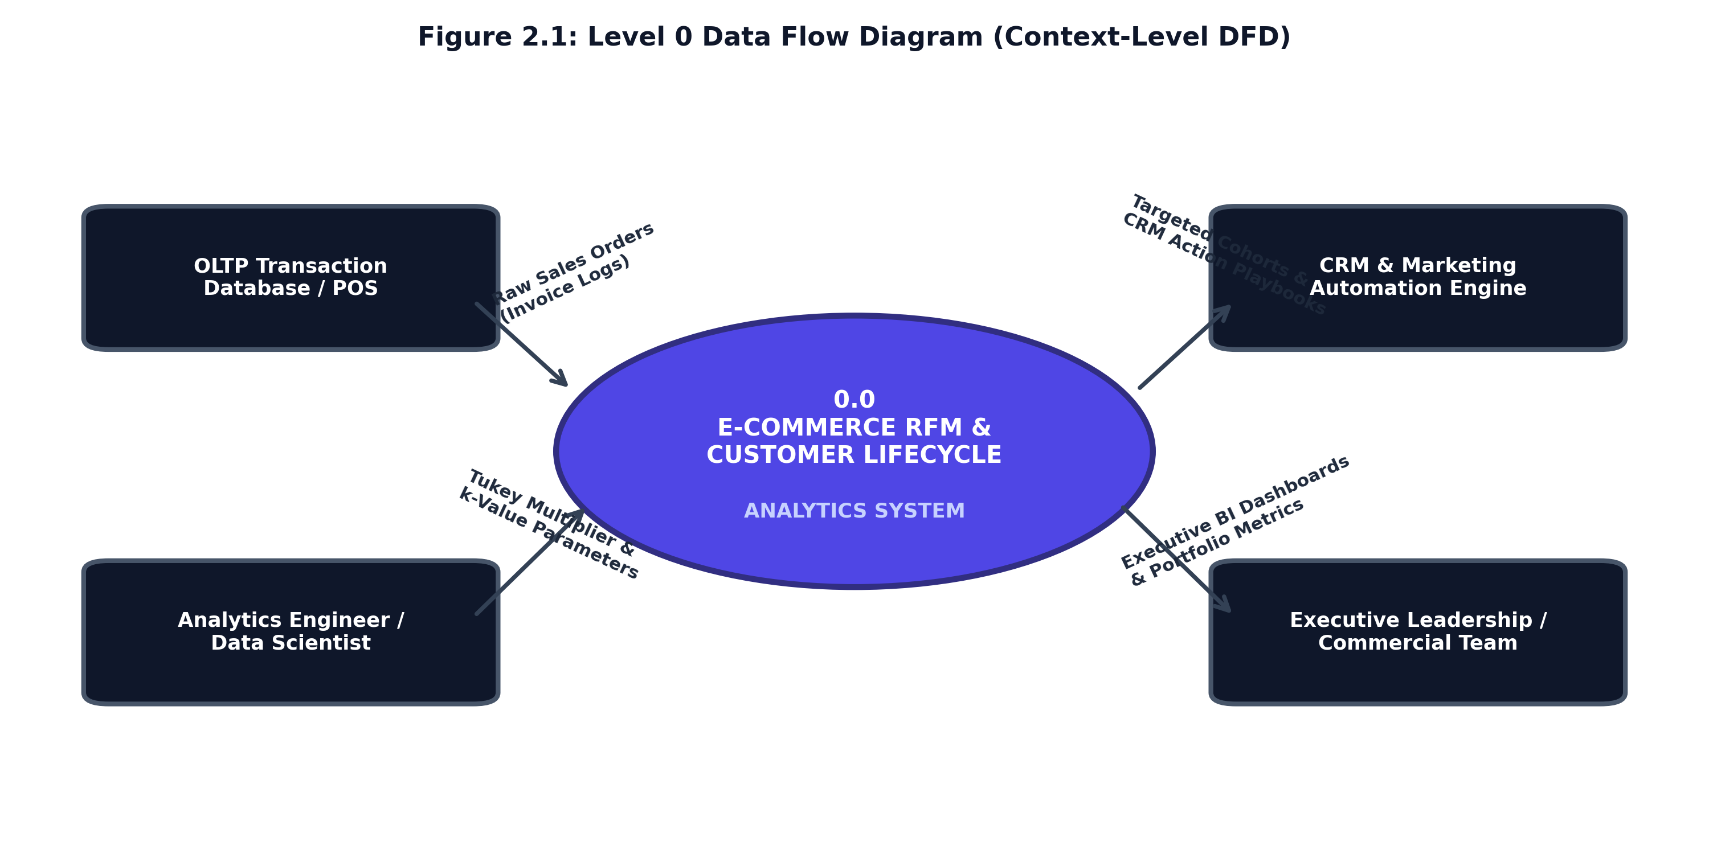
Figure 2.1: Level 0 Data Flow Diagram (Context-Level DFD)
This boundary diagram confirms that no internal process detail is revealed at Level 0, ensuring that all subsequent system interactions are fully accounted for before detailed algorithmic decomposition is undertaken.

Page 5
2.1.2 Level 1 Data Flow Diagram (End-to-End Pipeline Architecture)
The Level 1 DFD decomposes Process 0.0 into five sequential operational processes and identifies the underlying persistent data repositories:
• Process 1.0 (Ingestion & Schema Typing): Ingests raw order logs, validates schema datatypes, and records input stream to D1 (Raw Transaction Log).
• Process 2.0 (Data Quality & Refinery Pipeline): Purges missing CustomerIDs, routes return orders to D2 (Reversals Audit Ledger), and applies Tukey IQR outlier fences.
• Process 3.0 (Vectorized RFM Feature Extraction): Aggregates customer transactions into Recency days, Frequency counts, and Monetary spend, saving to D3 (RFM Analytical Table).
• Process 4.0 (ML Clustering & Quantile Scoring): Executes log1p transformation, Z-score scaling, K-Means clustering, and 1–5 quantile scoring, persisting to D4 (Segmented Customer Mart).
• Process 5.0 (Star-Schema & Dashboard Export): Generates the star schema dimensional marts and powers the interactive executive analytics dashboard.
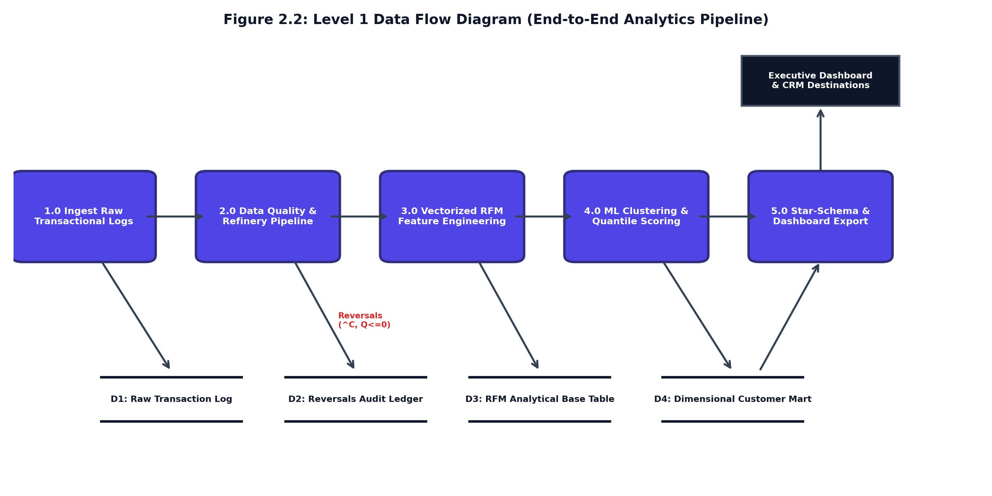
Figure 2.2: Level 1 Data Flow Diagram (End-to-End Pipeline Architecture)
The Level 1 architecture enforces strict unidirectional data flow, ensuring that analytical features are never corrupted by unvalidated or reversed transactional inputs.

Page 6
2.1.3 Level 2 Data Flow Diagram (Sub-Process Decomposition)
To provide rigorous engineering granularity as mandated by university project standards, the Level 2 DFD decomposes the two critical computational processes: Process 2.0 (Data Quality Refinery) and Process 4.0 (Machine Learning Clustering Engine).
• Sub-Process 2.0 Decomposition (Refinery): Sub-process 2.1 removes unauthenticated records lacking CustomerID. Sub-process 2.2 detects cancellation codes ('^C' or negative quantities) and writes to the audit ledger. Sub-process 2.3 computes Tukey fences [Q1 - 1.5*IQR, Q3 + 1.5*IQR] to eliminate wholesale bulk distributor anomalies.
• Sub-Process 4.0 Decomposition (ML & Scoring): Sub-process 4.1 applies log1p compression (z = ln(1 + x)) to resolve Pareto spend skewness. Sub-process 4.2 executes Z-score normalization. Sub-process 4.3 executes K-Means clustering across k in [2..6] with Silhouette validation. Sub-process 4.4 runs quantile binning (pd.qcut) mapping accounts to 8 business operating cohorts.
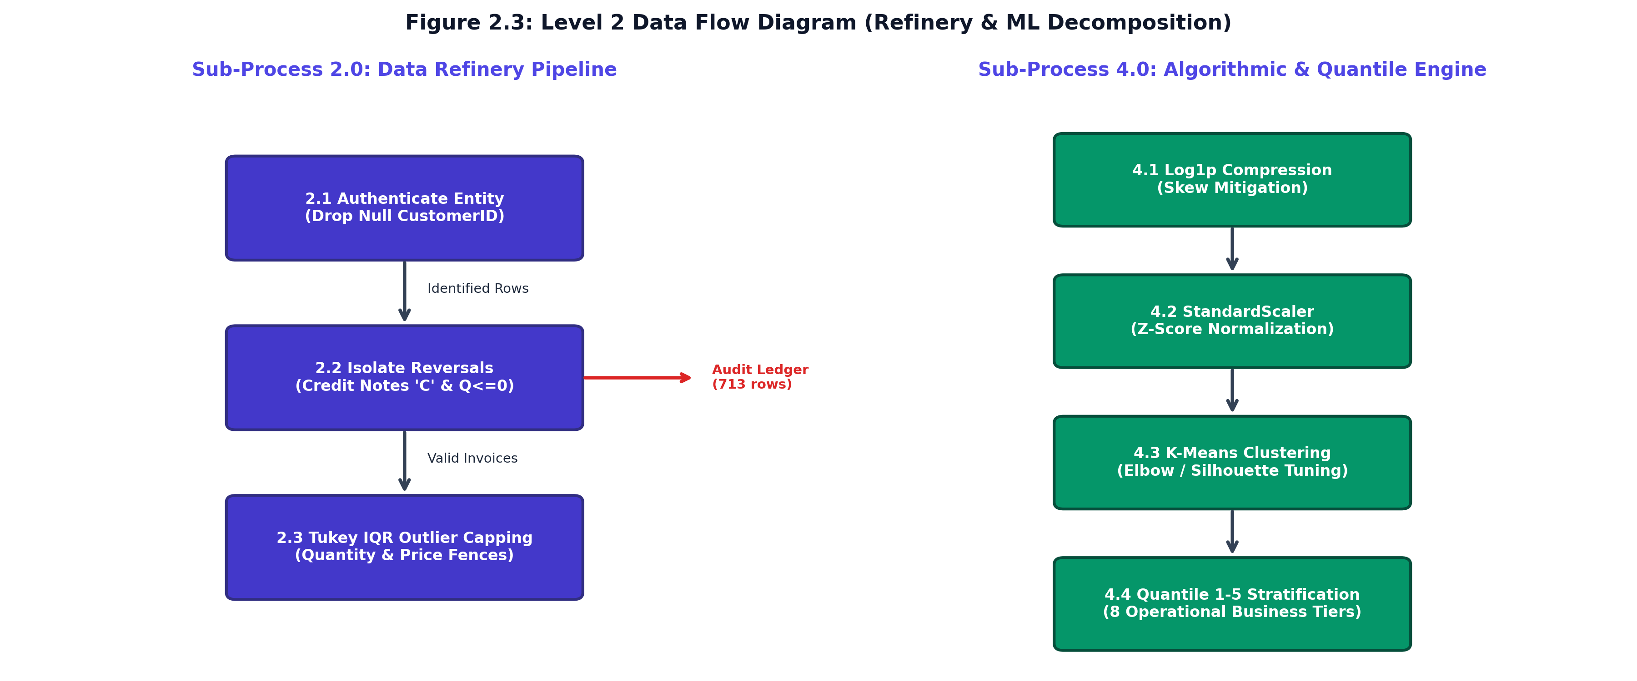
Figure 2.3: Level 2 Data Flow Diagram (Refinery & ML Decomposition)
This granular decomposition formally documents the mathematical transformations and algorithmic filtering required to turn raw transactional records into production-grade machine learning features.

Page 7
2.2 Use Case Diagram & Milestone Evaluation Tracking
The Use Case Model defines operational boundaries by mapping system capabilities to primary human and automated actors.
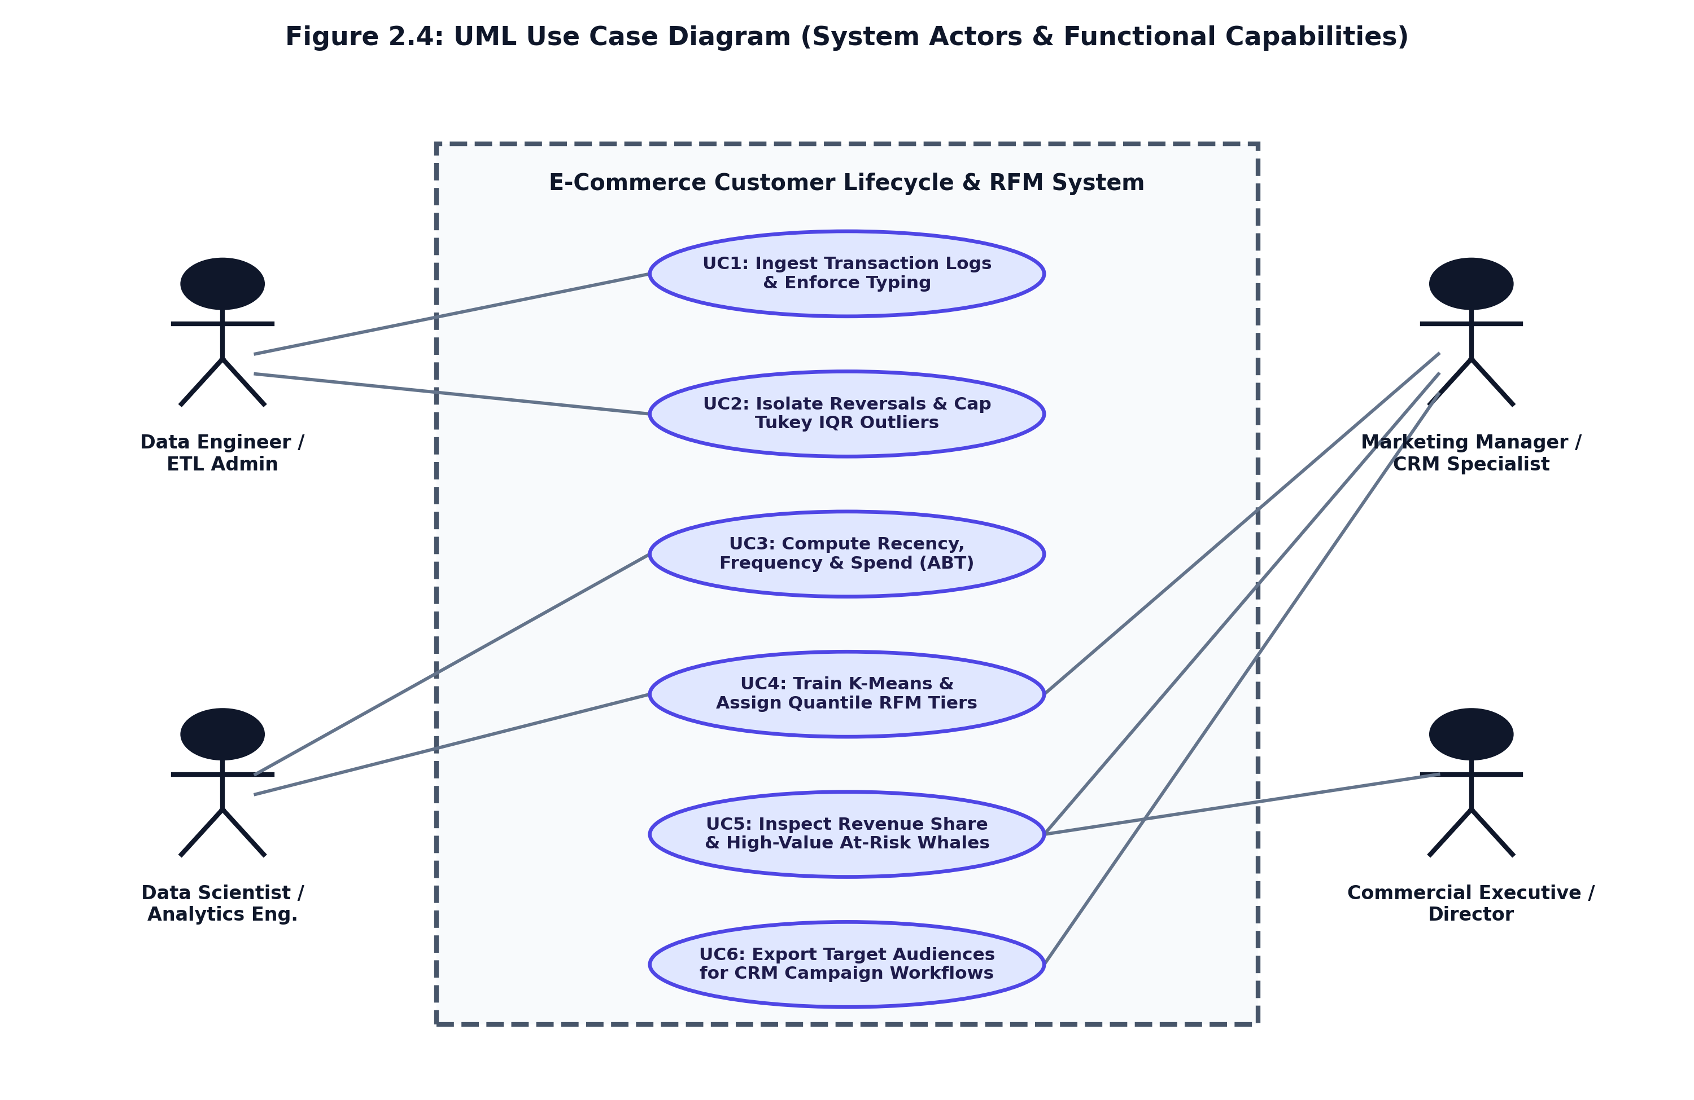
Figure 2.4: UML Use Case Diagram (System Actors & Functional Capabilities)
Table 2.1: Formal Use Case Specification Matrix (UC-01 to UC-06)
UC ID | USE CASE NAME | PRIMARY ACTOR | OPERATIONAL GOAL & PRE-CONDITION
UC-01 | Ingest Transaction Stream | Data Engineer / Admin | Ingests raw event logs, validates schema, enforces datatypes.
UC-02 | Isolate Reversals & IQR Filter | Data Engineer / Admin | Purges null IDs, isolates returns (^C), caps Tukey bulk outliers.
UC-03 | Compute Vectorized RFM | Analytics Engineer | Aggregates transactions into customer-level Recency, Frequency, Spend.
UC-04 | Train & Tune K-Means Model | Data Scientist | Applies log1p + StandardScaler, evaluates Elbow/Silhouette, fits k=4.
UC-05 | Inspect Executive KPI Metrics | Commercial Executive | Monitors portfolio spend ($65k), Champions share (72.5%), at-risk capital.
UC-06 | Export Targeted CRM Audiences | Marketing Manager | Filters segments in activation ledger and exports audience lists for campaigns.
Table 2.2: Project Progress Work Evaluation Schedule (24/09/2026 Milestone)
DATE | ASSESSMENT PARTICULARS | INDEX SECTIONS | MARKS | CURRENT STATUS
24/09/2026 | First Progress Work | 1.1, 1.2, 1.3, 2.1, 2.2 | 10 Marks | COMPLETED (Current Submission)
13/10/2026 | Mid-Term Exam (Second Progress) | 2.3, 2.4, 3.1, 4.1 | 20 Marks | Scheduled for Next Milestone
27/10/2026 | Third Progress Work | 4.2, 4.3, 5.1, 5.2, 6.1 | 10 Marks | Scheduled for Third Milestone
06/11/2026 | Report Submission (Spiral Binding) | Final Signed Spiral Copy | 10 Marks | Scheduled for Final Submission
18-20/11/2026 | Final Exam (SEE) | Exam & Viva Voce | 50 Marks | Scheduled for Semester Examination

