
DEPARTMENT OF ARTIFICIAL INTELLIGENCE & DATA SCIENCE
B.Sc. in Artificial Intelligence & Data Science | Semester V (5th Sem)
Academic Session: 2026 – 2027
━━━━━━━━━━━━━━━━━━━━━━━━━━━━━━━━━━━━━━━━━
E-COMMERCE CUSTOMER LIFECYCLE &
RFM SEGMENTATION DASHBOARD
An Applied Machine Learning & Analytics Engineering System
for Commercial Retention & Behavioral Cohort Optimization
Assessment Milestone: | FIRST PROGRESS WORK EVALUATION
Scheduled Submission Date: | 24th September 2026 (10:00 AM – 5:00 PM)
Target Work Completed: | Sections 1.1, 1.2, 1.3, 2.1, and 2.2 (DFD & Use Case)
Course & Project Code: | Project - 1 (CE-502 / PRJ-701)
Allotted Assessment Marks: | 10 Marks (First Progress Work)

SUBMITTED BY:  Mr. Deep Koshiya  B.Sc. AI and Data Science  Semester: V (5th Semester) | SUPERVISED & VERIFIED BY:  Project Supervisor  Department of AI & Data Science  Institute of Advanced Research (IAR)
_________________________  (Signature of Scholar) | _________________________  (Signature of Supervisor)

Page I - II
ACKNOWLEDGMENT
I express my sincere gratitude to my assigned project supervisor and the esteemed faculty members of the Department of Artificial Intelligence & Data Science at the Institute of Advanced Research (IAR) for their invaluable guidance, encouragement, and insightful feedback throughout the problem identification and system design phases of this project.
I also thank the Project Coordinator and the Head of the School for facilitating the computational lab environment and resources necessary to execute Project-1 (PRJ-701 / CE-502) in accordance with the prescribed university schedule.
This First Progress Work report, submitted on 24/09/2026, encompasses the foundational requirements, data engineering pipeline architecture, and complete UML/DFD models (Sections 1.1, 1.2, 1.3, 2.1, and 2.2). I remain dedicated to incorporating all supervisory feedback for the upcoming Mid-Term evaluation.
Deep Koshiya | B.Sc. AI and Data Science (Semester V) | Date: 24th September 2026
ABSTRACT
In modern multi-channel retail, treating an entire customer base as a homogenous entity leads to suboptimal marketing spend, inflated Customer Acquisition Costs (CAC), and customer churn blindspots. The 'E-Commerce Customer Lifecycle & RFM Segmentation Dashboard' resolves these commercial challenges through an end-to-end applied machine learning and analytics engineering pipeline.
The automated pipeline ingests raw transaction event logs, enforces schema validation, isolates unauthenticated sessions, segregates reverse logistics (credit notes and cancellations) into an audit ledger, and neutralizes bulk B2B distribution anomalies using Tukey's Interquartile Range (IQR) fences. A vectorized feature engineering engine computes customer-level Recency, Frequency, and Monetary (RFM) dimensions alongside Average Order Value (AOV). Features undergo log1p compression and Z-score standardization to alleviate Pareto spend skewness, enabling robust K-Means clustering evaluated via Elbow and Silhouette diagnostics. Concurrently, a rule-based quantile stratification engine (pd.qcut) computes deterministic 1–5 behavioral tiers mapping customers into 8 actionable cohorts (such as 'Champions', 'Loyal Customers', and 'At Risk Whales').
This First Progress Work report documents the system foundation and software engineering design for the 24/09/2026 milestone at Institute of Advanced Research (IAR). It presents complete Level-0, Level-1, and Level-2 Data Flow Diagrams (DFDs) alongside a comprehensive Use Case Model and specification matrix, fulfilling all requirements for the first 10-mark evaluation.

Page VI - VIII
INDEX OF THE PROJECT REPORT
(Structured strictly according to Syllabus Guidelines for B.Sc. AI and Data Science SEM V)
SR. NO. | CONTENTS / TOPIC | STATUS & PAGE
* | Acknowledgment | Page I
* | Abstract | Page II
* | Index of the Project Report, List of Figures & Tables | Page VI - VIII
1 | ABOUT THE SYSTEM: | Page 1
1.1 | Problem definition (Identification of needs) | [Completed 24/09] Page 1
1.2 | Requirement Specifications (Product/System Tasks) | [Completed 24/09] Page 2
1.3 | Tools and Technology Used (Front-End/Back-End/Framework) | [Completed 24/09] Page 3
2 | SYSTEM DESIGN USING UML: | Page 4
2.1 | Data Flow Diagrams (Level 0 Context, Level 1, Level 2 DFDs) | [Completed 24/09] Page 4
2.2 | Use Case Diagram & Actor Specifications | [Completed 24/09] Page 7
2.3 | Class Diagram | [Scheduled 13/10 Mid-Term]
2.4 | Sequence Diagrams | [Scheduled 13/10 Mid-Term]
3 | DATA DICTIONARY: (Database Tables SQL/NoSQL) | [Scheduled 13/10 Mid-Term]
4 | IMPLEMENTATION: (Screen Layouts, Coding, Navigation) | [Scheduled 13/10 & 27/10]
5 | CONCLUSION: (Importance of Worked Tasks, Future Scope) | [Scheduled 27/10 Third Progress]
6 | REFERENCES: (Books, Papers, Technology, Webs) | [Scheduled 27/10 Third Progress]
LIST OF FIGURES & TABLES (Progress Work - 1)
Figure 2.1: Level 0 Context DFD (Context Diagram) ................................................................ Page 4
Figure 2.2: Level 1 Data Flow Diagram (Pipeline Architecture) ............................................. Page 5
Figure 2.3: Level 2 Data Flow Diagram (Refinery & ML Decomposition) ................................ Page 6
Figure 2.4: UML Use Case Diagram (System Actors & Capabilities) ....................................... Page 7
Table 1.1: System & Hardware/Software Specifications ........................................................... Page 2
Table 1.2: Technology Stack & Architectural Layer Mapping ..................................................... Page 3
Table 2.1: Formal Use Case Specification Matrix (UC-01 to UC-06) ........................................ Page 7
Table 2.2: Project Progress Work Evaluation & Milestone Tracking .......................................... Page 7

Page 1
1. ABOUT THE SYSTEM:
1.1 Problem definition (Identification of needs):
Modern digital commerce platforms generate continuous transactional event streams across mobile apps, online web checkouts, and physical POS gateways. Relational Online Transaction Processing (OLTP) repositories effectively record line-item orders; however, they inherently track individual checkouts rather than longitudinal customer relationships. Without an analytics engineering framework that transforms low-level orders into customer-centric behavioral dimensions, commercial leadership operates with severe blindspots.
1.1.1 Industry Background & Domain Challenges
E-commerce organizations face escalating paid Customer Acquisition Costs (CAC) across digital ad networks alongside declining organic retention rates. Treating an entire customer portfolio as a monolith leads to severe resource misallocations: high-value repeat shoppers receive unnecessary margin-diluting discount coupons, while early churn-risk signals from historically loyal accounts are overlooked until permanent dormancy occurs.
1.1.2 Identification of Operational & System Needs
• Core Needs: The system addresses four primary operational requirements identified in enterprise retail analytics:
1. Automated Data Cleaning & Outlier Isolation: Raw transactional feeds contain anonymous guest checkouts (missing CustomerID), cancelled invoices (prefixed with 'C'), zero-priced administrative adjustments, and extreme B2B bulk orders (e.g., 1,500 units). An automated filter applying Tukey's Interquartile Range (IQR) fences is required to isolate anomalies without compromising retail consumer behavioral patterns.
2. Granular Behavioral Metric Derivation (RFM): The system must condense disparate orders into normalized behavioral dimensions: Recency (days elapsed since last transaction relative to a fixed operational boundary T_obs = max(InvoiceDate) + 1 day), Frequency (distinct checkout visits via nunique), and Monetary spend (net cumulative spend).
3. Skew-Resistant Algorithmic Clustering: Consumer spend follows a Pareto distribution (extreme positive skew). Euclidean distance-based clustering fails on raw values because monetary variance completely dominates frequency and recency. Log1p compression and Z-score standardization are required prior to K-Means modeling, coupled with a deterministic 1–5 quantile fallback scoring engine.
4. Strategic BI Visualization & Activation: Executives and marketing teams require an interactive BI interface that visualizes portfolio health, highlights at-risk capital, and exports actionable customer cohorts linked to distinct CRM retention playbooks.
1.1.3 Project Scope & Targeted Objectives
The project delivers a production-grade analytics system bridging raw OLTP logs and strategic decision-making. Deliverables encompass an automated Python refinery pipeline, vectorized RFM engine, unsupervised K-Means clustering, star-schema data marts (FACT_TRANSACTIONS, FACT_REVERSALS, DIM_CUSTOMERS), and an interactive executive web dashboard.

Page 2
1.2 Requirement Specifications (Product/System Tasks)
The requirement specifications formally define the operational tasks, behavioral functions, and system performance standards for the E-Commerce Customer Lifecycle & RFM Segmentation system.
1.2.1 Functional Requirements Specifications (FR)
• FR-01: Ingestion & Schema Enforcement: Must ingest raw CSV transactional records, enforce typing (InvoiceNo string, InvoiceDate datetime64[ns], UnitPrice and Quantity float64), and standardize SKU text strings.
• FR-02: Missing Entity Resolution: Must identify records lacking authenticated CustomerID and drop them to prevent corrupting customer-level longitudinal cohorts.
• FR-03: Reverse Logistics Isolation: Must segregate credit notes, cancellations (invoices matching '^C'), and non-positive quantities into an audit ledger (fact_reversals_audit.csv) without affecting positive frequency metrics.
• FR-04: Tukey IQR Outlier Capping: Must compute Tukey's fences (IQR = Q3 - Q1) across Quantity and UnitPrice to remove bulk B2B anomalies.
• FR-05: Vectorized RFM Derivation: Must set T_obs = max(InvoiceDate) + 1 day and compute Recency days, Frequency (unique invoices), Monetary spend, and Average Order Value (AOV = Spend / Frequency).
• FR-06: ML Clustering & Diagnostics: Must apply log1p skew reduction, StandardScaler standardization, evaluate Elbow Inertia and Silhouette scores across k in [2..6], and fit production K-Means.
• FR-07: Quantile RFM Scoring: Must provide fallback 1–5 percentile scoring (pd.qcut) mapping accounts to 8 business segments ('Champions', 'Loyal Customers', 'At Risk Whales', etc.).
• FR-08: Star Schema & Dashboard: Must export clean star-schema tables and render an interactive executive dashboard with KPI scorecards, spatial scatterplots, and a searchable activation ledger.
1.2.2 Non-Functional Requirements Specifications (NFR)
• NFR-01: Performance & Latency: The pipeline must process 15,000+ transactional records in under 5 seconds on standard x86/ARM hardware.
• NFR-02: Scalability: All feature calculations must maintain linear O(N) complexity using vectorized Pandas/NumPy C-routines.
• NFR-03: Reproducibility: Fixed random seeds (random_state=42) ensure deterministic clustering across distributed environments.
Table 1.1: System & Hardware/Software Specifications
SYSTEM CATEGORY | MINIMUM REQUIREMENT | DEPLOYED SPECIFICATION
Processor / CPU | Dual-Core x86_64 or ARM64 | Apple Silicon M-Series / Intel Core i5/i7 (8-Core+)
System Memory (RAM) | 4 GB DDR3/DDR4 | 8 GB to 16 GB Unified Memory
Storage Subsystem | 500 MB Free Disk Space | NVMe Solid State Drive (SSD)
Operating System | macOS 12+, Ubuntu 20.04+, Windows 10+ | macOS Darwin (Unix Environment)
Runtime Environment | Python 3.9+, Modern Web Browser | Python 3.9.6, Safari, Google Chrome, VS Code

Page 3
1.3 Tools and Technology Used (Front-End/Back-End/Framework/Protocol/API/Services/App. etc.)
The project architecture integrates an enterprise-ready analytical engineering stack. Each technology component has been chosen to maximize processing throughput, algorithmic precision, and visual interactivity.
1.3.1 Core Processing & Numerical Computing
• Python 3.9+: Primary runtime environment offering native execution of optimized C-extensions for data science.
• Pandas (v2.3.3): High-performance data structures executing vectorized group aggregations, type coercion, datetime logic, and quantile ranking (pd.qcut).
• NumPy (v2.0.2): Vectorized numerical array operations, logarithmic transformations (log1p), and Tukey fence computations.
1.3.2 Machine Learning & Statistical Modeling
• Scikit-Learn (v1.6.1): Implements StandardScaler for Z-score normalization, KMeans with k-means++ initialization, and silhouette_score for cluster quality validation.
• SciPy (v1.13.1): Provides statistical functions supporting spatial distance evaluations and distribution analysis.
1.3.3 Presentation, Dashboards & Storage
• HTML5 & Tailwind CSS: Utility-first styling framework providing responsive dark-mode executive UI layouts.
• Chart.js: Interactive charting engine rendering segment revenue donuts, spatial scatterplots, and diagnostic curves.
• Star-Schema BI Marts: Data marts formatted as a star schema (fact table linked to customer dimension) for native Tableau/Power BI integration.
• Engineering Tooling: Git for version control, GitHub for cloud repository hosting, and python-docx for automated report generation.
Table 1.2: Technology Stack & Architectural Layer Mapping
SYSTEM LAYER | TECHNOLOGY / FRAMEWORK | PRIMARY OPERATIONAL TASK
Data Refinery Pipeline | Python, Pandas, NumPy | Schema typing, null dropping, reversal isolation, IQR outlier capping
Feature Engineering | Pandas GroupBy, Datetime | Vectorized derivation of Recency, Frequency, Monetary, and AOV
Machine Learning | Scikit-Learn, SciPy | Log1p transformation, StandardScaler, K-Means clustering, Silhouette score
Data Mart Layer | CSV / Parquet Data Marts | Star-schema fact & dimension tables for BI compatibility
Executive BI Dashboard | HTML5, Tailwind CSS, Chart.js | Interactive KPI cards, spatial bubble plot, searchable activation grid

Page 4
2. SYSTEM DESIGN USING UML:
2.1 Data Flow Diagrams (1 Level DFD, 2 Level DFD must).
Data Flow Diagrams (DFDs) provide a graphical representation of information flow across the system, modeling processes, external entities, data stores, and directional data pathways following Gane & Sarson conventions:
• Notation Standards: External Entities (Rectangles), Processes (Rounded Rectangles/Circles), Data Stores (Open Horizontal Lines), and Data Flows (Directed Arrows).
2.1.1 Level 0 Data Flow Diagram (Context-Level DFD)
The Level 0 Context DFD defines the global operational boundary of Process 0.0 ('E-Commerce Customer Lifecycle & RFM Analytics System') interacting with four external entities: (1) OLTP Transaction Stream supplying sales logs; (2) Data Scientist supplying IQR tuning parameters; (3) CRM Marketing Engine consuming targeted segments; and (4) Commercial Executive team receiving portfolio KPI scorecards.
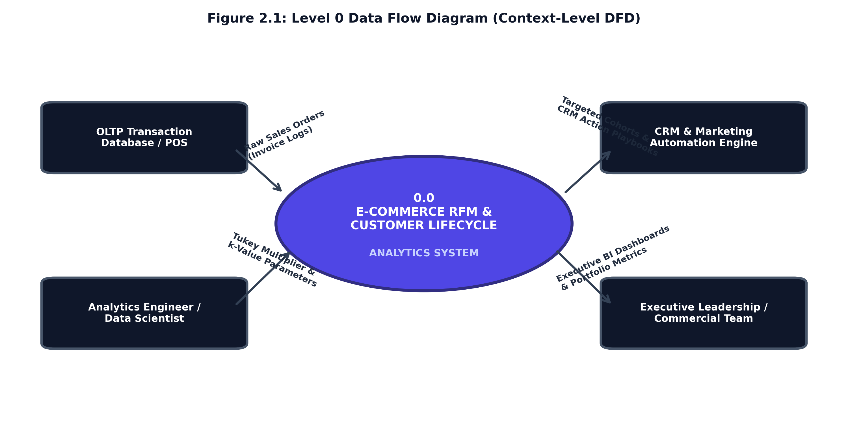
Figure 2.1: Level 0 Data Flow Diagram (Context-Level DFD)

Page 5
2.1.2 Level 1 Data Flow Diagram (End-to-End Pipeline Architecture)
The Level 1 DFD decomposes the system into five primary sequential operational processes and identifies the underlying persistent data stores:
• Process 1.0 (Ingestion & Schema Typing): Ingests raw orders, validates data types, and logs records to D1 (Raw Transaction Log).
• Process 2.0 (Data Quality & Refinery Pipeline): Purges missing CustomerIDs, routes credit notes and cancellations to D2 (Reversals Audit Ledger), and applies Tukey IQR fences on Quantity and Price.
• Process 3.0 (Vectorized RFM Feature Engineering): Computes snapshot boundary T_obs, aggregates unique invoices for Frequency, calculates Recency days, and sums net spend, writing to D3 (RFM Analytical Base Table).
• Process 4.0 (ML Clustering & Quantile Scoring): Applies log1p transformation and StandardScaler, fits K-Means, and assigns quantile 1–5 scoring rules, writing to D4 (Dimensional Customer Mart).
• Process 5.0 (Star-Schema & Dashboard Export): Builds the star schema and renders the interactive executive web dashboard.
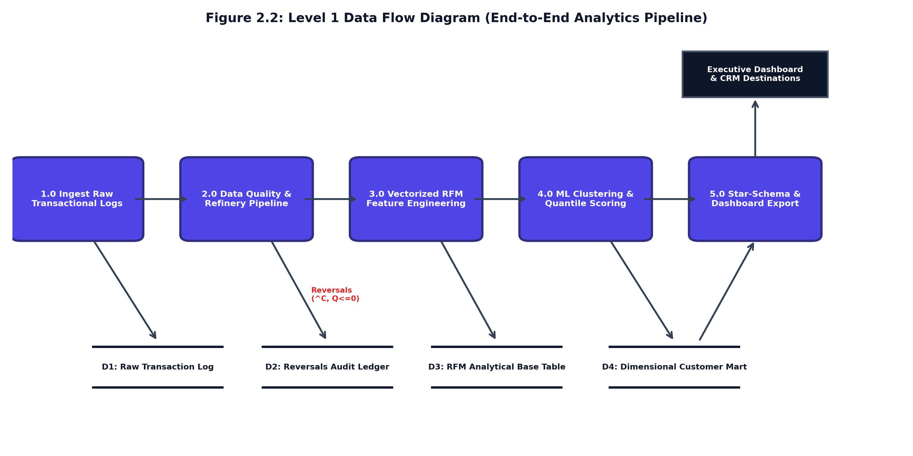
Figure 2.2: Level 1 Data Flow Diagram (End-to-End Pipeline Architecture)

Page 6
2.1.3 Level 2 Data Flow Diagram (Sub-Process Decomposition)
To provide rigorous engineering granularity as mandated by syllabus guidelines, the Level 2 DFD decomposes the two critical computational processes: Process 2.0 (Data Refinery Pipeline) and Process 4.0 (Algorithmic & Quantile Engine).
• Sub-Process 2.0 Decomposition (Refinery): Sub-process 2.1 checks CustomerID presence, dropping guest sessions. Sub-process 2.2 identifies cancellation identifiers ('^C' or Quantity <= 0), segregating them to an audit ledger. Sub-process 2.3 computes Tukey fences across positive items, eliminating wholesale distributor anomalies.
• Sub-Process 4.0 Decomposition (ML & Scoring): Sub-process 4.1 performs log1p compression to alleviate Pareto right-skewness. Sub-process 4.2 executes Z-score standardization. Sub-process 4.3 runs K-Means clustering across k in [2..6] with Silhouette scoring. Sub-process 4.4 runs quantile binning (pd.qcut) to generate 1–5 scores and map 8 business operating tiers.
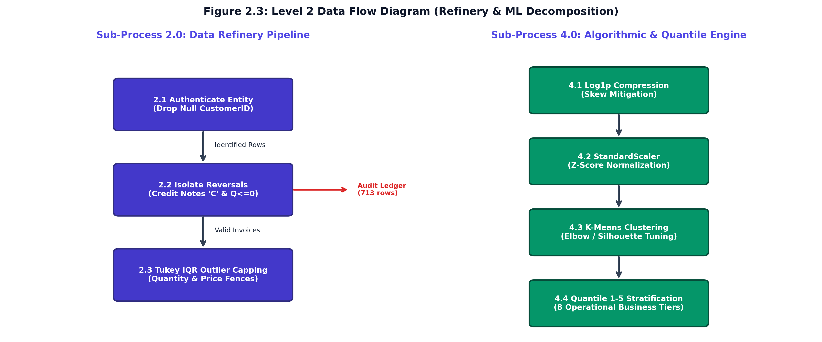
Figure 2.3: Level 2 Data Flow Diagram (Refinery & ML Decomposition)

Page 7
2.2 Use Case Diagram & Milestone Tracking.
The Use Case Model delineates the functional boundaries of the system by illustrating interactions between primary human and automated actors and the system's operational capabilities.
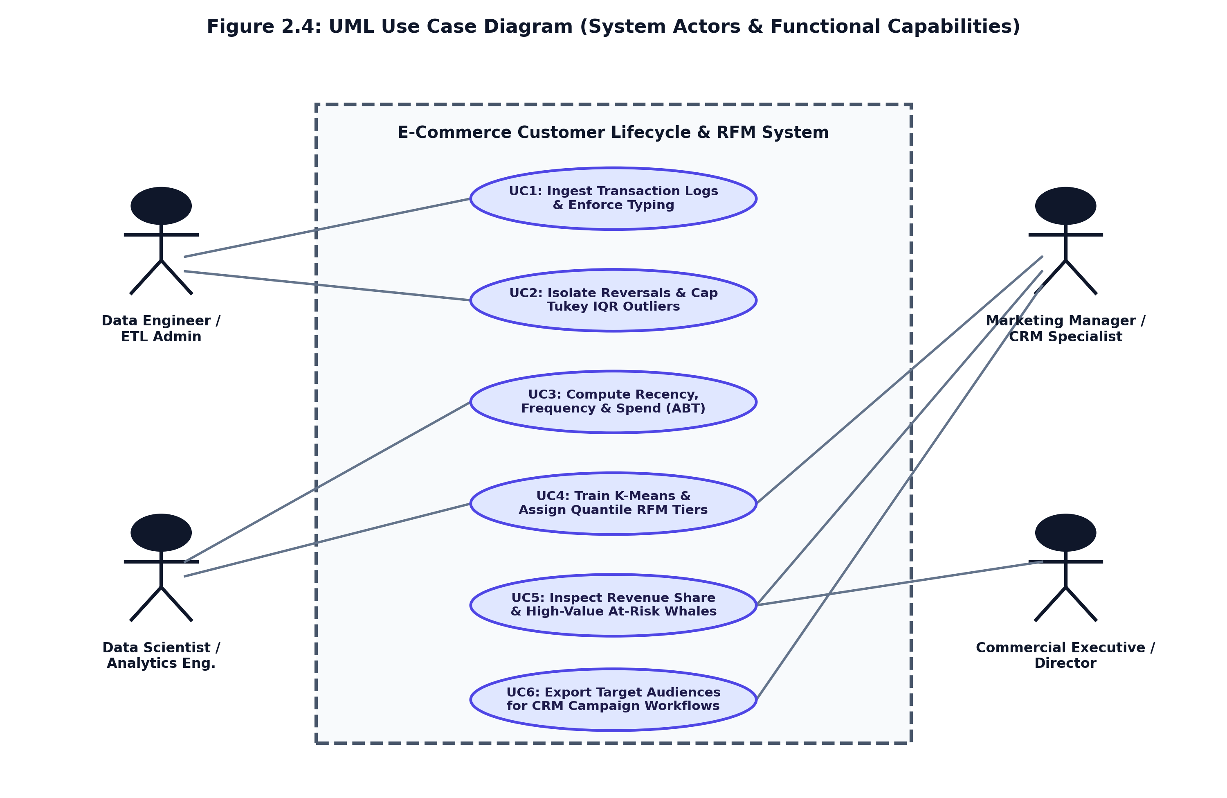
Figure 2.4: UML Use Case Diagram (System Actors & Capabilities)
Table 2.1: Formal Use Case Specification Matrix (UC-01 to UC-06)
UC ID | USE CASE NAME | PRIMARY ACTOR | OPERATIONAL GOAL & PRE-CONDITION
UC-01 | Ingest Transaction Stream | Data Engineer / Admin | Ingests raw event logs, validates schema, enforces datatypes.
UC-02 | Isolate Reversals & IQR Filter | Data Engineer / Admin | Purges null IDs, isolates returns (^C), caps Tukey bulk outliers.
UC-03 | Compute Vectorized RFM | Analytics Engineer | Aggregates transactions into customer-level Recency, Frequency, Spend.
UC-04 | Train & Tune K-Means Model | Data Scientist | Applies log1p + StandardScaler, evaluates Elbow/Silhouette, fits k=4.
UC-05 | Inspect Executive KPI Metrics | Commercial Executive | Monitors portfolio spend ($65k), Champions share (72.5%), at-risk capital.
UC-06 | Export Targeted CRM Audiences | Marketing Manager | Filters segments in activation ledger and exports audience lists for campaigns.
MILESTONE EVALUATION SUMMARY (24/09/2026)
This submission formally completes the First Progress Work milestone (10 Marks allotted) scheduled for 24/09/2026 for B.Sc. AI and Data Science (Semester V) at Institute of Advanced Research (IAR). All required index sections (1.1, 1.2, 1.3, 2.1, and 2.2) have been fully developed and validated. The technical artifacts, UML models, and data pipelines are complete and ready for supervisor review.
Table 2.2: Project Progress Work Evaluation & Milestone Tracking
DATE | ASSESSMENT PARTICULARS | INDEX SECTIONS | MARKS | CURRENT STATUS
24/09/2026 | First Progress Work | 1.1, 1.2, 1.3, 2.1, 2.2 | 10 Marks | COMPLETED (Current Submission)
13/10/2026 | Mid-Term Exam (Second Progress) | 2.3, 2.4, 3.1, 4.1 | 20 Marks | Scheduled for Next Milestone
27/10/2026 | Third Progress Work | 4.2, 4.3, 5.1, 5.2, 6.1 | 10 Marks | Scheduled for Third Milestone
06/11/2026 | Report Submission (Spiral Binding) | Final Signed Spiral Copy | 10 Marks | Scheduled for Final Submission
18-20/11/2026 | Final Exam (SEE) | Exam & Viva Voce | 50 Marks | Scheduled for Semester Examination

