Ultimate Technologies
Data Science Challenge — Summary Report
Prepared by Deepthi
June 2026

Overview
This report summarizes findings across the three parts of the Ultimate data analysis challenge: (1) exploratory analysis of login activity time series, (2) an experiment design for a toll-reimbursement program intended to encourage cross-city driver availability, and (3) a predictive model of rider retention. Full code, intermediate outputs, and additional plots are provided in the accompanying Jupyter notebook.

Part 1 — Login Activity: Exploratory Analysis
Individual login timestamps from logins.json (93,142 events spanning roughly 103 days) were aggregated into 15-minute intervals and analyzed for daily and weekly demand patterns.

Data Quality
- No missing or null timestamps; the aggregated series has no gaps across the full date range.
- A small number of exact duplicate second-level timestamps (877, under 1% of records) were found — plausible given near-simultaneous logins, but worth monitoring upstream.
- 407 of the 9,788 fifteen-minute intervals had zero logins, concentrated in the early-morning quiet period rather than indicating missing data.

Key Patterns
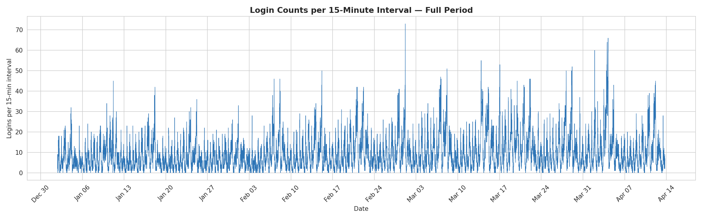
Figure 1. Full login time series (15-minute counts) across the observed period.
The full series shows a clear repeating oscillation with two layers of seasonality: a fast daily cycle and a slower week-to-week cycle where some peaks (weekends) are taller than others.
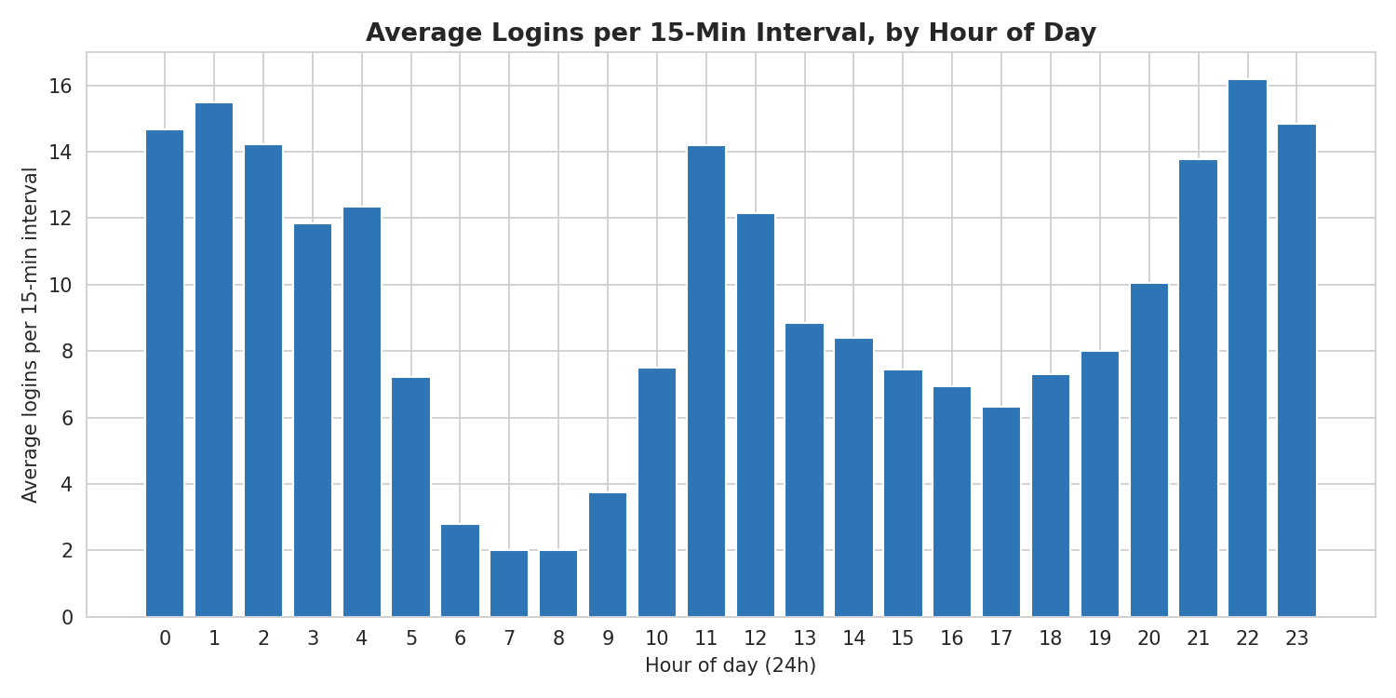
Figure 2. Average logins per 15-minute interval, by hour of day.
Demand follows a strong daily cycle: it peaks overnight (roughly 10 PM–2 AM), declines through the early morning, and bottoms out between 6 AM and 9 AM, before climbing again through the day toward the next overnight peak.
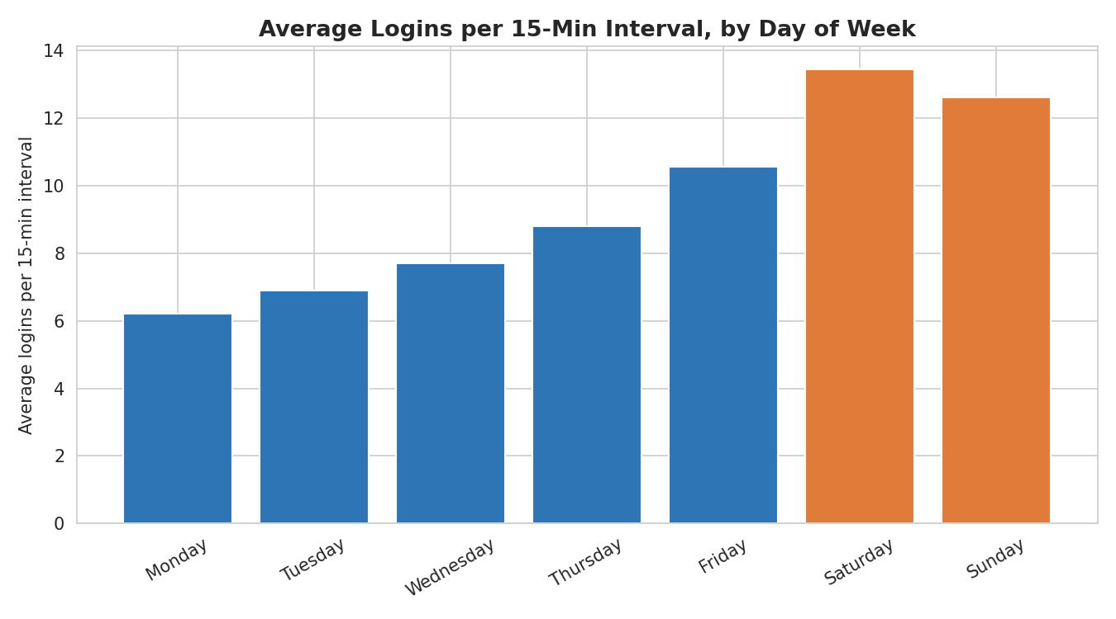
Figure 3. Average logins per 15-minute interval, by day of week.
Demand rises through the work week and is clearly highest on Saturday, with Sunday close behind — consistent with weekend leisure usage.
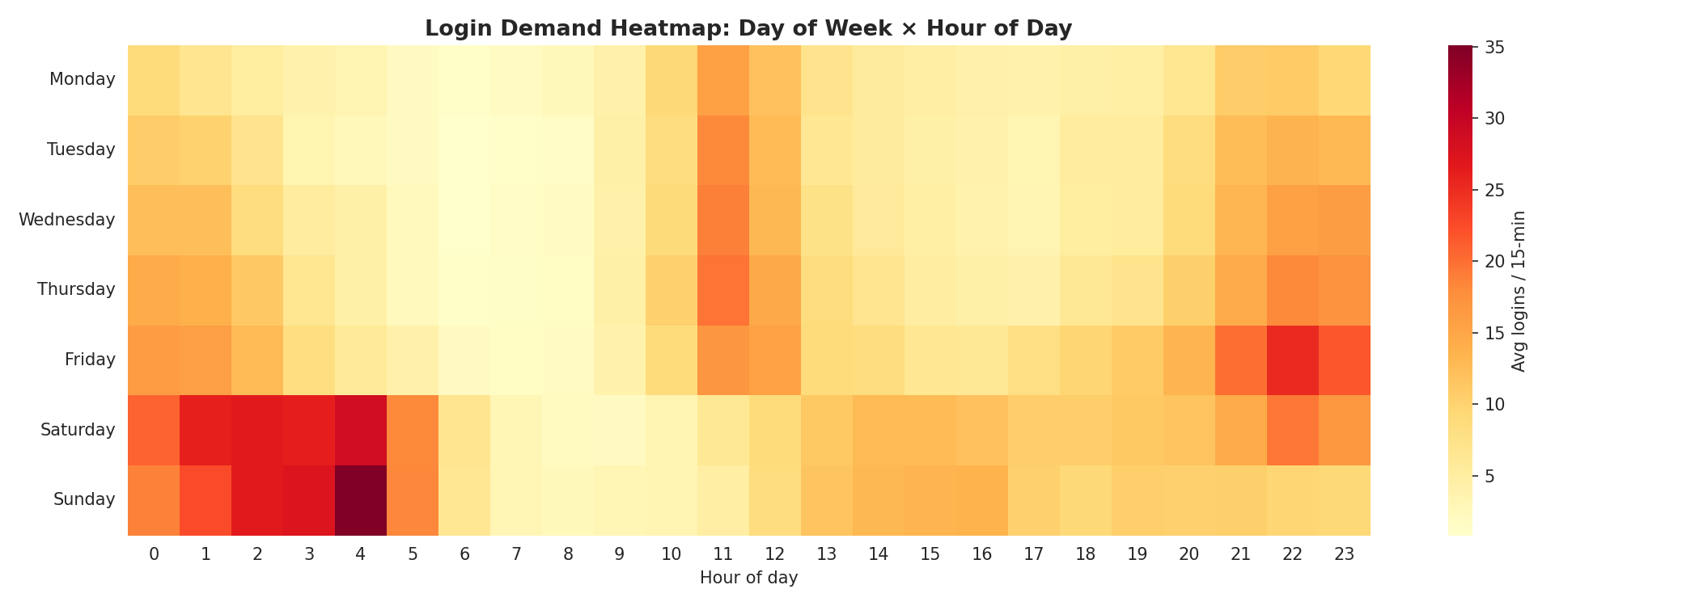
Figure 4. Demand heatmap, day of week × hour of day.
The heatmap shows both cycles at once: the overnight band is present every night, but it is widest and most intense from Friday night through Sunday night, confirming an interaction between the daily and weekly cycles — weekend nights are disproportionately busier than weekday nights.

Summary
- Daily cycle: demand peaks overnight (~10 PM–2 AM) and troughs in early morning (~6–9 AM).
- Weekly cycle: demand grows across the work week and peaks on Saturday/Sunday.
- Interaction effect: the overnight peak is amplified and extended on weekends, suggesting a meaningful weekend-nightlife demand component.
- Overall data quality is good, with only minor, non-material duplicate-timestamp issues.

Part 2 — Experiment & Metrics Design
Gotham and Metropolis have complementary demand patterns (Gotham peaks at night on weekdays; Metropolis peaks during the day on weekdays), but a two-way toll bridge discourages drivers from working both cities. Ultimate proposes reimbursing toll costs to encourage cross-city availability.

1. Key Success Metric
Recommended metric: the weekly share of driver partners who complete at least one trip in both cities (“dual-city active driver rate”).
- Directly reflects the targeted behavior — drivers actually crossing the bridge — rather than a downstream proxy.
- As a rate (share of drivers), it is not confounded by overall demand growth the way a raw trip-count or toll-spend metric would be.
- Straightforward to compute weekly, giving city ops teams a fast read on adoption.
A useful secondary metric: the share of driver-hours supplied in each city during the other city's peak window — this more directly captures whether the cross-city coverage gap is actually being filled.

2. Experiment Design

a) Implementation
- Randomized controlled experiment, randomized at the driver level (the unit where the behavior of interest — crossing the bridge — actually occurs).
- Population: drivers active in either city at randomization time, stratified by home city and weekday/weekend activity pattern so both arms have comparable driver mixes.
- Treatment: toll costs reimbursed for bridge-crossing trips. Control: status quo (drivers pay tolls).
- Run for 4–6 weeks to capture repeated weekday/weekend cycles and allow time for habit formation.
- Watch for contamination between arms (drivers informally sharing the offer); driver-level randomization with account-specific framing mitigates this.

b) Statistical Test
- Primary metric (binary: dual-city active or not) — two-proportion z-test / chi-squared test between arms.
- Because the same drivers are observed repeatedly over weeks, a mixed-effects logistic regression (driver random effect, week as repeated measure) is preferred over a single pooled test.
- Secondary metric (driver-hours in complementary peak) — Mann-Whitney U test, or a Poisson/negative-binomial regression if modeling trip counts directly.
- Pre-register significance threshold (e.g. α = 0.05) and compute minimum detectable effect during planning to confirm adequate power.

c) Interpretation, Recommendations & Caveats
- Significant, meaningful lift in dual-city activity → recommend full rollout.
- Significant but small effect → weigh reimbursement cost against the operational value of improved cross-city coverage.
- Not significant → toll cost may not be the binding constraint; consider time/familiarity barriers instead.
- Caveats: possible novelty effects (early trial, later reversion), limited generalizability beyond the experiment period/season, and uneven benefit for drivers who live far from the bridge — recommend a sub-group breakdown by driver proximity to the bridge.

Part 3 — Predictive Modeling: Rider Retention
Using the January 2014 signup cohort (50,000 users), a rider is considered retained if their last trip falls within 30 days of the data pull date (July 1, 2014 — the latest last_trip_date observed).

Retention Rate
37.6% of users were retained (active within the last 30 days of the observed window); roughly 62% had churned by the time of the data pull.

Data Cleaning
- avg_rating_of_driver (~16% missing) and avg_rating_by_driver (~0.4% missing) imputed with the median, given the left-skewed distribution of ratings.
- phone (396 missing) recoded as an “Unknown” category rather than dropped, since device type is a meaningful behavioral signal.
- A small number of fully duplicated rows were identified but left in place as immaterial at this dataset size.

Exploratory Findings
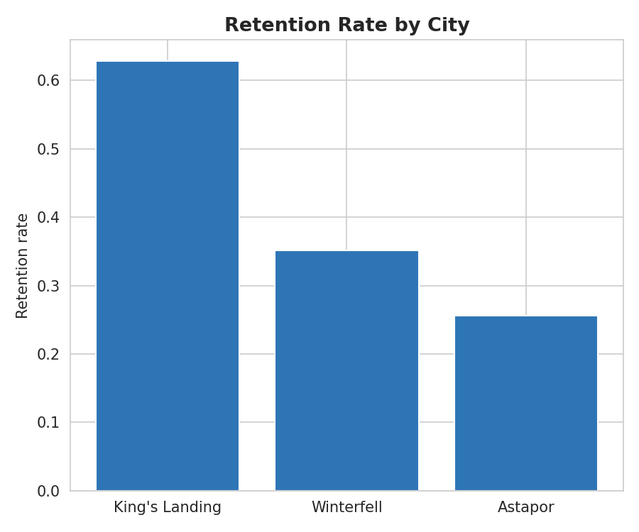
Figure 5. Retention rate by city.
Retention varies meaningfully by city, with King's Landing retaining noticeably better than Astapor or Winterfell — an early signal that city would be a useful predictor.
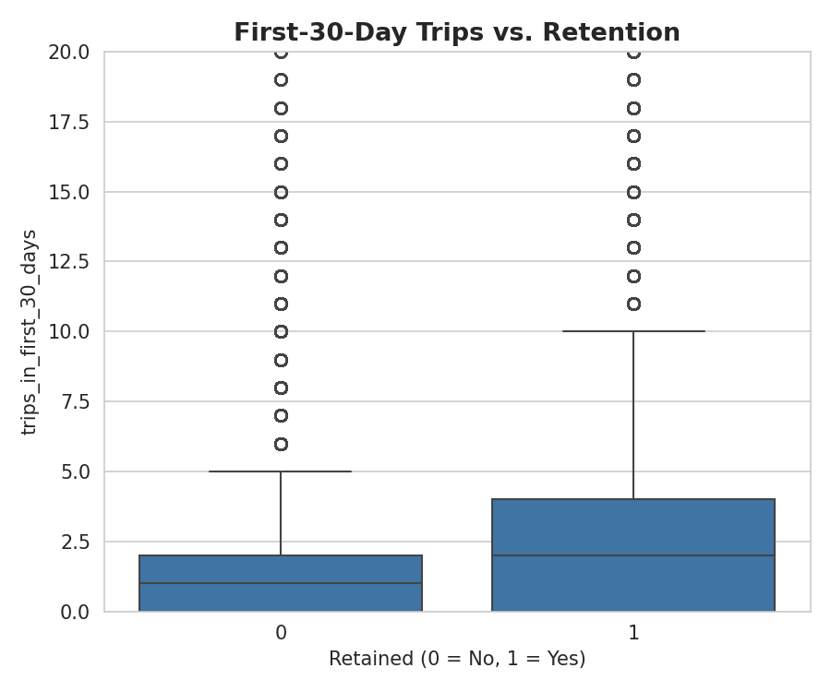
Figure 6. First-30-day trip count vs. retention.
Retained users took visibly more trips in their first 30 days than churned users, suggesting that early engagement and habit formation matter.

Modeling Approach
Three classifiers were compared: Logistic Regression (interpretable linear baseline), Random Forest, and Gradient Boosting (tuned via 5-fold cross-validated GridSearchCV over n_estimators, max_depth, and learning_rate). AUC was used as the primary evaluation metric given the moderate class imbalance (~38% retained), with accuracy as a secondary, more interpretable measure.
Model | Test AUC | Test Accuracy
Logistic Regression | 0.754 | 71.5%
Random Forest | 0.849 | 78.2%
Gradient Boosting (tuned) | 0.858 | 79.2%

Gradient Boosting achieved the best test performance and was selected as the final model. Best hyperparameters: n_estimators=200, max_depth=4, learning_rate=0.1 (selected via 5-fold cross-validated grid search).
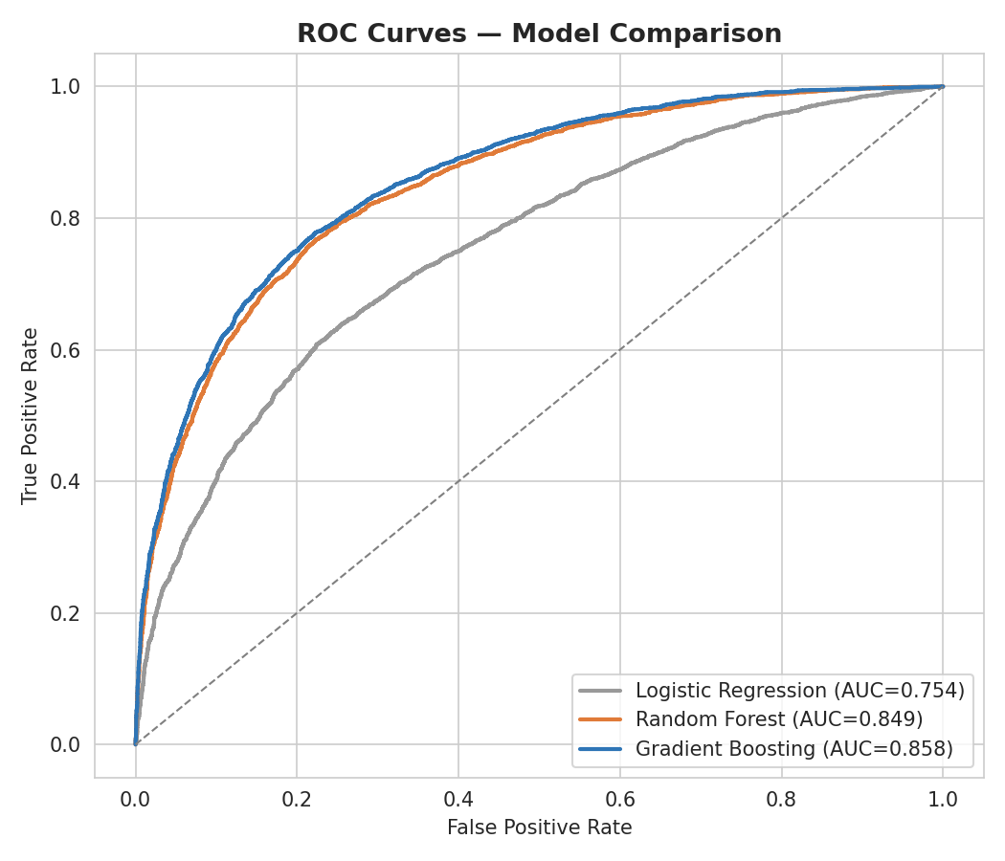
Figure 7. ROC curves comparing all three models on the held-out test set.

Model Validity
The final Gradient Boosting model achieves a test AUC of 0.858 and test accuracy of 79.2%, indicating strong ranking ability well above chance (0.50). Cross-validated and held-out performance are close, suggesting the model generalizes reasonably well rather than overfitting to the training data. Recall on the “retained” class is somewhat lower than precision, meaning the model is conservative about predicting retention — an acceptable trade-off if used to target at-risk users for retention outreach, since false positives (incorrectly flagging a retained user as at-risk) are cheaper than false negatives in that context.

Top Predictors of Retention
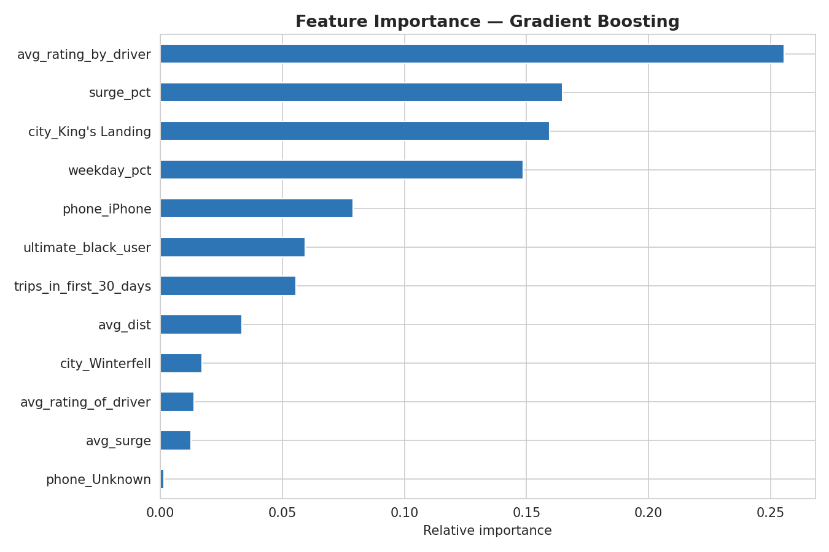
Figure 8. Feature importance, Gradient Boosting model.
- avg_rating_by_driver — the strongest predictor; riders rated highly by drivers are retained at a higher rate.
- surge_pct — the share of a rider's trips taken during surge pricing.
- city (King's Landing) — consistent with the higher raw retention rate observed for that city.
- weekday_pct — whether a rider's usage skews weekday vs. weekend.
- phone (iPhone), ultimate_black_user, and trips_in_first_30_days are meaningful secondary contributors.

Recommendations for Improving Retention
- Investigate why King's Landing retains better than Astapor/Winterfell (driver supply, pricing, service reliability) and apply those learnings to weaker cities.
- Treat low driver-given ratings as an early warning signal in a proactive retention/support workflow.
- Encourage early trip volume — onboarding incentives in the first 30 days could pay off in longer-term retention, given how strongly early engagement correlates with retention.
- Investigate whether high surge exposure is actively driving churn (a pricing/UX issue to address) versus merely correlating with certain rider segments (a confound).
- Use model-predicted churn risk scores to prioritize retention outreach and promotional offers toward riders most likely to lapse.
Caveat: these are associations learned from a single January 2014 cohort over roughly six months. Several features (e.g. ultimate_black_user, phone) may proxy for unobserved factors like income or urban density rather than being directly causal. Any retention intervention informed by this model should ideally be validated with a follow-up experiment before being rolled out broadly.

