*MATLAB CODE FOR 2D CONVECTION-DIFFUSION*

L = 5; % length of rod

n_points = 101; % n_points = nx = ny

h = L/(n_points-1); % h = dx = dy = L/(n_points-1)

x = 0:h:L;

y = 0:h:L;

T(1, 1:n_points) = 0;

T(1:n_points, 1) = 25;

T_new(1, 1:n_points) = 100;

T_new(1:n_points, 1) = 0;

rho = 1; %density of material

u = 1; %velocity in x direction

v = 1; %velocity in y direction

gamma = 0.05;

error = 1;

itr = 0;

while error > 1e-7

for i = 2:n_points-1

for j = 2:n_points-1

aE = gamma/h - rho*u*h/2;

aW = gamma/h + rho*u*h/2;

aN = gamma/h - rho*v*h/2;

aS = gamma/h + rho*v*h/2;

aP = aE + aW + aS + aN + 0;

T_new(i,j) = (aE*T(i+1,j) + aW*T(i-1,j) + aN*T(i, j-1) + aS*T(i, j+1))/aP;

end

end

itr = itr + 1;

error = 0;

for i = 2:n_points-1

for j = 2:n_points-1

error = error + abs(T(i,j)-T_new(i,j));

end

end

T = T_new;

end

x_L = ((1:n_points)-1).*h;

y_L = 1-((1:n_points)-1).*h;

[X,Y] = meshgrid(x_L, y_L);

contourf(X,Y,T,20);

colorbar;

figure;

plot(1-y,T(:, (n_points+1)/2),'--o');

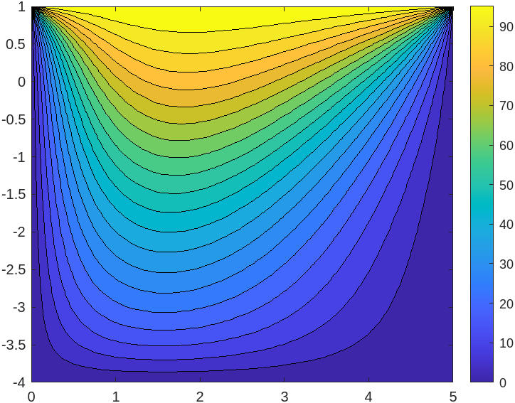

*MATLAB CODE FOR 2D CONVECTION-DIFFUSION WITH POROUS MEDIA*

L = 5; % length of rod

n_points = 101; % n_points = nx = ny

h = L/(n_points-1); % h = dx = dy = L/(n_points-1)

x = 0:h:L;

y = 0:h:L;

T(1, 1:n_points) = 0;

T(1:n_points, 1) = 25;

T_new(1, 1:n_points) = 100;

T_new(1:n_points, 1) = 0;

rho = 1; %density of material

u = 1; %velocity in x direction

v = 1; %velocity in y direction

mu=1e-2; %porosity of porous media

k=1; %conductance

gamma = 0.05;

error = 1;

itr = 0;

while error > 1e-7

for i = 2:n_points-1

for j = 2:n_points-1

aE = gamma/h - rho*u*h/2;

aW = gamma/h + rho*u*h/2;

aN = gamma/h - rho*v*h/2;

aS = gamma/h + rho*v*h/2;

aP = aE + aW + aS + aN + 0;

T_new(i,j) = (aE*T(i+1,j) + aW*T(i-1,j) + aN*T(i, j-1) + aS*T(i, j+1))/aP+(mu*u)*h*h/k+(mu*v)*h*h/k;

end

end

itr = itr + 1;

error = 0;

for i = 2:n_points-1

for j = 2:n_points-1

error = error + abs(T(i,j)-T_new(i,j));

end

end

T = T_new;

end

x_L = ((1:n_points)-1).*h;

y_L = 1-((1:n_points)-1).*h;

[X,Y] = meshgrid(x_L, y_L);

contourf(X,Y,T,20);

colorbar;

figure;

plot(1-y,T(:, (n_points+1)/2),'--o');

