**Name- Swapnadeep Mishra**

**Roll- 002211001115, Group- A3**

**Assignment – 6 (Cloudsim)**

**Introduction:-**

* CloudSim is a widely used toolkit for modeling and simulating cloud computing infrastructures and services.
* It helps in simulating data centers, virtual machines, cloud providers, and energy-efficient cloud management.
* A brief overview of its use cases:
  + Research in cloud computing
  + Resource allocation and scheduling algorithms
  + Performance evaluation

CloudSim is an open-source simulation framework used for modeling and simulating cloud computing environments and services. It allows researchers, developers, and engineers to experiment with and evaluate cloud infrastructure, resource management, and scheduling algorithms in a cost-effective and time-efficient way. The framework abstracts complex cloud environments into manageable components, enabling simulations of cloud data centers, virtual machines (VMs), cloudlets (tasks), and resource allocation policies.

Here are the steps to install the Cloudsim. Follow the below steps to go through ---

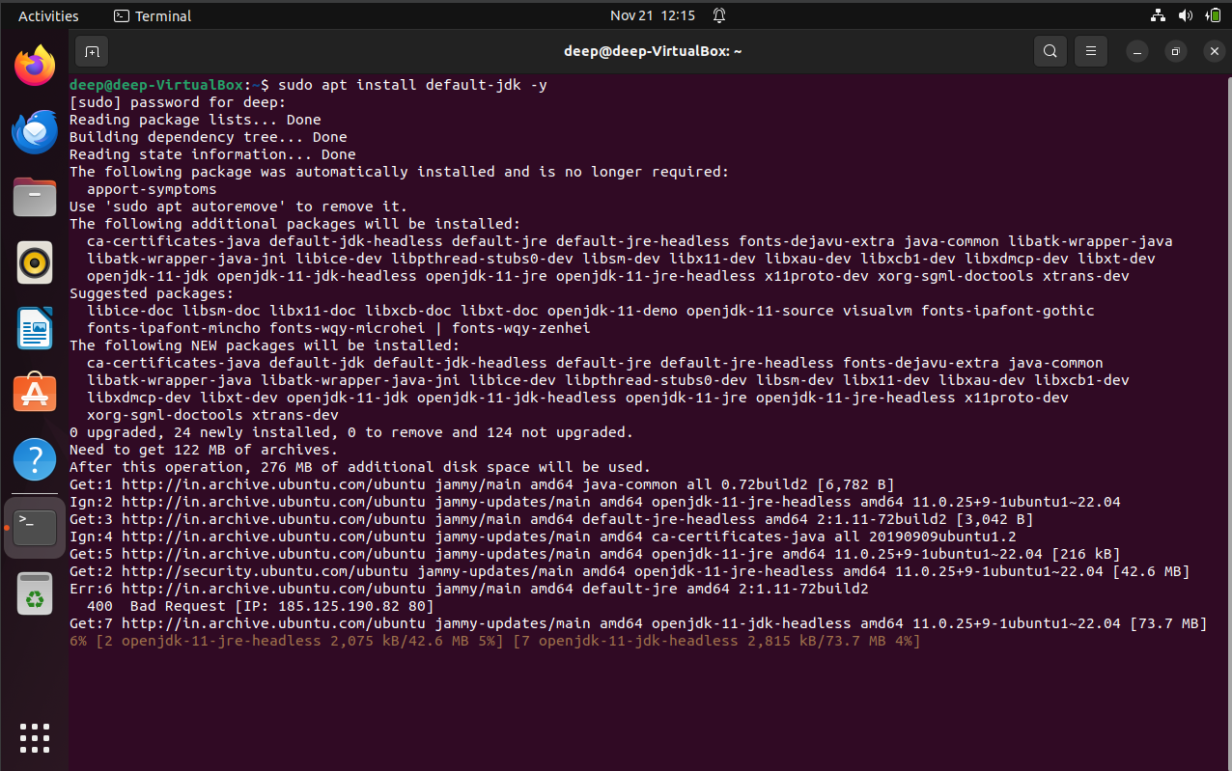

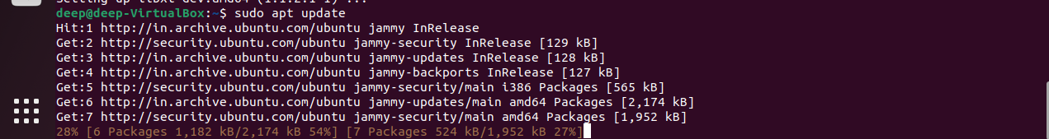

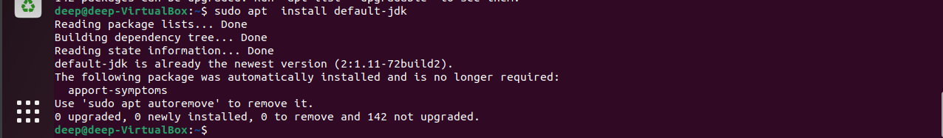



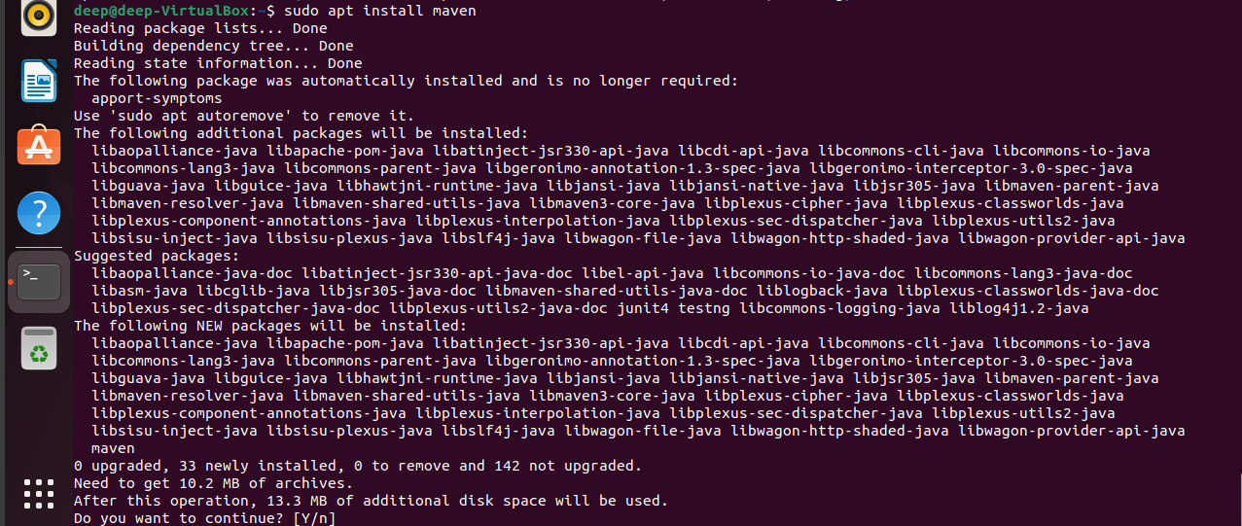

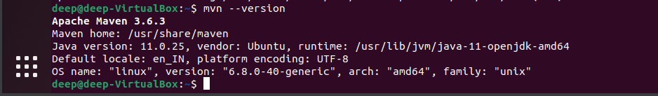

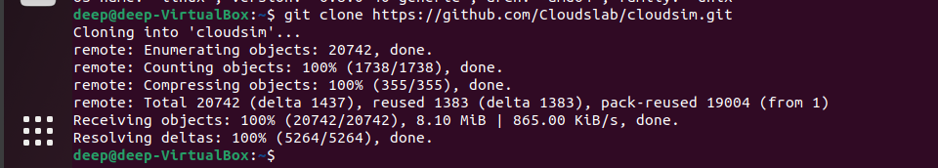



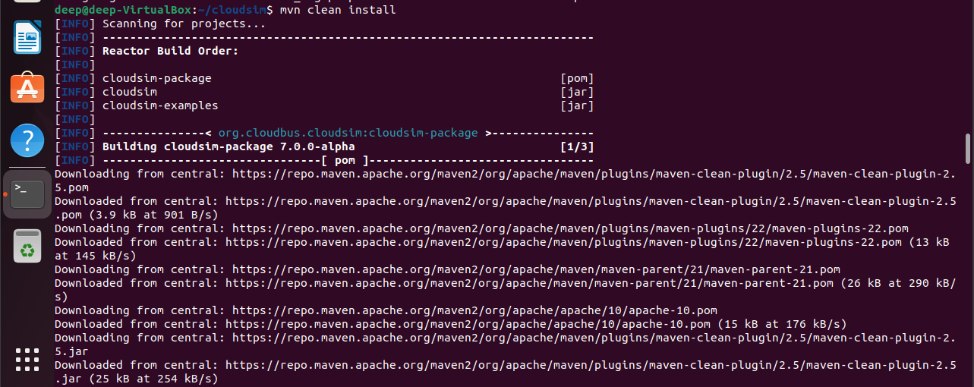

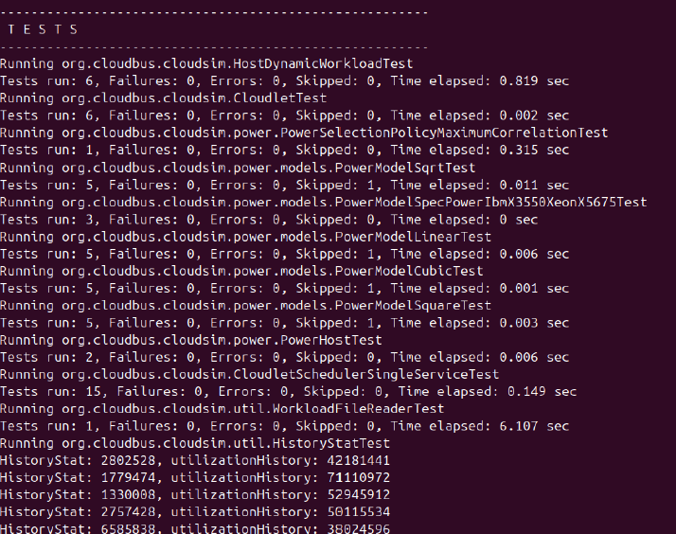

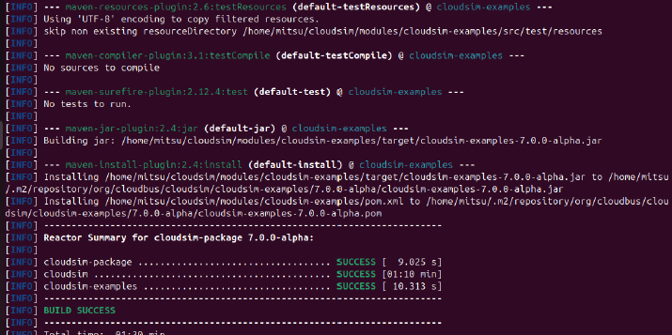

After the successful download. We can go through the next processes.

Then we should go to the Intellijidea download page to continue download the ide.

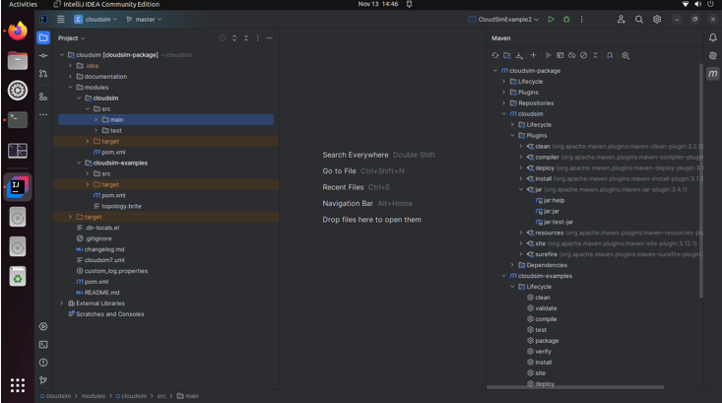

**Importing CloudSim into Idea IDE:-**

1. Open the **CloudSim** project in Eclipse.
2. Navigate to the sample simulation file (typically in the examples folder).
3. Right-click on the sample class (e.g., CloudSimExample3.java),
4. Add 2 hosts in the data center in the createDatacenter() function

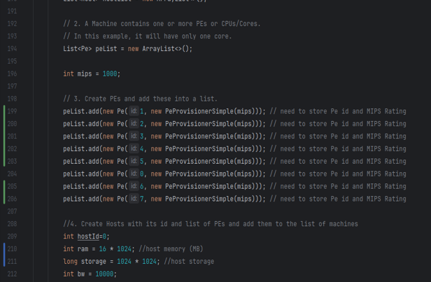

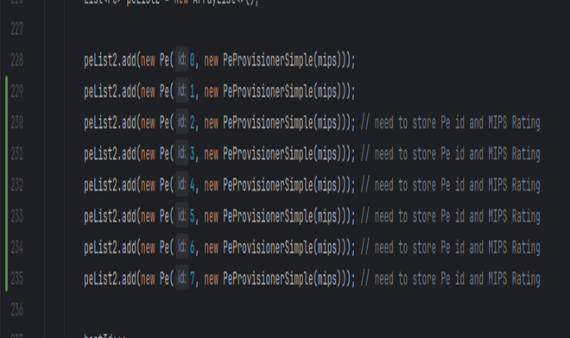

1. Add 4 vms and 6 cloudlets into the datacenters

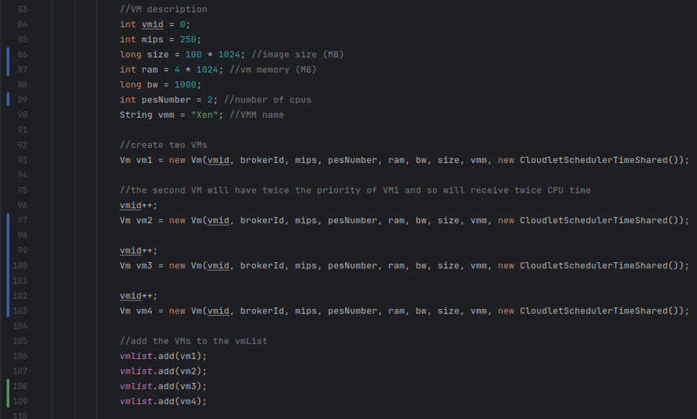

**Output**

