**CLOUD COMPUTING LAB**

**Assignment 2**

**Name : Swapnadeep Mishra**

**Roll No : 002211001115**

**Section No : A3**

**Team Member:**

**Samudra Roy(002211001114)**

**Collaborator Group Member**

**–**

**Swapnil Mal(002211001123)**

**Task 1: Check the internet connection on the installed guest operating systems. Usually, it works automatically as long as the host system has Internet in it.**

The connectivity of the Linux VM was checked to ensure an active internet connection, which is usually shared depending on the host system configuration. In this case, the Linux VM already had internet access by default, confirmed using the ping command to test reachability on an IP network.

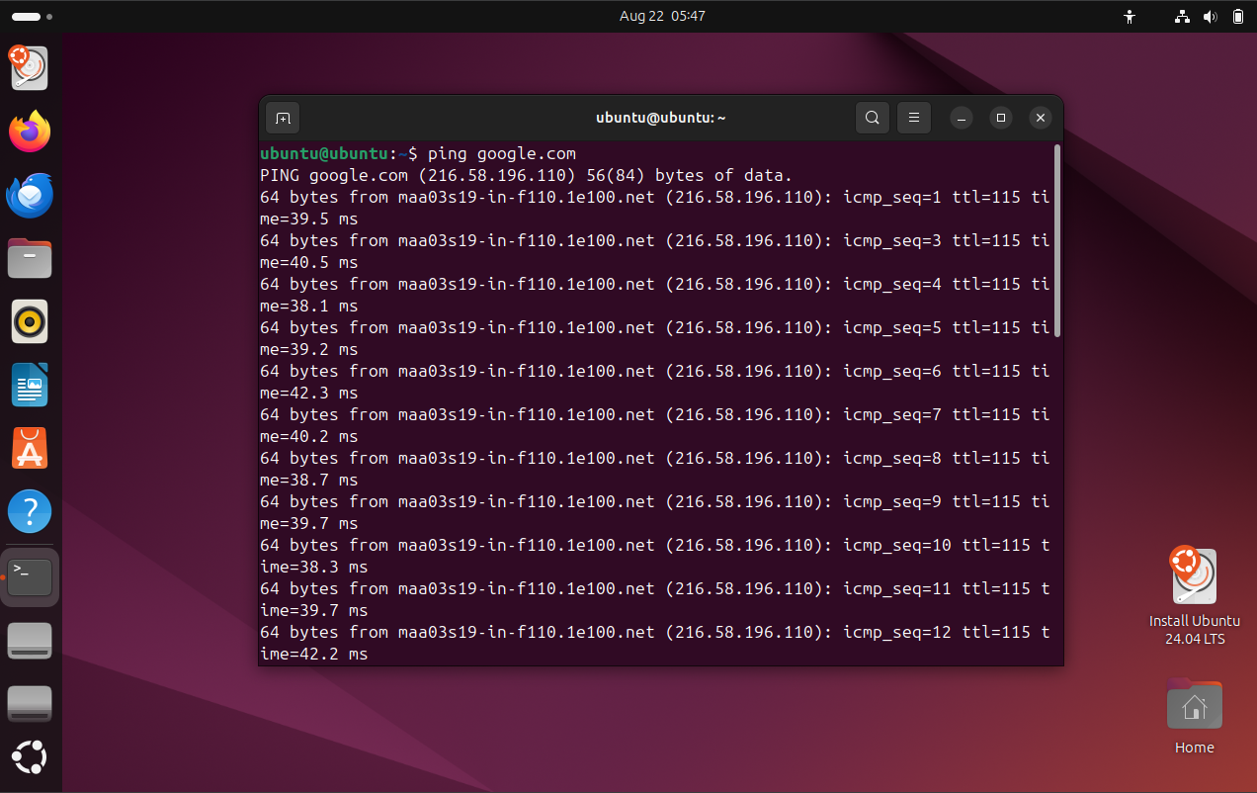

**Task 2: Transfer a file between one guest operating system to another guest operating system, where first guest system is your guest system and second guest system is from another group. Mention the paired group's roll numbers along with your group's roll number in the documentation.**

We utilized SSH (Secure Shell) and SCP (Secure Copy Protocol) to accomplish the task, which involved securely accessing and managing the remote Linux VM as well as transferring files between the host system and the VM. SSH allowed us to establish an encrypted connection to the VM, providing a secure environment for executing commands remotely, while SCP enabled the secure and efficient transfer of files over the SSH connection. This combination of tools ensured both the integrity and confidentiality of the data being transmitted, making them ideal for managing the remote system and facilitating the necessary file exchanges.

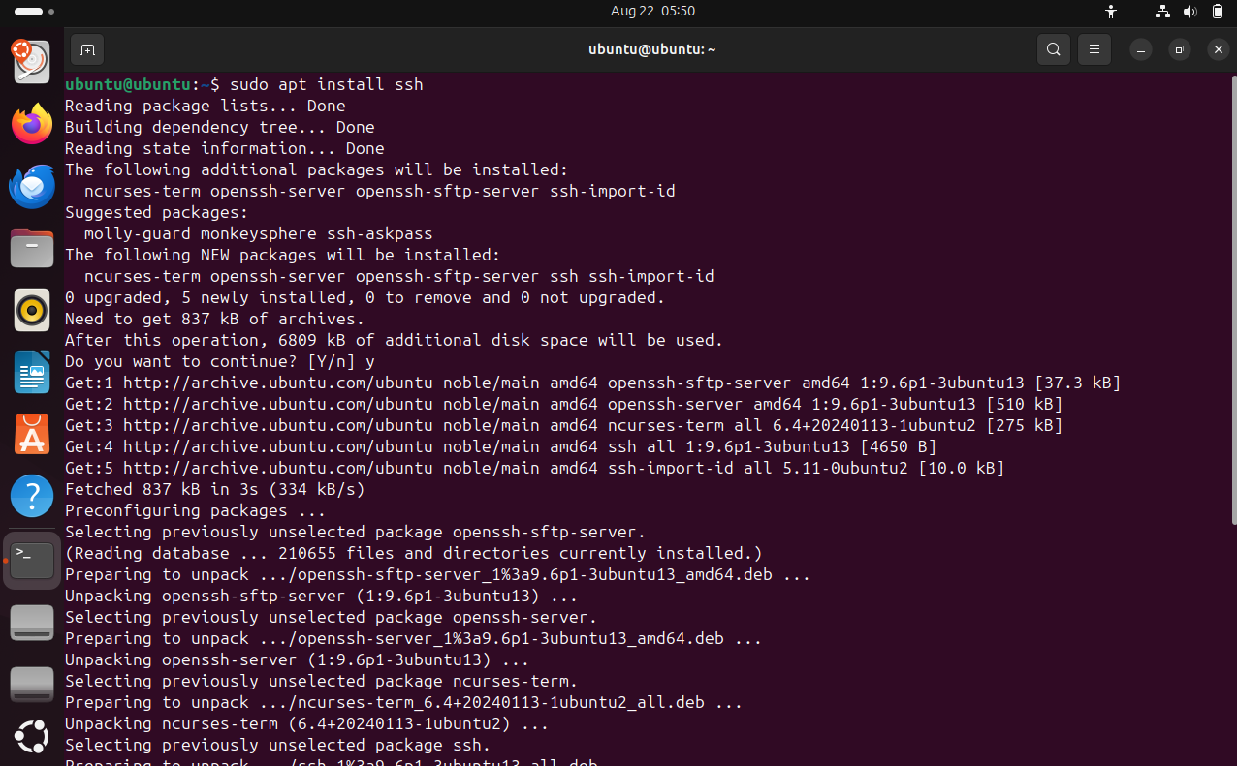

Next, we started SSH and established a connection between our computers using the following commands:

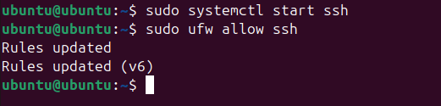

We made a demo text file named ‘sample. txt,’ with some text .

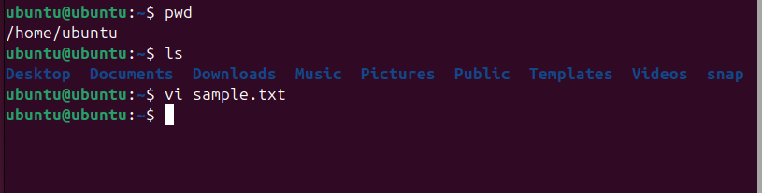

We transferred it to Swapnil’s virtual machine using the scp command. After being prompted for his password, we entered it, and the file was successfully transferred to his VM, as demonstrated.

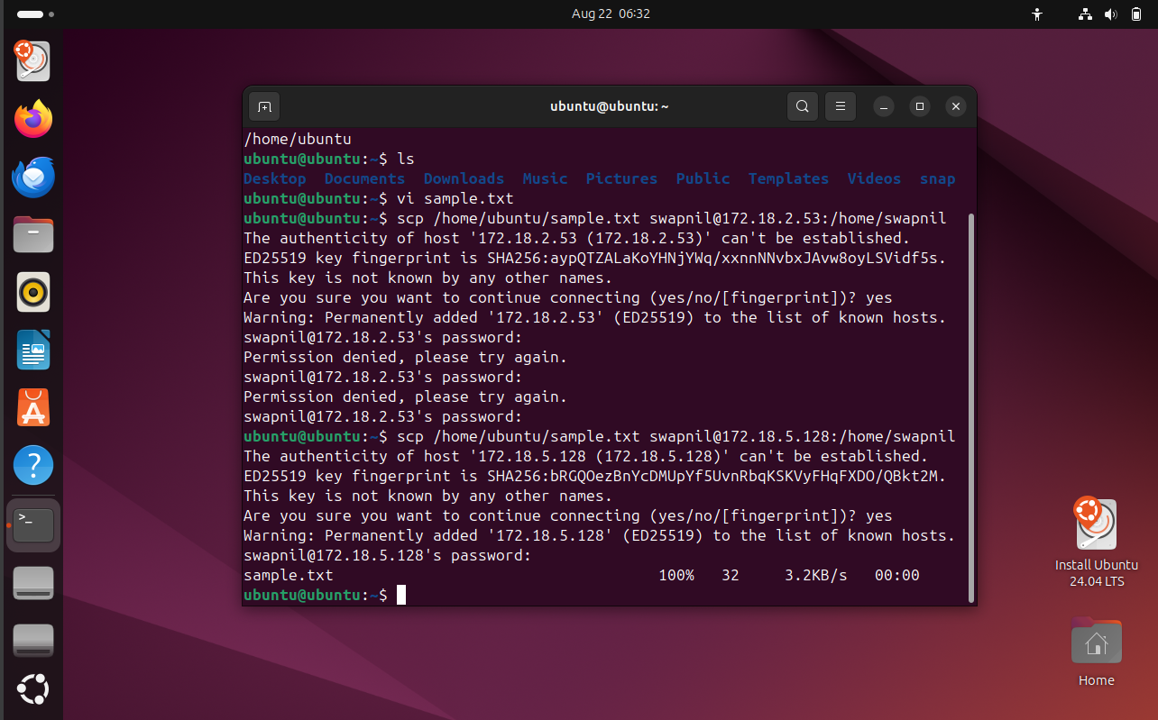



**Task 3: Install a C compiler in the virtual machine and create a C program file and run it in your guest operating system and once it is successfully run on your guest system, send the file to your friend's guest system with whom you made a pair for the above sub-task.**

The first step was to install a C compiler. Among the many available options, we chose GCC, a widely used compiler for C and C++ programs. We installed it using the `apt` package manager.

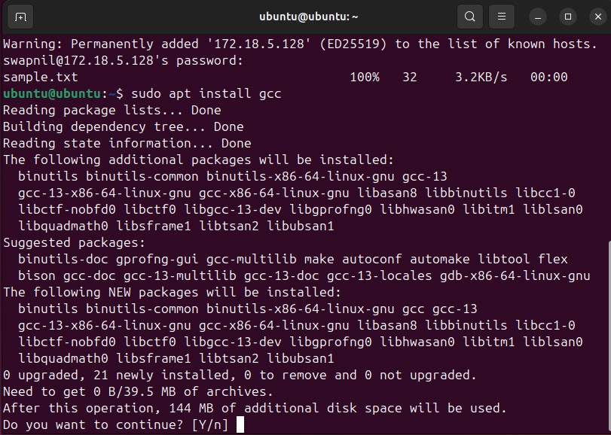

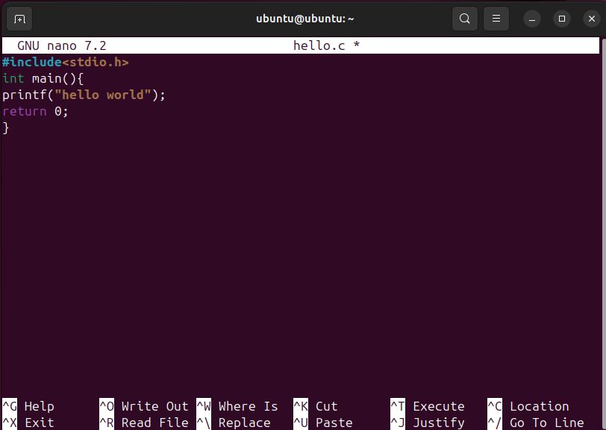  
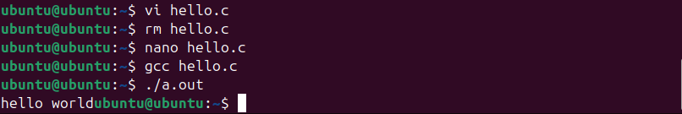

After that we moved the `hello.c` program to our group partner Swapnil’s VM using the `scp` command as shown below.

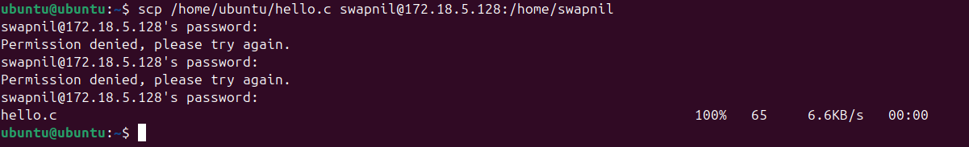

As demonstrated, the file was copied to his VM as intended and the procedure completed without an issue.



**Task 4: Delete that C file present in your guest system and run the C file present in your friend's guest system from your guest system.**

To simulate a situation where the C program was no longer present on our guest system, we first deleted the `hello.c` file using the rm command.

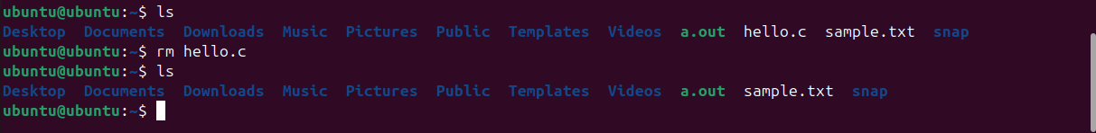

We accessed a remote server via SSH to compile and run a C program. We used the gcc compiler to compile the hello.c file, located in the remote directory /home/swapnil/, into an executable named abc. After successful compilation, we executed the program, which printed "hello world" in the terminal, confirming that our code ran correctly.

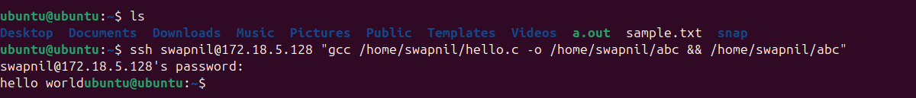

**Task -5: File transfer from host to guest operating system.**

At first we open the terminal in our guest(ubuntu) system and enter the command “ip add” to get the ip address.

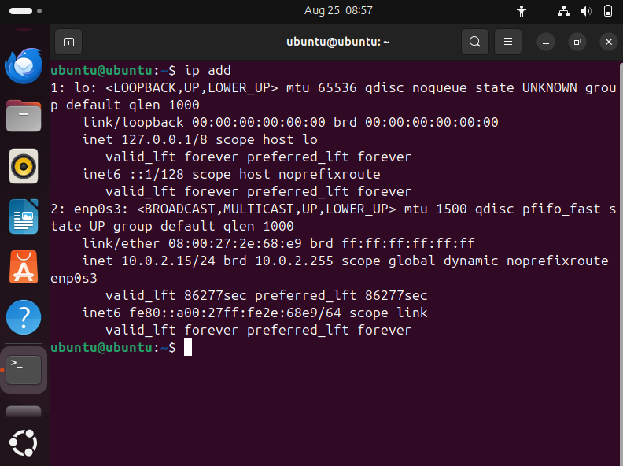

Then we open cmd in our host windows 11 system and enter the command “ipconfig” to get the ip address.

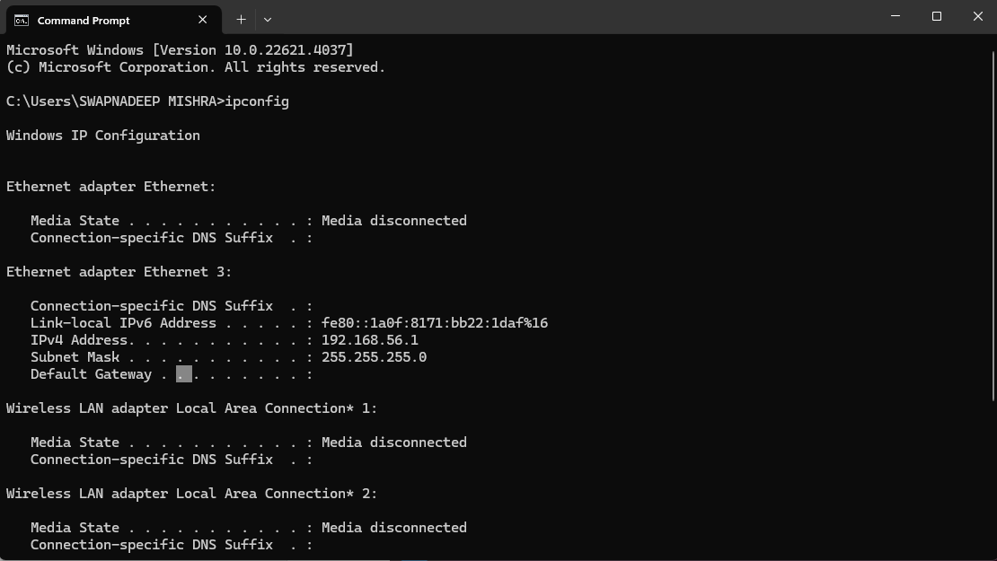

After that we created a folder named “Share with Ubuntu” in our Local disk C.

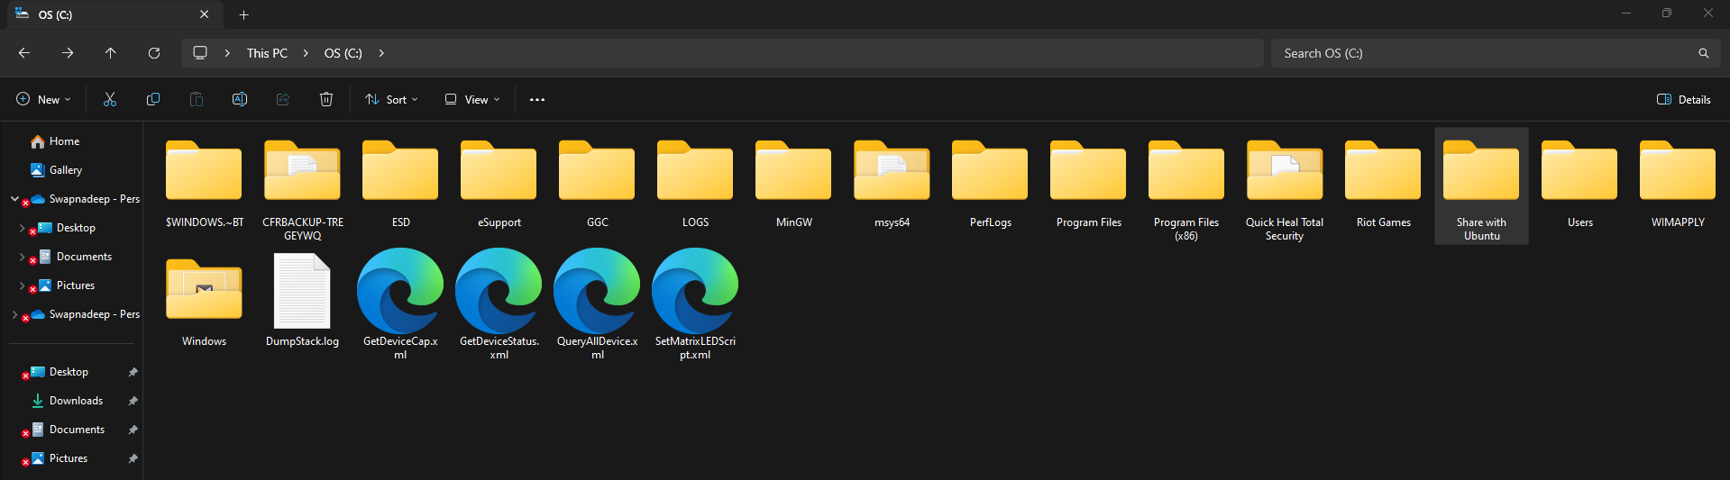

After that we gave all the sharing permissions to the created file thus it will not show us any issues while sharing.

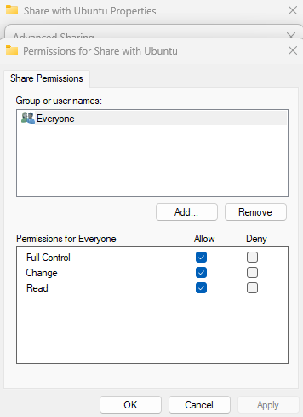

Then opening the settings we opened the network & internet and we gave access to all private , public and all network sharing options .

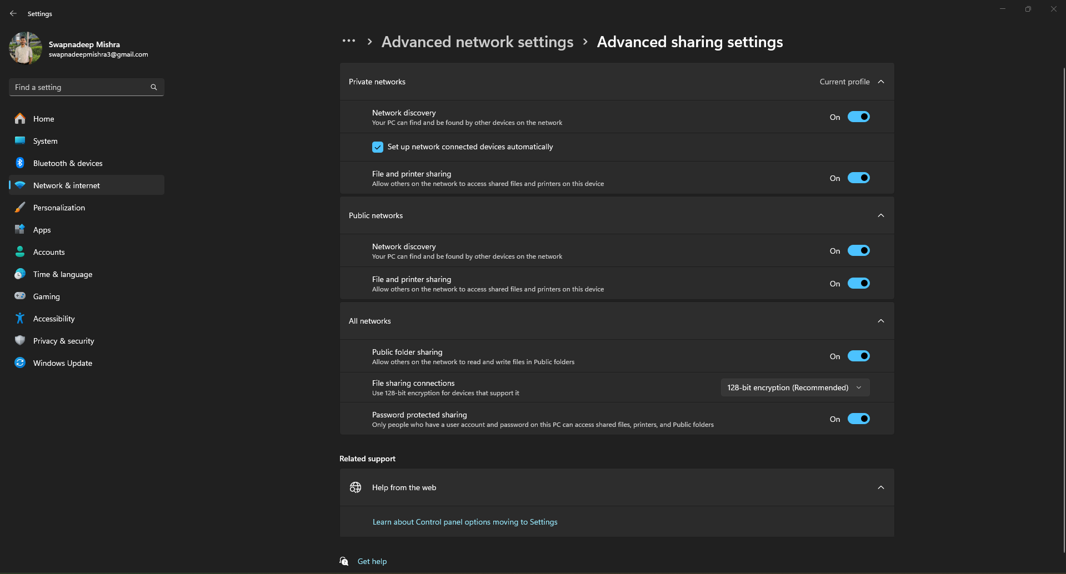

After that we opened our guest system and opened files. Next in the files we went to other locations and in that field we enter our ip address of our host system and press the connect button.

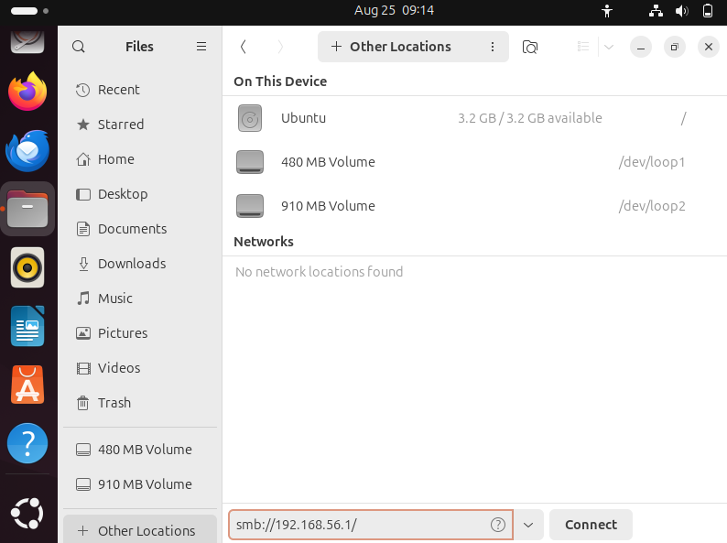

After pressing connect we saw that the folder that we created was there . Then we create a file inside the folder in our windows system and after refreshing that in ubuntu system we saw that the folder is also created in our guest system.

