**Swapnadeep Mishra**

**IT-A3-1115 DBMS Assignment 3**

**Database Schema:**

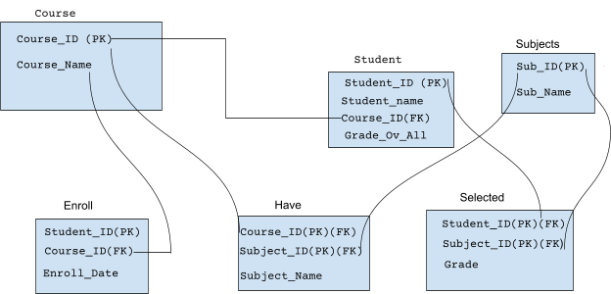

**ER Diagram:**

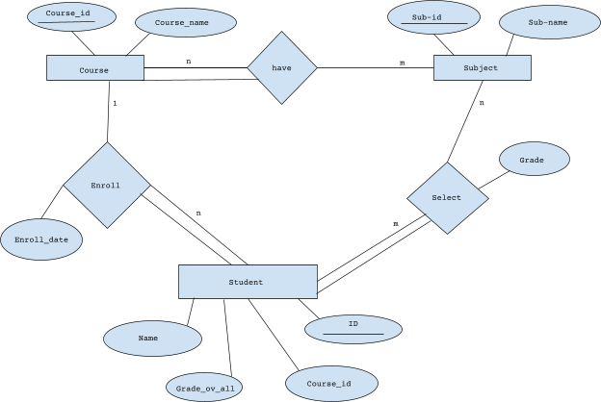

**QUESTION 1.**

-- COURSE Table

CREATE TABLE COURSE(

COURSE_ID NUMBER(2),

COURSE_NAME VARCHAR2(10)

);

INSERT INTO COURSE VALUES (10, 'CS');

INSERT INTO COURSE VALUES (20, 'IT');

INSERT INTO COURSE VALUES (30, 'ECE');

INSERT INTO COURSE VALUES (40, 'AI');

INSERT INTO COURSE VALUES (50, 'WEB DEV');

-- SUBJECT Table

CREATE TABLE SUBJECT(

SUBJECT_ID NUMBER(3),

SUBJECT_NAME VARCHAR2(15) );

INSERT INTO SUBJECT VALUES (101, 'DSA');

INSERT INTO SUBJECT VALUES (102, 'OOP');

INSERT INTO SUBJECT VALUES (103, 'DBMS');

INSERT INTO SUBJECT VALUES (104, 'ML');

INSERT INTO SUBJECT VALUES (105, 'BIG DATA');

INSERT INTO SUBJECT VALUES (106, 'COA');

INSERT INTO SUBJECT VALUES (107, 'GRAPH THERORY');

INSERT INTO SUBJECT VALUES (108, 'NETWORKING');

-- STUDENT Table

CREATE TABLE STUDENT(

STUDENT_ID NUMBER(5),

STUDENT_NAME VARCHAR2(25),

COURSE_ID NUMBER(2),

GRADE VARCHAR2(1)

);

INSERT INTO STUDENT VALUES (18066, 'Swapnadeep', 10, 'B');

INSERT INTO STUDENT VALUES (18067, 'Samudra', 20, 'A');

INSERT INTO STUDENT VALUES (18068, 'Swapnil', 20, 'C');

INSERT INTO STUDENT VALUES (18069, 'Abhijit', 20, 'B');

INSERT INTO STUDENT VALUES (18070, 'Syamantak', 20, 'A');

INSERT INTO STUDENT VALUES (18071, 'Sudip', 40, 'A');

INSERT INTO STUDENT VALUES (18072, 'Suraj', 50, 'B');

-- ENROLLED Table

CREATE TABLE ENROLLED(

STUDENT_ID NUMBER(5),

COURSE_ID NUMBER(2)

);

INSERT INTO ENROLLED VALUES (18066, 10);

INSERT INTO ENROLLED VALUES (18067, 20);

INSERT INTO ENROLLED VALUES (18068, 20);

INSERT INTO ENROLLED VALUES (18069, 20);

INSERT INTO ENROLLED VALUES (18070, 20);

-- HAVE Table

CREATE TABLE HAVE(

COURSE_ID NUMBER(2),

STUDENT_ID NUMBER(3),

SUBJECT_NAME VARCHAR(15)

);

INSERT INTO HAVE VALUES (40, 101, 'DSA');

INSERT INTO HAVE VALUES (40, 102, 'OOP');

INSERT INTO HAVE VALUES (40, 103, 'DBMS');

INSERT INTO HAVE VALUES (40, 104, 'ML');

INSERT INTO HAVE VALUES (40, 105, 'BIG DATA');

INSERT INTO HAVE VALUES (40, 107, 'GRAPH THEROY');

-- SELECTED Table

CREATE TABLE SELECTED(

STUDENT_ID NUMBER(5),

SUBJECT_ID NUMBER(3),

GRADE VARCHAR2(1)

);

INSERT INTO SELECTED VALUES (18071, 101, 'A');

INSERT INTO SELECTED VALUES (18071, 102, 'B');

INSERT INTO SELECTED VALUES (18071, 103, 'A');

INSERT INTO SELECTED VALUES (18071, 104, 'C');

INSERT INTO SELECTED VALUES (18071, 105, 'B');

INSERT INTO SELECTED VALUES (18071, 107, 'A');

**QUESTION 2.**

ALTER TABLE ENROLLED

ADD (ENROLL_DATE DATE);

UPDATE ENROLLED SET ENROLL_DATE='19-NOV-19' WHERE STUDENT_ID=18066;

UPDATE ENROLLED SET ENROLL_DATE='17-JUL-18' WHERE STUDENT_ID=18067;

UPDATE ENROLLED SET ENROLL_DATE='14-DEC-19' WHERE STUDENT_ID=18068;

UPDATE ENROLLED SET ENROLL_DATE='21-JUL-19' WHERE STUDENT_ID=18069;

UPDATE ENROLLED SET ENROLL_DATE='04-JUN-21' WHERE STUDENT_ID=18070;

**QUESTION 3.**

ALTER TABLE COURSE

MODIFY COURSE_NAME VARCHAR(10) NOT NULL;

**QUESTION 4.**

SELECT * FROM(

SELECT

COUNT(COURSE_ID) AS STUDENT_COUNT, COURSE_ID, COURSE_NAME

FROM(

SELECT ENROLLED.COURSE_ID, COURSE.COURSE_NAME

FROM ENROLLED,COURSE

WHERE ENROLLED.COURSE_ID=COURSE.COURSE_ID)

GROUP BY COURSE_ID,COURSE_NAME) WHERE STUDENT_COUNT>3;

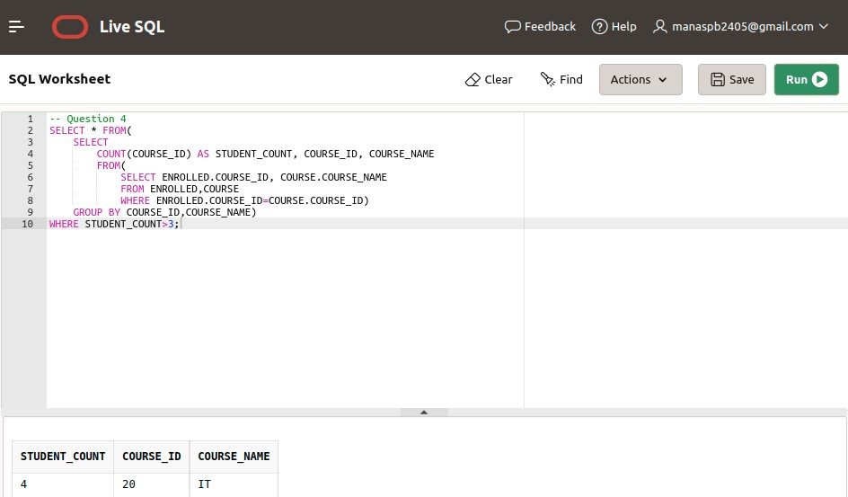

**QUESTION 5.**

SELECT

STUDENT.STUDENT_ID,

STUDENT.STUDENT_NAME,

SUBJECT.SUBJECT_ID,

SUBJECT.SUBJECT_NAME,

SELECTED.GRADE

FROM student

INNER JOIN SELECTED on STUDENT.STUDENT_ID = SELECTED.STUDENT_ID

INNER JOIN SUBJECT on SELECTED.SUBJECT_ID = SUBJECT.SUBJECT_ID where STUDENT.STUDENT_ID = 18071;

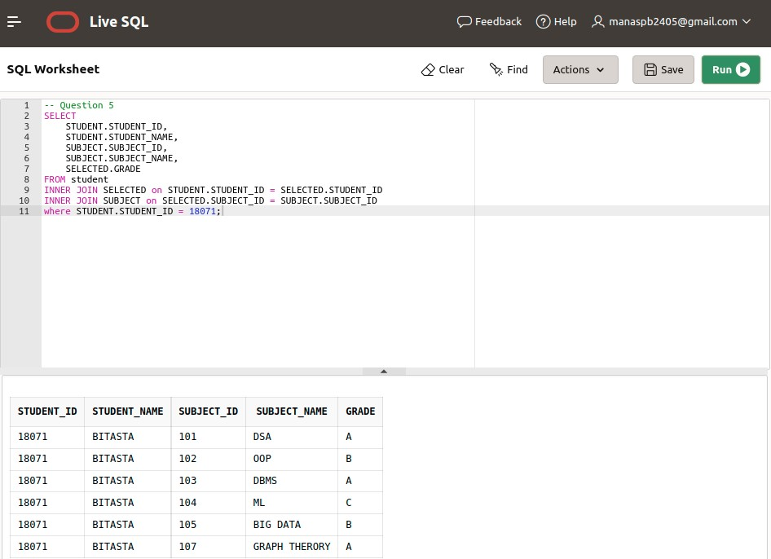

**QUESTION 6.**

SELECT STUDENT_COUNT, COURSE_NAME FROM ( SELECT COUNT(COURSE_ID) AS STUDENT_COUNT ,COURSE_ID, COURSE_NAME

FROM (

SELECT ENROLLED.COURSE_ID , COURSE.COURSE_NAME

FROM ENROLLED,COURSE

WHERE ENROLLED.COURSE_ID=COURSE.COURSE_ID)

GROUP BY COURSE_ID,COURSE_NAME)

WHERE STUDENT_COUNT = (

SELECT MAX(STUDENT_COUNT) FROM(

SELECT COUNT(COURSE_ID) AS STUDENT_COUNT ,COURSE_ID, COURSE_NAME

FROM (

SELECT ENROLLED.COURSE_ID , COURSE.COURSE_NAME

FROM ENROLLED,COURSE

WHERE ENROLLED.COURSE_ID=COURSE.COURSE_ID) GROUP BY COURSE_ID,COURSE_NAME));

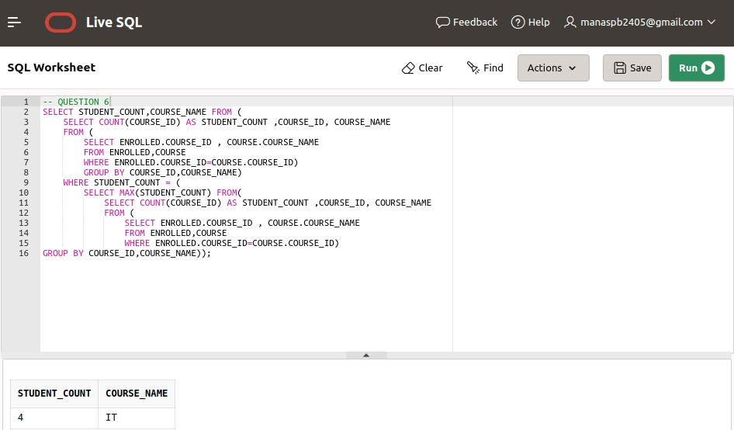

**QUESTION 7.**

SELECT

COURSE.COURSE_ID,

COURSE_NAME

FROM COURSE

LEFT JOIN STUDENT ON COURSE.COURSE_ID = STUDENT.COURSE_ID

WHERE STUDENT_ID IS NULL;

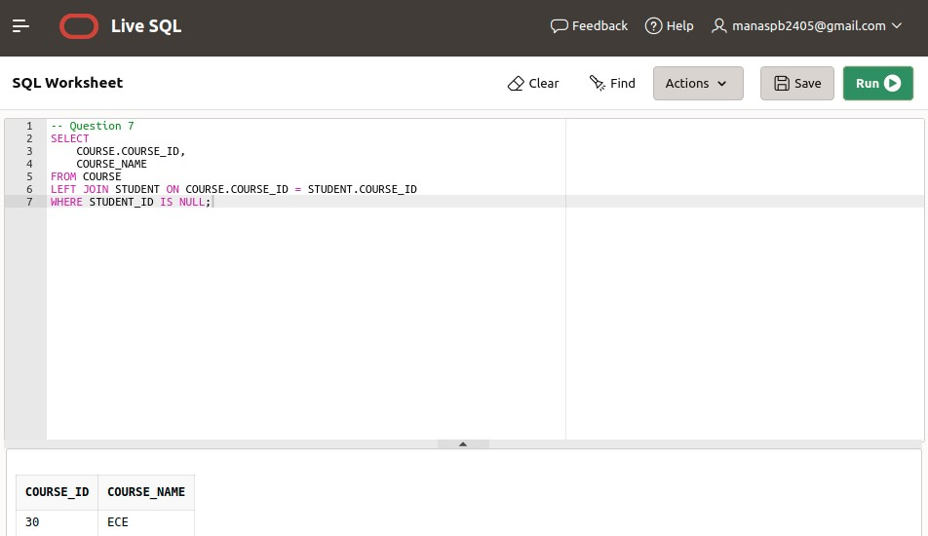

**QUESTION 8.**

DELETE FROM COURSE

WHERE COURSE_ID = 30; **QUESTION 9.**

RENAME COURSE TO DEPARTMENT;

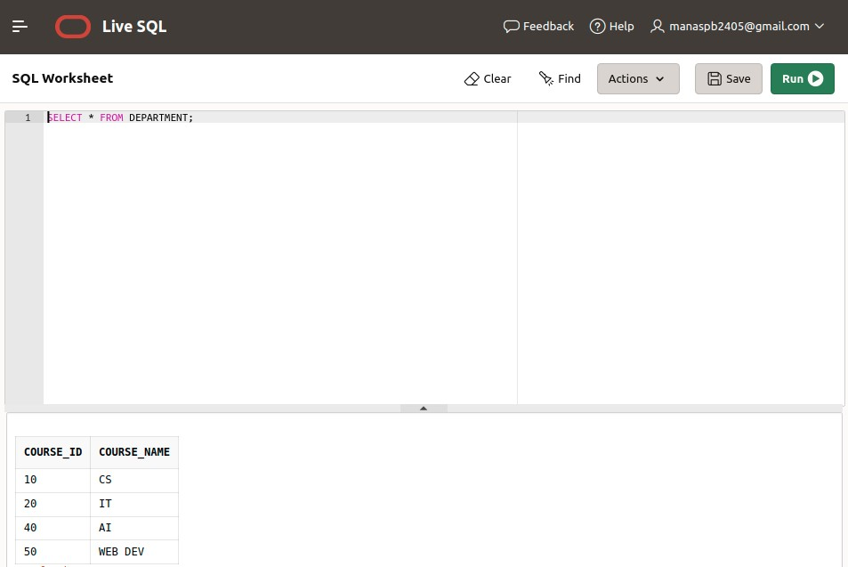

**QUESTION 10.**

UPDATE SELECTED

SET GRADE='B'

WHERE SUBJECT_ID =103 AND GRADE='A';

**QUESTION 11.**

DELETE FROM STUDENT

WHERE COURSE_ID = 20; **QUESTION 12.**

UPDATE ENROLLED

SET ENROLL_DATE = '16-AUG-18'

WHERE STUDENT_ID = 18069;