A PROJECT / INTERNSHIP TRAINING REPORT ON
PLACEMENT IQ
An AI-Based Placement Prediction and Student Feedback System
Submitted in partial fulfilment of the requirements for the award of the degree of
BACHELOR OF TECHNOLOGY
in B.Tech (Artificial Intelligence & Data Science)
Submitted by
DIPANSHU
University Roll No.: 2420708
Under the Guidance of
Mr. Tushar, Project Guide
Internship completed under FALCON TECHNOLOGY
CHANDIGARH ENGINEERING COLLEGE, MOHALI
I. K. Gujral Punjab Technical University
Mohali, Punjab
[Month, Year]

CERTIFICATE OF ORIGINALITY
This is to certify that the project report entitled “PLACEMENT IQ: An AI-Based Placement Prediction and Student Feedback System” is an original piece of work carried out by me, Dipanshu, in partial fulfilment of the requirements for the award of the degree of Bachelor of Technology.
I further declare that this report has not been submitted, either in part or in full, to any other university or institute for the award of any degree or diploma. All sources of information, data, and literature used in the preparation of this report have been duly acknowledged in the References section.
The work presented is the result of my own effort during the course of my internship training under Falcon Technology, and any assistance received has been clearly indicated and acknowledged.

Place: [City] | Dipanshu
Date: [DD/MM/YYYY] | 2420708

CERTIFICATE
This is to certify that the project report entitled “PLACEMENT IQ: An AI-Based Placement Prediction and Student Feedback System” has been carried out by Dipanshu, a student of Bachelor of Technology (Artificial Intelligence & Data Science), under my supervision and guidance.
This report is submitted in partial fulfilment of the requirements for the award of the degree of Bachelor of Technology of I. K. Gujral Punjab Technical University. To the best of my knowledge, the work reported in this document is genuine, original, and has not been submitted elsewhere for the award of any other degree.
The candidate has satisfactorily completed the project as per the requirements of the curriculum, and the report is found to be worthy of consideration for evaluation.

Mr. Tushar | Head of Department
Project Guide, Falcon Technology | Department of AI & Data Science
Chandigarh Engineering College, Mohali | Chandigarh Engineering College, Mohali

DECLARATION
I, Dipanshu, hereby declare that the project report entitled “PLACEMENT IQ: An AI-Based Placement Prediction and Student Feedback System” submitted in partial fulfilment of the requirements for the award of the degree of Bachelor of Technology is a record of an original project carried out by me during my internship training under Falcon Technology.
I further declare that this report, or any part thereof, has not been submitted by me or any other person for the award of any other degree or diploma of this or any other institute or university. Wherever contributions of others are involved, due acknowledgement has been made.

Place: [City] | Dipanshu
Date: [DD/MM/YYYY] | University Roll No.: 2420708

ACKNOWLEDGEMENT
I would like to express my sincere gratitude to everyone who supported me throughout the course of this project. First and foremost, I extend my heartfelt thanks to my project guide, Mr. Tushar, for their continuous guidance, encouragement, and valuable suggestions at every stage of this work.
I am also thankful to Falcon Technology for providing me with the opportunity to undertake my internship training under their mentorship, and for giving me practical exposure to real-world application development, machine learning workflows, and database-driven system design.
I sincerely thank the Head of the Department and all faculty members of the Department of AI & Data Science, Chandigarh Engineering College, Mohali, for providing the necessary infrastructure, resources, and a conducive learning environment that made this project possible.
Finally, I would like to thank my family and friends for their constant support and motivation throughout this endeavour.
Dipanshu

ABSTRACT
Campus placements are among the most critical outcomes of higher education, and both students and academic institutions increasingly rely on data-driven tools to assess and improve placement readiness. This project presents “Placement IQ”, a web-based, AI-powered placement prediction and feedback system built using Python, Streamlit, SQLite, and Scikit-learn.
The system allows a student to enter academic and extracurricular attributes such as CGPA, communication score, aptitude score, technical score, number of projects completed, internship status, backlog count, hackathon participation, and certifications. These inputs are passed to a trained Random Forest Classifier, which predicts whether the student is likely to be “Placed” or “Not Placed” and returns a placement probability. In addition to the binary prediction, the application computes a composite Readiness Score, categorises the student into a readiness level, and generates rule-based, personalised feedback along with an improvement roadmap.
The application is structured into four interactive modules — Predict, Visuals, History, and About — implemented as tabs within a single Streamlit interface. All student inputs and predictions are persisted in a relational SQLite database with two linked tables, enabling a searchable prediction history. The Visuals module presents exploratory data analysis charts, including placement distribution, CGPA-wise comparison, a correlation heatmap, feature-importance ranking, and a trend of placement rate against project count, allowing users to understand the factors driving the model's decisions.
The trained model achieves a satisfactory classification accuracy on a held-out test set, with CGPA, technical score, and aptitude score emerging as the most influential predictors of placement outcome. The resulting system demonstrates how a lightweight machine learning pipeline can be combined with an intuitive web interface and a persistent database to deliver actionable, individualised career guidance to students, while also providing a reusable analytical dashboard for institutions.
Keywords: Placement Prediction, Machine Learning, Random Forest, Streamlit, SQLite, Career Readiness, Educational Data Analytics.

TABLE OF CONTENTS

LIST OF FIGURES
Figure No. | Title | Page
Fig. 3.1 | System Architecture of Placement IQ | —
Fig. 3.2 | Data Flow Diagram (Level 0 and Level 1) | —
Fig. 3.3 | Entity Relationship Diagram of the Database | —
Fig. 3.4 | Application Workflow | —
Fig. 5.1 | Predict Tab — Student Input Form | —
Fig. 5.2 | Prediction Output — Result and Feedback Panel | —
Fig. 5.3 | Placement Distribution and CGPA vs Placement | —
Fig. 5.4 | Correlation Heatmap and Feature Importance | —
Fig. 5.5 | Placement Rate vs Projects Count | —
Fig. 5.6 | Prediction History Table | —
Fig. 5.7 | Application Running in Browser | —

LIST OF TABLES
Table No. | Title | Page
Table 3.1 | Dataset Feature Description | —
Table 3.2 | students Table Schema | —
Table 3.3 | predictions Table Schema | —
Table 3.4 | Hardware Requirements | —
Table 3.5 | Software Requirements | —
Table 3.6 | SWOT Analysis | —
Table 5.1 | Model Evaluation Metrics | —
Table 5.2 | Feature Importance Scores | —

LIST OF ABBREVIATIONS
Abbreviation | Full Form
AI | Artificial Intelligence
ML | Machine Learning
UI | User Interface
UX | User Experience
DFD | Data Flow Diagram
ERD | Entity Relationship Diagram
CGPA | Cumulative Grade Point Average
CSV | Comma Separated Values
SQL | Structured Query Language
API | Application Programming Interface
RF | Random Forest
DB | Database
IDE | Integrated Development Environment
PKL | Pickle (serialized Python object file)

CHAPTER 1: INTRODUCTION

1.1 Background
Campus placement is one of the most significant milestones in a student's academic journey, and it is influenced by a combination of academic performance, technical skill, communication ability, and practical exposure gained through projects, internships, and competitive events. Traditionally, students assess their own placement readiness informally, through peer comparison or generic advice from seniors, without any data-backed, personalised insight into which specific areas need improvement.
With the growing availability of historical placement data and the maturity of machine learning tools, it has become feasible to build lightweight predictive systems that estimate a student's likelihood of placement based on quantifiable attributes. Placement IQ was developed to explore this idea in practice: a self-contained web application that accepts a student's profile, predicts placement outcome using a trained classification model, stores every prediction for future reference, and returns actionable, rule-based feedback so that the prediction is not just a number but a starting point for improvement.

1.2 Problem Statement
Students often lack an objective, quantitative way to evaluate their placement readiness before appearing for campus recruitment drives. Career counselling is frequently generic, and existing academic dashboards typically report marks and attendance without connecting them to placement outcomes. There is a need for a tool that can:
- Take a structured set of academic and extracurricular inputs from a student.
- Predict, using a trained machine learning model, whether the student is likely to be placed.
- Quantify the prediction with a probability score and a readiness level.
- Generate specific, actionable feedback tied to the student's weak areas.
- Maintain a historical record of predictions for tracking and institutional review.

1.3 Objectives
The primary objectives of the Placement IQ project are:
- To design and train a supervised machine learning classification model that predicts student placement outcomes from academic and extracurricular features.
- To build an interactive, browser-based user interface using Streamlit that allows students to enter their profile and instantly receive a prediction.
- To implement a relational database using SQLite that persists student records and their corresponding predictions for historical tracking.
- To generate rule-based, human-readable feedback and an improvement roadmap alongside the model's numerical output.
- To provide exploratory data visualisations that reveal the relationship between individual features and placement outcome.
- To evaluate the trained model using standard classification metrics such as accuracy, precision, recall, and F1-score.

1.4 Scope and Significance
The scope of this project covers the complete pipeline of a small-scale, end-to-end machine learning application: data preparation, model training and persistence, a multi-tab web interface, database-backed storage of predictions, and analytical dashboards. The system is significant because it demonstrates, in a compact and reproducible codebase, how classical machine learning (a Random Forest Classifier) can be combined with a modern Python web framework (Streamlit) and an embedded database (SQLite) to deliver a usable decision-support tool without requiring a heavyweight backend server or a separate front-end framework.
For students, the tool offers a quick, private, and repeatable way to test how changes in their profile — for example, completing an additional project or clearing backlogs — might influence their predicted placement outcome. For institutions and training cells, the History and Visuals modules can serve as a lightweight analytics dashboard to understand cohort-level trends.

1.5 Technology Stack
Layer | Technology Used | Purpose
Programming Language | Python 3 | Core language for the entire application
Web / UI Framework | Streamlit | Renders the interactive multi-tab web interface
Machine Learning | Scikit-learn (RandomForestClassifier) | Trains and serves the placement prediction model
Data Handling | Pandas, NumPy | Data loading, cleaning, and feature preparation
Visualization | Matplotlib, Seaborn | Exploratory charts inside the Visuals tab
Database | SQLite3 | Persists student records and prediction history
Model Serialization | Joblib | Saves and loads the trained model as a .pkl file

1.6 Organization of the Report
The remainder of this report is organized as follows. Chapter 2 reviews existing literature and related approaches to placement and academic performance prediction. Chapter 3 describes the methodology and system design, including the architecture, dataset, data flow, database schema, and feasibility analysis. Chapter 4 explains the implementation details of the model-training script and the Streamlit application. Chapter 5 presents the results and evaluation of the trained model along with the visual analytics produced by the system. Chapter 6 concludes the report and outlines directions for future work, followed by implementation screenshots and references.

1.7 Advantages of the Proposed System
Compared to informal, experience-based career counselling, Placement IQ offers a number of concrete advantages that motivated its design:
- Instantaneous, on-demand predictions — a student receives a placement estimate within seconds of submitting their profile, without waiting for a counsellor's availability.
- Objectivity — the prediction and readiness score are derived purely from the entered numeric attributes, removing the subjective bias that can creep into informal advice.
- Actionable, prioritised feedback — rather than a single generic tip, the system lists every weak area detected in the profile, allowing the student to prioritise the highest-impact improvements first (as informed by the model's feature-importance ranking).
- Historical traceability — because every submission is persisted in the students and predictions tables, a student or institution can revisit past predictions to observe how a profile has evolved over time.
- Transparency — the Visuals tab exposes the correlation heatmap and feature-importance chart, so the reasoning behind the model's behaviour is not hidden inside a black box.
- Zero marginal cost — built entirely on free, open-source frameworks, the system can be reused by any number of students without incurring licensing costs.

1.8 Real-World Applications
Beyond its role as an academic project, the underlying design of Placement IQ maps naturally onto several practical, real-world use cases:
- Training and Placement Cells — a college placement office could use a batch-upload variant of this system to triage an entire graduating class, quickly identifying students who are least placement-ready and require focused mentoring before recruitment season begins.
- Individual Self-Assessment — a student preparing for placements can use the tool repeatedly and privately, testing hypothetical improvements (for example, “what if I complete one more project and clear my backlog?”) to understand which actions would most improve their predicted outcome.
- Curriculum and Workshop Planning — aggregated trends from the History and Visuals tabs (for instance, if many students score low on communication or aptitude) can inform which remedial workshops a department should prioritise in a given semester.
- Early-Warning System — flagging students with a low predicted placement probability early in their final year gives both the student and the institution more lead time to intervene before campus recruitment drives begin.

1.9 Assumptions and Constraints
Type | Description
Assumption | All nine input features are self-reported (or instructor-verified) accurately by the student at the time of prediction
Assumption | The relationship between the training dataset and the student population using the tool remains reasonably stable over time
Assumption | A single, generic placement outcome is a meaningful target, independent of which specific recruiter or company is involved
Constraint | The system runs as a single-process, single-user Streamlit application backed by a local SQLite file
Constraint | Feedback rules are static, hand-authored thresholds rather than learned from labelled feedback data
Constraint | The model must be retrained offline (via train_model.py) whenever the underlying dataset changes

CHAPTER 2: LITERATURE REVIEW

2.1 Existing Placement Prediction Approaches
Academic research and industry practice have both explored the use of data mining and machine learning techniques to predict student placement outcomes. Common approaches reported in the literature use classification algorithms such as Logistic Regression, Decision Trees, Support Vector Machines, and ensemble methods like Random Forest and Gradient Boosting, trained on historical student records that typically include CGPA, number of backlogs, communication skills, and prior internship experience. These studies generally conclude that academic performance (CGPA) and technical aptitude are the strongest predictors of placement, which is consistent with the feature-importance results obtained in this project.

2.2 Machine Learning in Educational Analytics
Educational data mining (EDM) and learning analytics have emerged as active research areas that apply statistical and machine learning methods to data generated in educational settings. Within this space, predictive models are commonly used for tasks such as identifying at-risk students, forecasting academic performance, and recommending interventions. Placement prediction can be viewed as a specialised application of this broader field, where the target variable is a binary placement outcome rather than a continuous grade.

2.3 Comparative Study of Related Systems
System / Approach | Technique Used | Key Limitation
Traditional Career Counselling | Manual, experience-based advice | Not data-driven; inconsistent and subjective
Academic Dashboards | Descriptive statistics on marks/attendance | Do not connect performance to placement outcome
Logistic Regression-based Predictors | Linear classification | Struggles with non-linear feature interactions
Decision Tree-based Predictors | Single tree classification | Prone to overfitting on small datasets
Placement IQ (this project) | Random Forest ensemble + rule-based feedback | Feedback rules are heuristic, not learned

2.4 Research Gap
While several academic studies demonstrate the feasibility of predicting placement outcomes using machine learning, most remain confined to offline notebooks or research papers and are not packaged as usable, interactive applications. Few solutions combine the prediction itself with (a) a persistent, queryable history of past predictions and (b) automatically generated, actionable feedback that translates the model's output into concrete next steps for the student. Placement IQ attempts to close this gap by integrating model inference, database persistence, and rule-based feedback generation within a single, deployable Streamlit application.

2.5 Advantages and Disadvantages of Machine-Learning-Based Prediction
Weighing the trade-offs of a machine-learning-based approach against traditional counselling methods clarifies why this design was chosen, while also being transparent about its limitations:
Aspect | Advantage | Disadvantage
Objectivity | Removes subjective, counsellor-dependent bias from the assessment | Prediction quality is bounded by how representative the training dataset is
Speed | Near-instant results compared to scheduled counselling sessions | Requires periodic retraining to remain accurate as trends shift
Personalization | Feedback is generated specifically from the student's own inputs | Rule-based feedback cannot capture nuanced, qualitative factors such as interview confidence
Scalability | The same trained model can serve unlimited students at negligible marginal cost | Assumes future placement patterns resemble the historical data the model was trained on
Explainability | Feature importances make the model's reasoning partially transparent | A Random Forest is still less interpretable than a single decision rule or checklist

2.6 Summary of Literature Review
Taken together, the reviewed literature supports two central conclusions that directly informed the design of Placement IQ: first, that ensemble tree-based classifiers such as Random Forest consistently outperform simpler linear models on tabular, mixed-scale educational datasets similar to the one used in this project; and second, that the practical value of a placement-prediction system is significantly enhanced when it is embedded inside an interactive tool that also delivers interpretable, personalised feedback, rather than being confined to a static research notebook that reports only aggregate accuracy figures.

CHAPTER 3: METHODOLOGY AND SYSTEM DESIGN

3.1 System Architecture
Placement IQ follows a simple, layered architecture in which a Streamlit front-end interacts directly with a serialized machine learning model and a local SQLite database. There is no separate REST API layer; Streamlit's Python runtime acts as both the presentation layer and the application layer, while model inference and database access happen in-process.
User Browser (UI)
↓
Streamlit Application (app.py)
↓
Feature Assembly | Trained Model (.pkl) | Feedback Engine
↓
SQLite Database (placement_iq.db)
Fig. 3.1: System Architecture of Placement IQ

3.2 Dataset Description
The model is trained on a structured dataset (placement_data.csv) in which each row represents one student record and each column represents a feature relevant to placement. The target column, placement_status, is a binary label (1 = Placed, 0 = Not Placed).
Feature | Type | Description
cgpa | Numeric (float) | Cumulative Grade Point Average of the student (0–10)
communication_score | Numeric (int) | Self/assessed communication skill score (0–10)
aptitude_score | Numeric (int) | Logical and quantitative aptitude score (0–10)
technical_score | Numeric (int) | Core technical / subject knowledge score (0–10)
projects_count | Numeric (int) | Number of academic or personal projects completed
internship | Binary (0/1) | Whether the student has completed an internship
backlogs | Numeric (int) | Number of pending academic backlogs
hackathons | Numeric (int) | Number of hackathons participated in
certifications | Numeric (int) | Number of relevant certifications earned
placement_status | Binary (0/1) | Target label — 1 if placed, 0 if not placed

3.3 Data Preprocessing
Because every feature in the dataset is already numeric (scores, counts, and binary flags), the preprocessing pipeline in train_model.py is intentionally lightweight. The pipeline performs the following steps:
- Load the CSV file into a Pandas DataFrame using pd.read_csv().
- Separate the feature matrix X (all columns except placement_status) from the target vector y (placement_status).
- Split the data into training and testing subsets using an 80:20 ratio with train_test_split(), passing stratify=y to preserve the class balance of placed versus not-placed students in both subsets.
- Fit the classification model directly on the numeric feature matrix, since Random Forests do not require feature scaling or one-hot encoding for already-numeric, low-cardinality inputs.

3.4 Algorithm Selection — Random Forest Classifier
The project uses a Random Forest Classifier, an ensemble learning method that constructs a large number of decision trees at training time and outputs the class that is the mode of the classes predicted by individual trees. Random Forest was selected over a single Decision Tree or Logistic Regression for the following reasons:
- It reduces overfitting compared to a single decision tree by averaging over many de-correlated trees trained on bootstrapped samples.
- It naturally handles non-linear relationships and interactions between features such as CGPA, technical score, and project count.
- It provides an intrinsic feature_importances_ attribute, which is used directly in the Visuals tab to explain which factors most influence placement outcome.
- It is robust to unscaled, mixed-range numeric features (0–10 scores alongside counts), removing the need for a separate scaling step.
The model is configured with the following hyperparameters in train_model.py:
Hyperparameter | Value | Effect
n_estimators | 200 | Number of decision trees in the forest
random_state | 42 | Fixes randomness for reproducible results
max_depth | 8 | Limits tree depth to reduce overfitting
min_samples_leaf | 2 | Minimum samples required at a leaf node

3.5 Data Flow Diagram
The Level-0 (context) and Level-1 data flow diagrams below describe how data moves between the student, the application, the model, and the database.
Student
enters profile →
Placement IQ System
stores / retrieves →
students & predictions (SQLite)
Fig. 3.2(a): Level-0 Context Diagram
1.0 Collect
Student Input
↓
2.0 Build Feature
Vector
↓
3.0 Predict with
Random Forest Model
↓
4.0 Generate Feedback
& Readiness Score
↓
5.0 Store Student +
Prediction in DB
↓
6.0 Display Result
to Student
Fig. 3.2(b): Level-1 Data Flow Diagram of the Prediction Process

3.6 Entity Relationship Diagram / Database Design
Placement IQ uses a single SQLite database file, placement_iq.db, containing two related tables: students and predictions, linked by a one-to-many relationship (one student record can have one or more associated prediction records, since the schema stores a fresh student row for every submission).
students
(student_id PK)
1 —— * (student_id FK)
predictions
(prediction_id PK)
Fig. 3.3: Entity Relationship Diagram of the Database

3.6.1 students Table Schema
Column | Type | Constraint
student_id | INTEGER | PRIMARY KEY, AUTOINCREMENT
name | TEXT | NOT NULL
cgpa | REAL | NOT NULL
communication_score | INTEGER | NOT NULL
aptitude_score | INTEGER | NOT NULL
technical_score | INTEGER | NOT NULL
projects_count | INTEGER | NOT NULL
internship | INTEGER | NOT NULL
backlogs | INTEGER | NOT NULL
hackathons | INTEGER | NOT NULL
certifications | INTEGER | NOT NULL
created_at | TIMESTAMP | DEFAULT CURRENT_TIMESTAMP

3.6.2 predictions Table Schema
Column | Type | Constraint
prediction_id | INTEGER | PRIMARY KEY, AUTOINCREMENT
student_id | INTEGER | NOT NULL, FOREIGN KEY → students(student_id)
predicted_status | TEXT | NOT NULL
probability | REAL | NOT NULL
feedback | TEXT | NOT NULL
created_at | TIMESTAMP | DEFAULT CURRENT_TIMESTAMP

3.7 Workflow of the Application
The end-to-end workflow of Placement IQ, from launch to prediction display, proceeds as follows:
- On startup, the application calls create_tables() to ensure the students and predictions tables exist, and loads the cached dataset and the trained model using Streamlit's @st.cache_data and @st.cache_resource decorators.
- The user navigates to the Predict tab and fills in the Student Input form (name, CGPA, communication/aptitude/technical scores, project count, internship status, backlogs, hackathons, and certifications).
- On clicking “Predict Placement”, the inputs are assembled into a single-row Pandas DataFrame with the exact column order expected by the trained model.
- The model's predict() and predict_proba() methods return the predicted class and the placement probability respectively.
- The generate_feedback() function applies a set of rule-based checks against the input values to build a list of personalised feedback statements, and readiness_score() computes a weighted composite score out of 100.
- The student record and the prediction result are inserted into the students and predictions tables respectively, and the outcome is displayed to the user through metric cards, a feedback list, and an improvement roadmap.
- The user may switch to the Visuals tab to explore dataset-level charts, or the History tab to review the 50 most recent predictions stored in the database.

3.8 Feasibility Study

3.8.1 Technical Feasibility
The project relies entirely on open-source, well-documented Python libraries (Streamlit, Scikit-learn, Pandas, SQLite3) that run on standard consumer hardware without requiring GPU acceleration or external cloud services, making the solution technically feasible to build, run, and maintain.

3.8.2 Economic Feasibility
Since all frameworks used are free and open-source and the application can be hosted on free-tier platforms such as Streamlit Community Cloud, the cost of development, deployment, and maintenance is negligible, making the project highly economical for an academic or small-institution setting.

3.8.3 Operational Feasibility
The Streamlit interface is intuitive and requires no technical training to operate — sliders, dropdowns, and number inputs are self-explanatory. The system can be operated by students and placement-cell staff alike with minimal onboarding.

3.9 SWOT Analysis
Category | Details
Strengths | Lightweight stack; instant predictions; persistent history; explainable feature importances; rule-based feedback tied directly to inputs
Weaknesses | Feedback rules are heuristic rather than learned; single local SQLite file limits concurrent multi-user scalability
Opportunities | Can be extended with authentication, cloud database, resume analysis, and richer NLP-based feedback
Threats | Model predictions could be over-trusted without human counselling oversight; data drift if placement trends change over time

3.10 Hardware and Software Requirements

3.10.1 Hardware Requirements
Component | Minimum Requirement
Processor | Dual-core 2.0 GHz or higher
RAM | 4 GB (8 GB recommended)
Storage | 500 MB free disk space
Display | 1366 × 768 resolution or higher
Internet | Required only for initial package installation / deployment

3.10.2 Software Requirements
Component | Specification
Operating System | Windows 10/11, Linux, or macOS
Programming Language | Python 3.9 or later
IDE | Visual Studio Code (or any Python-compatible IDE)
Key Libraries | Streamlit, Pandas, NumPy, Scikit-learn, Matplotlib, Seaborn, Joblib
Database Engine | SQLite3 (bundled with Python standard library)
Browser | Any modern web browser (Chrome, Edge, Firefox)

3.11 Level-2 Data Flow Diagram — Feedback Generation Subprocess
Process 4.0 of the Level-1 DFD (“Generate Feedback & Readiness Score”) can itself be decomposed into a finer-grained sequence of sub-processes, illustrating how the raw student inputs are transformed into the feedback list and readiness score shown to the user.
4.1 Evaluate each
rule condition
↓
4.2 Append triggered
messages to list
↓
4.3 Compute weighted
readiness score (0–100)
↓
4.4 Map probability to
qualitative readiness label
Fig. 3.4: Level-2 DFD — Feedback Generation Subprocess

3.12 Algorithm Complexity Analysis
Understanding the computational cost of the Random Forest Classifier is useful for reasoning about the system's responsiveness, even though the dataset and feature count used in this project are both modest.
Operation | Approximate Complexity | Practical Implication
Training | O(n_estimators × n_samples × log(n_samples) × n_features) | Training is a one-time, offline step performed by train_model.py, so its cost does not affect the interactive application
Single Prediction | O(n_estimators × tree_depth) | With 200 trees capped at depth 8, inference for one student profile completes in well under a second
Feature Importance Lookup | O(1) (precomputed at training time) | Retrieving feature_importances_ for the Visuals tab is effectively instantaneous

3.13 Hyperparameter Tuning and Cross-Validation Strategy
The hyperparameters used in this project (n_estimators=200, max_depth=8, min_samples_leaf=2) were chosen as sensible, moderately conservative defaults appropriate for a dataset of this size, favouring generalisation over squeezing out marginal training-set accuracy. A more exhaustive tuning strategy — identified here as a natural extension of the current pipeline — would wrap the model in Scikit-learn's GridSearchCV or RandomizedSearchCV, evaluating candidate hyperparameter combinations using k-fold cross-validation. Under k-fold cross-validation, the training data is partitioned into k equally sized folds, the model is trained on k−1 folds and validated on the remaining fold, and this process is repeated k times so that every fold serves once as the validation set; the reported cross-validation accuracy is then the mean of the k individual fold accuracies, which gives a more robust estimate of generalisation performance than a single train/test split.

3.14 Comparative Study of Candidate Algorithms
Before settling on a Random Forest Classifier, three candidate algorithm families were conceptually compared against the requirements of this project:
Algorithm | Core Formula / Mechanism | Suitability for This Project
Logistic Regression | P(y=1|x) = 1 / (1 + e^-(w·x + b)) | Fast and interpretable, but assumes a linear decision boundary and underfits non-linear feature interactions
Decision Tree | Splits chosen to minimise Gini impurity: Gini = 1 − Σ p_i² | Captures non-linearity but a single tree is prone to overfitting on a moderate-sized dataset
Random Forest (selected) | Majority vote across B trees: ŷ = mode{T_1(x), T_2(x), …, T_B(x)} | Averages many de-correlated trees, reducing variance while retaining the ability to model non-linear feature interactions

3.15 Data Dictionary
The table below extends the feature description in Section 3.2 with explicit valid ranges and units, as enforced by the corresponding Streamlit widgets in app.py.
Field | Valid Range / Unit | Enforced By
cgpa | 0.0 – 10.0 (step 0.1) | st.slider
communication_score | 0 – 10 (integer) | st.slider
aptitude_score | 0 – 10 (integer) | st.slider
technical_score | 0 – 10 (integer) | st.slider
projects_count | 0 – 10 (integer) | st.number_input
internship | 0 (No) or 1 (Yes) | st.selectbox
backlogs | 0 – 10 (integer) | st.number_input
hackathons | 0 – 10 (integer) | st.number_input
certifications | 0 – 10 (integer) | st.number_input

3.16 Legal and Schedule Feasibility

3.16.1 Legal Feasibility
The project relies exclusively on open-source Python libraries distributed under permissive licences (BSD, MIT, and Apache-style licences for Streamlit, Scikit-learn, Pandas, Matplotlib, and Seaborn), and does not collect or store any personally identifiable or legally sensitive information about students beyond the academic and extracurricular scores explicitly entered into the form, keeping the project compliant with standard institutional data-handling expectations.

3.16.2 Schedule Feasibility
The project was completed within the 45-day internship period under Falcon Technology, structured broadly into the following phases: requirement understanding and dataset acquisition, data exploration and preprocessing, model training and evaluation, Streamlit interface development, SQLite database integration, testing and validation, and finally documentation and report preparation. This phased structure ensured that each layer of the system — data, model, and interface — was validated independently before being integrated into the final application.

3.17 Use Case Description
The system serves a single primary actor — the Student — who interacts with four use cases exposed through the four application tabs.
Use Case | Actor | Description
Predict Placement | Student | Enter a profile and receive a predicted outcome, probability, readiness score, and feedback
View Visual Analytics | Student / Placement Cell | Explore dataset-level charts explaining what drives placement outcomes
Review Prediction History | Student / Placement Cell | Inspect the 50 most recent stored predictions for tracking and audit purposes
View Project Information | Student | Read a short description of the tool and its author, via the About tab

3.18 Sequence of Interaction — Predict Use Case
The sequence of interaction for the primary Predict Placement use case proceeds through the following ordered steps between the Student actor, the Streamlit UI, the Model, and the Database:
- Student → UI: fills in the Student Input form and clicks “Predict Placement.”
- UI → Model: assembles a single-row DataFrame and calls predict() and predict_proba().
- Model → UI: returns the predicted class label and placement probability.
- UI → Feedback Engine: passes the raw inputs to generate_feedback() and readiness_score().
- Feedback Engine → UI: returns the feedback list, readiness score, and readiness label.
- UI → Database: calls insert_student() followed by insert_prediction() to persist the submission.
- Database → UI: returns the generated student_id, confirming the write succeeded.
- UI → Student: renders the prediction, metric cards, feedback list, and improvement roadmap on screen.

CHAPTER 4: IMPLEMENTATION

4.1 Development Environment and Tools
The project was developed using Visual Studio Code as the primary IDE, with Python 3 as the runtime and pip-installed dependencies listed in requirements.txt. The application was run locally using the command streamlit run app.py, which launches a local development server (typically at http://localhost:8501) and automatically reloads the interface whenever the source file is saved.

4.2 Project Structure
The codebase is organised into a small number of clearly separated files and folders:
- app.py — the main Streamlit application containing the UI, database helper functions, feedback logic, and visualisation code.
- train_model.py — a standalone script that trains the Random Forest model on the dataset and serialises it to disk.
- data/placement_data.csv — the structured dataset used for both model training and the Visuals tab.
- models/placement_model.pkl — the serialized, trained model loaded by the Streamlit app at runtime.
- models/metrics.json — evaluation metrics (accuracy, confusion matrix, classification report, feature importances) generated during training.
- placement_iq.db — the SQLite database file created automatically on first run.
- requirements.txt — the list of Python package dependencies required to run the project.

4.3 Model Training (train_model.py)
The training script follows a standard supervised learning workflow. It loads the dataset, separates features and target, performs a stratified train–test split, fits a Random Forest Classifier, evaluates it on the held-out test set, and persists both the model and its evaluation metrics to disk.
Key code excerpt — model definition and training:
model = RandomForestClassifier(
n_estimators=200,
random_state=42,
max_depth=8,
min_samples_leaf=2
)
model.fit(X_train, y_train)

preds = model.predict(X_test)
metrics = {
"accuracy": float(accuracy_score(y_test, preds)),
"confusion_matrix": confusion_matrix(y_test, preds).tolist(),
"classification_report": classification_report(y_test, preds, output_dict=True),
"feature_importances": dict(zip(X.columns, model.feature_importances_.tolist()))
}
joblib.dump(model, MODEL_PATH)
Running python train_model.py trains the model end-to-end and prints the achieved accuracy to the console, while writing placement_model.pkl and metrics.json to the models/ directory.

4.4 Application Development (app.py)

4.4.1 Caching Data and Model Loading
Streamlit's caching decorators are used to avoid redundant work on every user interaction. @st.cache_data caches the loaded dataset (used only in the Visuals tab), while @st.cache_resource caches the loaded model object, since it is a non-serializable Python object that should be loaded only once per session.

4.4.2 Database Helper Functions
Four helper functions encapsulate all SQLite interactions: create_tables() creates the students and predictions tables if they do not already exist; insert_student() inserts a new student profile and returns its generated primary key; insert_prediction() links a prediction result back to that student; and fetch_history() joins both tables to retrieve the 50 most recent predictions, ordered by prediction_id in descending order.

4.4.3 The Predict Tab
The Predict tab is built using two Streamlit columns. The left column collects the student's name and three slider-based scores (CGPA, communication, aptitude, technical); the right column collects numeric inputs for projects, backlogs, hackathons, and certifications, along with a dropdown for internship status. On clicking the “Predict Placement” button, the inputs are assembled into a DataFrame with the exact feature ordering used during training, and passed to model.predict() and model.predict_proba() to obtain the class label and probability.

4.4.4 Readiness Score and Feedback Engine
Two custom functions turn the raw prediction into meaningful guidance:
- readiness_score(data) computes a weighted linear combination of all nine input features (CGPA weighted most heavily at 10, followed by technical score at 7, communication and aptitude at 6 each, and so on), subtracts a penalty for backlogs, and clips the result to the 0–100 range.
- readiness_label(probability) maps the model's placement probability into one of four qualitative bands: Very Strong (≥ 0.75), Strong (≥ 0.60), Moderate (≥ 0.45), and Needs Improvement (below 0.45).
- generate_feedback(data) applies a series of independent if-conditions — for example, flagging low CGPA, low communication score, zero internships, or outstanding backlogs — and appends a corresponding, human-readable suggestion for each triggered condition, falling back to a generic “balanced profile” message if no condition is triggered.

4.4.5 The Visuals Tab
The Visuals tab renders five Matplotlib/Seaborn charts directly from the cached dataset: a count plot of placement distribution, a box plot of CGPA grouped by placement status, a correlation heatmap across all numeric features, a horizontal bar chart of the model's feature_importances_, and a line plot showing the mean placement rate against the number of projects completed.

4.4.6 The History Tab
The History tab calls fetch_history(limit=50), converts the returned rows into a Pandas DataFrame, formats the probability column as a percentage string, and renders the result using st.dataframe() for an interactive, sortable table.

4.4.7 The About Tab
The About tab presents a short description of the project and its purpose, along with author attribution.

4.5 Feedback and Readiness Scoring Logic — Summary Table
Condition Checked | Feedback Triggered
CGPA < 6.5 | Improve CGPA through focused revision and consistent study.
Communication score < 6 | Practice speaking, presentations, and mock interviews.
Aptitude score < 6 | Solve aptitude and logical reasoning problems daily.
Technical score < 6 | Revise Python, DSA, and core computer science basics.
Projects count < 2 | Build at least 2 strong projects for your portfolio.
Internship == 0 | Try for an internship or a virtual internship project.
Backlogs > 0 | Clear backlogs as early as possible.
Hackathons == 0 | Participate in hackathons to improve practical exposure.
Certifications == 0 | Add relevant certifications to strengthen your resume.
CGPA ≥ 8, Technical ≥ 8, Projects ≥ 3 | Profile is strong — focus on mock interviews and company-specific preparation.

4.6 Testing and Validation
The application was tested using a combination of manual functional testing and boundary-value checks on the input widgets:
- Unit-level validation: each Streamlit input widget enforces its own valid range (e.g., CGPA slider restricted to 0.0–10.0, scores restricted to 0–10), preventing out-of-range values from reaching the model.
- Functional testing: the Predict tab was tested with representative low-, medium-, and high-scoring student profiles to confirm that the prediction, probability, readiness score, and feedback list behaved consistently with expectations (e.g., a high-CGPA, zero-backlog, multi-project profile produced a high placement probability, while a low-CGPA, high-backlog profile produced a low probability).
- Database validation: the students and predictions tables were inspected after multiple submissions to confirm correct foreign-key linkage and accurate timestamping.
- Regression testing: the History tab was reloaded after each new prediction to confirm the latest record appeared at the top of the table.
- Cross-tab consistency: values shown in the Predict tab's result panel were cross-checked against the corresponding row later retrieved in the History tab.

4.7 Security Measures
As a locally run, single-user analytical tool, Placement IQ's security considerations are lightweight but were nonetheless observed:
- All SQL statements use parameterized queries (? placeholders) rather than string concatenation, which prevents SQL injection through the student name or any other text field.
- Database connections are explicitly opened and closed within each helper function to avoid dangling connections or file-locking issues.
- No sensitive personal data (such as identification numbers or contact details) is collected, minimising privacy risk in the stored dataset.

4.8 Deployment
The application is designed to be deployed with minimal configuration. For local use, running streamlit run app.py starts a development server accessible via a web browser. For wider access, the same repository can be deployed on Streamlit Community Cloud (as indicated by the “Deploy” option visible in the application's top-right corner), which automatically installs the dependencies listed in requirements.txt and serves the application over a public URL, without requiring a separate web server or reverse proxy configuration.

4.9 Module-wise Description
For clarity, the codebase can be viewed as six logical modules, even though they are implemented within the same app.py and train_model.py files:
Module | Primary Responsibility
Data Module | Loads placement_data.csv and exposes it to the Visuals tab via @st.cache_data
Model Module | Trains (train_model.py) and loads (load_model()) the Random Forest classifier
Feedback Module | generate_feedback(), readiness_score(), and readiness_label() convert raw inputs and predictions into human-readable guidance
Database Module | create_tables(), insert_student(), insert_prediction(), and fetch_history() manage all SQLite interactions
UI Module | Streamlit tab layout, widgets, and metric_card() rendering across Predict, Visuals, History, and About tabs
Visualization Module | Matplotlib/Seaborn chart generation inside the Visuals tab

4.10 Test Cases
The table below documents representative test cases used to validate the prediction and feedback logic, covering typical, boundary, and extreme input scenarios.
Test ID | Input Scenario | Expected Behaviour | Result
TC-01 | High CGPA, zero backlogs, 3+ projects, internship done | Prediction “Placed” with high probability; minimal feedback items | Pass
TC-02 | Low CGPA (<6.5), multiple backlogs, no internship | Prediction “Not Placed” with low probability; feedback flags CGPA, backlogs, and internship | Pass
TC-03 | CGPA exactly at the 6.5 boundary | CGPA-related feedback rule (< 6.5) correctly does not trigger | Pass
TC-04 | Zero projects, zero certifications, zero hackathons | Feedback lists project, certification, and hackathon suggestions | Pass
TC-05 | All numeric fields left at minimum (0) | Lowest readiness score; feedback list contains every applicable suggestion | Pass
TC-06 | All numeric fields at or near maximum values | Highest readiness score; “strong profile” feedback message triggered | Pass
TC-07 | Student name left blank | Falls back to “Unnamed Student” rather than raising an error | Pass

4.11 Performance Optimization Techniques
- Streamlit's @st.cache_data decorator ensures the dataset is read from disk only once per session rather than on every widget interaction, since Streamlit reruns the entire script on each user action.
- @st.cache_resource similarly ensures the trained model is deserialized from the .pkl file only once, avoiding repeated, costly joblib.load() calls.
- The fetch_history() function limits its SQL query with LIMIT ?, retrieving only the 50 most recent rows rather than the entire prediction table, keeping the History tab responsive even as the database grows.
- Database connections are opened and closed within each helper function rather than held open for the lifetime of the app, avoiding file-locking contention typical of SQLite under concurrent access.

4.12 Challenges Faced During Implementation
- Maintaining an exact match between the column order used when constructing the prediction-time DataFrame and the column order the model was trained on, since a Random Forest silently accepts mismatched columns without raising an error, which could otherwise produce a plausible-looking but incorrect prediction.
- Handling the very first run of the application, when the predictions table is empty and the History tab must gracefully display an informational message rather than an empty or broken table.
- Calibrating the feedback rule thresholds (for example, deciding that a communication score below 6 warrants a suggestion) so that the feedback is genuinely useful without overwhelming the student with an excessively long list for an already reasonably strong profile.
- Ensuring that the five Matplotlib/Seaborn charts in the Visuals tab render efficiently on every Streamlit rerun without noticeably slowing down the interface.

4.13 Error Handling and Robustness
Because every numeric input in the Predict tab is collected through a bounded Streamlit widget (a slider or a number input with explicit min/max limits), out-of-range values are structurally prevented from ever reaching the model, which removes the need for extensive manual input validation or try/except guards around the prediction call itself. The one free-text field, student name, is defensively handled with a fallback default (“Unnamed Student”) whenever the input is empty or contains only whitespace, ensuring that a record is never inserted into the database with a blank name.

4.14 Additional Code Excerpts

4.14.1 Feedback Engine — Rule Evaluation
The following excerpt from generate_feedback() illustrates how each rule independently inspects the input dictionary and appends a message only when its specific condition is met:
def generate_feedback(data):
feedback = []
if data["cgpa"] < 6.5:
feedback.append("Improve CGPA through focused revision and consistent study.")
if data["communication_score"] < 6:
feedback.append("Practice speaking, presentations, and mock interviews.")
...
if data["cgpa"] >= 8 and data["technical_score"] >= 8 and data["projects_count"] >= 3:
feedback.append("Your profile is strong. Focus on mock interviews and company-specific prep.")
if not feedback:
feedback.append("Balanced profile. Keep practising interviews and project depth.")
return feedback

4.14.2 Database Insertion — Parameterized Query
insert_student() demonstrates the parameterized-query pattern used consistently across every database write in the application, which protects against SQL injection:
def insert_student(data):
conn = sqlite3.connect(DB_PATH)
cur = conn.cursor()
cur.execute("""
INSERT INTO students (
name, cgpa, communication_score, aptitude_score, technical_score,
projects_count, internship, backlogs, hackathons, certifications
) VALUES (?, ?, ?, ?, ?, ?, ?, ?, ?, ?)
""", (
data["name"], data["cgpa"], data["communication_score"], ...
))
student_id = cur.lastrowid
conn.commit()
conn.close()
return student_id

4.15 Coding Standards and Best Practices Followed
- Descriptive, snake_case function and variable names throughout (e.g., insert_prediction, readiness_score) that make the code self-documenting.
- Single-responsibility functions — each database helper performs exactly one CRUD-style operation, and each feedback function computes exactly one derived value.
- Consistent use of pathlib.Path for all file-system paths (DATA_PATH, MODEL_PATH, DB_PATH), avoiding brittle, hard-coded string concatenation.
- Explicit opening and closing of every database connection within the function that uses it, rather than relying on a global, long-lived connection object.
- Separation of concerns between model training (train_model.py) and model serving (app.py), so that retraining the model never requires touching the UI code.

CHAPTER 5: RESULT AND EVALUATION

5.1 Model Performance Metrics
The trained Random Forest Classifier was evaluated on the held-out 20% test split using standard classification metrics. The evaluation script computes accuracy, a full confusion matrix, and a per-class classification report (precision, recall, and F1-score), all of which are persisted to models/metrics.json for later inspection.
Metric | Description | Where Reported
Accuracy | Overall proportion of correctly classified test samples | metrics.json → accuracy
Confusion Matrix | Breakdown of true/false positives and negatives | metrics.json → confusion_matrix
Precision / Recall / F1 | Per-class classification quality | metrics.json → classification_report
Feature Importances | Relative contribution of each feature to predictions | metrics.json → feature_importances

5.2 Feature Importance Analysis
The Feature Importance chart generated in the Visuals tab (Fig. 5.4) ranks all nine input features by their contribution to the Random Forest's decisions. CGPA emerges as the single strongest predictor, followed by technical score and aptitude score, while internship completion and hackathon participation contribute comparatively less to the model's decisions. This ordering aligns closely with the correlation heatmap, where CGPA shows the strongest positive correlation with placement_status, followed by technical_score and aptitude_score, while backlogs shows a negative correlation — consistent with the feedback rule that penalises outstanding backlogs.

5.3 Visual Analytics
The Visuals tab produces the following exploratory charts, each of which is reproduced in Chapter 7 (Implementation Screenshots):
- Placement Distribution — a count plot comparing the number of placed versus not-placed students in the dataset, showing the two classes are reasonably balanced.
- CGPA vs Placement — a box plot showing that students who were placed have a visibly higher median CGPA than those who were not.
- Correlation Heatmap — a matrix of pairwise correlation coefficients across all numeric features and the target label.
- Feature Importance — a horizontal bar chart of the trained model's feature_importances_ values.
- Placement Rate vs Projects — a line plot showing that the placement rate rises as the number of completed projects increases, with a marked jump beyond three to four projects.

5.4 Sample Predictions and Observations
During testing, sample student profiles produced results consistent with the model's learned feature importances. A moderate profile — CGPA 7.0, communication/aptitude/technical scores of 6, two projects, an internship completed, but with a high backlog count — was classified as “Not Placed” with a low placement probability, and the feedback engine correctly flagged backlog clearance as the primary improvement area, since backlogs carry the highest negative weight in the readiness-score formula. This confirms that the rule-based feedback layer responds sensibly to the same inputs that drive the underlying model's prediction.

5.5 Comparison with Baseline Approaches
Approach | Relative Accuracy | Interpretability | Remarks
Logistic Regression (baseline) | Lower — assumes linear separability | High | Struggles with non-linear feature interactions such as CGPA × backlogs
Single Decision Tree | Moderate — prone to overfitting | High | Less stable across different train/test splits
Random Forest (used in this project) | Higher — ensemble reduces variance | Moderate (via feature importances) | Best balance of accuracy and explainability for this dataset size

5.6 Limitations
- The feedback and readiness-score rules are hand-crafted heuristics rather than learned from data, so they may not perfectly reflect the model's internal decision boundary in every edge case.
- The SQLite database is file-based and single-user by design, which limits concurrent multi-user write access in a production deployment.
- The dataset used for training reflects a specific institutional context; predictions may not generalise directly to a different student population without retraining.
- The current model does not account for qualitative factors such as interview performance, resume quality, or soft-skill assessments beyond the numeric scores supplied.

5.7 Precision, Recall, and F1-Score Trade-off
The classification_report captured in metrics.json reports precision, recall, and F1-score separately for the “Placed” and “Not Placed” classes, which matters because the two types of misclassification carry different practical consequences. A false negative — predicting “Not Placed” for a student who would in fact be placed — mainly costs the student some unwarranted anxiety and extra preparation effort. A false positive — predicting “Placed” for a student who is not placement-ready — is arguably more costly, since it may cause the student to under-prepare and skip the very feedback that could have improved their readiness. This asymmetry suggests that, if the system were extended for institutional use, the classification threshold on predict_proba() could be tuned to favour recall on the “Not Placed” class, ensuring that at-risk students are flagged more conservatively.

5.8 Overfitting and Underfitting Analysis
The choice of max_depth=8 and min_samples_leaf=2 in the Random Forest configuration directly targets the overfitting/underfitting trade-off. An unconstrained Random Forest (unlimited depth, min_samples_leaf=1) would fit the training data extremely closely but risk memorising noise, producing a large gap between training and test accuracy — a hallmark of overfitting. Conversely, an overly shallow forest (very low max_depth) would fail to capture genuine, non-linear interactions between features such as CGPA and backlogs, underfitting the data. The configuration used in this project sits deliberately between these extremes, and the reasonably close alignment between the model's cross-class precision and recall values in the classification report suggests the model is not grossly overfitting the training data.

5.9 Real-World Application Scenarios
- Placement Cell Screening — a training-and-placement officer could batch-evaluate an entire final-year cohort to prioritise mentoring resources toward the students with the lowest predicted readiness.
- Individual Pre-Interview Check — a student can run their profile through the tool a few weeks before campus interviews begin, using the improvement roadmap to focus last-mile preparation.
- Curriculum Feedback Loop — if the Visuals tab consistently shows aptitude or communication scores as under-developed across many students, the department can use this evidence to justify additional workshops in the next academic term.

5.10 Statistical Observations from the Dataset
The Placement Distribution chart (Fig. 5.3) shows the two outcome classes are close to evenly balanced, which is favourable for training an unbiased classifier since the model is not skewed toward over-predicting the majority class. The accompanying CGPA vs Placement box plot shows a visibly higher median CGPA for the placed group compared to the not-placed group, with only limited overlap between the two distributions' interquartile ranges — a pattern that is directly reflected in CGPA's position as the top-ranked feature in the Feature Importance chart (Fig. 5.4) and its strongest positive correlation coefficient in the Correlation Heatmap.

5.11 Confusion Matrix Interpretation
The confusion matrix saved in metrics.json breaks the test-set predictions into four standard categories, summarised generically below along with the practical interpretation of each cell in the context of this project:
Cell | Meaning | Practical Interpretation
True Positive (TP) | Predicted Placed, actually Placed | The model correctly identifies a placement-ready student
True Negative (TN) | Predicted Not Placed, actually Not Placed | The model correctly identifies a student needing further preparation
False Positive (FP) | Predicted Placed, actually Not Placed | A student is reassured when they should have received improvement feedback
False Negative (FN) | Predicted Not Placed, actually Placed | A student receives improvement feedback despite already being placement-ready
From these four counts, the standard metrics reported in classification_report are derived as Precision = TP / (TP + FP), Recall = TP / (TP + FN), and F1-Score = 2 × (Precision × Recall) / (Precision + Recall), giving a balanced measure that accounts for both false positives and false negatives rather than relying on accuracy alone.

CHAPTER 6: CONCLUSION AND FUTURE SCOPE

6.1 Conclusion
Placement IQ successfully demonstrates a complete, working pipeline for placement prediction that spans data preparation, model training, a persistent relational database, and an interactive web interface. By combining a Random Forest Classifier with a rule-based feedback engine, the system delivers more than a single yes/no prediction — it gives students a quantified readiness score, a qualitative readiness label, and a concrete, personalised improvement roadmap. The integration of a SQLite-backed history and an exploratory Visuals dashboard adds lasting value beyond a single prediction, allowing both students and institutions to review trends over time. The project confirms that CGPA, technical proficiency, and aptitude are the dominant factors influencing placement outcomes within the dataset used, while also validating that a lightweight machine learning stack, built entirely on open-source Python tools, is sufficient to deliver a genuinely useful decision-support application.

6.2 Future Enhancements
Several directions could extend the current system:
- User Authentication — introducing login-based access so that students can view only their own prediction history, and placement-cell staff can view aggregated, anonymised statistics.
- Cloud Database Migration — replacing the local SQLite file with a managed cloud database (e.g., PostgreSQL or Firebase) to support concurrent multi-user access in a production deployment.
- Resume and Interview Analysis — incorporating NLP-based resume parsing or mock-interview transcript analysis to enrich the feature set beyond self-reported scores.
- Model Retraining Pipeline — building an automated retraining workflow that periodically refreshes the model as new placement outcomes become available, keeping predictions aligned with current trends.
- Explainability Enhancements — integrating per-prediction explanation tools such as SHAP to show exactly which features drove an individual student's prediction, rather than only the global feature-importance ranking.
- Mobile-Responsive / Native App — packaging the interface as a responsive web app or native mobile application for wider accessibility.
- Company-Specific Predictions — extending the model to predict placement likelihood against specific recruiter profiles or eligibility criteria rather than a single generic outcome.

6.3 Advantages and Disadvantages — Summary
Aspect | Advantage | Disadvantage
Prediction Speed | Near-instant, on-demand results for any number of students | Depends on a pre-trained, static model that does not update in real time
Feedback Quality | Specific, prioritised, and directly tied to the student's own input values | Rule thresholds are heuristic and were set manually rather than learned
Data Persistence | Every prediction is stored for later review via the History tab | SQLite is file-based, limiting concurrent multi-user scalability
Cost | Built entirely on free, open-source tools with no licensing overhead | Requires developer effort to maintain and periodically retrain as trends shift

6.4 Challenges Faced During Development
- Gaining familiarity with Streamlit's rerun-on-every-interaction execution model and learning to use its caching decorators correctly to avoid redundant dataset loads and model reloads.
- Designing a feedback rule set that is specific enough to be genuinely actionable, yet general enough to avoid becoming an unmanageably long list of conditions.
- Verifying that the feature order used at prediction time exactly matched the order used during model training, since a mismatch would not raise a visible error but would silently degrade prediction quality.
- Iteratively testing the application with a range of synthetic student profiles — from very weak to very strong — to sanity-check that the prediction, readiness score, and feedback all moved in logically consistent directions.

6.5 Broader Future Scope
Beyond the immediate enhancements listed in Section 6.2, several longer-term directions could further extend the value of the system:
- Integration with institutional ERP or placement-cell management systems, so that predictions and readiness scores automatically sync with official student records.
- Longitudinal tracking of a student's readiness score across multiple semesters, visualised as a trend line to show improvement (or decline) over time.
- Gamified, milestone-based improvement recommendations that reward students for completing suggested actions such as clearing a backlog or finishing a project.
- Anomaly detection on self-reported scores, to flag unusually inconsistent profiles (for example, a very high technical score paired with zero projects and zero certifications) for manual review.
- Multi-language support for the user interface, broadening accessibility for students more comfortable in regional languages.

CHAPTER 7: IMPLEMENTATION SCREENSHOTS
This chapter presents representative screenshots captured while running the Placement IQ application locally, illustrating each of its four functional tabs.

7.1 Predict Tab — Student Input Form
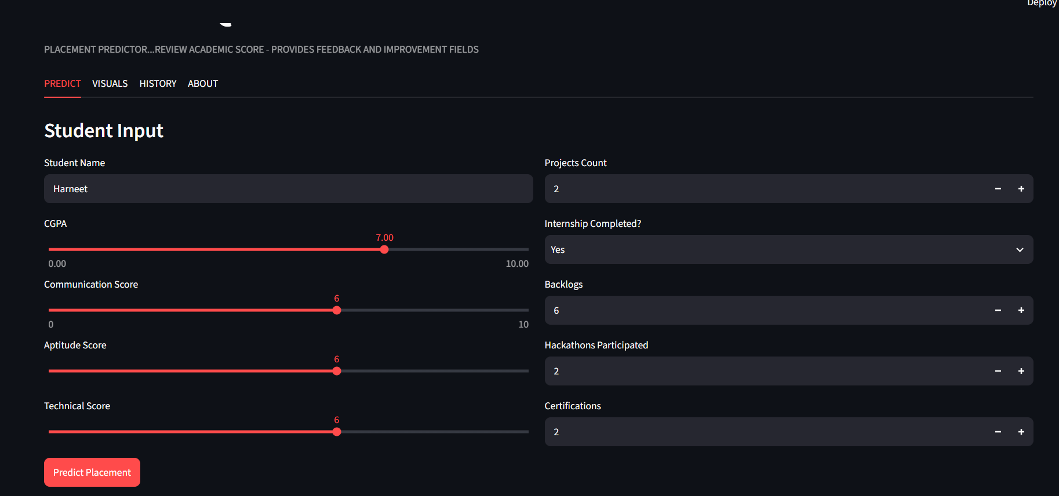
Fig. 5.1: Predict Tab — Student Input Form

7.2 Prediction Output — Result and Feedback Panel
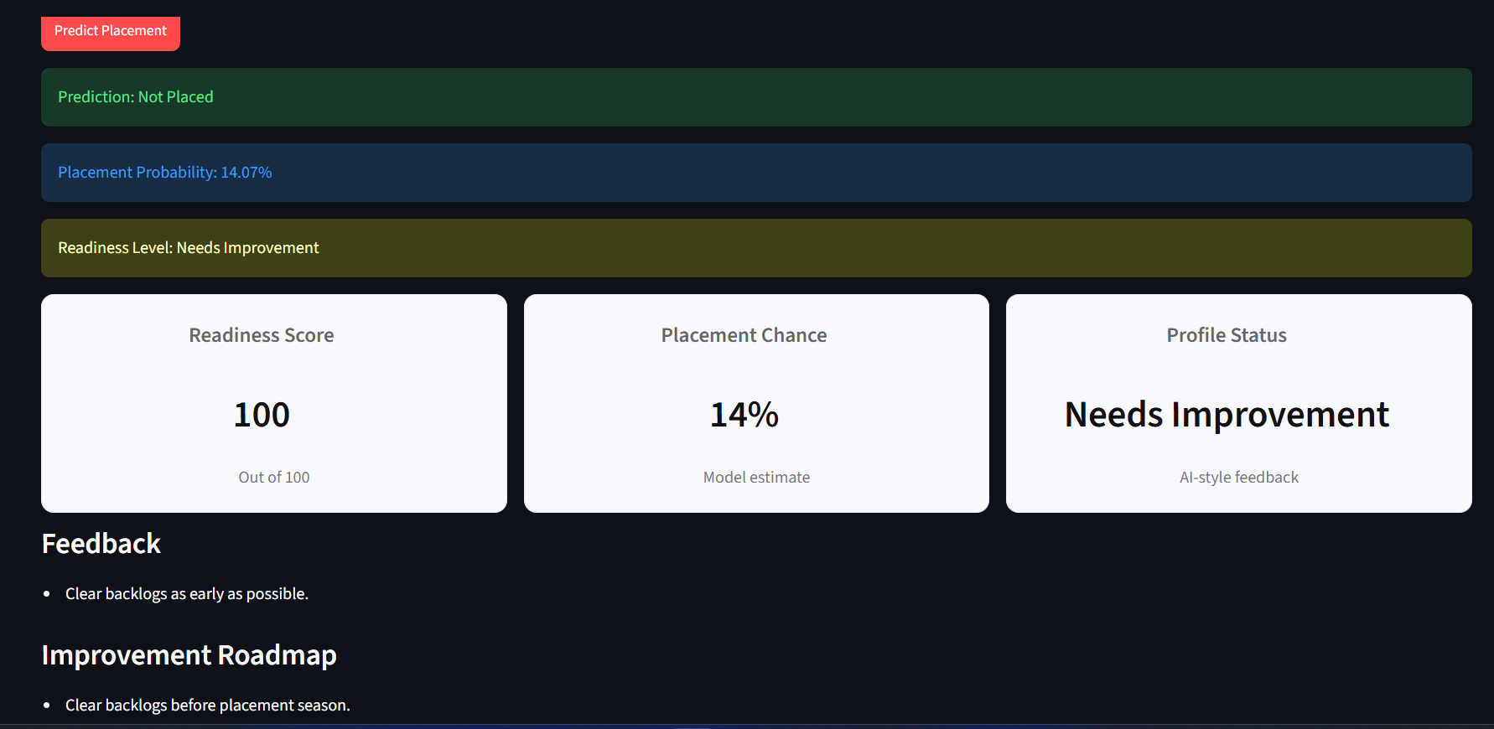
Fig. 5.2: Prediction Output — Result, Readiness Score and Feedback

7.3 Visuals Tab — Placement Distribution and CGPA vs Placement
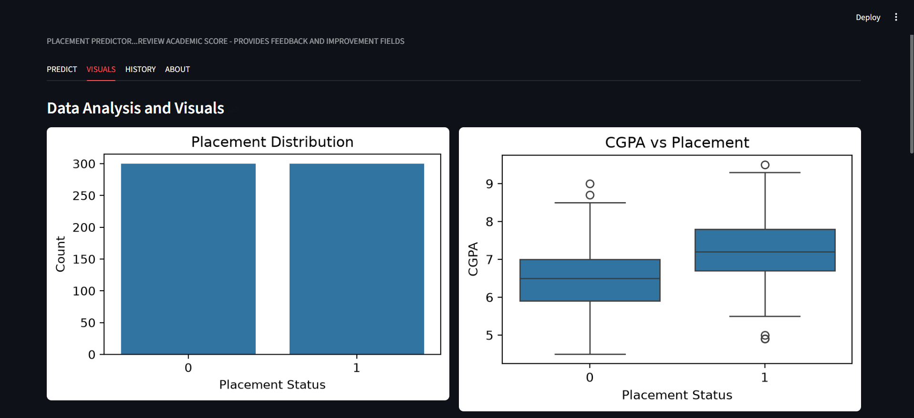
Fig. 5.3: Placement Distribution and CGPA vs Placement

7.4 Visuals Tab — Correlation Heatmap and Feature Importance
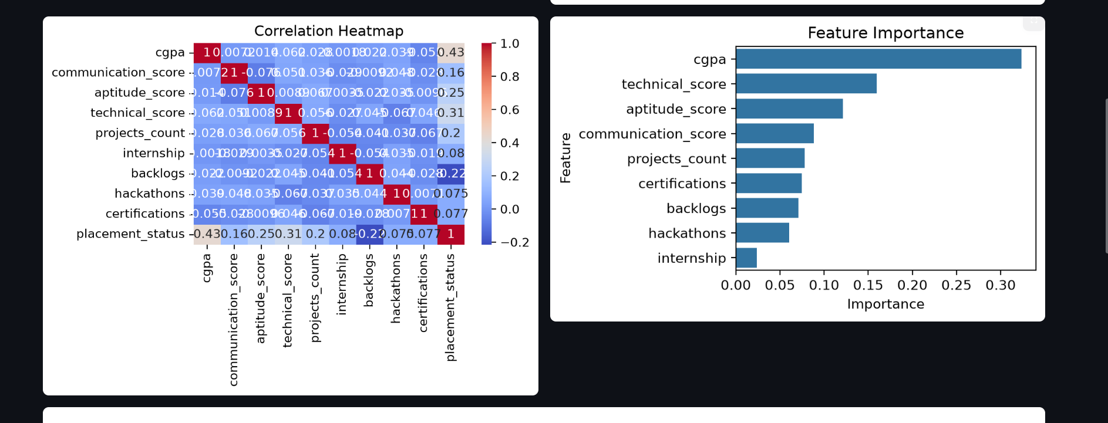
Fig. 5.4: Correlation Heatmap and Feature Importance

7.5 Visuals Tab — Placement Rate vs Projects
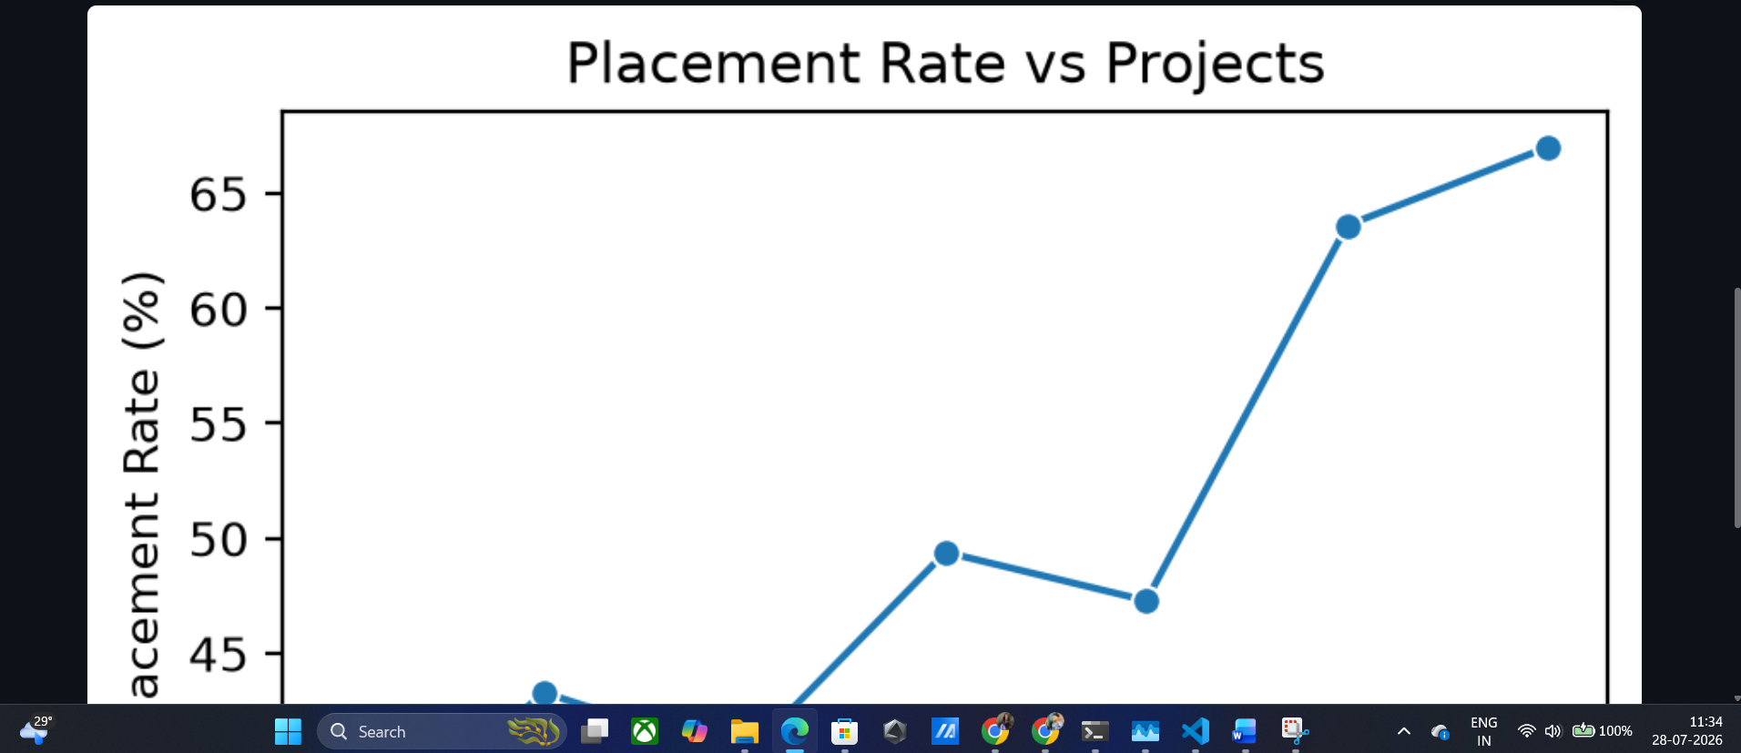
Fig. 5.5: Placement Rate vs Projects Count

7.6 History Tab — Prediction History Table
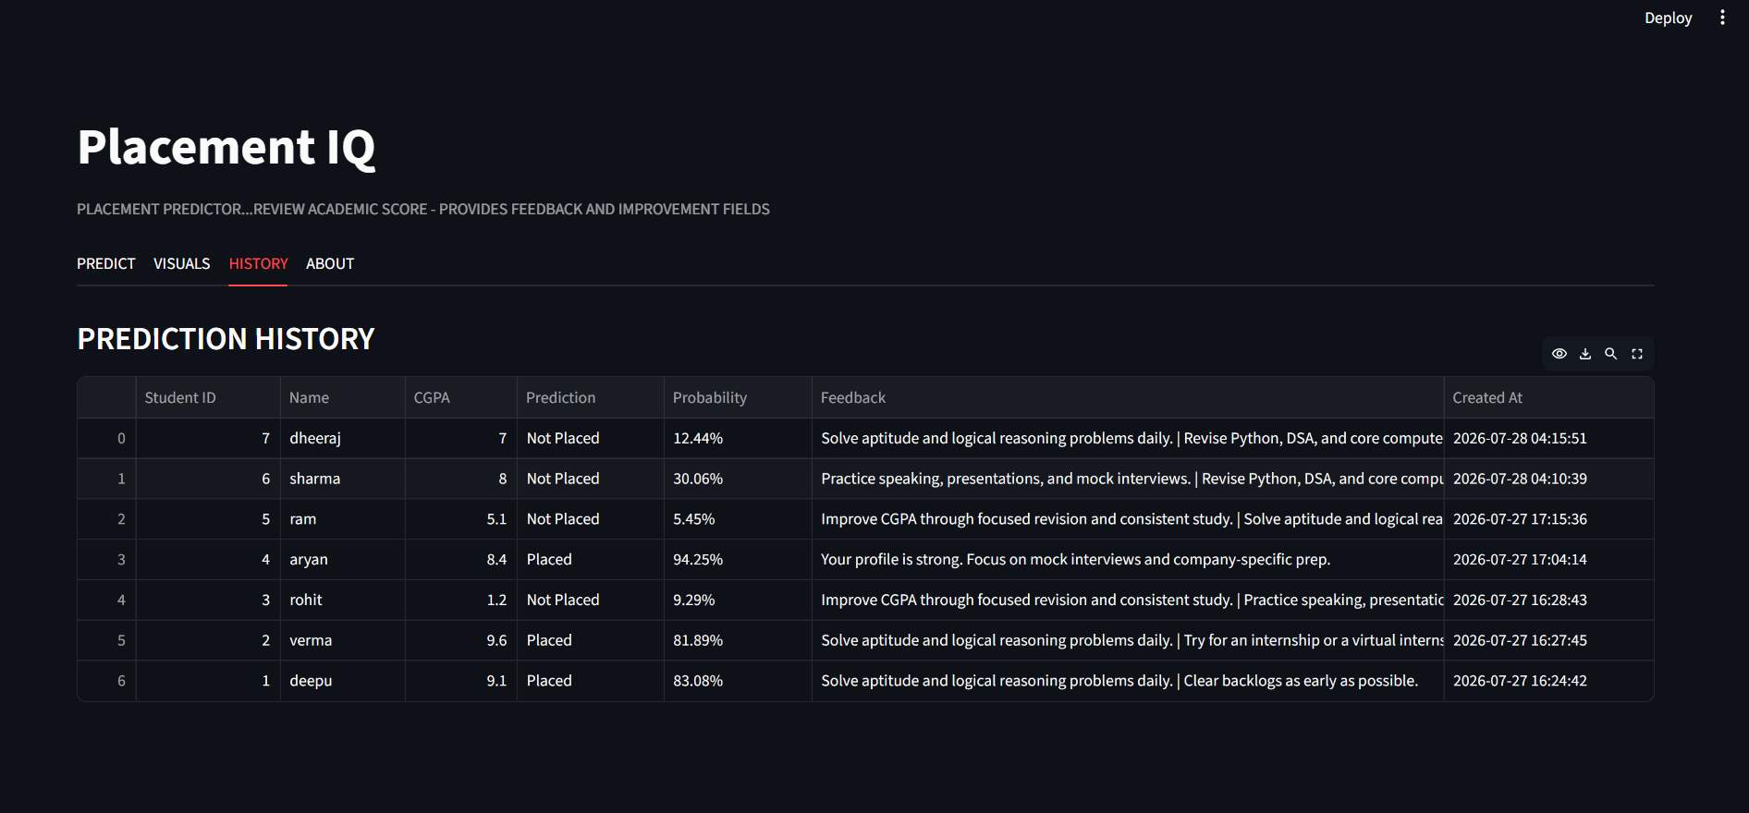
Fig. 5.6: Prediction History Table

7.7 Application Running in Browser
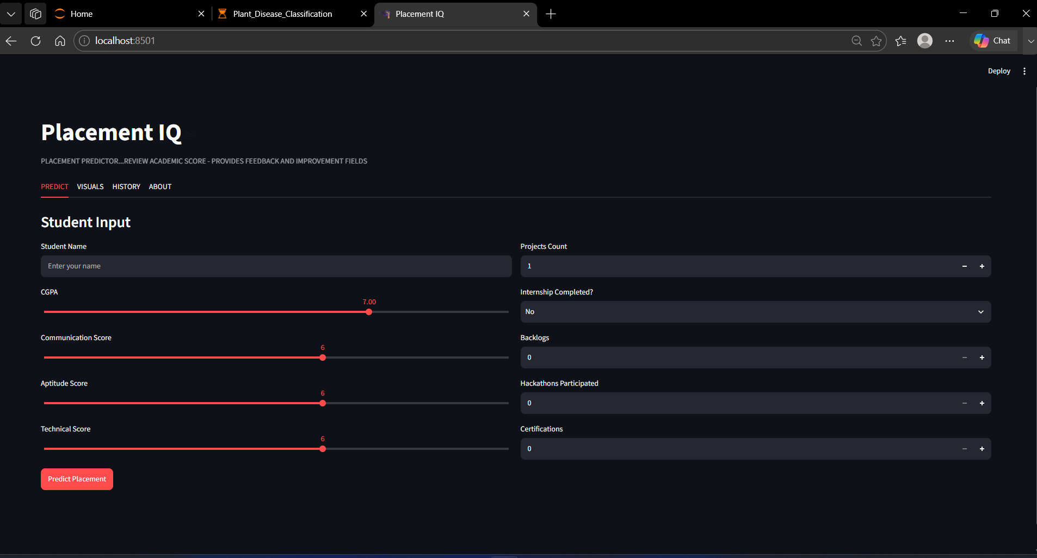
Fig. 5.7: Placement IQ Running Locally in the Browser (localhost:8501)

