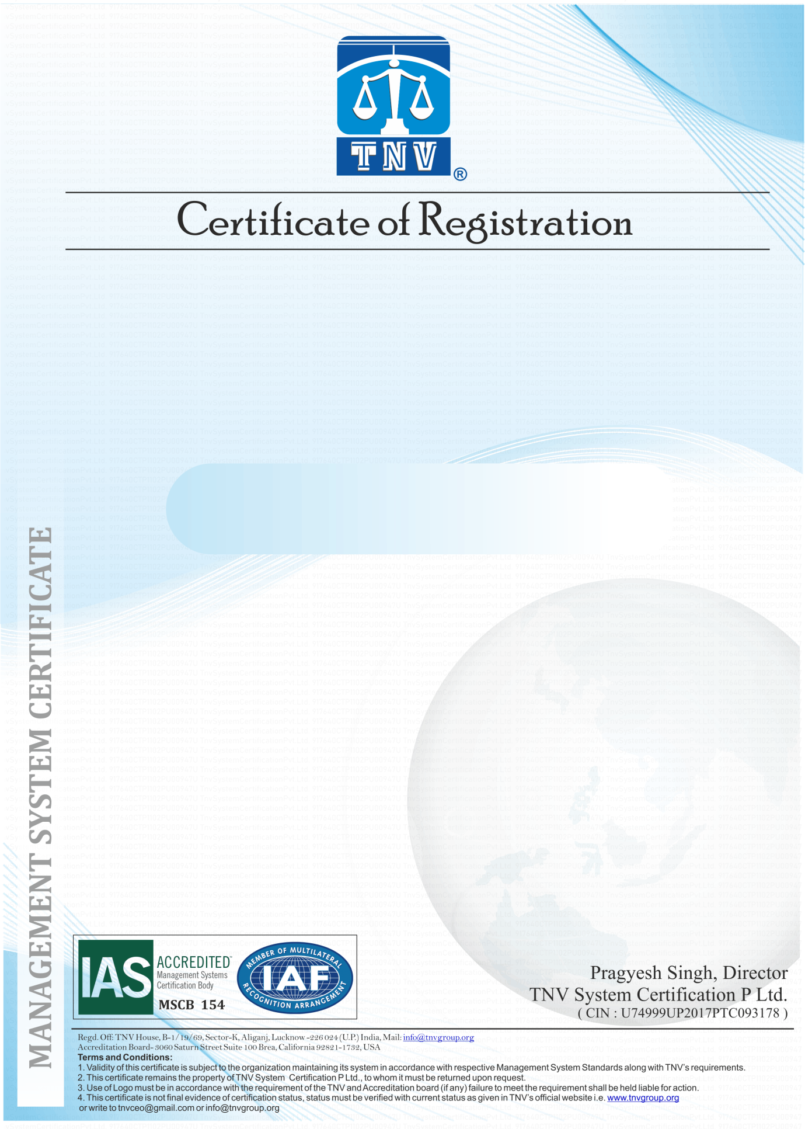

**LKO**

**TNVNew1**

**This is to Certify that the Anti-Bribery Management System of**

**has been assessed and registered by TNV as conforming**

**to the requirements of:**

**ISO 37001:2016**

**(Anti-Bribery Management System)**

***TNV is accredited by International Accreditation Services (IAS), Status of Certificate can be verified on***

***www.tnvgroup.org & www.iafcertsearch.org***

Initial Registration Date 8/5/2024

Validity of this Certificate 8/6/2024

Recertification due on 8/5/2024

Revision No./Date 00/8/6/2024

IAF Code 3473

Certificate Numb qewe123

Current Issue Date 8/5/2024

1st Surveillance on or before 8/6/2024

2nd Surveillance on or before 8/6/2024

Issue No. THN4546­­

**This is good Organization**

**For the following activities**