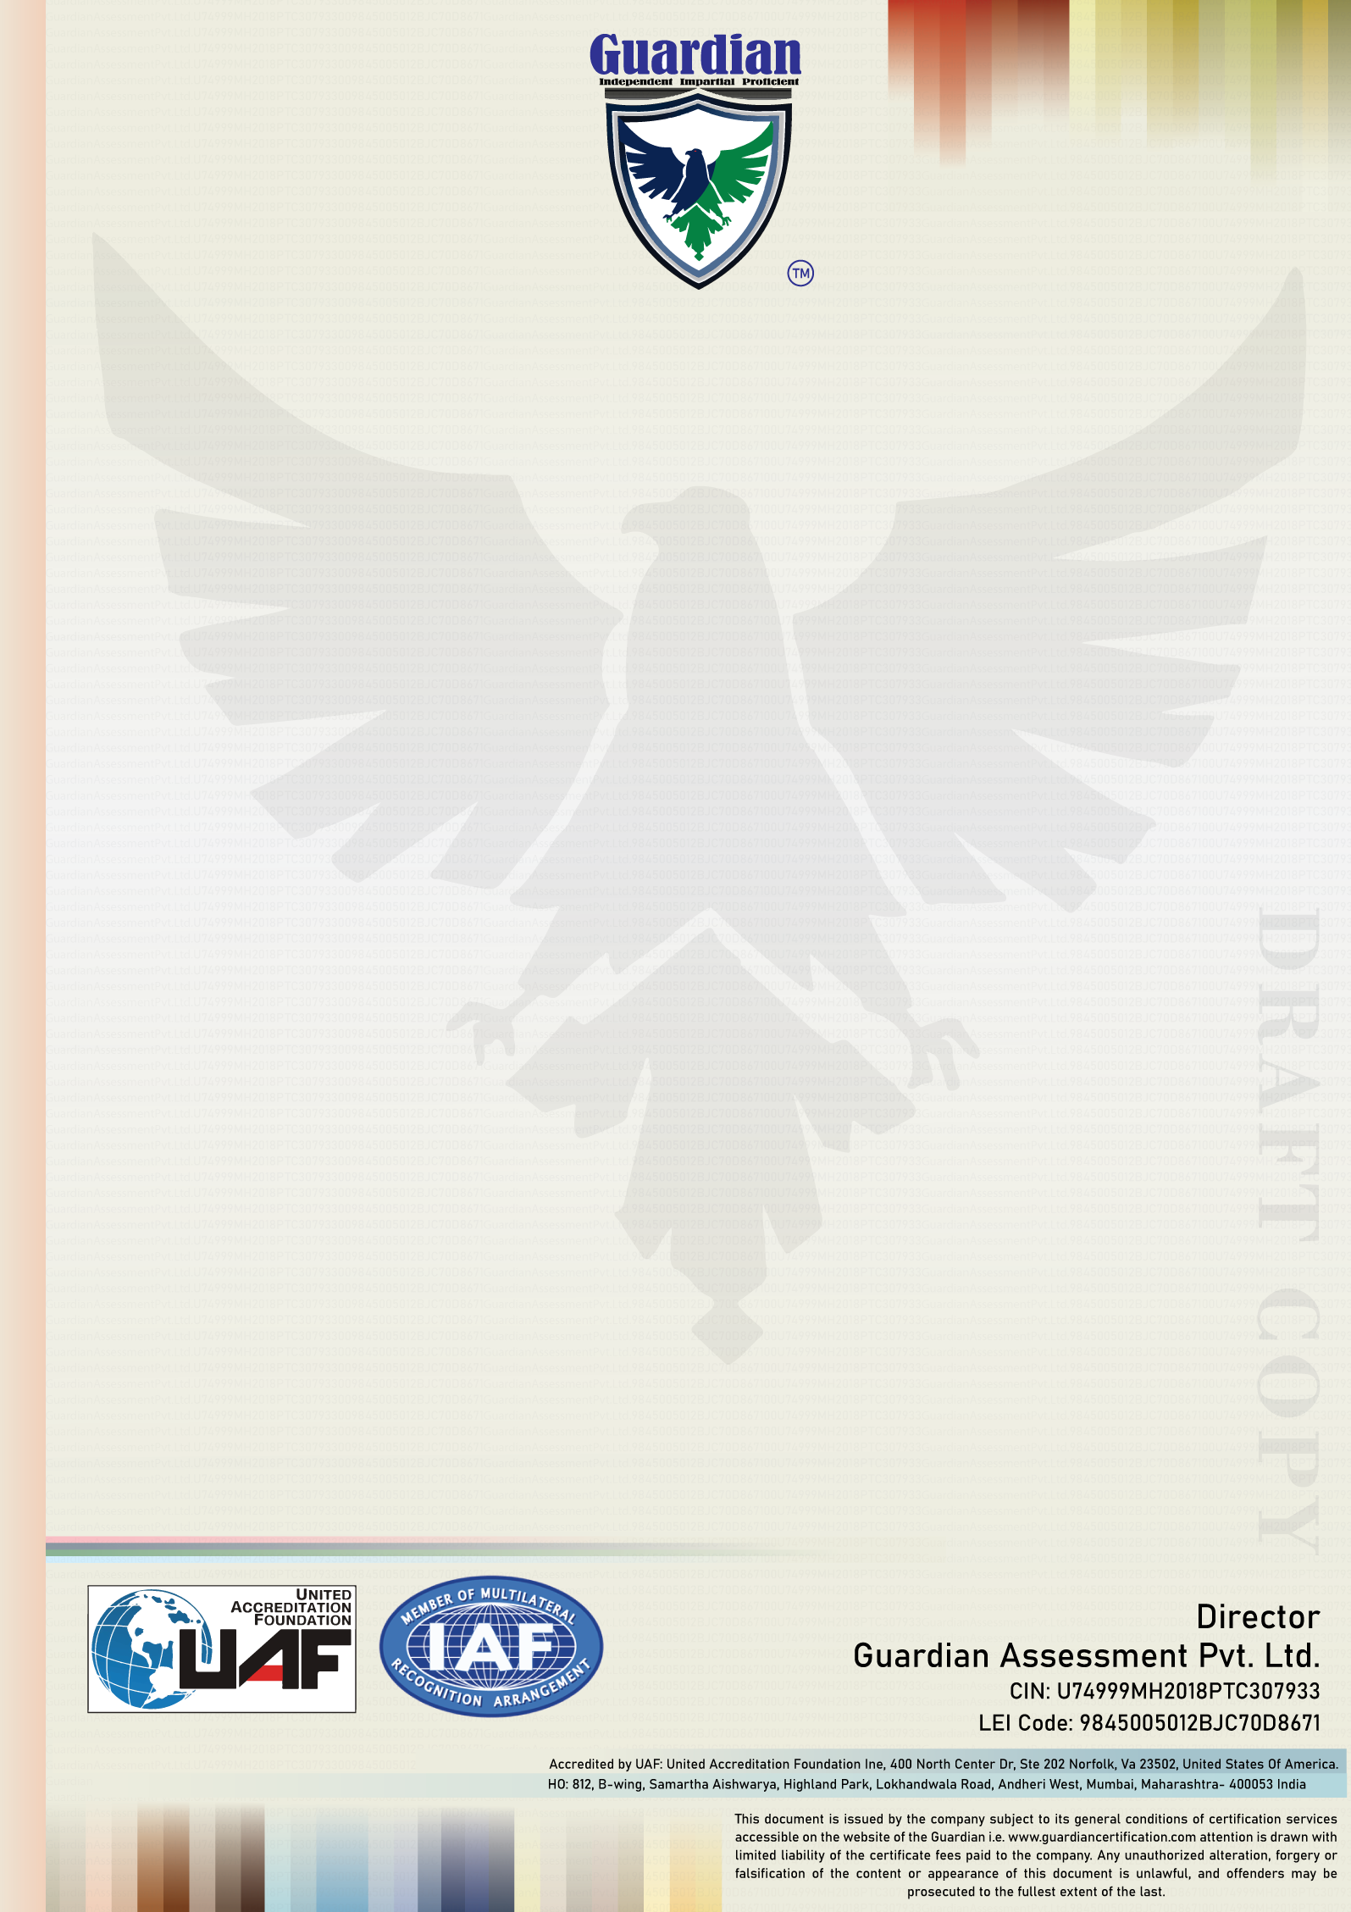

**{SCOPE}**

**Scope**

**{ADDRESS}**

**ISO 9001:2015**

**(Quality Management System)**

**For the following activities**

**has been assessed and found to be in accordance with the**

**requirements of standard detailed below**

{COMPANY NAME}

**Certificate of Registration**

**This is to Certify that the Quality Management System of**

Accreditation No. 51809380119

Certificate Number {CERTIFICATE NUMBER}

Validity of this Certificate {VALIDITY}

1st Surveillance on or before {SUR1}

2nd Surveillance on or before {SUR2}

Initial Issue Date {INITIAL}

Recertification due on {RECERTIFICATION}

Current Issue Date {ISSUE}

Revision No./Date {REVISION}

IAF Code {IAF}

***GAPL is accredited by United Accreditation Foundation (UAF), Status of Certificate can be verified on***

***www.guardiancertification.com & www.iafcertsearch.org***