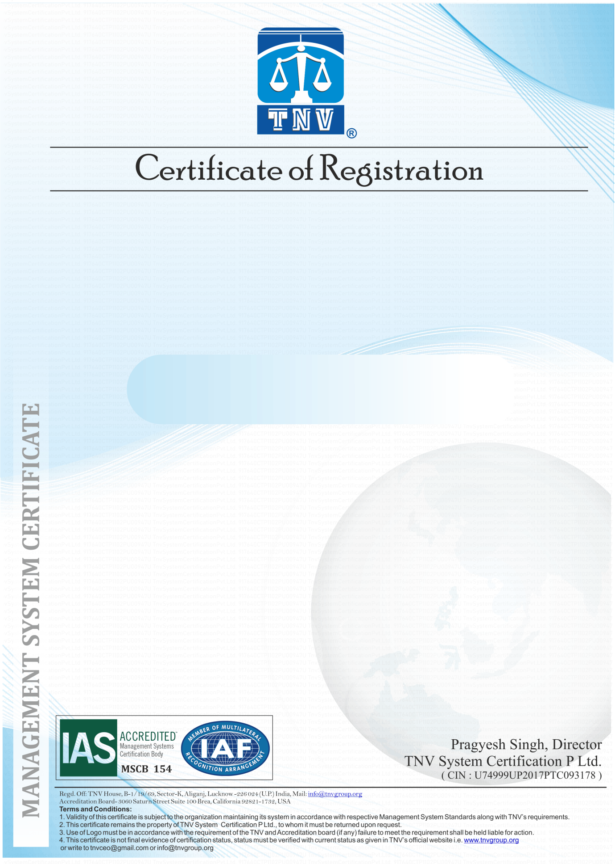

**(Occupational Health & Safety Management System)**

**{ADDRESS}**

**{COMPANY NAME}**

**This is to Certify that the Occupational Health & Safety Management System of**

**has been assessed and registered by TNV as conforming**

**to the requirements of:**

**ISO 45001:2018**

***TNV is accredited by International Accreditation Services (IAS), Status of Certificate can be verified on***

***www.tnvgroup.org & www.iafcertsearch.org***

Initial Registration Date {REGISTRATION}

Validity of this Certificate {VALIDITY}

Recertification due on {RECERTIFICATION}

Revision No./Date {REVISION}

IAF Code {IAF}

Certificate Numb {CERTIFICATE NUMBER}

Current Issue Date {ISSUE}

1st Surveillance on or before {SUR1}

2nd Surveillance on or before {SUR2}

Issue No. {ISSUE NO}­­

**{SCOPE}**

**For the following activities**