1. Find the Minimum Marks and Maximum marks scored by each student.

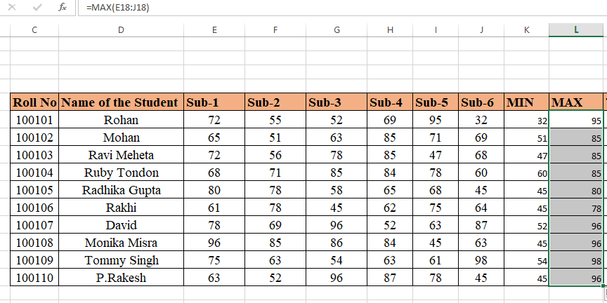

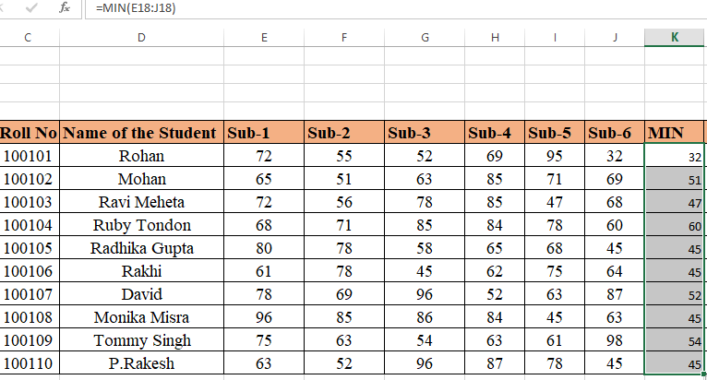

2. Calculate the totals for each student, use conditional formatting to

highlight the top students who have scored more than 480.

None have scored more than 480.

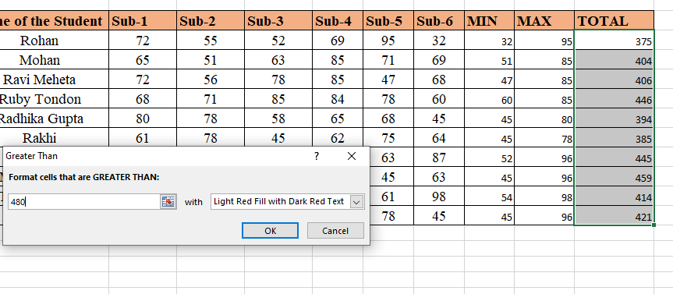

1. Calculate the length of the names of each student.

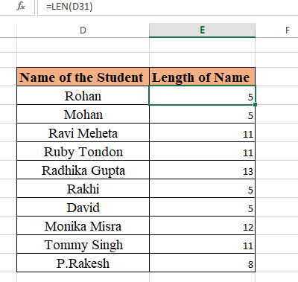

1. Replace the Name Rakhi with Rocky. Use Formulas

Using Find and Replace option.

1. Combine the Roll Numbers and Names. Use formulas. The end result

should look like below.

100101Rohan

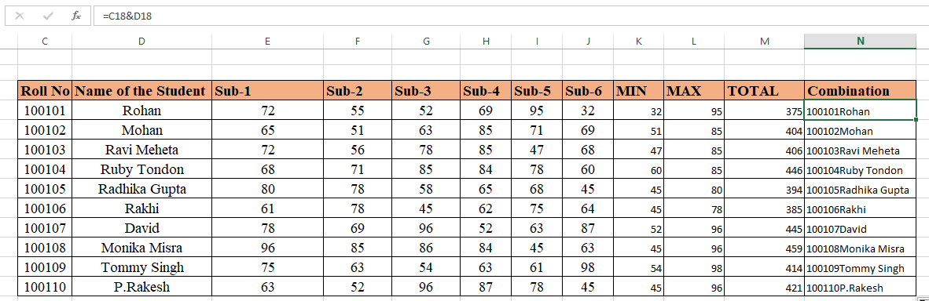

1. As you can see that some names have spacing issues. Use Formulas

to correct that spacing. Also ensure that the names and surnames start

with a capital letter

