Use the above dataset and answer the following questions.

1. Create a Pivot table and show what the main export product is?

The main product is scale.

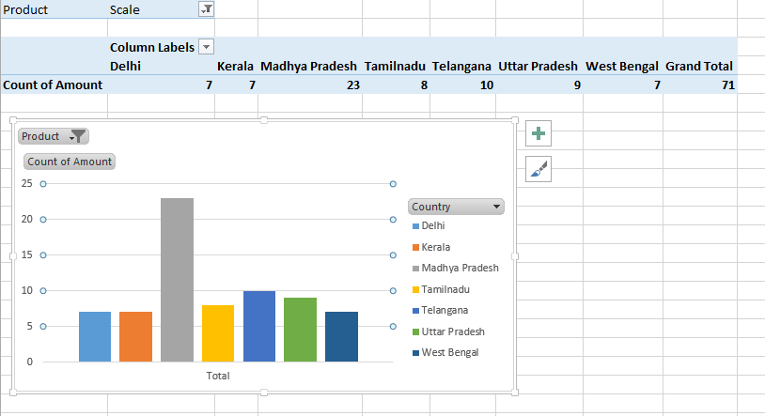

2. Create a bar graph showing the amount spent for each product?

3. Create a Pivot table to show The sales in each city

4. Create a chart showing the amount spent for each product in each city