1. Using Insert Function, give examples of any function available in the

different dropdowns present in the function library. For example

AutoSum, Recently Used, Text, Date & Time, etc.

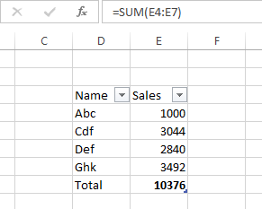

1. What are the different ways you can select columns and rows?
2. Shift + Spacebar – to select entire rows and columns
3. Cntl + Shift + Arrows – to either select rows or column to last used cell
4. What is AutoFit and why do we use it?

Autofit is used to resize the a cell automatically according to width and height. It is used to adjust multiple rows or columns at a time.

1. How can you insert new rows and columns into the existing table?
2. Right-click in a table cell next to where a row or column is to be added.
3. On the mini toolbar, click Insert and choose where to insert the row or column.
4. How do you hide and unhide columns in excel?

Home tab – Format – Visibility – Hide/Unhide

1. Create an appropriate table within the worksheet and use different

functions available in the AutoSum command.

