1. What are the different margins options and do we adjust the margins of

the excel worksheet?

Horizontal and Vertical options are different margin options, we adjust them as and when its required. Else its left at default space.

1. Set a background for your table created.

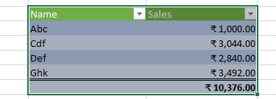

3. What is freeze panes and why do we use freeze panes? Give

examples.

Freeze panes are a feature in spreadsheet applications that allows you to lock rows or columns in place while scrolling through the rest of the data.

4. What are the different features available within the Freeze Panes

command?

A. Freeze Panes: Lock more than one column or row (select the row below the last row you want to freeze and/or to the right of the last column you want to freeze).

B. Freeze Top Row: Only lock the top row.

C. Freeze First Column: Only lock the first column.

5. Explain what the different sheet options present in excel are and what

they do?

* Normal view is the default view for all worksheets in Excel.
* Page Layout view displays how your worksheets will appear when printed. You can also add headers and footers in this view.
* Page Break view allows you to change the location of page breaks, which is especially helpful when printing a lot of data from Excel.