3. Walking
Threre are constraints in enlarging the application area of a humanoid, because a small size humanoid has restricted system resource for its limited space and cost. Under these curcumstances, to achieve stable walking for a humanoid, it is important to consider the performance level required by a designed walking method.
Since Zero Moment Point theory was published, various walking methods based on dynamics analysis have been suggested. As these approaches require high computational cost, the approximation method of dynamics model becomes a significant issue. However, since a simplified dynamics model also tends to cause an estimation error, an appropriate approximation is required to guarantee the stability of walking. Kajita et al. proposed the linear inverted pendulum model for bipedal walking, and developed their method with the preview control of ZMP for the compensation of the model error caused by simplification. Takenaka et al. suggested the approximate dynamics model with two point masses added to the linear inverted pendulum for reducing the estimation error. Nevertheless, considering the computational performance of a small size humanoid, it is still difficult to apply the proposed methods mentioned above.
On the other side, in biologically inspired methods for bipedal walking triggered by Central Pattern Generator (CPG), it is significant matter to find feasible CPG parameters. However, for its large parameter space and the obscure physical relation between CPG parameters and external environmental condition, it is hard to implement on a real humanoid. End et al. proposed the reduced neural oscillator for overcoming of environmental perturbations.
From these studies, Inyong Ha, Yusuke Tamura and Hajume Asama has extended their neural oscillator model to the simplified coupled linear oscillator model divided into a movement oscillator and balance oscillator. The proposed oscillator model gives the community between oscillator parameter and dynamics estimation. Through the full body ZMP simulation, they analyzed the effect of oscillator parameters on the dynamic stability of walking and showed how to deside appropriate parameters for a balanced walking. They also designed the feedback controller correlating with oscillator parameters and sensor data, which makes it possible to guarantee the stabilization of walking without a real time ZMP calculation.
The suggested method was tested on the open humanoid platform DARwIn-OP.
1.1 Gait Pattern Generation
1.1.1 Coupled Oscillator Model
The proposed coupled oscillator model is composed of two kinds of oscillator groups. Two movement oscillator groups represent the each foot trajectory, and the balance oscillator group manages the fixed Center Of Mass (COM) trajectory. All oscillator groups have six sub oscillators taking charge of each axis, and there are 18 oscillators in Cartesian coordinate system as shown in Fig.1.
Fig.1. Coupled oscillator model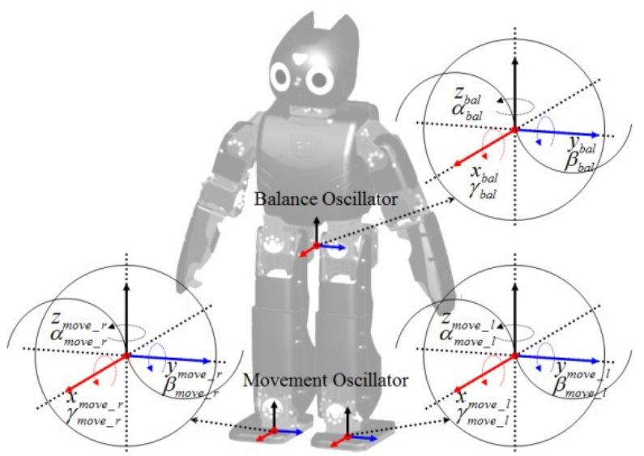
The total foot trajectory of a humanoid can be expressed by the superposition of the movement oscillator and balance oscillator as in (1). Whereas the balance oscillator activates in the entire walking period the movement oscillator is restrained during Double Support Phase (DSP). We define the oscillator parameters, amplitudeangular velocity phase shift offset and DSP ratio From the definition above, we can express the balance oscillator as in (2) and the movement oscillator as in (3).
(1)
(2)
(3)
Fig.2. Superposition of movement oscillator and balance oscillator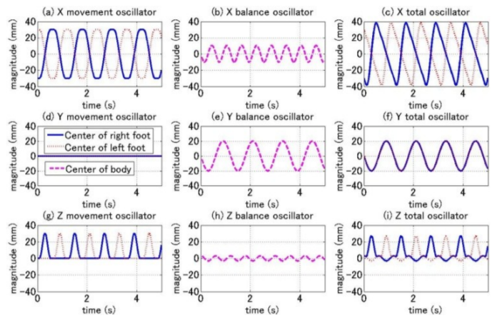
1.1.2 Oscillator Parameter and Gait Pattern
is where is a positive integer and depends on the axis of sub oscillator, and also can be determined considering the symmetric characteristics of kinematics and a gait pattern. Therefore, for the design of a gait pattern, and are the significant parameters for movement and balance.
Fig.3 shows the operation of each oscillator in a front walking with parameter value The other parameter values not mentioned above are set to zero. and in Fig.2(c)(f)(i) correspond with position values of the foot trajectory.
Fig.3. Trajectories of foot and fixed COM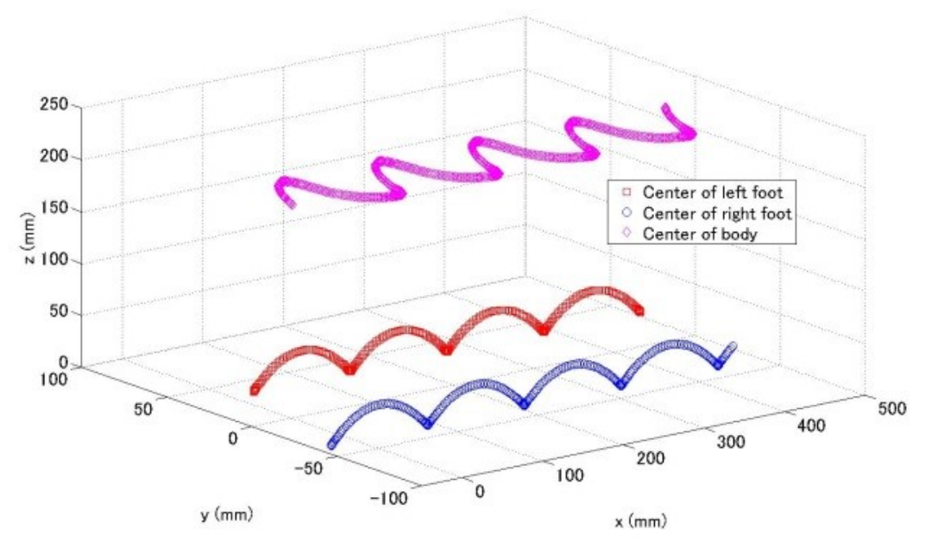
Fig.3 illustrates trajectories of the fixed COM and foot in a three dimensional space. We can confirm that andexactly match with the length of stride, height of the lifting foot, magnitude of the front-rear swapping, magnitude of the lateral swapping, and magnitude of up-down swapping.
A cycloid gait pattern also can be generated by selecting the appropriate oscillator parameter values. For example, ifis given, we can find the ratio of with which can make the fixed COM move at an almost uniform velocity as in Fig.4. In the simulation above, we find that the ratio is 0.35 and is never affected by other parameters except for
Fig.4. Trajectories of foot and fixed COM in time with variant ratio of with 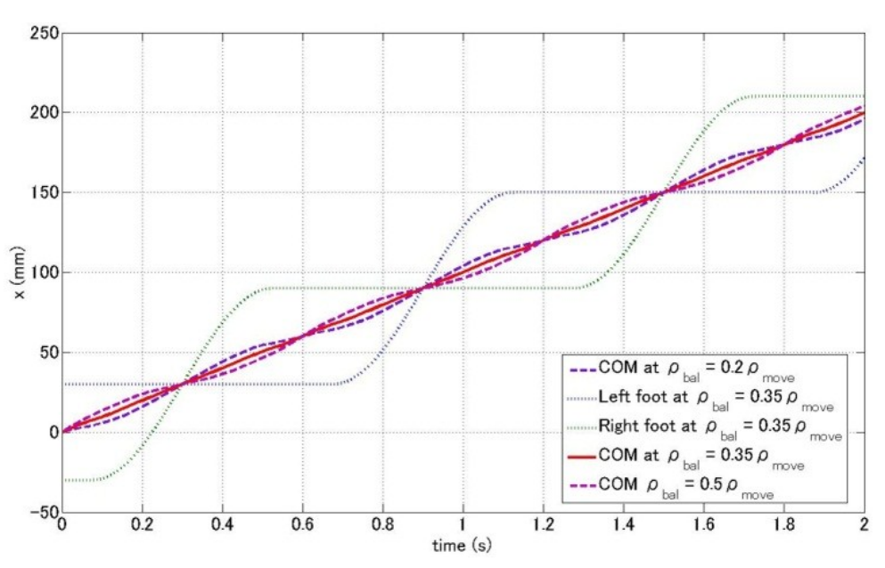
Fig.5. Solved joint angle value by analytic inverse kinematics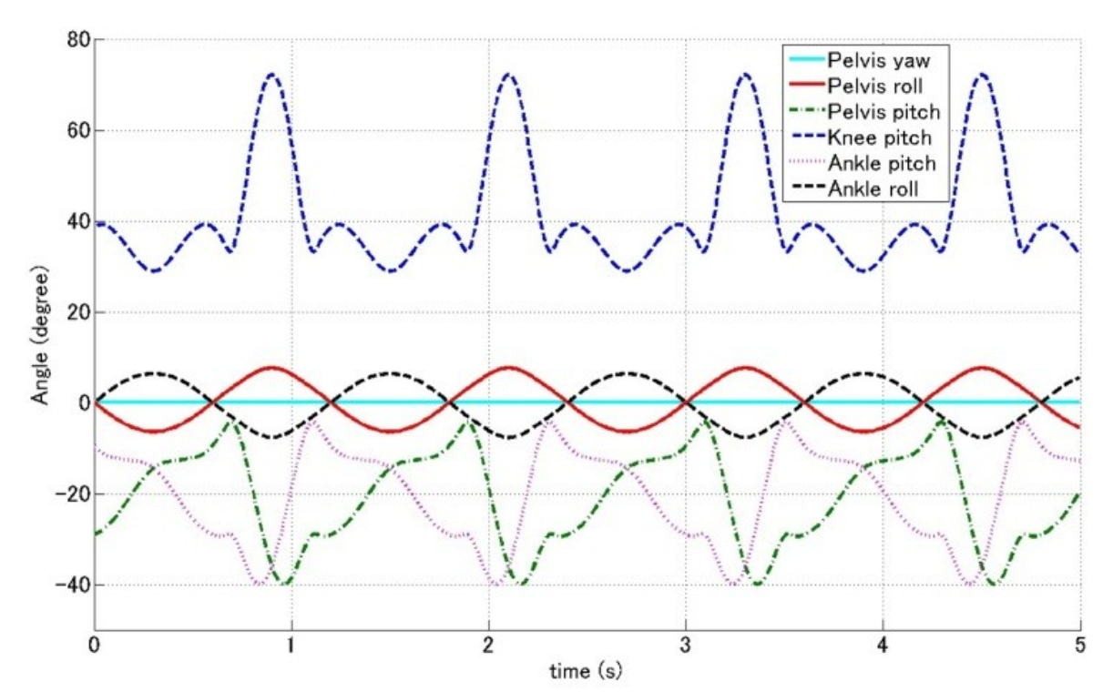
From the generated trajectory by the proposed model, we calculate the joint angle by solving inverse kinematics with an analytic method. Fig.5 shows the calculated joint angle of a front walking.

