|  |  |  |  |  |
| --- | --- | --- | --- | --- |
|  |  | | | |
|  | |  | | |
| Project: | | Lost in Space | | |
| Team No.: | | Team 5 | | |
| Class: | | CSE 3310; Spring 2018 | | |
| Module: | | System Requirements Analysis (SRA) | | |
| Deliverable: | | SRA Document | | |
| **Version:** | | **[1.0]** | **Date:** | **[03/22/2018]** |

**Contributors:**

Andrew Hernandez

Deep Patel

Umair Hafeez

Shreyash Shrivastava

**Revision History**

|  |  |  |  |  |
| --- | --- | --- | --- | --- |
| ***Version number*** | ***Date*** | ***Originator*** | ***Reason for change*** | ***High level description of changes*** |
| 1.0 | 03/12/2018 | Andrew, Umair, Shrey, Deep | Initial draft | Completed entire requirements |
|  |  |  |  |  |
|  |  |  |  |  |
|  |  |  |  |  |

TABLE OF CONTENTS

**1. Introduction and Project Overview** **4**

**2. Objectives** **5**

2.1 BUSINESS Objectives 6

2.2 SYSTEM Objectives 8

**4. Systems Requirements** **10**

**5. Software Processes and Infrastructure** **32**

5.1 Hardware and Infrastructure 32

5.2 UML Diagrams 32

5.3 Big picture UML 32

5.4 Artificial Intelligence UML 33

5.5 Ship UML 34

5.6 Canvas UML 35

5.7 Score UML 36

5.8 Controls UML 37

5.9 Debris UML 37

5.10 Save UML 38

5.11 Sound UML 39

5.12 Conceptual Data Model - Database 39

5.13 Screen Shots 39

5.14 Test Plan 39

**6. Assumptions and Constraints** **40**

6.1 ASSUMPTIONS 40

6.2 CONSTRAINTS 40

6.3 Out of Scope material 40

**7. Delivery and Schedule** **41**

**8. Stakeholder Approval Form** **42**

**Appendix:** **43**

# 1. Introduction and Project Overview

# The project that team 5 is building and developing is a still-screen unity based shooter game based in space. The primary goal of the user is to take control of the user ship and protect it from getting attacked by the incoming objects such as asteroids and bullets from the incoming enemy ships.

# This mobile-based android application will have very basic controls, which will be a slider to control the position of the user ship and touch to fire the bullets at the incoming threats. This project will be completed by early May 2018 with the requirements, processes and infrastructures, and the assumptions and constraints as highlighted below in the document. 2. Objectives

## 2.1 BUSINESS Objectives

The following is a list of business objectives:

**Objective 1**: “Score” functionality must be supported that tracks the user's current progress, and best score from previous rounds. It contains the following data.

* Current Score
* Top Score

**Objective 2**: “Canvas” funcationaly must be supported that draws the game screen and includes the following types:

* Pregrame Screen
* Game Screen
* Endgame Screen

**Objective 3**: “Control” System will require input from the user to control his ship.

**Objective 4**: “Sound” functionality must be supported that plays sounds and includes the following types:

* Start Screen Audio
* Game Audio
* Endgame Audio

**Objective 5**: “Debris” System will interact with user’s position and keep track of the AI ship and includes the following data.

* Debris position
* Player position
* AI position

**Objective 6**: “Save” functionality must be supported that saves the players best score and includes the following data.

* Top Score

**Objective 7**: “AI” functionality must be supported that tracks the human player and reacts to his movements and includes the following data.

* AI position
* Player position

**Objective 8**: “Ships” functionality must be track the health of both human and ai ships and includes the following data.

* Ai health
* Player health

## 

## 

## 

## 

## 

## 

## 

## 

## 

## 

## 

## 

## 

## 

## 

## 

## 

## 

## 

## 2.2 SYSTEM Objectives

The following is a list of system objectives:

**Objective 1**: System will be an Android application

**Objective 2**: Search functionality will utilize Google’s search

**Objective 3:** SQL-Lite will be used to save limited amount of data

**Objective 4:** System will be created using unity3. Project Context Diagram

# 

# 4. Systems Requirements

4.1 “Artificial intelligence” Requirements

|  |  |
| --- | --- |
| **Requirement Title:** | Artificial intelligence |
| **Sequence No:** | 1 |
| **Short description:** | Initialize enemy ship AI |
| **Description:** | The system shall create an enemy AI ship for the user to shoot at and destroy. |
| **Pre-Conditions**: | User must have a certain amount of time pass before the enemy ship appears and attacks them. |
| **Post Conditions:** | N/A |
| **Other attributes:** | - Game will continue with debris if AI function doesn’t respond. |

|  |  |
| --- | --- |
| **Requirement Title:** | Artificial intelligence |
| **Sequence No:** | 2 |
| **Short description:** | Ability for the ship to move vertically and shoot at the user. |
| **Description:** | The system shall allow the AI ship to move only vertically and shoot at the user to end their run in the game and have them reset. The AI will track the players movement and its vertically movement will be dependent on it. The ship will constantly fire at the user’s ship. |
| **Pre-Conditions**: | The AI must be initialized for the enemy ship. |
| **Post Conditions:** | The game will track see if any shots have hit the user’s ship. |
| **Other attributes:** | N/A |

|  |  |
| --- | --- |
| **Requirement Title:** | Artificial intelligence |
| **Sequence No:** | 3 |
| **Short description:** | Ship AI will be deactivated if player destroys it. |
| **Description:** | The system shall deactivate the enemy ship AI if the player is able to hit it with three shots. After an amount of time has passed, the ship AI will be initialized again and attack the player. |
| **Pre-Conditions**: | The AI must be initialized for the enemy ship. |
| **Post Conditions:** | Debris will continue to approach the user’s ship once the enemy AI ship has been destroyed/deactivated. |
| **Other attributes:** | N/A |

4.2 “Save” Requirements

|  |  |
| --- | --- |
| **Requirement Title:** | Save |
| **Sequence No:** | 1 |
| **Short description:** | Load Start Screen |
| **Description:** | Phone will open a start screen, presenting user the option to start the game. |
| **Pre-Conditions**: | User must have opened the app. |
| **Post Conditions:** | User might have finished a game to reach this screen. |
| **Other attributes:** | N/A |

|  |  |
| --- | --- |
| **Requirement Title:** | Save |
| **Sequence No:** | 2 |
| **Short description:** | Load Game Screen |
| **Description:** | Phone will open the game screen, allowing user the play the game. |
| **Pre-Conditions**: | User must have selected the start game option. |
| **Post Conditions:** | The game will start. |
| **Other attributes:** | N/A |

|  |  |
| --- | --- |
| **Requirement Title:** | Save |
| **Sequence No:** | 3 |
| **Short description:** | Load Endgame/Failure Screen |
| **Description:** | Phone will end the game, and present user with their score. |
| **Pre-Conditions**: | Players ship has been destroyed. |
| **Post Conditions:** | Game is ended, and score is saved. |
| **Other attributes:** | N/A |

4.3 “Ships” Requirements

|  |  |
| --- | --- |
| **Requirement Title:** | Ships |
| **Sequence No:** | 1 |
| **Short description:** | AI Ship (enemy) enters the game. |
| **Description:** | Player will be presented with an enemy AI ship to fight. |
| **Pre-Conditions**: | Game must have started already. |
| **Post Conditions:** | N/A |
| **Other attributes:** | N/A |

|  |  |
| --- | --- |
| **Requirement Title:** | Ships |
| **Sequence No:** | 2 |
| **Short description:** | AI collides with players shots. |
| **Description:** | The AI will check for any collisions and move to sequence 3 if any are found. |
| **Pre-Conditions**: | AI must be hit by player. |
| **Post Conditions:** | N/A |
| **Other attributes:** | N/A |

|  |  |
| --- | --- |
| **Requirement Title:** | Ships |
| **Sequence No:** | 3 |
| **Short description:** | AI Ships health is validated. |
| **Description:** | AI Ship removes one health from its total health, and checks to see if any health is remaining. |
| **Pre-Conditions**: | AI must have been hit. |
| **Post Conditions:** | AI loses health. |
| **Other attributes:** | N/A |

|  |  |
| --- | --- |
| **Requirement Title:** | Ships |
| **Sequence No:** | 4 |
| **Short description:** | AI Ship is destroyed. |
| **Description:** | AI is removed from the game screen when it loses all its health. |
| **Pre-Conditions**: | AI must be shot a specific number of times, and have lost all its health. |
| **Post Conditions:** | AI is removed from the game. |
| **Other attributes:** | N/A |

4.4 “Canvas” Requirements

|  |  |
| --- | --- |
| **Requirement Title:** | Canvas |
| **Sequence No:** | 1 |
| **Short description:** | The first background picture with all game objects for the start screen |
| **Description:** | This creates the first screen to be displayed |
| **Pre-Conditions**: | No Pre-Conditions, as it is the first screen |
| **Post Conditions:** | Clicking start would go into another canvas |
| **Other attributes:** | Background Object layering will be present |

|  |  |
| --- | --- |
| **Requirement Title:** | Canvas |
| **Sequence No:** | 2 |
| **Short description:** | The second background picture with all game objects |
| **Description:** | This is created after the introduction canvas screen to be displayed |
| **Pre-Conditions**: | This is created after the introduction Canvas screen |
| **Post Conditions:** | Game end would transition into another canvas |
| **Other attributes:** | Background Object layering will be present |

|  |  |
| --- | --- |
| **Requirement Title:** | Canvas |
| **Sequence No:** | 3 |
| **Short description:** | The third background picture with all game objects, this is also the end screen with score game object |
| **Description:** | This is created after the second screen is displayed |
| **Pre-Conditions**: | This is created after the introduction Canvas screen |
| **Post Conditions:** | Game end would transition into another canvas |
| **Other attributes:** | Background Object layering will be present, and score screen |

4.5 “Controls” Requirements

|  |  |
| --- | --- |
| **Requirement Title:** | Controls |
| **Sequence No:** | 1 |
| **Short description:** | User gameobject with other other game objects |
| **Description:** | It is the user game object which will includes the joystick control, and the shoot button control |
| **Pre-Conditions**: | This is created after the introduction canvas screen |
| **Post Conditions:** | This game objects will end after gameover |
| **Other attributes:** | Two game objects present |

|  |  |
| --- | --- |
| **Requirement Title:** | Controls |
| **Sequence No:** | 2 |
| **Short description:** | User Joystick game object |
| **Description:** | It is the user Joystick game object which will includes the joystick control and Joystick implementation |
| **Pre-Conditions**: | This game object is created after user game object |
| **Post Conditions:** | This game objects will end after gameover |
| **Other attributes:** | No other attributes |

|  |  |
| --- | --- |
| **Requirement Title:** | Controls |
| **Sequence No:** | 3 |
| **Short description:** | User shoot button game object |
| **Description:** | It is the user game object which will includes the shoot button control, and the shoot button implementation |
| **Pre-Conditions**: | This is created after the introduction canvas screen |
| **Post Conditions:** | This game objects will end after gameover |
| **Other attributes:** | No other attributes |

4.6 “Debris” Requirements

|  |  |
| --- | --- |
| **Requirement Title:** | Debris |
| **Sequence No:** | 1 |
| **Short description:** | The debris game object |
| **Description:** | The Debris game object interacts with user’s position, and also keeps track of the AI ship |
| **Pre-Conditions**: | This is created after the introduction canvas screen |
| **Post Conditions:** | This game objects will end after game over, or when the AI ship comes to the screen |
| **Other attributes:** | No other attributes |

4.7 “Sound” Requirements

|  |  |
| --- | --- |
| **Requirement Title:** | Sound |
| **Sequence No:** | 1 |
| **Short description:** | The audio of the start screen |
| **Description:** | The audio will begin to play as soon as the menu screen pops up. The user is presented with options to play the game, or toggle the sound to off. |
| **Pre-Conditions**: | This is created during the presentation of the start menu screen |
| **Post Conditions:** | The sound will turn off if user toggles sound to off |
| **Other attributes:** | No other attributes |

|  |  |
| --- | --- |
| **Requirement Title:** | Sound |
| **Sequence No:** | 2 |
| **Short description:** | The audio during the duration of the game |
| **Description:** | If the audio has not been toggled to off and the user presses the play button, the audio will switch from menu screen audio to “game” audio, and it will continue to play during the duration of the game |
| **Pre-Conditions**: | * Sound toggle is turned to “on”, has not been switched to “off” * User has pressed “play” button and game has started |
| **Post Conditions:** | When the user runs out of lives and the end screen pops up, the audio changes back to “start menu audio” |
| **Other attributes:** | No other attributes |

|  |  |
| --- | --- |
| **Requirement Title:** | Sound |
| **Sequence No:** | 3 |
| **Short description:** | The audio of the end screen |
| **Description:** | When the user runs out of lives, the end screen pops up with options to return to menu or restart game. When this end screen pops up, the audio changes back to the “start menu” audio |
| **Pre-Conditions**: | This is created after the emergence of the end screen |
| **Post Conditions:** | Audio switches back to “start screen” audio |
| **Other attributes:** | No other attributes |

# 

4.8 “Score” Requirements

|  |  |
| --- | --- |
| **Requirement Title:** | Score |
| **Sequence No:** | 1 |
| **Short description:** | The score at start of game |
| **Description:** | When the user starts the game, and presses the “play” button, the score is automatically set to 0 |
| **Pre-Conditions**: | This is created after the “play” button is pressed on the start menu screen |
| **Post Conditions:** | Score will continue to increment by 1 per second as long as the user’s health is not 0 |
| **Other attributes:** | No other attributes |

# 

|  |  |
| --- | --- |
| **Requirement Title:** | Score |
| **Sequence No:** | 2 |
| **Short description:** | Score during game |
| **Description:** | The score during the game increments by seconds. So +1 is added to the score per second that the user is alive and has health |
| **Pre-Conditions**: | User’s health is not 0 |
| **Post Conditions:** | When users health reaches 0, the score sets back to 0. However, IF the user’s highest score at the end of game surpasses the previous highest score, the new highest score is saved and the previous highest score is erased |
| **Other attributes:** | No other attributes |

# 

# 5. Software Processes and Infrastructure

## 5.1 Hardware and Infrastructure

Project will be made in Unity and made in mind for Android phones.

## 5.2 UML Diagrams

## 5.3 Big picture UML

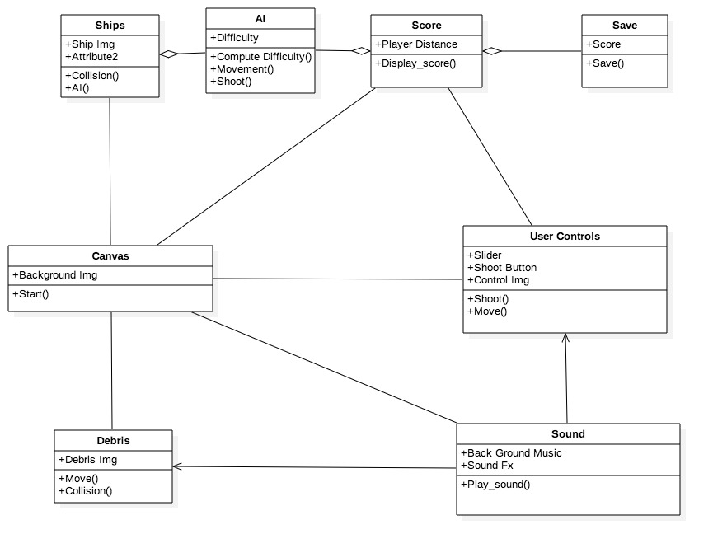

## 5.4 Artificial Intelligence UML

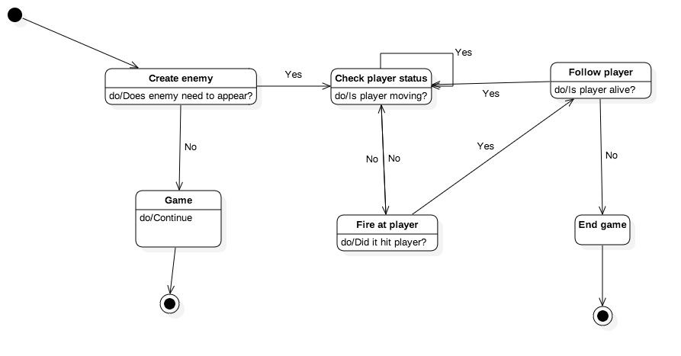

## 

## 

## 

## 

## 

## 

## 

## 

## 

## 

## 

## 

## 

## 

## 5.5 Ship UML

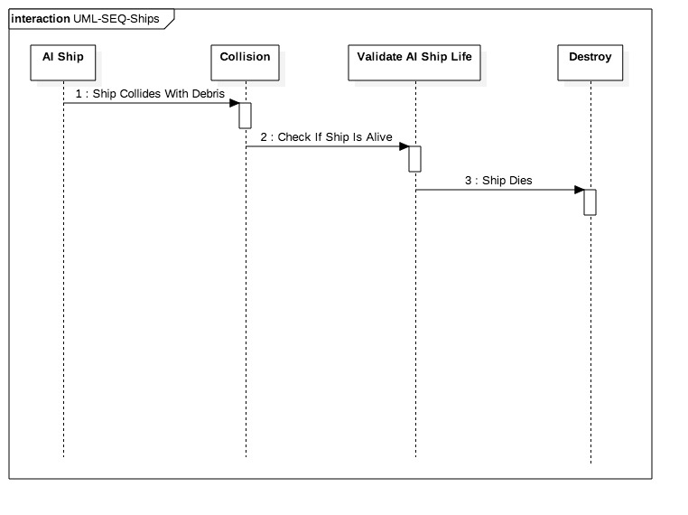

## 5.6 Canvas UML

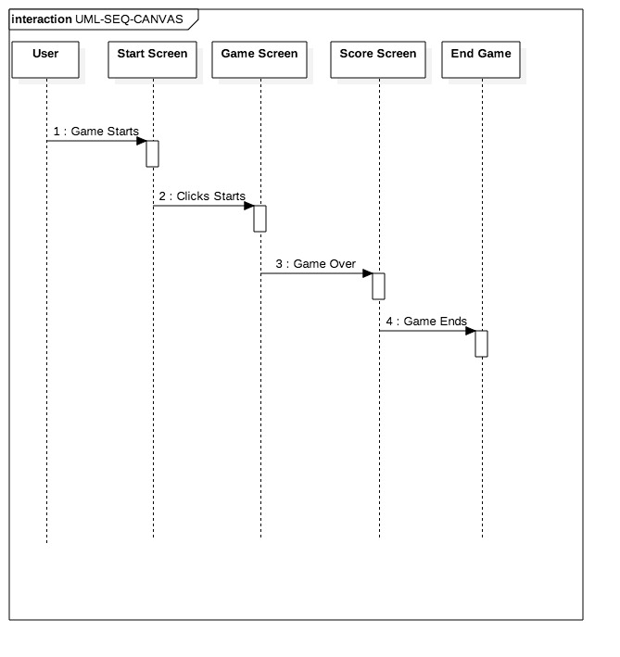

## 5.7 Score UML

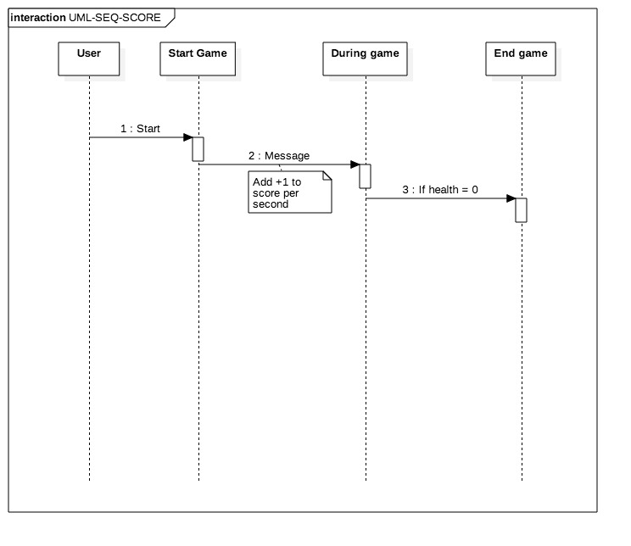

## 5.8 Controls UML

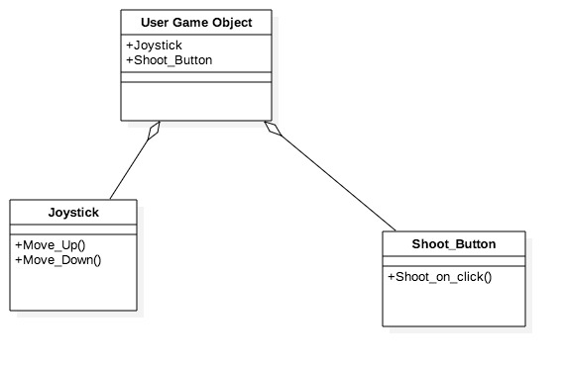

## 5.9 Debris UML

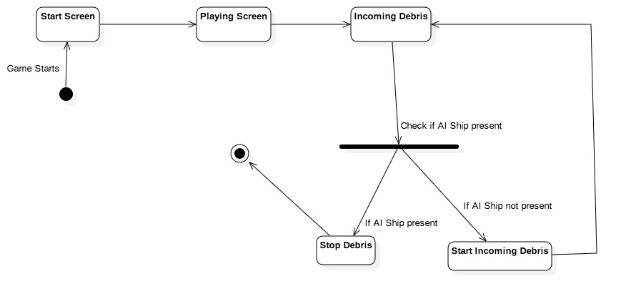

## 5.10 Save UML

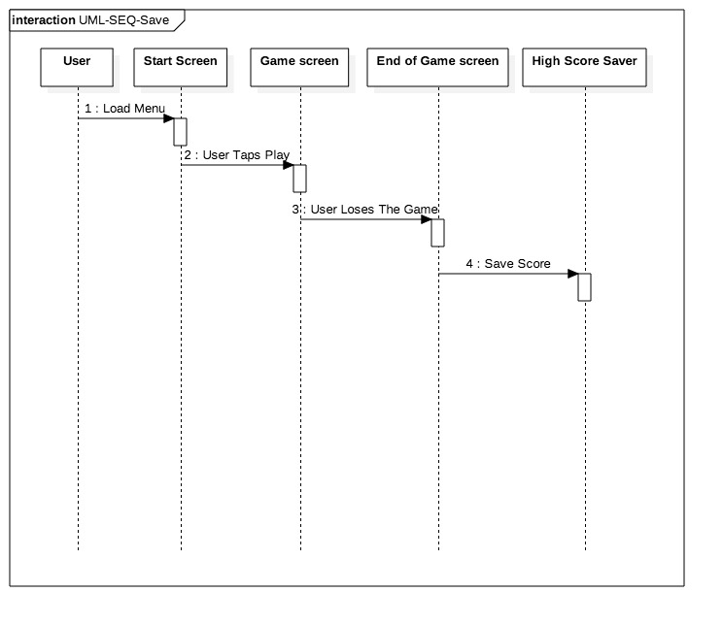

## 5.11 Sound UML

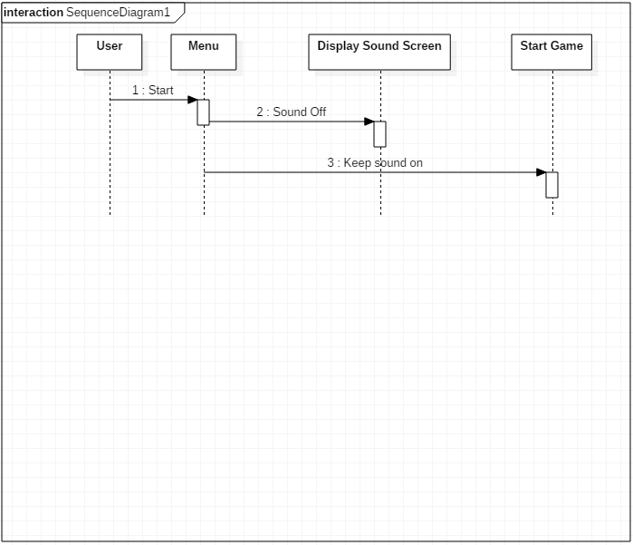

## 5.12 Conceptual Data Model - Database

We will save our data using SQL-lite since we are only saving the score.

## 5.13 Screen Shots

None Available at this time

## 5.14 Test Plan

A few testing methods will be implemented :-

* Clean Room testing

This approach combines mathematical reasoning, design refinement and

statistical reasoning during test case generation and testing

* Compatibility Testing

This is used to find whether a game is functioning properly or not with respect to

the hardware, graphics and software configuration that the device is built with

* Play Testing

The method of game testing by playing the game to analyse non-functional

features like fun factors, difficulty levels, and balance.

# 6. Assumptions and Constraints

## 6.1 ASSUMPTIONS

The following is a list of assumptions:

* All ages can play the game.
* Little to no money will be spent on making the project.
* No plan to monetize the game.

## 6.2 CONSTRAINTS

The following is a list of constraints:

* Scripting language is C#, experience constrain
* Team also lack game design experience
* Physics Implementation constraint
* Canvas drawing constrain

## 6.3 Out of Scope material

The following is a list of “out of scope” material:

* Post Project maintenance is not covered
* Advertising the game to the public.

# 7. Delivery and Schedule

{List all tasks/milestones from start of the project to the end with specific dates for both Anticipated Start & End Dates

|  |  |  |  |  |
| --- | --- | --- | --- | --- |
| Task/Milestone Description | Anticipated Start Date | Anticipated End Date | Status | Comments |
| Prepare Requirements and UML diagram | 2-9-2018 | 3-01-2018 | Completed |  |
| SRA document (Includes project objectives, Requirements and UML diagrams) | 3-2-2018 | 3-18-2018 | In Progress | Deliverable will be the SRA document. All stakeholders agree on the content of the SRA by signing in section 8. |
| Milestone: Presentation of SRA |  | 4-24-2018 | To Do |  |
| Database Design | TBD | TBD | To Do |  |
| Interface control and navigation | TBD | TBD | To Do |  |
| Test Data Entry | TBD | TBD | To Do |  |
| Milestone:  App Demonstration |  | TBD | To Do |  |
| Test Plan Delivery | TBD | 4-12-2018 | To Do | Deliverable will be Test Plan. Test plan is to be utilized for requirements verification. |
| External Documentation (i.e. User Manual) | TBD | 5-3-2018 | To Do |  |
| Final Milestone: Project delivery |  | 5-3-2018 | To Do |  |

# 8. Stakeholder Approval Form

|  |  |  |  |
| --- | --- | --- | --- |
| Stakeholder Name | Stakeholder Role | Stakeholder Comments | Stakeholder Approval Signature and Date |
| Bahram Khalili | Development Mgr |  |  |
| Akshit Singhal | Project Assistant |  |  |
| Umair Hafeez | Developer |  | Umair Hafeez 3/16/18 |
| Deep Patel | Developer |  | Deep Patel  3/19/18 |
| Andrew Hernandez | Developer |  | Andrew Hernandez  3/18/18 |
| Shreyash Shrivastava | Developer |  | Shreyash Shrivastava  3/17/18 |

# Appendix:

None