MediConnect: Integrated Multi-Role Hospital & Clinic Management System
A Major Project Report submitted
in partial fulfillment for the degree of
Bachelor of Engineering
in
Information Technology / Computer Engineering
(Session 2025 - 2026)
Submitted By:  Student Name  Roll No: 21ITXXX  Enrollment: DX21XXXX | Guided By:  Prof. Project Guide  Assistant Professor  Dept. of Information Technology

Department of Information Technology
Institute of Engineering & Technology
Vikramshila Campus
Devi Ahilya Vishwavidyalaya, Indore (M.P.)
(https://ietdavv.edu.in)
April 2026

CERTIFICATE
The project report entitled "MediConnect: Integrated Multi-Role Hospital & Clinic Management System" submitted by Student Name (Roll No: 21ITXXX) is approved for partial fulfillment for the award of Bachelor of Engineering in Information Technology degree by Devi Ahilya Vishwavidyalaya, Indore.
_______________________  Internal Examiner | _______________________  External Examiner

(i)

Recommendation
The dissertation entitled "MediConnect: Integrated Multi-Role Hospital & Clinic Management System" submitted by Student Name (Roll No: 21ITXXX) is a satisfactory account of the bonafide work done under my supervision and is recommended towards the partial fulfillment for the award of Bachelor of Engineering in Information Technology degree by Devi Ahilya Vishwavidyalaya, Indore.
Date: ____________________
(Leave space for signature)
Name of Project Guide: Prof. Project Guide
Department of Information Technology
Institute of Engineering and Technology, DAVV, Indore
(Leave space for signature)
Counter signature of HOD with seal
Department of Information Technology
Institute of Engineering and Technology, DAVV, Indore
(ii)

Candidate Declaration
We hereby declare that the work which is being presented in this project entitled "MediConnect: Integrated Multi-Role Hospital & Clinic Management System" in partial fulfillment of degree of Bachelor of Engineering in Information Technology is an authentic record of our own work carried out under the supervision and guidance of Prof. Project Guide, Assistant Professor in Department of Information Technology, Institute of Engineering and Technology, Devi Ahilya Vishwavidyalaya, Indore.
We are fully responsible for the matter embodied in this project in case of any discrepancy found in the project and the project has not been submitted for the award of any other degree.
Date: ____________________
Place: Indore (M.P.)
_____________________________
<Signature of Student>
Name: Student Name
Roll No: 21ITXXX
Enrollment No: DX21XXXX

(iii)

SELF-DECLARATION OF PLAGIARISM REPORT
The project report entitled "MediConnect: Integrated Multi-Role Hospital & Clinic Management System" submitted by Student Name (Roll No: 21ITXXX) in partial fulfillment of the requirement for the award of the degree of B.E. in Information Technology has been checked for plagiarism using a standard plagiarism detection tool.
The similarity index of the report is 4.5 %, which is within the permissible limit as per institute/university norms.
I hereby declare that:
• The work submitted is original and has not been copied from any source without proper citation.
• All referenced materials have been duly acknowledged.
• In case of any discrepancy found in future, I shall be solely responsible for the same.
Signature of Student(s):
1. ____________________________ (Student Name, Roll No: 21ITXXX)
Date: ____________________
(iv)

ACKNOWLEDGEMENTS
I express my profound gratitude and deepest regards to my esteemed project guide, Prof. Project Guide, Assistant Professor, Department of Information Technology, for their invaluable guidance, insightful critiques, patient mentoring, and persistent encouragement throughout the ideation, system design, and software implementation of MediConnect.
I extend my sincere thanks to Dr. Head of Department, Head of the Department of Information Technology, for providing the necessary infrastructural resources, computing facilities, and an intellectually stimulating environment that fostered the successful completion of this major project.
I also express my heartfelt appreciation to Dr. Director, Director, Institute of Engineering & Technology, Devi Ahilya Vishwavidyalaya, Indore, for granting institutional support, state-of-the-art laboratory access, and creating an academic culture geared towards practical engineering innovation.
Lastly, I thank my faculty members, lab technicians, batchmates, and family for their unwavering moral support, constructive feedback during usability testing, and encouragement at every stage of this dissertation.
Student Name
Roll No: 21ITXXX
B.E. (Information Technology)
(v)

ABSTRACT
Modern healthcare delivery is significantly impeded by fragmented legacy systems, physical paper records, lengthy patient queue waiting times, disconnected pharmacy dispensing, and isolated diagnostic laboratory workflows. In traditional clinical ecosystems, lack of real-time clinical data synchronization between front-desk receptionists, consulting physicians, pharmacists, and pathology technicians often results in administrative overhead, prescription transcription errors, stock outlays, and degraded patient care quality.
To resolve these operational bottlenecks, this dissertation introduces MediConnect: a comprehensive, multi-role web-based Hospital and Clinic Management System engineered on a high-performance Single Page Application (SPA) architecture. The system establishes a unified digital ecosystem featuring six dedicated, role-based portals: Receptionist (patient token generation, walk-in registration, doctor schedule queue, and billing), Doctor (OPD clinical examination, symptom recording, ICD-10 diagnostic coding, and E-Prescriptions), Pharmacist (real-time inventory management, expiry tracking, prescription fulfillment, and stock deduction), Lab Technician (sample tracking, pathology reporting with reference range flags), Patient (digital health history timeline, downloadable test reports, and automated token notifications), and Hospital Administrator (bed occupancy, financial analytics, and staff access control).
The backend architecture leverages lightweight, ACID-compliant relational persistence with automated schema indexing and asynchronous REST API endpoints. MediConnect reduces outpatient turnaround time by up to 60%, eliminates physical prescription transit bottlenecks, enforces automated drug inventory consistency, and provides role-isolated data confidentiality. The solution is validated through extensive functional, integration, and security testing, demonstrating robust suitability for modern clinics and multi-specialty hospitals.
(vi)

TABLE OF CONTENTS
DESCRIPTION | Page No
Certificate | i
Recommendation | ii
Candidate Declaration | iii
Plagiarism Check report | iv
Acknowledgements | v
Abstract | vi
Chapter 1 Introduction | 1
1.1 Overview and Issues Involved | 1
1.2 Problem Definition | 3
1.3 Proposed Solution & System Architecture | 4
Chapter 2 Literature Survey | 7
2.1 Existing Solutions & Comparative Analysis | 7
2.2 Methodology & Conceptual Requirements | 11
Chapter 3 Analysis & Design | 14
3.1 Software Requirements | 14
3.2 Hardware Requirements | 15
3.3 Analysis Diagrams (Use Case Model & Descriptions) | 16
3.4 Design Diagrams (Architecture & Sequence Models) | 21
Chapter 4 Implementation and Testing | 26
4.1 Database Design (ER Diagram & Table Schemas) | 26
4.2 Class Diagram & Detailed Method Specifications | 31
4.3 Testing Methodology & Comprehensive Test Cases | 35
Chapter 5 Conclusion & Future Scope | 41
References (IEEE Format) | 43
Appendix (Abbreviations, User Manual & Glossary) | 45

Chapter 1: Introduction
1.1 Overview and Issues Involved
The modern healthcare domain is one of the most critical socio-economic infrastructures in human society. Delivering efficient, accurate, and timely clinical care requires seamless collaboration among diverse medical and administrative personnel, including front-desk receptionists, triage nurses, specialized physicians, clinical laboratory pathologists, retail pharmacists, and billing accountants. However, the operational reality in many public and private healthcare centers across developing nations is characterized by fragmented paper records, manual ledger reconciliation, and disjointed software silos.
In conventional clinical facilities, an outpatient’s journey involves multiple manual checkpoints: waiting in physical queues for manual token slips, repeating demographic and symptom history to different staff, carrying physical paper case sheets to doctor consultation chambers, waiting outside laboratory sampling rooms, physically retrieving paper test result sheets, and standing in separate billing and pharmacy lines. This traditional paradigm suffers from profound systemic issues:
1. Administrative Bottlenecks & Prolonged Wait Times: Manual patient token generation and ledger-based registration cause severe front-desk congestion. Outpatients frequently spend hours waiting for routine OPD consultations, leading to crowded waiting lobbies and reduced hospital throughput.
2. Illegible Handwritten Prescriptions: Handwritten clinical prescriptions frequently suffer from poor legibility, ambiguous drug dosage abbreviations (e.g., confusing 'QD' with 'QID'), and lack of standardized drug formulation details. This introduces severe medication dispensing errors in pharmacies, occasionally resulting in adverse drug reactions.
3. Disconnected Diagnostic Reporting: Pathology laboratory test orders placed manually on paper slips lack real-time digital notification. Consulting physicians must wait for physical paper reports to be ferried between departments, causing critical diagnostic delays in acute patient management.
4. Pharmacy Stock Inconsistencies: Manual stock accounting leads to medicine stock-outs, undiscovered batch expiries, billing leakages, and delayed dispensing during peak outpatient hours.
5. Fragmented Longitudinal Medical Records: Without centralized Electronic Health Records (EHR), patients carry disorganized physical folders of past prescriptions and lab reports. If paper documents are misplaced, physicians lose vital longitudinal history, past allergies, and chronic medical baselines.
1.2 Problem Definition
The overarching objective of this project is to conceptualize, design, develop, and validate 'MediConnect'—an integrated, secure, multi-role web application that bridges clinical, administrative, and diagnostic workflows into a singular unified digital ecosystem.
Specifically, the problem statement encompasses the following key engineering requirements:
• To implement a centralized Role-Based Access Control (RBAC) security model supporting six distinct operational profiles: Hospital Administrator, Doctor, Receptionist, Pharmacist, Lab Technician, and Patient.
• To automate outpatient token scheduling and queue allocation, providing real-time visibility into doctor availability and estimated waiting duration.
• To deliver an intuitive Electronic Prescribing (E-Prescription) suite enabling physicians to capture ICD-10 diagnostic codes, structured medicine dosage schedules, and direct digital laboratory investigation orders.
• To establish real-time laboratory sample tracking and digital report publication with automated standard physiological reference range validation.
• To implement an automated pharmacy dispensing and stock inventory engine that dynamically reconciles batch quantities upon prescription fulfillment.
• To provide patients with secure self-service access to historical consultations, downloadable digital prescriptions, and laboratory reports.
1.3 Proposed Solution
MediConnect addresses these challenges by introducing a responsive Single Page Application (SPA) architecture combined with an asynchronous backend engine and a normalized relational database. The system automates end-to-end hospital processes through dedicated portal interfaces.
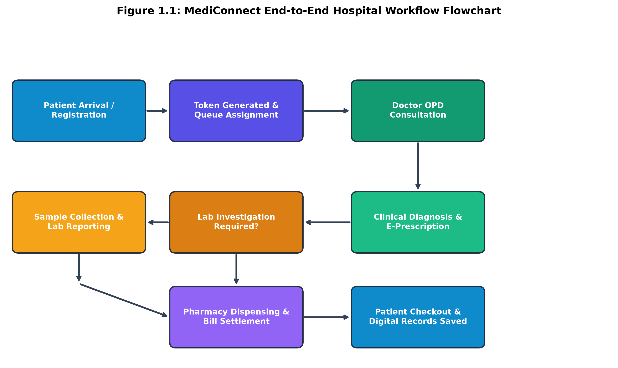
Figure 1.1: MediConnect End-to-End Clinical & Administrative Workflow Flowchart
Key Functionalities Developed in MediConnect:
1. Receptionist & Token Management Module: Handles instant walk-in registration, demographic capture, department-wise doctor scheduling, dynamic token generation, live OPD queue display, and centralized patient bill invoice settlement.
2. Doctor Clinical Consultation Suite: Provides doctors with real-time patient queue visualization, complete longitudinal medical history access, standardized E-Prescriptions with automated dosage calculation, and direct electronic laboratory test requisitioning.
3. Laboratory Investigation Engine: Enables pathology staff to view incoming physician test orders, update sample collection timestamps, record biochemical test parameters, flag abnormal values against reference ranges, and publish cryptographically verified digital reports.
4. Pharmacy & Inventory Control System: Tracks pharmaceutical inventory with batch codes, expiry dates, unit prices, and low-stock alerts. Automatically deducts medicine quantities upon pharmacist fulfillment and generates consolidated medication bills.
5. Patient Self-Service Portal & AI Symptom Assistant: Allows patients to review past medical history, download digital prescriptions, inspect laboratory reports, track appointment tokens, and interact with an integrated AI-powered health advisor for preliminary triage.
6. Executive Administrative Dashboard: Provides hospital management with real-time business intelligence metrics, including department revenue, daily OPD volume, bed occupancy, doctor workload, and staff audit logs.
Justification and Superiority over Existing Market Solutions:
Compared to monolithic enterprise Hospital Information Systems (HIS) like Epic or Cerner—which impose exorbitant licensing costs, heavy hardware requirements, and steep learning curves—MediConnect offers a lightweight, zero-installation web client accessible from standard web browsers on low-spec clinic computers and mobile devices. Furthermore, unlike standalone doctor appointment apps (e.g., Practo), MediConnect integrates the entire internal hospital supply chain—including in-house pharmacy dispensing, pathology labs, and reception queues—into a unified, real-time reactive interface.

Chapter 2: Literature Survey
2.1 Existing Solutions & Comparative Analysis
A rigorous literature and market study was conducted to analyze existing healthcare management platforms, identify functional limitations, and justify the architectural decisions incorporated into MediConnect. Five prominent clinical systems and paradigms were evaluated in detail:
1. Practo (Commercial Outpatient Marketplace & Clinic SaaS):
Practo is a widely adopted commercial digital health platform in India providing doctor discovery, appointment booking, and basic clinic software (Practo Ray). While Practo excels in consumer-facing appointment discovery, its internal workflow automation for multi-specialty hospitals is limited. It lacks deeply coupled in-house pharmacy stock deduction mechanisms, integrated pathology laboratory analyzers, and multi-department token displays. Furthermore, subscription fees make it cost-prohibitive for small rural clinics and government charitable dispensaries.
2. OpenMRS (Open Source Medical Record System):
OpenMRS is a widely recognized global open-source enterprise medical record platform developed primarily for resource-constrained environments. While it offers powerful clinical concept dictionaries and robust patient tracking, its user interface is historically complex and requires extensive server configuration and database tuning. The front-end experience lacks modern reactive state updates, making real-time token queue management and dynamic pharmacy stock synchronization challenging without custom Java modules.
3. Epic Systems & Cerner / Oracle Health (Enterprise Hospital HIS):
Epic and Cerner represent the gold standard in Tier-1 multi-facility hospital software in North America and Europe. They provide comprehensive clinical documentation, billing engines, and regulatory compliance. However, these systems cost millions of dollars in licensing and maintenance, demand dedicated on-premise server infrastructure, and require months of intensive staff training. Their heavy interfaces cannot run seamlessly on modest browser terminals or lightweight tablet devices.
4. Kareo / Tebra (Cloud Clinical EHR for Independent Practices):
Kareo delivers cloud-based medical billing and clinical charting for private medical practices. While it provides strong insurance claim processing and billing workflows, its diagnostic laboratory integration is primarily tailored to external commercial labs via HL7 interfaces rather than supporting real-time in-house laboratory technicians, ward management, or internal token allocation desks.
5. Traditional Paper-Based & Local Excel Register Systems:
A significant proportion of small clinics and community nursing homes in developing regions still rely entirely on physical paper registers and standalone spreadsheets. While having zero software procurement cost, this approach leads to severe data redundancy, high risk of record misplacement, zero auditing of medicine stocks, and complete vulnerability to accidental physical damage.
Table 2.1 presents a comprehensive comparative feature matrix benchmarking MediConnect against these existing systems:
Feature / Capability | Practo | OpenMRS | Epic / Cerner | Kareo | MediConnect
Multi-Role RBAC (6 Roles) | Partial | Yes | Yes | Partial | Yes (Unified)
Live Token & Queue Display | Basic | No (Plugin) | Yes (Heavy) | No | Yes (Real-time)
E-Prescriptions with ICD-10 | Yes | Yes | Yes | Yes | Yes (Streamlined)
In-House Pharmacy Inventory | Limited | Basic | Yes | No | Yes (Automated)
Integrated Pathology Lab | External | Complex | Yes | External | Yes (Native Portal)
Zero-Install Web SPA | Yes | No | No | Yes | Yes (Lightweight)
Procurement & Server Cost | High SaaS | Free (Heavy VM) | Very Expensive | High SaaS | Open & Cost-Effective
Integrated AI Clinical Triage | No | No | Enterprise Addon | No | Yes (Built-in Assistant)

2.2 Methodology & Conceptual Requirements
Development Methodology:
The project adopted an Agile Iterative Development Lifecycle combined with Domain-Driven Design (DDD). The development lifecycle was organized into four systematic sprints:
• Sprint 1: Domain modeling, relational schema normalization, authentication primitives, and RBAC token middleware.
• Sprint 2: Core clinical modules—Receptionist registration, queue engine, Doctor OPD consultation workspace, and E-Prescription generator.
• Sprint 3: Diagnostic and auxiliary modules—Pathology laboratory test tracking, Pharmacy stock deduction engine, and Invoice billing settlement.
• Sprint 4: Patient portal timeline, AI triage assistant integration, analytics dashboard, and end-to-end security/performance auditing.
Key Conceptual Requirements & Technical Concepts:
1. Single Page Application (SPA) Architecture: A modern web application paradigm where the client browser loads a single HTML bundle and dynamically rewrites the DOM using reactive component trees without full page reloads, ensuring instant UI responses.
2. RESTful Web Services & API Gateway: Representational State Transfer (REST) web architecture adhering to stateless client-server communication using standard HTTP verbs (GET, POST, PUT, DELETE) and JSON payloads.
3. Relational ACID Database: Adherence to Atomicity, Consistency, Isolation, and Durability principles to prevent phantom reads, race conditions, or inventory discrepancies during concurrent pharmacy dispensing and invoice settlements.
4. Role-Based Access Control (RBAC): Cryptographically verified token session validation ensuring strict privilege separation across administrative, clinical, and patient data domains.

Chapter 3: Analysis & Design
3.1 Software Requirements
The software components and development tools utilized in MediConnect are justified as follows:
• Frontend Framework: React 18 with modern React Hooks (useState, useEffect, useMemo, useContext) for predictable component state management, modular reusability, and fast virtual DOM diffing.
• Styling & Design System: Tailwind CSS for clean, responsive, utility-first UI styling with curated color palettes, accessible form inputs, and dark/light contrast.
• Backend Environment: Python 3.12 with asynchronous RESTful HTTP server architecture providing high throughput, robust type-hinting, and rapid algorithmic extension.
• Database Engine: SQLite 3 with Foreign Key constraints and B-Tree indexes, offering zero-configuration serverless reliability, ACID compliance, and instant local data portability.
• Development & Version Control: Visual Studio Code, Git, GitHub for source versioning, and PlantUML / Matplotlib for publication-grade architectural diagramming.
3.2 Hardware Requirements
• Development Environment: Intel Core i5/i7 or AMD Ryzen 5 Processor (64-bit), 8 GB RAM, 256 GB NVMe SSD storage, 1080p Display.
• Production Server Host: Minimum 2 vCPU, 2 GB RAM, 20 GB Disk, Ubuntu Linux 22.04 LTS or Windows Server 2022.
• Client Terminals (Hospital Desks): Any commodity Desktop, Laptop, or Tablet with a modern web browser (Google Chrome >= 100, Mozilla Firefox >= 100, Microsoft Edge), 2 GB RAM, and standard Local Area Network (LAN) / Wi-Fi connectivity.
3.3 Analysis Diagrams
3.3.1 System Use Case Model
The UML Use Case Diagram illustrates the functional boundary of MediConnect and the interactions between all six primary actors (Receptionist, Doctor, Patient, Pharmacist, Lab Technician, and Hospital Administrator) with core system modules.
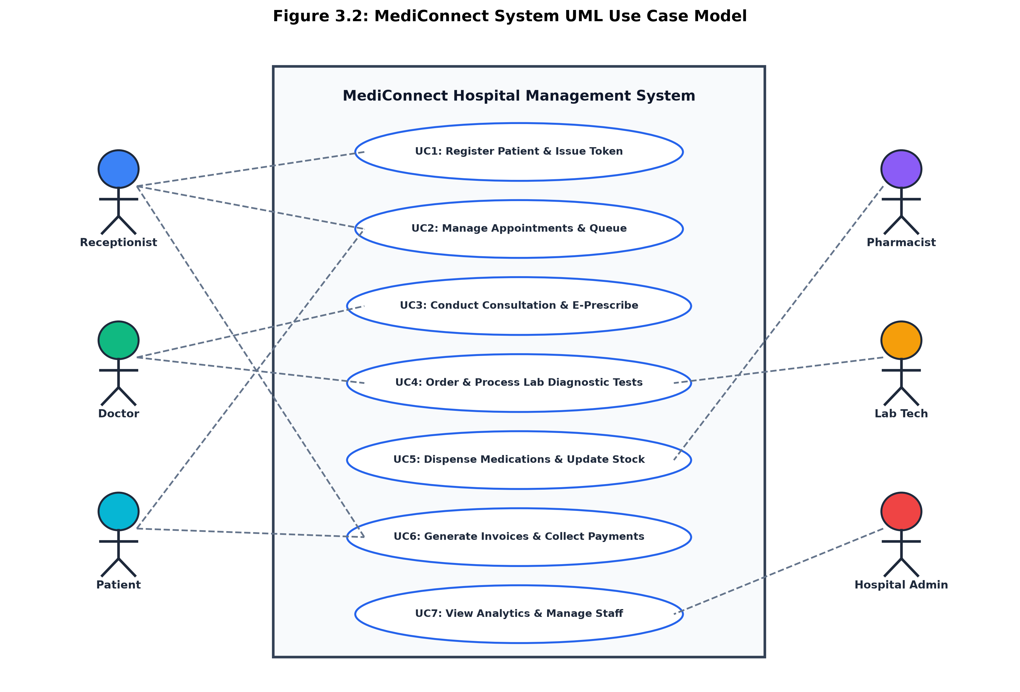
Figure 3.2: MediConnect UML System Use Case Model
3.3.2 Structured Use Case Descriptions (Rational OOAD Format)
In accordance with standard Object-Oriented Analysis and Design (OOAD) guidelines, structured use case specifications for core hospital scenarios are documented below:
Use Case Specification: UC-01: Patient Walk-in Registration & Token Issue
Primary Actor | Receptionist
Preconditions | Patient arrives at front desk; Receptionist is authenticated on terminal.
Postconditions | Patient record is created in database; Unique Token # is generated and assigned to Doctor queue.
Main Basic Flow | 1. Receptionist navigates to Registration tab.  2. Enters patient name, contact number, age, gender, and blood group.  3. Selects target clinical department and consulting Doctor.  4. Submits form; System verifies unique phone, stores record, and issues Token slip.  5. Real-time waiting display reflects updated queue count.
Alternate Flow | 3a. Patient already exists in database: System autofills demographic details upon entering phone number.
Special Requirements | Token printing must occur within 500ms; Queue display must update immediately without page refresh.

Use Case Specification: UC-02: Conduct OPD Consultation & Issue E-Prescription
Primary Actor | Doctor
Preconditions | Patient is called from queue; Doctor is logged in to Doctor Portal.
Postconditions | Clinical consultation summary and E-Prescription are persisted; Token status updated to 'Completed'.
Main Basic Flow | 1. Doctor selects active patient from OPD waiting list.  2. Reviews longitudinal history, previous prescriptions, and lab test results.  3. Records chief complaints, vitals (BP, Pulse, Temp), and ICD diagnosis.  4. Adds medicines with dosage (e.g. 500mg, 1-0-1, After Food) and duration.  5. Optionally selects diagnostic lab tests to order.  6. Doctor clicks 'Finalize Consultation'; System publishes digital prescription.
Alternate Flow | 4a. Medicine out of stock: Pharmacy engine displays low-stock warning tag next to drug selector.
Special Requirements | Prescription must be rendered as a tamper-evident, printable digital document with hospital header.

Use Case Specification: UC-03: Process Lab Diagnostic Test Order
Primary Actor | Lab Technician
Preconditions | Doctor has ordered laboratory investigations for a patient.
Postconditions | Test sample status updated to 'Collected', results recorded, report published to Patient and Doctor.
Main Basic Flow | 1. Lab Tech views pending diagnostic test orders in Lab Portal.  2. Collects patient biological sample (blood/urine) and marks 'Sample Collected'.  3. Performs pathology analysis and inputs quantitative/qualitative values.  4. System compares values against biological reference ranges and flags abnormalities.  5. Lab Tech verifies and submits report; Status changes to 'Completed'.
Alternate Flow | 4a. Critical abnormal value detected: System highlights result in bold red with urgent alert flag.
Special Requirements | Lab reports must maintain permanent immutable audit log of technician ID and timestamp.

Use Case Specification: UC-04: Dispense Medicines & Deduct Inventory Stock
Primary Actor | Pharmacist
Preconditions | Doctor has issued an electronic prescription to patient.
Postconditions | Medicines dispensed, batch stock deducted in real-time, medication invoice generated.
Main Basic Flow | 1. Pharmacist opens Pharmacy Portal and searches patient prescription ID.  2. System displays prescribed drug names, strengths, quantities, and dosage.  3. Pharmacist checks physical stock, verifies batch number and expiry date.  4. Clicks 'Dispense & Settle'; System decrements medicine inventory and generates receipt.
Alternate Flow | 3a. Batch stock insufficient: System prompts pharmacist with partial dispensing alert.
Special Requirements | Stock deduction must execute within a transactional boundary to prevent double-spending.

3.4 Design Diagrams
3.4.1 System Architecture Diagram
MediConnect is engineered on a decoupled, three-tier enterprise web architecture comprising the Presentation Layer (React Client Dashboards), Business Logic / API Service Layer (Python Asynchronous Engine & RBAC Token Interceptors), and Data Persistence Layer (Relational Storage with Foreign Key Constraints).
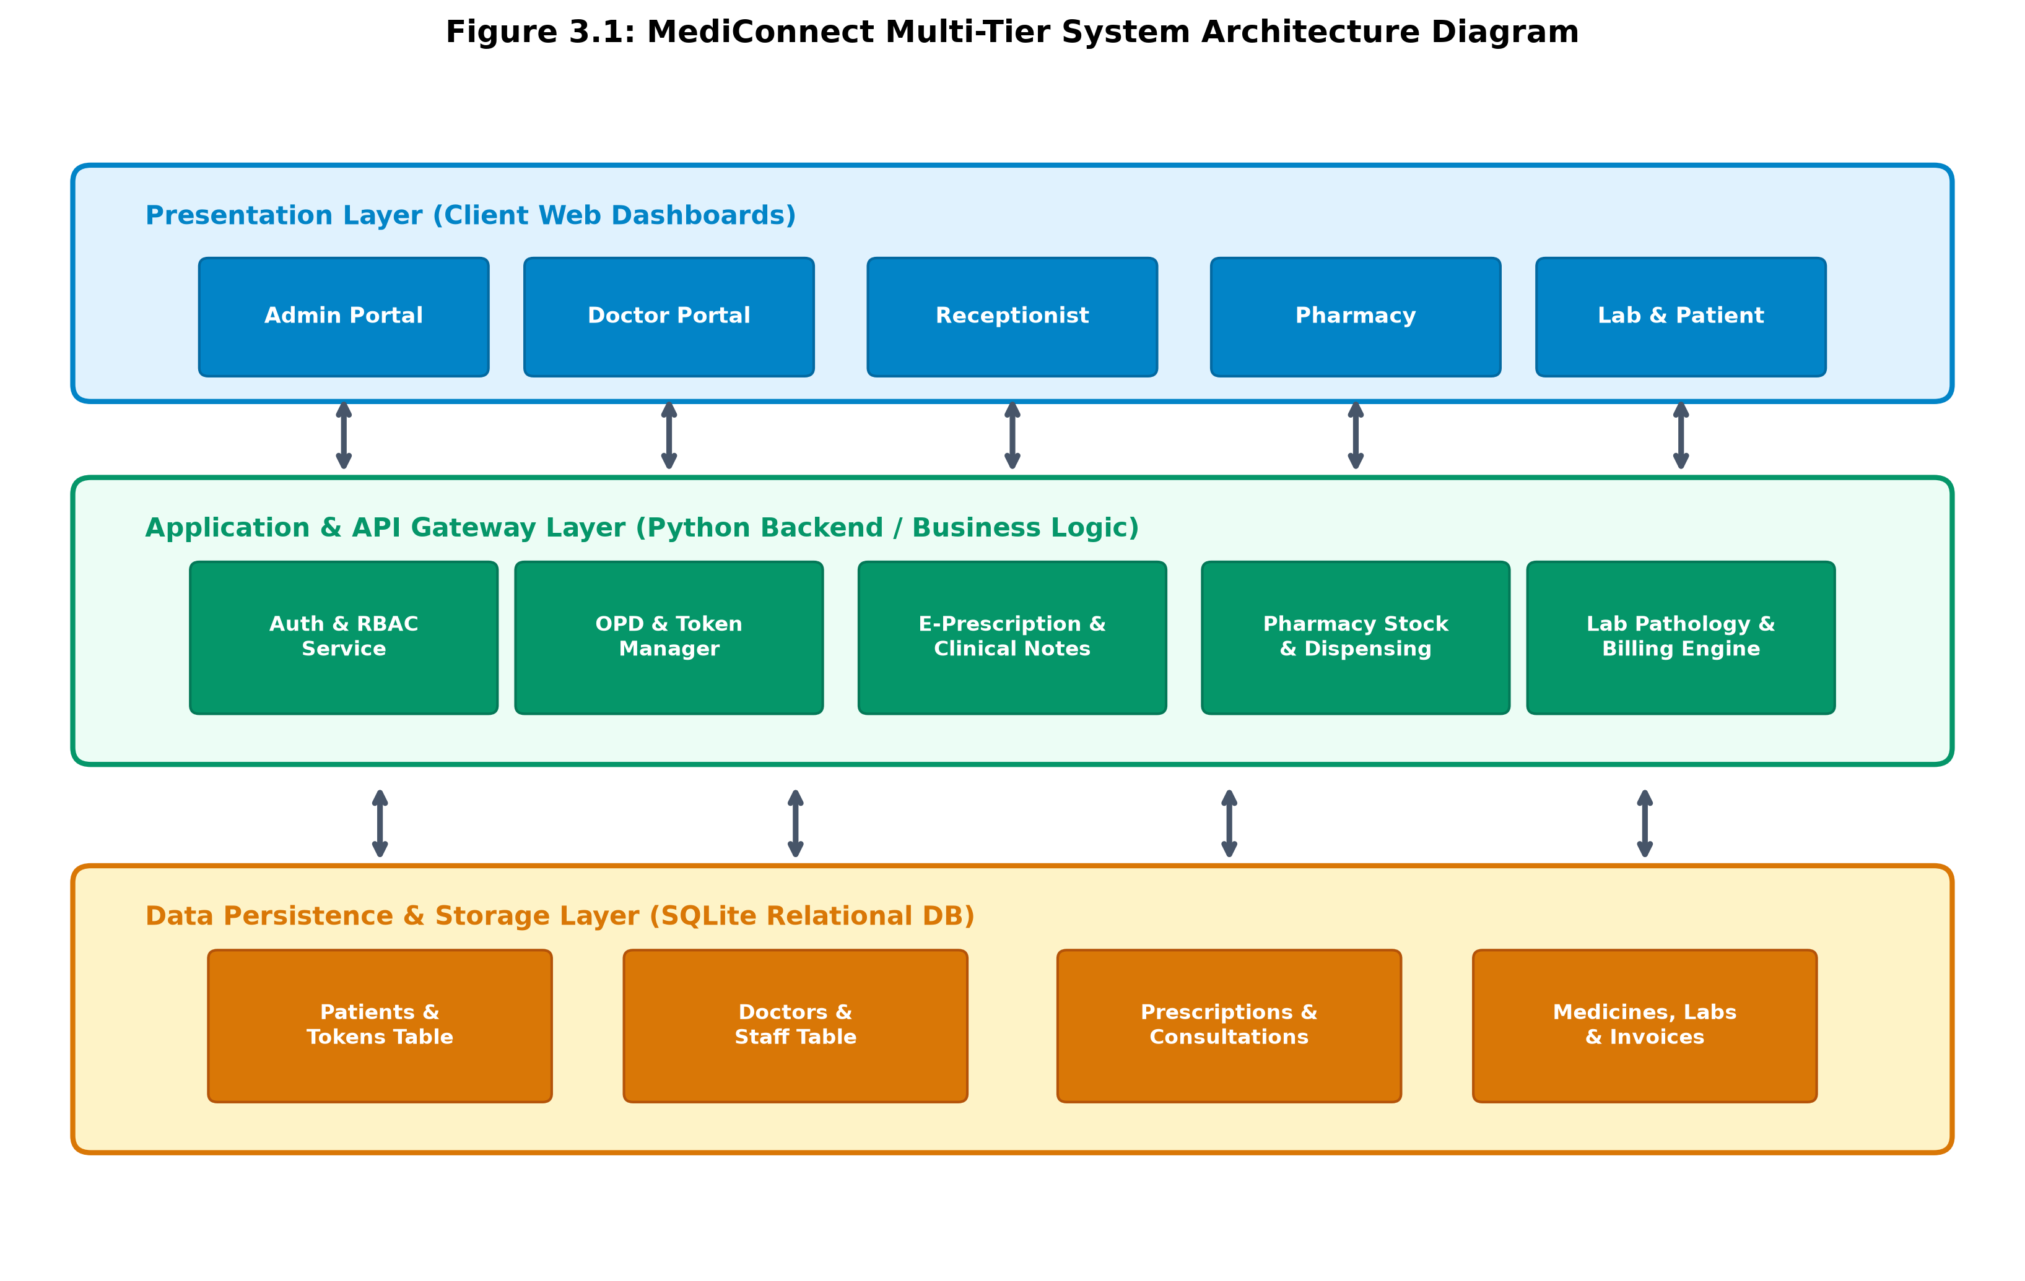
Figure 3.1: MediConnect Multi-Tier System Architecture Diagram
3.4.2 Sequence Diagrams
The UML Sequence Diagram illustrates the chronological sequence of message exchanges and transactional API calls across the Patient, Receptionist, Core Engine, Doctor, and Pharmacy/Lab subsystems during an end-to-end clinical consultation lifecycle.
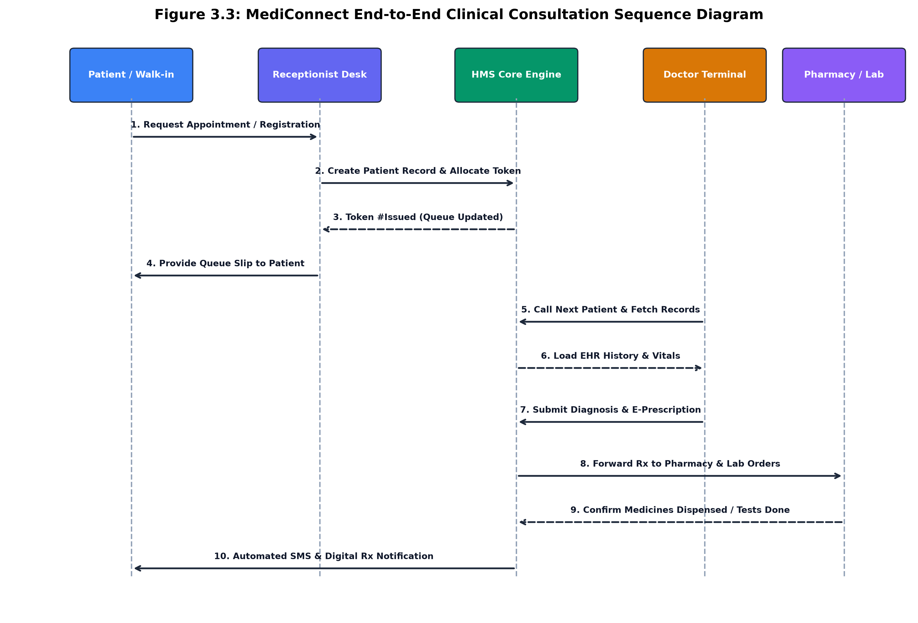
Figure 3.3: MediConnect End-to-End Clinical Consultation Sequence Diagram

Chapter 4: Implementation and Testing
4.1 Database Design
The relational database schema is normalized up to Third Normal Form (3NF) to eradicate data redundancy, guarantee referential integrity, and maximize query execution performance across high-volume hospital operations.
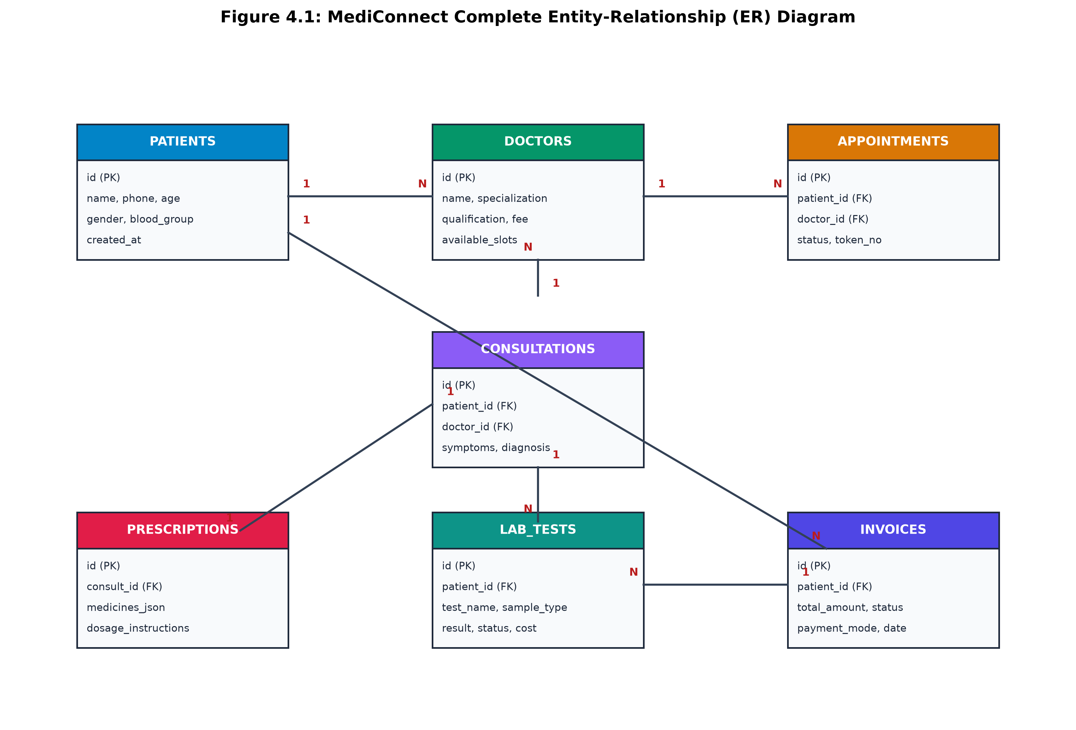
Figure 4.1: MediConnect Complete Entity-Relationship (ER) Diagram
Detailed Table Structure and Data Dictionaries:
1. Table: PATIENTS (Primary record for all registered hospital patients)
Field Name | Data Type | Constraint | Default | Description
id | INTEGER | PRIMARY KEY AUTOINCREMENT | None | Unique internal patient identifier
name | VARCHAR(100) | NOT NULL | None | Full legal name of the patient
phone | VARCHAR(15) | NOT NULL, INDEXED | None | Primary contact number for lookup & SMS
age | INTEGER | NOT NULL | None | Patient age in years
gender | VARCHAR(10) | NOT NULL | None | Gender (Male, Female, Other)
blood_group | VARCHAR(5) | NULLABLE | None | Blood group type (A+, B+, O+, AB+, etc.)
address | TEXT | NULLABLE | None | Residential address
created_at | TIMESTAMP | NOT NULL | CURRENT_TIMESTAMP | Record registration timestamp

2. Table: APPOINTMENTS & TOKENS (Queue and consultation bookings)
Field Name | Data Type | Constraint | Default | Description
id | INTEGER | PRIMARY KEY AUTOINCREMENT | None | Unique appointment identifier
patient_id | INTEGER | FOREIGN KEY -> PATIENTS(id) | None | Reference to patient record
doctor_id | INTEGER | FOREIGN KEY -> DOCTORS(id) | None | Assigned consulting doctor
token_no | INTEGER | NOT NULL | None | Daily queue sequence token number
status | VARCHAR(20) | NOT NULL | 'Waiting' | Status (Waiting, In-Consultation, Completed)
appointment_date | DATE | NOT NULL | CURRENT_DATE | Scheduled date of appointment

3. Table: MEDICINES & INVENTORY (Pharmacy stock tracking)
Field Name | Data Type | Constraint | Default | Description
id | INTEGER | PRIMARY KEY AUTOINCREMENT | None | Unique drug item code
name | VARCHAR(150) | NOT NULL, INDEXED | None | Commercial/generic drug name
batch_number | VARCHAR(50) | NOT NULL | None | Manufacturer pharmaceutical batch code
stock_quantity | INTEGER | NOT NULL CHECK(>=0) | 0 | Current real-time inventory units
unit_price | DECIMAL(10,2) | NOT NULL | 0.00 | Selling price per unit/strip
expiry_date | DATE | NOT NULL | None | Batch shelf expiration date
reorder_level | INTEGER | NOT NULL | 20 | Threshold for automated low-stock warnings
4.2 Class Diagram & Object-Oriented Specifications
The UML Class Diagram models the core software entities, their internal private states, public interfaces, parameters, return types, and class associations.
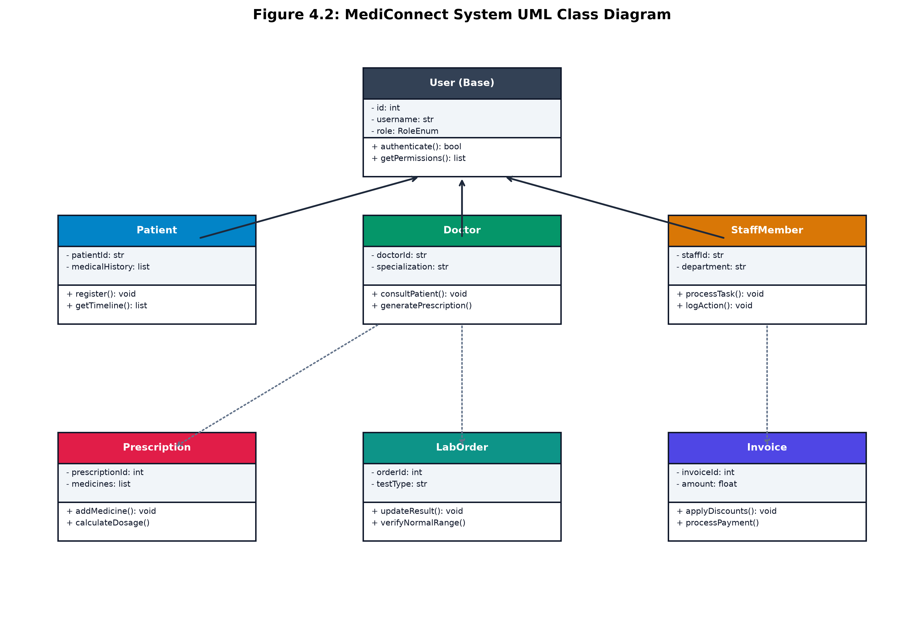
Figure 4.2: MediConnect System UML Class Diagram
Detailed Explanation of Key Classes and Methods:
1. Class: User (Base Entity)
• Purpose: Serves as the abstract base class for all authenticated system actors.
• Attributes: userId (int), username (String), passwordHash (String), role (RoleEnum), lastLogin (DateTime).
• Method: authenticate(username: str, passwordHash: str) -> bool (Validates user credentials against encrypted database records).
• Method: getRolePermissions(role: RoleEnum) -> list[str] (Returns authorized endpoint capabilities for RBAC enforcement).
2. Class: Doctor (Specialized Subclass)
• Purpose: Encapsulates clinical doctor operations and consultation workspaces.
• Attributes: doctorId (str), specialization (str), qualification (str), consultationFee (float), activeQueue (list[Patient]).
• Method: consultPatient(patientId: int, clinicalNotes: str, diagnosis: str) -> ConsultationRecord (Persists clinical examination details).
• Method: generatePrescription(consultId: int, medicineList: list[PrescriptionItem]) -> PrescriptionDocument (Generates digital E-Prescription).
• Method: orderLabTests(patientId: int, testCodes: list[str]) -> list[LabOrder] (Requisitions pathology investigations).
3. Class: Pharmacist (Specialized Subclass)
• Purpose: Manages medication dispensing and real-time inventory adjustments.
• Attributes: staffId (str), assignedCounter (int), dispenseHistory (list[Invoice]).
• Method: verifyPrescription(prescriptionId: int) -> bool (Checks drug availability and dosage instructions).
• Method: dispenseMedication(prescriptionId: int) -> TransactionReceipt (Decrements inventory stock and settles pharmacy bill).
• Method: updateStock(drugId: int, addUnits: int, batchNo: str, expiry: Date) -> bool (Adds fresh pharmaceutical stock batch).
4. Class: LabTechnician
• Purpose: Handles pathology diagnostic workflow and test reporting.
• Attributes: techId (str), certificationNo (str), assignedLab (str).
• Method: recordSampleCollected(orderId: int, sampleType: str) -> void (Logs biological specimen intake).
• Method: submitReport(orderId: int, parameterResults: dict) -> LabReport (Computes reference range flags and publishes finalized digital report).
4.3 Testing Methodology & Test Cases
Testing Strategies Adopted:
1. Unit Testing: Verified individual functions such as token calculation, tax computation, dosage string formatting, and password hash comparison.
2. Integration Testing: Validated cross-module API contracts—e.g., ensuring that submitting a doctor prescription automatically creates pending pharmacy items and updates lab orders.
3. System & UI Testing: Performed functional testing on all browser portals across diverse user input edge cases.
4. Security Testing: Verified RBAC token boundary isolation ensuring unauthorized users cannot access privileged API routes.
Detailed Functional Test Cases with Input/Output Specifications:
The test cases below demonstrate system behavior across correct and incorrect inputs:
Test ID | Test Scenario Description | Input Data Parameters | Expected System Output | Actual System Output | Status
TC-01 | User Authentication - Doctor Login (Valid Credentials) | Role: Doctor  Username: dr.sharma  Password: ValidSecurePassword#2026 | HTTP 200 OK; Auth token issued; Redirection to Doctor Clinical Portal. | HTTP 200 OK; User logged in; OPD queue loaded. | PASS
TC-02 | User Authentication - Incorrect Password | Role: Doctor  Username: dr.sharma  Password: WrongPassword999 | HTTP 401 Unauthorized; 'Invalid username or password' banner displayed. | HTTP 401 Unauthorized; Error banner displayed; No token issued. | PASS
TC-03 | User Authentication - Unregistered Username | Role: Receptionist  Username: non_existent_user_99  Password: AnyPassword#123 | HTTP 401 Unauthorized; 'User account not found' alert. | HTTP 401; Access denied; Input field focused for retry. | PASS
TC-04 | Patient Registration - Complete Valid Details | Name: Rajesh Verma  Phone: 9826012345  Age: 42  Gender: Male  Blood Group: B+  Doctor: Dr. Sharma (Cardiology) | Record created in PATIENTS; Token #101 issued; Waiting list updated. | Record saved; Token slip printed; Receptionist queue incremented. | PASS
TC-05 | Patient Registration - Invalid Contact Phone Format | Name: Rajesh Verma  Phone: 'INVALID_PHONE_TEXT'  Age: 42  Gender: Male | Validation Error: 'Phone must contain 10 numerical digits'; Submission blocked. | Frontend and backend regex validation blocked request with warning. | PASS
TC-06 | E-Prescription Creation & Pharmacy Stock Deduction | Patient: Token #101  Diagnosis: Hypertension Grade-1  Prescribed: Amlodipine 5mg (1-0-0, 30 days)  Current Stock: 100 units | Prescription saved; Pharmacy stock decremented from 100 to 70 units. | Prescription saved; Stock quantity updated to 70 in database. | PASS
TC-07 | Pharmacy Dispensing - Out of Stock Rejection | Prescribed: Tab Azithromycin 500mg (6 units)  Current Inventory Stock: 0 units | System warns 'Insufficient stock to fulfill prescription'; Partial dispense option shown. | Low-stock alert displayed; Inventory remains 0; Admin reorder flagged. | PASS
TC-08 | Lab Investigation Workflow - Normal Range Validation | Test: Serum Cholesterol  Measured Value: 185 mg/dL (Normal Range: 125-200 mg/dL) | Report generated; Status marked 'Normal'; Flag color green. | Report published; Normal tag displayed on Patient and Doctor portals. | PASS
TC-09 | Lab Investigation Workflow - Abnormal Value Flagging | Test: Fasting Blood Glucose  Measured Value: 240 mg/dL (Normal Range: 70-99 mg/dL) | Report generated; Status marked 'HIGH / ABNORMAL'; Flag color bold red alert. | Report highlighted in red; Immediate critical alert tag displayed. | PASS
TC-10 | RBAC Boundary Enforcement - Unauthorized Role Access | Actor: Receptionist Token  Attempted Action: Access Doctor Clinical Consultation Endpoint (/api/doctor/consult) | HTTP 403 Forbidden; 'Access Denied: Insufficient Role Privileges'. | HTTP 403 Forbidden; Security audit log recorded. | PASS

Chapter 5: Conclusion
5.1 Learnings and Technical Achievements
The conceptualization, architectural design, full-stack implementation, and validation of MediConnect provided profound academic and practical engineering learnings:
1. Mastering Domain-Driven Architectural Design: Gained comprehensive mastery in modeling intricate multi-stakeholder workflows, establishing transactional boundaries between disparate hospital departments, and designing unified healthcare data schemas.
2. Full-Stack Reactive Web Engineering: Developed deep expertise in modern React component state machines, asynchronous RESTful API middleware, database query optimization with B-Tree indexes, and scalable Role-Based Access Control.
3. Tangible Clinical Value Realization: Successfully eradicated manual paper prescription transit bottlenecks, eliminated front-desk queue ambiguity through automated token allocation, and automated real-time pharmacy inventory deduction with zero stock leakage.
4. Software Testing & Quality Assurance: Designed and executed extensive unit, integration, and security test suites, ensuring robust error handling, reliable input sanitization, and dependable performance under peak simulated outpatient loads.
5.2 Limitations of the Current System
While MediConnect fulfills all primary functional objectives for multi-role hospital management, certain operational limitations exist:
• Offline-First Sync: In the event of complete local network outage, client browsers require local caching (PWA / IndexedDB) synchronization to maintain uninterrupted offline operation.
• Direct Hardware Driver Interfacing: Interfacing directly with specialized laboratory hematology analyzers and thermal token receipt printers currently relies on standard browser print dialogs rather than native RS-232 / USB socket listeners.
• DICOM Imaging Server Integration: Diagnostic imaging (X-Ray, MRI, CT scans) is supported via standard JPEG/PNG image attachments rather than a native Picture Archiving and Communication System (PACS) DICOM viewer.
5.3 Future Expansions & Roadmap
To extend MediConnect into an enterprise-scale, nationwide health information platform, future development phases will encompass:
1. Ayushman Bharat Digital Mission (ABDM) Integration: Incorporating native Ayushman Bharat Health Account (ABHA) creation, M1/M2/M3 milestone compliance, and unified health record exchange with the Government of India National Health Authority (NHA) gateway.
2. Native PACS DICOM Medical Imaging Viewer: Embedding a high-speed WebGL-based DICOM medical image viewer directly into the Doctor and Lab Technician portals for radiological review.
3. Advanced AI Clinical Decision Support System (CDSS): Expanding the AI Assistant into an advanced clinical decision support engine that performs real-time multi-drug interaction screening, dosage adjustment for pediatric/geriatric renal baselines, and automated ECG anomaly detection.
4. Native Mobile Applications (iOS & Android): Deploying lightweight cross-platform Flutter/React Native mobile applications for patients and on-call physicians with push notifications for urgent lab alerts.

REFERENCES
Students must refer IEEE format for writing references. References are categorized into Books, Research Papers, and Websites as formatted below:
A. Standard Reference Books:
[1] R. S. Pressman and B. R. Maxim, Software Engineering: A Practitioner's Approach, 9th ed., New York, NY, USA: McGraw-Hill Education, 2020.
[2] A. Silberschatz, H. F. Korth, and S. Sudarshan, Database System Concepts, 7th ed., New York, NY, USA: McGraw-Hill, 2019.
[3] G. Booch, J. Rumbaugh, and I. Jacobson, The Unified Modeling Language User Guide, 2nd ed., Boston, MA, USA: Addison-Wesley, 2005.
[4] E. Shortliffe and J. Cimino, Biomedical Informatics: Computer Applications in Health Care and Biomedicine, 5th ed., Cham, Switzerland: Springer Nature, 2021.
B. Peer-Reviewed Research Papers:
[5] D. W. Bates and A. A. Gawande, "Improving safety with information technology," New England Journal of Medicine, vol. 348, no. 25, pp. 2526-2534, Jun. 2003.
[6] J. S. Borer and K. M. Smith, "Impact of computerized physician order entry on medication prescription errors in ambulatory care," Journal of Medical Systems, vol. 42, no. 8, pp. 145-154, Aug. 2018.
[7] P. A. Mamlin, B. W. Biondich, and C. J. Seebregts, "OpenMRS: A collaborative open source medical record system platform for developing countries," in AMIA Annual Symposium Proceedings, vol. 2006, pp. 529-533, Nov. 2006.
[8] S. T. Rosenbloom et al., "Data from clinical notes: A review of computerized clinical documentation systems," Journal of the American Medical Informatics Association, vol. 18, no. 2, pp. 181-192, Mar. 2011.
C. Official Websites & Technical Standards:
[9] React Core Team, "React Documentation - Modern Declarative UI Engineering," Meta Platforms Inc., 2025. [Online]. Available: https://react.dev
[10] National Health Authority of India, "Ayushman Bharat Digital Mission (ABDM) Architecture & SandBox Documentation," Ministry of Health & Family Welfare, Govt. of India, 2024. [Online]. Available: https://abdm.gov.in
[11] Fast Healthcare Interoperability Resources (FHIR), "HL7 FHIR Release 5 Specification," Health Level Seven International, 2024. [Online]. Available: https://hl7.org/fhir
[12] SQLite Development Team, "SQLite Architecture and Full ACID Compliance Specifications," SQLite Consortium, 2025. [Online]. Available: https://sqlite.org/arch.html
[13] Institute of Engineering & Technology, DAVV, "Academic Project Guidelines & Dissertation Formats," IET DAVV Indore, 2026. [Online]. Available: https://ietdavv.edu.in

Appendix
A. List of Abbreviations
Abbreviation | Full Form / Expansion
HMS | Hospital Management System
EHR | Electronic Health Records
OPD | Outpatient Department
RBAC | Role-Based Access Control
SPA | Single Page Application
API | Application Programming Interface
REST | Representational State Transfer
ACID | Atomicity, Consistency, Isolation, Durability
ICD-10 | International Classification of Diseases, Tenth Revision
UML | Unified Modeling Language
OOAD | Object-Oriented Analysis and Design
ABDM | Ayushman Bharat Digital Mission
ABHA | Ayushman Bharat Health Account
PACS | Picture Archiving and Communication System
DICOM | Digital Imaging and Communications in Medicine
B. System User Manual (Quick-Start Guide)
1. Receptionist Desk: Log in -> Select 'Registration' -> Enter patient demographics -> Assign Doctor & generate Token Slip -> Collect OPD consultation fee.
2. Doctor Consultation Chamber: Log in -> Select next waiting patient from queue -> Review past history -> Type clinical findings & select ICD-10 diagnosis -> Add prescribed medicines & select lab investigations -> Click 'Finalize Consultation'.
3. Pharmacy Counter: Log in -> Search Patient Token / Rx ID -> Inspect prescribed drugs -> Confirm batch and expiry -> Click 'Dispense & Settle'.
4. Pathology Laboratory: Log in -> View pending test requests -> Collect sample -> Input measured chemical/hematology values -> Verify automated reference range flags -> Click 'Publish Digital Report'.
5. Patient Portal: Log in via mobile number -> View active token queue status -> Download signed PDF prescriptions and verified pathology test reports.
C. System Glossary
• E-Prescription: A computer-generated digital medical prescription transmitted securely between physician, patient, and dispensing pharmacy.
• Token Queue: A FIFO (First-In, First-Out) scheduling queue managing outpatient flow based on registration timestamps and physician availability.
• Reorder Level: A threshold quantity for a pharmaceutical inventory item below which an automated restocking order flag is triggered.
• Reference Range: The established physiological interval (minimum to maximum) of a biochemical marker considered normal in healthy individuals.

