**1. What are the different margins options and do we adjust the margins of the excel worksheet?**

In Excel, margins refer to the space between the edge of the page and the data on the worksheet. There are different margin options that can be adjusted, including:

Top Margin: The space between the top edge of the page and the data on the worksheet.

Bottom Margin: The space between the bottom edge of the page and the data on the worksheet.

Left Margin: The space between the left edge of the page and the data on the worksheet.

Right Margin: The space between the right edge of the page and the data on the worksheet.

Header Margin: The space between the top edge of the page and the header section of the worksheet.

Footer Margin: The space between the bottom edge of the page and the footer section of the worksheet.

To adjust the margins of an Excel worksheet, you can follow these steps:

Click on the Page Layout tab in the ribbon.

Click on the Margins drop-down menu in the Page Setup group.

Select the margin option you want to adjust.

Click on Custom Margins to set the margin size and orientation.

Click OK to apply the changes.

**2. Set a background for your table created.**

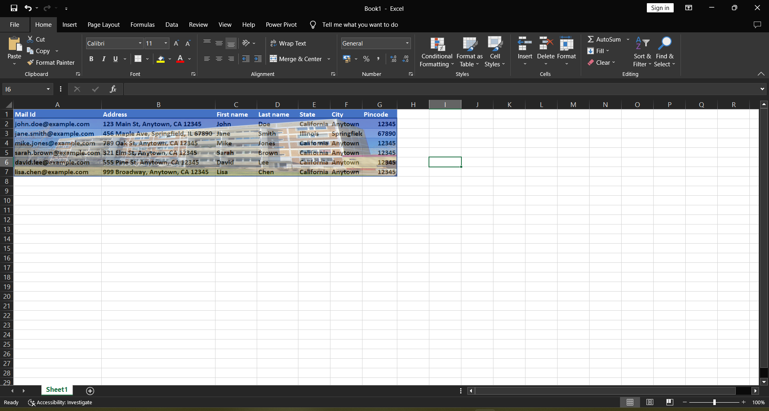

**3. What is freeze panes and why do we use freeze panes? Give examples.**

Freeze panes is a feature in Excel that allows you to freeze certain rows or columns in place, while the rest of the worksheet can be scrolled through normally. This is useful when you have a large dataset and want to keep certain headings or labels visible as you scroll through the rest of the data.

To use freeze panes, you can select the row or column that you want to freeze and then click on the Freeze Panes option under the View tab in the ribbon. You can choose to freeze the top row, left column, or a specific row or column that you have selected.

Here are some examples of when you might use freeze panes:

You have a large dataset with headers in the first row. By freezing the top row, you can keep the headers visible as you scroll through the rest of the data.

You have a worksheet with a lot of data, but you want to keep certain columns in view as you scroll horizontally. By freezing a column, you can keep it visible while scrolling through the rest of the data.

You are working on a complex formula that requires referencing multiple cells. By freezing the rows and columns that contain the necessary data, you can keep them in view while working on the formula in another section of the worksheet.

**4. What are the different features available within the Freeze Panes command?**

The Freeze Panes command in Excel provides different options for freezing rows or columns. The available features within the Freeze Panes command are:

Freeze Top Row: This option freezes the first row of the worksheet, keeping it visible as you scroll down through the rest of the data.

Freeze First Column: This option freezes the first column of the worksheet, keeping it visible as you scroll horizontally through the rest of the data.

Freeze Panes: This option allows you to freeze any number of rows or columns at once. To use this option, select the cell below and to the right of the rows and columns you want to freeze, and then choose Freeze Panes.

Unfreeze Panes: This option removes any existing freeze panes and allows you to scroll through the entire worksheet.

Freeze Panes Options: This option allows you to specify exactly which rows or columns you want to freeze. To use this option, select the cell below and to the right of the rows and columns you want to freeze, and then choose Freeze Panes Options. In the Freeze Panes dialog box, you can choose to freeze the top row, left column, or a specific number of rows and columns.

By using these different features within the Freeze Panes command, you can customize the freezing of rows and columns according to your specific needs.

**5. Explain what the different sheet options present in excel are and what they do?**

In Excel, there are different sheet options available that allow you to manage and customize the appearance and behavior of worksheets. These options include:

Rename Sheet: This option allows you to change the name of the current worksheet.

Move or Copy Sheet: This option allows you to move or make a copy of the current worksheet within the same workbook or to another workbook.

Hide Sheet: This option allows you to hide the current worksheet, making it invisible in the workbook. You can unhide a hidden sheet at any time.

Unhide Sheet: This option allows you to unhide a sheet that has been hidden. You can choose which hidden sheet you want to unhide from a list of all hidden sheets in the workbook.

Protect Sheet: This option allows you to password-protect the current worksheet, preventing users from making changes to the data, formatting, or other sheet options.

Tab Colour: This option allows you to change the colour of the worksheet tab, making it easier to identify specific sheets in a workbook.

Tab Order: This option allows you to rearrange the order of worksheet tabs in the workbook, making it easier to find specific sheets.

By using these different sheet options, you can customize and manage worksheets in Excel to better suit your needs and improve your productivity.