System Design Document (SDD)
Turn-Based Multiplayer Game

Introduction
This document describes the system architecture, components, data models, APIs, event schemas, and deployment model for the Turn-Based Multiplayer Game project. The system is designed as a distributed, event-driven microservices architecture suitable for scalable turn-based gameplay environments.

1.1 Purpose of the System
The purpose of the system is to enable scalable, fault-tolerant turn-based gameplay by distributing components across independent services and using event-driven communication via a Pub/Sub system.

1.2 System Scope
The system includes player authentication, matchmaking, real-time event updates, game logic processing, persistent storage, and WebSocket notifications.

2. High-Level Architecture
The system consists of:
- Player Service | - Matchmaking Service
- Game Logic Service | - Event/Notification Service
- Pub/Sub system (RabbitMQ or Kafka)

3. Component Design
Each service operates independently and communicates through REST APIs and event-driven messaging.
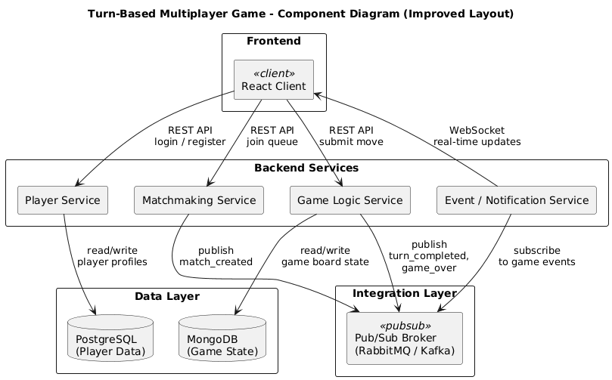

3.1 Player Service
Responsibilities:
- Player registration and authentication | - Player registration and authentication
- JWT token issuance | - JWT token issuance

3.2 Matchmaking Service
Responsibilities:
- Maintain a queue of players waiting for a match | - Publish match_created events
- Pair players into matches

3.3 Game Logic Service
Responsibilities:
- Initialize game sessions based on match_created events | - Publish turn_completed and game_over events
- Validate moves | - Store game state in MongoDB
- Manage turn flow

3.4 Event Service
Responsibilities:
- Subscribe to events from the Pub/Sub layer
- Send real-time WebSocket updates to clients

4. Deployment Architecture
All services run in Docker containers. Databases and the Pub/Sub broker are also containerized. The frontend may be served via CDN/Nginx.
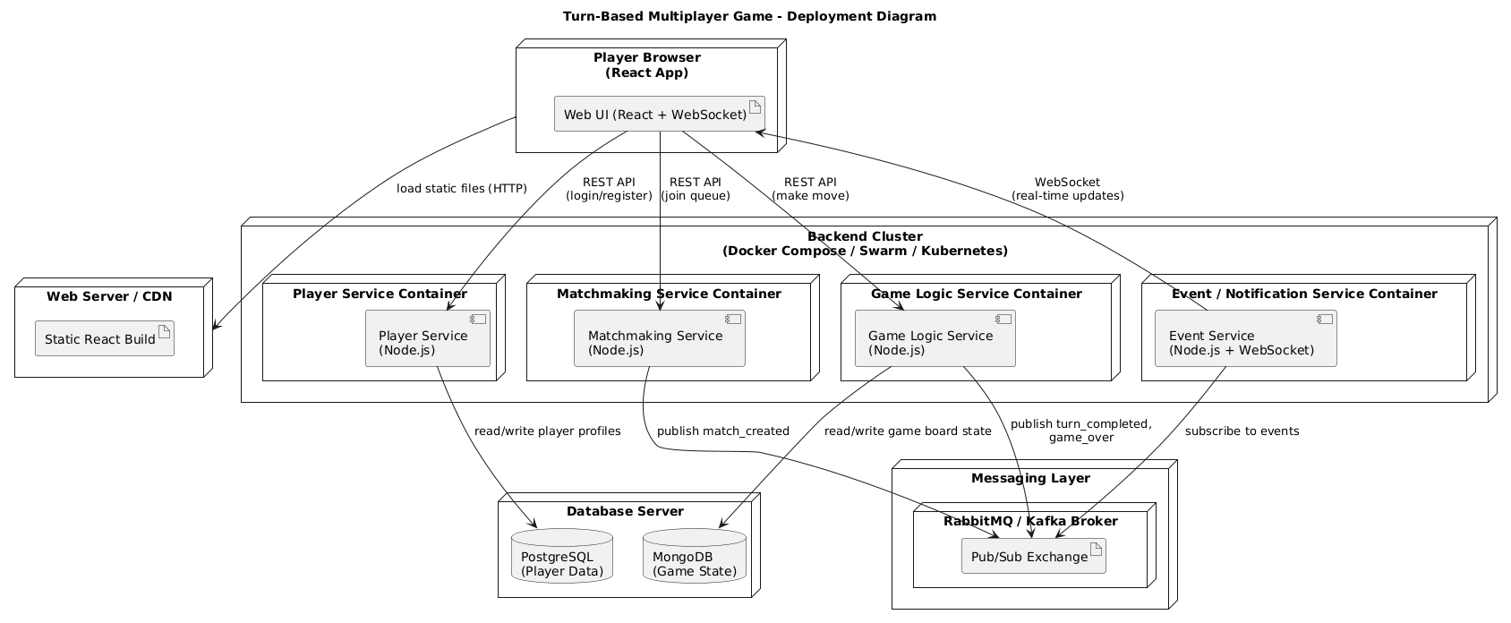

5. Data Storage Design
- PostgreSQL stores player accounts and stats.
- MongoDB stores board states, active matches, and turn metadata.

6. API Design
Each microservice exposes an HTTP REST API. OpenAPI specifications include endpoints for login, registration, matchmaking, game state queries, and submitting moves.

7. Pub/Sub Event Design
Events include:
- match_created | - match_created
- turn_submitted | - turn_submitted

Each event is validated using JSON Schema for consistency and reliability across microservices.

8. Sequence Diagrams
Sequence flows cover:
Matchmaking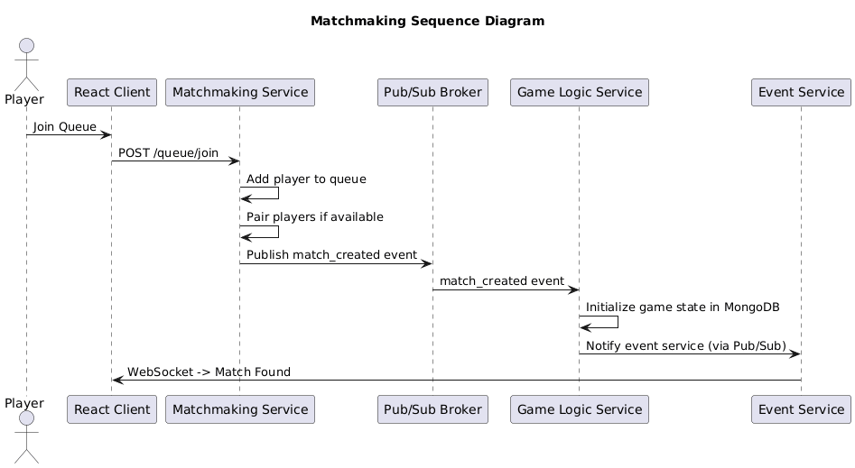Turn submission
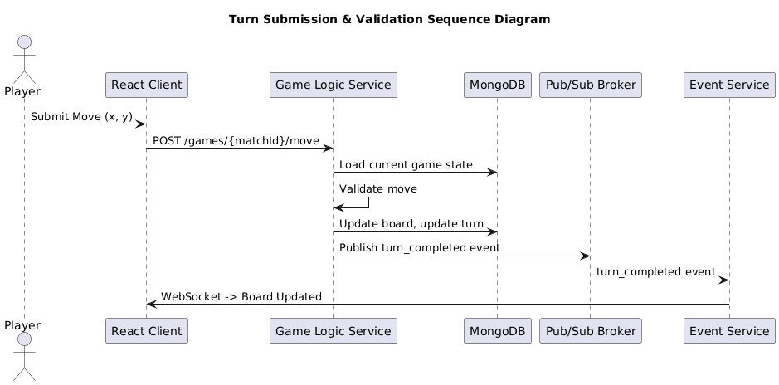
Game-over flow
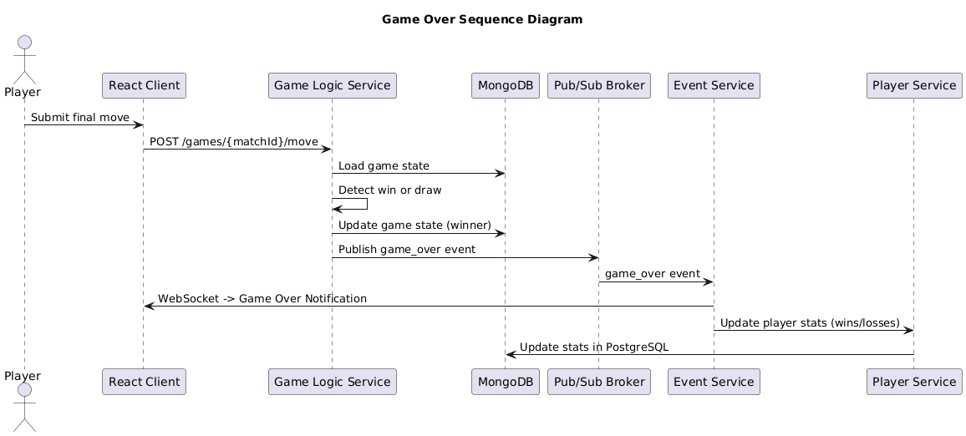

9. Non-Functional Requirements
- Security: JWT authentication across services
- Performance: Low-latency event handling
- Scalability: Horizontal scaling of stateless services
- Reliability: Durable queues, message acknowledgments

10. Risks and Mitigation
- Game logic errors → Unit and integration tests
- Pub/Sub delays → Durable queues, retry logic
- WebSocket congestion → Load balancing, horizontal scaling

12. Conclusion
The system architecture provides a scalable, modular, event-driven backend suitable for turn-based multiplayer games, ensuring performance, maintainability, and extensibility.

