**Carnation**

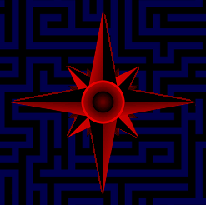

**Users Manual**

**Index**

1. *Introduction*
2. *Chapter 1: Account Creation*
3. *Chapter 2: Logging In*
4. *Chapter 3: The Dashboard*
5. *Chapter 4: Image Gallery*
6. *Chapter 5: Path Start/Goal Selection*
7. *Chapter 6: Loading – Finding Resources*
8. *Chapter 7: Results*
9. *Chapter 8: Installation*
10. *Appendix 1: Example Use-Case*

**Introduction**

Those who have visited the University of Massachusetts Lowell North campus may be impressed by the various styles and architectures which are encompassed by the many buildings, spanning from the 1930s to modern times. However, one might also rapidly become lost while trying to navigate the labyrinth of halls, classrooms, and tunnels.

It is this problem which I propose to solve. This project will consist of a web app (post likely a HTML web page) in which a person can enter their, relative location on campus, e.g. "Dandeneau Hall, room 409", and a desired destination in a similar fashion. The application will then use the universities floorplans to determine the most efficient way to traverse from the current location to to the goal location, and provide instructions.

**Chapter 1: Account Creation**

User accounts can be created by selecting “Create an account” on the “Sign In” page. The user will be requested to enter certain information. This data is stored in a “NoSQL” JSON database on the weblab server.

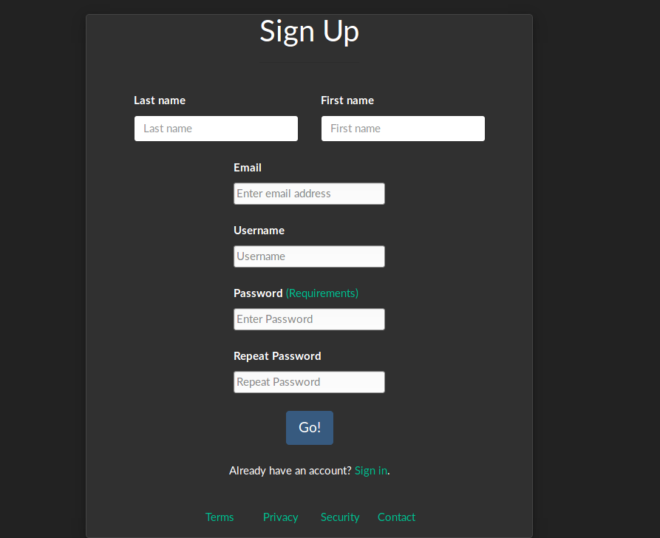

**Chapter 2: Logging In**

The login page is storied in “index.html”, that is, it will be the first page which the user sees. If the user already has an account, they can log in directly. Otherwise, they can select the “Create an account” link.

***To facilitate ease of use (and for debugging), several user accounts already exist:***

|  |  |
| --- | --- |
| **Username** | **Password** |
| Acadia | asdf1 |
| aaa | aaa |
|  |  |

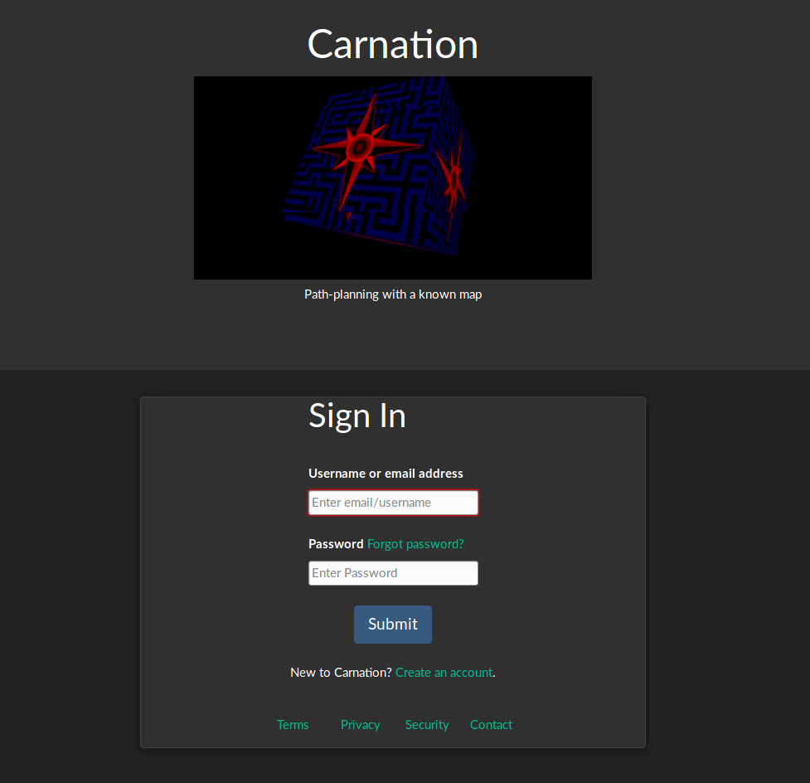

**Chapter 3: The Dashboard**

After logging in, the user will be redirected to the main page. In addition, there is a user dashboard with links to various other pages.

**Chapter 4: Image Gallery**

One of the pages which the dashboard directs to is the image gallery. This page contains thumbnails of each building on campus, along with a brief text description. Clicking on one of these will open the image full-size in a separate tag, where it can be downloaded, etc.

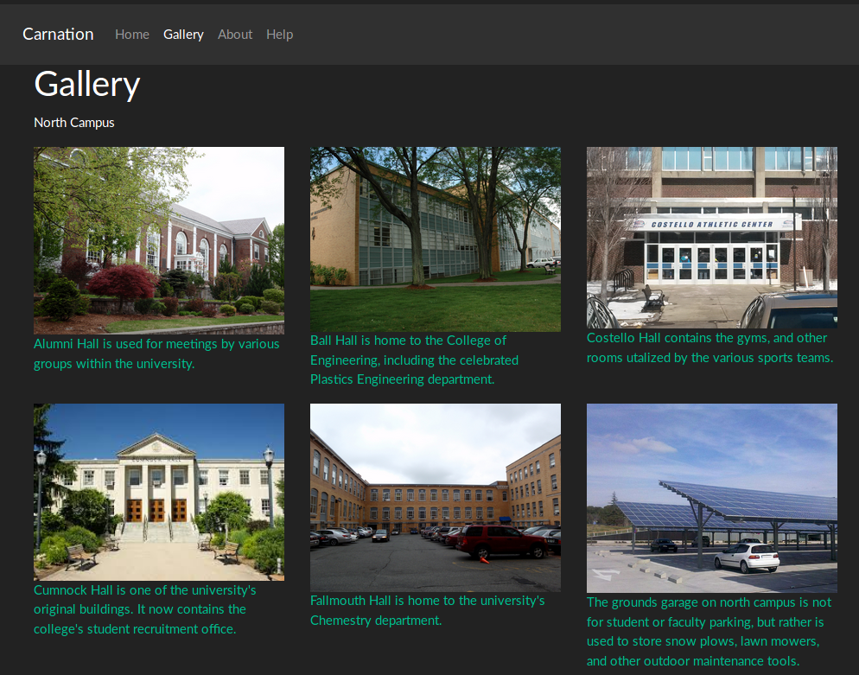

**Chapter 5: Path Start/Goal Selection**

After logging in, the user is redirected to the main page. This is where he can specify a start and goal locations. A subset of locations have been implemented: Olsen Hall 3rd floor, rooms 301-318.

Whenever a building is selected, a thumbnail image of that building will be dynamically loaded in.

**Chapter 6: Loading – Finding Resources**

asfdAfter the start and goal location have been selected and the form submitted, a loading screen will appear. After the required resources are found, the loading animation will disappear, and a button will be rendered. Upon clicking this, the results page will load.

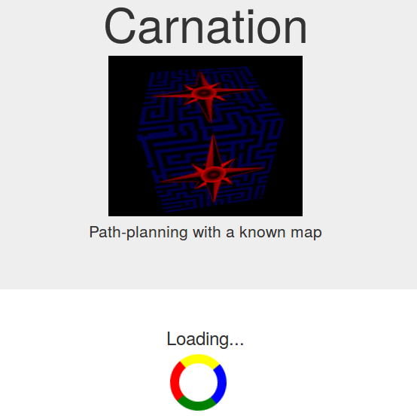

**Chapter 7: Results**

The results page will display the floorplan, and paint over it a path from the start room to the goal room. Unfortunately, there is a synchronization issue, so the page will freeze for a few seconds until this finishes loading.

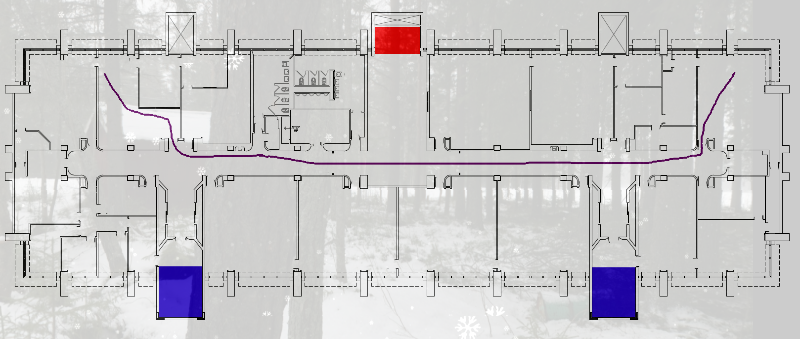

**Chapter 8: Installation**

The site can be accessed at:

<http://www.cs.uml.edu/~jkuczyns/513_f2018/Carnation/public/index.html>

Alternatively, you can download and run it from source.

Build & Run:

```

git clone <https://github.com/DeepBlue14/Carnation.git>

node server.js

```

Then open the index.html file in the web browser of your choice (testing in Firefox).

To run the CoffeeScript tests, first install the CoffeeScript compile via “npm i coffee-script”. Then run “coffee [filename].coffee” or “coffee -c [filename].coffee” to compile it to JavaScript.