Turtlebot--Getting Position
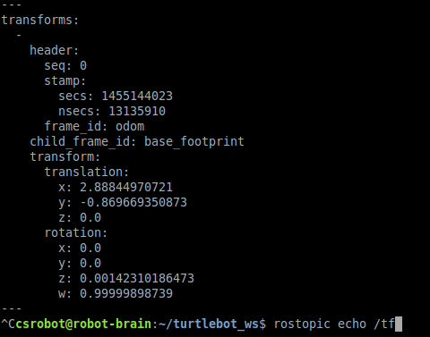

my_tf_msg.translation.x = total distance traversed in a linear.x manner. my_tf_rotation.z = rotation. 1.00 is a full clockwise circle, -1.00 is a full counterclockwise circle. Turing alone knows what the translation.y is :P

