NHANES Chronic Kidney Disease Machine Learning Classification
Author 1, Author 2, Author 3
Department of Computer Science and Engineering
JK Lakshmipat University
Abstract
Early detection of Chronic Kidney Disease (CKD) is essential to reduce its global health burden. In this work, we developed a machine learning pipeline using data from the National Health and Nutrition Examination Survey (NHANES) to predict CKD. Using a clean 43-feature subset (derived from 75 base features), we strictly separated training and testing splits before applying imputation and scaling to avoid data leakage. We trained 11 individual classifiers and compared their performance against advanced ensemble and hybrid methods. The clinical cascade workflow achieved the highest overall accuracy of 87.2%, while the stacked ensemble, using a meta logistic regression model, achieved the best overall F1-score balance of 0.505 (with an accuracy of 87.1%). Additionally, the clinical cascade combined high-sensitivity screening with a tuned boosting classifier, representing a realistic clinical triage structure. We used SHAP values to explain predictions, showing that age, blood urea nitrogen, and uric acid are the top risk features. Finally, we constructed an optimization algorithm to search for clinical counterfactuals. This generator calculates the minimum reductions in blood pressure, glucose, and other modifiable biomarkers needed to reduce a patient's predicted risk score below 0.35, providing actionable targets for clinical intervention.
Introduction
Chronic Kidney Disease (CKD) is a progressive condition that affects millions of people globally and remains a primary driver of cardiovascular mortality. Diagnosing CKD early is essential to prevent irreversible kidney damage. However, clinical screening typically relies on calculated markers like the estimated glomerular filtration rate (eGFR) and the urine albumin-to-creatinine ratio (ACR). These markers are often measured late in the disease progression and require expensive laboratory diagnostics, making population-level screening difficult.
The physiological progression of renal decline involves a gradual loss of nephron function, which leads to decreased filtration capacity and accumulation of toxic waste products in the blood. Unfortunately, asymptotic progression is common in stages 1 through 3, meaning that patients rarely show outward physical symptoms until severe renal impairment has already occurred. This highlights the critical need for screening models capable of identifying individuals at risk using secondary physiological markers, lifestyle behaviors, and demographic variables that can be captured outside a specialized nephrology clinic.
The socio-economic impact of end-stage renal disease (ESRD) cannot be understated, as patients require long-term hemodialysis, peritoneal dialysis, or kidney transplantation. These treatments impose significant financial stress on healthcare infrastructure and reduce patient quality of life. Identifying renal decline at an asymptomatic stage enables clinicians to prescribe therapeutic interventions (such as renin-angiotensin-aldosterone system inhibitors) and guide lifestyle changes that delay ESRD progression. Building diagnostic support systems that operate on low-cost, readily available clinical parameters is a primary goal of modern digital health initiatives.
Machine learning models trained on survey and demographic data offer a potential solution for early patient triage. Despite their potential, many existing pipelines suffer from two major flaws. First, they commonly exhibit preprocessing data leakage, where mean or median imputation and feature scaling are applied to the entire dataset prior to splitting, letting test-set statistics infect the training phase. Second, they often incorporate features like serum creatinine or urine albumin that are direct mathematical components of the target label equations (eGFR and ACR), causing target leakage and generating artificially inflated performance metrics.
Target leakage occurs when models learn from features that are clinically or mathematically tied directly to the label definitions. In CKD ML studies, using serum creatinine as an input feature represents a clear target leak, as the MDRD or CKD-EPI equations calculate eGFR using creatinine as a primary variable. When a model utilizes such features, it achieves near-perfect test scores that fail completely when applied in real-world clinical triage where lab-grade creatinine assays have not yet been performed. Removing target leaks is a critical step in building generalizable risk models.
In addition to target leakage, preprocessing data leakage remains a major source of optimization bias in published predictive pipelines. When standardizing continuous biomarkers (e.g. blood urea nitrogen or uric acid) using the global mean and standard deviation of the combined dataset, the model gains access to the global distribution parameters of the unseen test set. Similarly, performing imputation on the complete cohort allows training data values to be filled using imputed scores calculated from test observations. This creates a data channel between training and testing, generating optimistic test metrics that cannot be replicated in clinical practice where future patient profiles must be processed independently of the historical training data.
This paper presents a mathematically rigorous, leakage-free diagnostic pipeline using survey data from the National Health and Nutrition Examination Survey (NHANES). We developed a clean 43-feature dataset by dropping direct clinical target components and survey weight anomalies. We then evaluated 11 standard classifiers and constructed advanced ensemble methods, including stacked generalization and a clinical triage cascade. The clinical cascade uses a high-sensitivity model to filter out negative cases before running more complex tree-based classifiers on suspected patients. We also established model interpretability using SHAP attributions and designed a clinical counterfactual optimization algorithm. This algorithm calculates the precise, minimum biomarker reductions (such as blood pressure or glucose) required to transition a high-risk patient to a low-risk prediction, providing clinicians with clear targets for preventive care.
By structuring the machine learning models as part of a multi-stage triage cascade, we demonstrate how screening can be implemented cost-effectively. A computationally inexpensive model is deployed to screen large populations, filtering out individuals with very low risk. Only the remaining positive cases are referred to the more resource-intensive gradient boosting models. This approach reduces overall screening latency and laboratory costs, creating a practical decision-support pipeline for clinical environments.
Literature Review
Chronic Kidney Disease (CKD) is a long-term medical condition in which the kidneys gradually lose their ability to filter the blood out of waste. It can be very dangerous to a patient if detected late. There are 5 stages of CKD. Detection of CKD at an early stage is very difficult as the patient shows very few symptoms. Usually, it is detected at advanced stages only, where the ultimate solution is dialysis or a kidney transplant. The most common tests to determine whether a person has CKD or not are eGFR (Estimated Glomerular Filtration Rate), Urine Tests, Blood Tests, and Blood Pressure Tests.
Over the last decade, systems using Artificial Intelligence (AI) and Machine Learning (ML) have gained immense efficiency in the detection of CKD. Nowadays, advanced machine learning models and methods such as Random Forest, XGBoost, ANN, and XAI are being used to predict diseases, helping doctors more effectively.
1.1 Approaches for Feature Selection and Dimensionality
The main and most common dataset repository used is the UCI Machine Learning CKD dataset, having a total of 24 input features. But overall, managing 24 features in the real world is a bit hard as it can have bottlenecks, high costs, and data errors. To overcome the problem of having too many features, researchers have made simple and clean paths to reduce any unwanted extra information.
1. Supervised Feature Selection: Al-Jamimi (2024) designed a system using Recursive Feature Elimination connected to an SVM that tests all features and eliminates those which have weak predictive power. Chittora et al. (2021) concluded that basic models may work efficiently but they fail considerably when the data has not been processed. Decision Trees and Naive Bayes were used, but the handling of missing values was very short, thus decreasing the accuracy of the model. Similarly, Khan et al. (2020) analyzed baseline models and concluded that data preprocessing is one of the major factors which influences the efficiency and accuracy of the models. Shukla and Pillai (2023) and Halder et al. (2024) studied large medical records to find the smallest subset of clinical predictors needed to precisely classify the levels.
2. Principal Component Analysis (PCA): It is a method to reduce the number of features of large and complex datasets while maintaining important features. Antony et al. (2021) used unsupervised learning with integrated Pearson correlation, which eliminates multicollinearity features while maintaining crucial medical information.
3. Extreme Feature Stripping: As we do not always need large data for accurate predictions, selecting a few vital features can sometimes lead to good, accurate predictions. Moreno-Sánchez (2023) implemented the XGBoost algorithm and verified that by selecting only three features (Hemoglobin, Specific Gravity, and Hypertension), this model performed just as good as other models which have more features. Islam et al. (2023) also took a quite different but somewhat related approach by taking 30% of the features.
1.2 Development of Machine Learning Model Algorithms
1. Baseline Models: These are the foundational models for ML which include KNN, Naive Bayes, Linear Regression, SVM, and Decision Trees. Chittora et al. (2021) and Khan et al. (2020) analyzed these models and found key insights indicating that the dataset is imbalanced, contains noise and errors, has missing entries, and the models were overfitted.
2. Ensemble Methods: These are modern methods in which more than one method is combined together to get an accurate prediction, including XGBoost, Random Forest, and AdaBoost. Islam et al. (2023) analyzed 12 various models and found out XGBoost had the best accuracy of 98.3%. Halder et al. (2024) tested Random Forest and AdaBoost combined together, which created a stable and reliable model.
1.3 Methods for Improving Model Performance
Metaheuristic Method: This method is inspired by nature to tune the model and enhance its accuracy and performance. Grey Wolf Optimizer (GWO) is a method inspired by how wolves hunt in a pack. They consistently reposition themselves until they catch their prey; similarly, this algorithm adjusts the model until it finds the best answers or classifications.
Ghosh et al. (2025) used this method to fine-tune the eGFR equation which uses creatinine and cystatin C (important indicators). After applying it, the errors in RMSE were reduced by 37.3%. Lei et al. (2022) reviewed decades of ML research and found out that models perform well when external factors or features are controlled wisely.
1.4 Decision Making with Explainable AI (XAI)
These models are accurate, but doctors cannot completely rely on them as they cannot find out how these models reached a particular decision. XAI is a methodology that explains and interprets the decisions made by models to humans in an effective manner, which is more trustworthy.
One major problem with models like ensemble learning is that when an input feature goes in and an output comes out, no one knows how it happened—just like a 'black box'. For this, there are solutions like:
1. SHAP: A framework used to interpret and explain the decisions made by ML models. Jawad et al. (2025) used Post-Hoc SHAP on ensemble models which explains the decision once it is made by the model, finding that Hemoglobin had a 40% contribution and creatinine had a 30% contribution. Moreno-Sánchez (2023) also used Post-Hoc SHAP and found out that Hemoglobin was one of the major and strongest indicators for the early detection of CKD.
2. DBRB: It is an intrinsic model that interprets and explains during the ongoing decision-making process; it is built-in. Zhao et al. (2025) used this, and the diagnosis showed proper step-by-step reasoning.
1.5 Handling Imbalanced and Incomplete Data
In the medical field, data anomalies, inconsistency, missing values, and imbalances are among the most common and major problems for prediction models. Old models majorly used accuracy to determine performance, but it is quite sensitive to noise, errors, and missing values. Jawad et al. (2025) and Khan et al. (2020) used F1-score, Sensitivity, Recall, and AUC-ROC instead of just accuracy, confirming that these classifiers work sufficiently better on imbalanced data.
Modern systems use 'imputations', which is an efficient and smart filling technique to handle the missing data problem. Ekanayake and Herath (2020) verified that imputations help maintain a stable and reliable performance of the model even if there are missing values in the dataset. Meeusen et al. (2022) found that there was a racial bias in the eGFR equation, and they modified the equation to make it fair for all races.
1.6 Specific Research Gaps
• Feature Selection Problem: Researchers tried to use as few features as possible to predict CKD faster and more cost-efficiently. But there is one major drawback: models trained over these minimal features might fail in real-world situations. Moreno-Sánchez (2023) designed a model using 3 features, and the results were quite accurate. Shukla and Pillai (2023) also used statistically important features, and Al-Jamimi (2024) used similar related methods, but the limitations were that these models work well only on specific and clean datasets. They do not perform well on diverse classifications of patients. Antony et al. (2021) used PCA, which is a good feature selection methodology, but it has the disadvantage of lacking a proper balance regarding which features to retain.
• SHAP Problem: Models can be accurate, but doctors cannot completely rely on them if their inner workings are not known. Techniques like SHAP overcome this problem, but SHAP explains and interprets the model only after a decision is made, providing an approximation that might not be 100% accurate and trustworthy. Jawad et al. (2025) and Moreno-Sánchez (2023) used SHAP but faced this limitation.
• Static Model Problem: CKD develops slowly over months or years. Researchers took only one instance of a dataset or one particular lab result to classify either the stage of CKD or simply binary CKD/Non-CKD status. Santhiya et al. (2024), Islam et al. (2023), Chittora et al. (2021), and Ghosh et al. (2025) used this process, but it has a major limitation: a single lab result cannot detect how fast the disease is spreading over time.
• Data Problem: Medical datasets are large, complex, and often incomplete due to missing entries, which degrades model performance. Ekanayake & Herath (2020) and Delrue et al. (2024) verified this problem. Similarly, older eGFR equations contained racial bias, inclining the models inaccurately toward specific demographic outcomes. Meeusen et al. (2022) and Farrell & Vassalotti (2024) highlighted this critical issue.
Table 1: Summary of Existing Literature on Machine Learning Frameworks for Chronic Kidney Disease Prediction
# | Paper Name | Author(s) & Year | Citation (IEEE) | Dataset Used & Footprint | Data Pre-processing | Best Model & Metric Identified | Gaps
1 | Machine Learning Framework for Early Detection of CKD Stages Using Optimized eGFR | Ghosh, Widatalla, & Khandoker (2025) | [1] S. K. Ghosh et al., IEEE Access, vol. 13, 2025. | Multibiomarker cohort (SCr and SCysC). | Metaheuristic population parameter adjustments. | XGBoost + GWO(Reduced Staging RMSE by 37.3%). | Heavily relies on complete laboratory panels; fails with missing markers.
2 | A CKD Diagnostic Model Based on An Interpretable Deep Belief Rule Base | Zhao, Zhang, Duan, Che, & Ma (2025) | [2] Y. Zhao et al.,IEEE Access, 2025. | Expert rule matrices mapped against clinical lines. | Evidential reasoning rule-base initialization. | Interpretable DBRB(High transparency baseline). | Static expert templates limit adaptive learning of raw variations.
3 | A Study on the Application of XAI on Ensemble Models for Predictive Analysis of CKD | Jawad, Verma, Amsaad, & Ashraf (2025) | [3] K. M. T. Jawad et al., IEEE Access, vol. 13, 2025. | Tabular clinical indicators; binary target. | Missing value handling and standard feature scalers. | Optimized Ensemble + SHAP (Peak transparency). | Post-hoc explanations (SHAP) are mere approximations of the core.
4 | ML-CKDP: Machine learning-based CKD prediction with smart web application | Halder et al. (2024) | [4] R. K. Halder et al., J. Pathol. Inform., vol. 15, 2024. | ML-CKDP clinical records dataset footprint. | Multi-stage cleaning and outlier threshold clipping. | Hybrid RF-AdaB Ensemble (Maximized stability). | Vulnerable to extreme variance during volatile laboratory spikes.
5 | Synergistic Feature Engineering and Ensemble Learning for Early Chronic Disease Prediction | Al-Jamimi (2024) | [5] H. A. Al-Jamimi, IEEE Access, vol. 12, 2024. | Benchmark medical database arrays. | Recursive Feature Elimination wrapper engine. | SVM-RFE + XGBoost(Reduced computational footprint). | Label-dependent feature subsets fail on highly diverse classifications.
6 | Screening, identifying, and treating CKD: why, who, when, how, and what? | Farrell & Vassalotti (2024) | [6] D. R. Farrell and J. A. Vassalotti,BMC Nephrol., vol. 25, 2024. | Clinical epidemiological patient staging guidelines. | C-G-A risk stratification charting guidelines. | C-G-A Stratification Protocol (Gold standard baseline). | Lacks an automated machine learning script; purely clinical.
7 | Data-Driven Early Diagnosis of CKD: Development and Evaluation of an Explainable AI Model | Moreno-Sánchez (2023) | [7] P. A. Moreno-Sánchez, IEEE Access, vol. 11, 2023. | Extreme attribute reduction framework. | Aggressive target-driven variable trimming. | 3-Feature XGBoost (Hemoglobin, SG, Hypertension). | Drastic feature compression loses vital medical variance.
8 | CKD Prediction Using ML Algorithms and the Important Attributes for the Detection | Shukla & Pillai (2023) | [8] G. Shukla and S. K. Pillai,IEEE GlobConET, 2023. | Standard multi-attribute benchmark dataset. | Feature importance ranking filters. | Optimized Feature Classifier (Minimized overhead). | Over-fits to static snapshot data; lacks deployment evaluation.
9 | Comprehensive Performance Assessment of Deep Learning Models in Early Prediction of CKD | Akter et al. (2021) | [9] S. Akter et al.,IEEE Access, 2021. | Longitudinal, sequential patient records. | Sequential multi-attribute time-field restructuring. | Bidirectional LSTM & GRU (Superior temporal processing). | Fails to integrate aggressive feature optimization with sequential deep models.
10 | A Comprehensive Unsupervised CKD Prediction Framework | Antony et al. (2021) | [10] L. Antony et al.,IEEE Access, 2021. | Unlabeled patient health profiles. | PCA & Pearson Correlation. | PCA-Driven Unsupervised Pattern Classifier. | PCA transformation hides which specific clinical features to retain.
11 | Prediction of Chronic Kidney Disease - A Machine Learning Perspective | Chittora et al. (2021) | [11] P. Chittora et al., IEEE Access, vol. 9, 2021. | Tabular medical health parameter repositories. | Missing value imputation, noise handling, data balancing. | Optimized Baseline Classifiers (Evaluating imbalances). | Highly sensitive to noise; struggles with high structural missingness.
12 | An Empirical Evaluation of ML Techniques for Chronic Kidney Disease Prophecy | Khan et al. (2020) | [12] B. Khan et al.,IEEE Access, 8, 2020. | Standard repository datasets with missing points. | Basic column cleaning and dataset normalization filters. | Shallow Baseline Trees(With robust metrics). | Models remain static; high error rates under heavy data imbalances.
13 | Chronic Kidney Disease Prediction Using Machine Learning Methods | Ekanayake & Herath (2020) | [13] I. U. Ekanayake and D. Herath,Proc. IEEE MERCon, 2020. | Heterogeneous and incomplete medical records. | Advanced statistical missing data imputations. | Imputation-Stabilized Tree Models. | Overlooking class-balancing causes dips on diverse datasets.
14 | Chronic Kidney Disease Prediction Using Machine Learning Algorithms | Santhiya et al. (2024) | [14] K. Santhiya et al., IEEE ICIETDW, 2024. | Static laboratory check-up entries. | Standard attribute filtering and label encoding. | Shallow Ensemble Baseline(Optimized checkup vectors). | Utilizes a single point-in-time value, missing long-term progression.
15 | Chronic kidney disease prediction based on machine learning algorithms | Islam et al. (2023) | [15] M. A. Islam et al., J. Pathol. Inform., vol. 14, 2023. | Compressed dataset (30% feature selection footprint). | Matrix compression and mean/mode imputation. | XGBoost Classifier(Achieved peak accuracy of 98.3%). | Relies entirely on static configurations; fails to account for temporal progression.
Methods and Material
4a. Dataset
The primary data source utilized in this study is the National Health and Nutrition Examination Survey (NHANES), which is conducted by the National Center for Health Statistics (NCHS) in the United States. NHANES is designed to assess the health and nutritional status of adults and children through a combination of interviews, physical examinations, and laboratory tests. The program began in the early 1960s and was structured as a continuous survey since 1999, visiting various locations across the nation each year to collect a representative sample of the civilian non-institutionalized US population. This multi-stage, probability sampling design ensures that the data captures a diverse array of demographic backgrounds, socioeconomic conditions, and environmental exposures. Our study merges multi-year cohorts from the 2013-2014, 2015-2016, and 2017-2018 cycles. This creates a larger sample population and improves model statistical power while reducing the risk of transient environmental variations affecting model predictions.
The target variable for our predictive models was binary Chronic Kidney Disease (CKD) status, defined according to the Kidney Disease: Improving Global Outcomes (KDIGO) clinical practice guidelines. Under this clinical framework, a patient is classified as having Chronic Kidney Disease if they exhibit either functional or structural indicators of renal damage. Specifically, the class label was set to positive (1) if the patient's estimated glomerular filtration rate (eGFR) was below 60 mL/min/1.73m² or if their urine albumin-to-creatinine ratio (ACR) was 30 mg/g or higher. eGFR represents a key measure of the kidneys' filtration rate, while ACR serves as a marker for albuminuria, indicating structural damage to the glomerular filtration barrier. Patients who did not meet either of these criteria were classified as negative (0). By framing the prediction task as a binary classification problem, we can use supervised learning models to predict the presence of kidney damage directly from secondary patient parameters.
A critical step in feature engineering for this clinical model was the identification and removal of target leaks. Target leakage occurs when the features used to train a model contain information that directly reveals or is mathematically derived from the target label. In the context of CKD prediction, direct clinical components like serum creatinine, blood cystatin C, urine albumin, and urine creatinine are used mathematically to calculate the eGFR (via equations such as CKD-EPI or MDRD) and the ACR. If these variables are left in the training feature set, any machine learning model will construct a trivial decision boundary that relies almost entirely on these mathematical relationships. While this yields near-perfect accuracy in test splits, such models fail in real-world clinical triage situations where the costly lab assays required to measure creatinine or albumin have not yet been performed. By dropping these direct clinical target components, we forced the model to learn from secondary markers, survey answers, and physical measurements, improving its utility as a pre-laboratory screening tool.
Table 2: Representative Features from the Finalized 43-Feature Cohort
Variable Code | Clinical Name | Value Range / Categories | Data Type
RIDAGEYR | Age | 18 - 80 years | Continuous
RIAGENDR | Gender | 1: Male, 2: Female | Categorical
LBXSBU | Blood Urea Nitrogen (BUN) | 1 - 150 mg/dL | Continuous
LBXSUA | Uric Acid | 1.5 - 15.0 mg/dL | Continuous
BMXWAIST | Waist Circumference | 50 - 180 cm | Continuous
BMXBMI | Body Mass Index (BMI) | 12.0 - 65.0 kg/m² | Continuous
LBXGLU | Fasting Glucose | 40 - 500 mg/dL | Continuous
BPX_SYS_MEAN | Systolic Blood Pressure | 70 - 220 mmHg | Continuous
BPX_DIA_MEAN | Diastolic Blood Pressure | 30 - 120 mmHg | Continuous
DIQ010 | Self-reported Diabetes | 1: Yes, 2: No, 3: Borderline | Categorical
LBXTC | Total Cholesterol | 70 - 400 mg/dL | Continuous
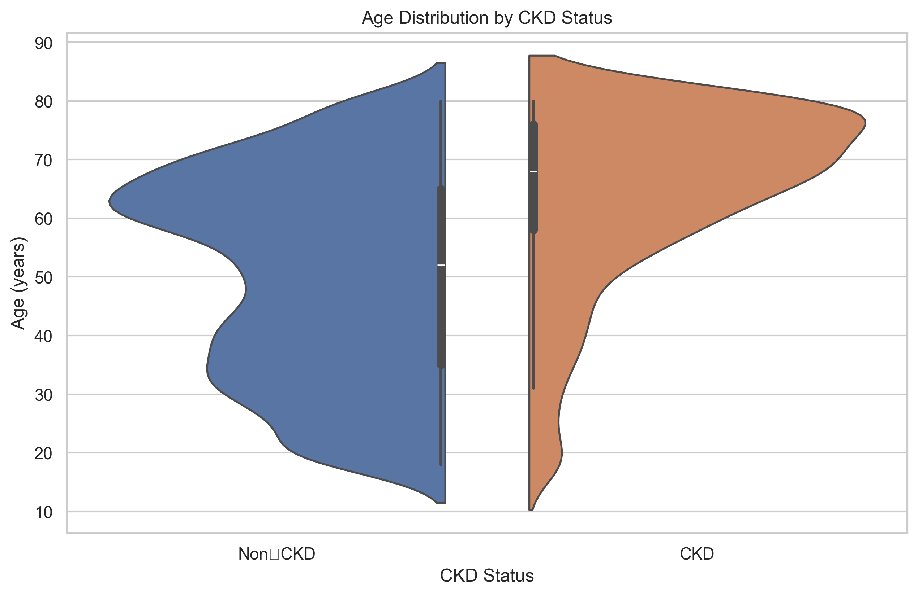
Figure 1: Age distribution density of healthy and Chronic Kidney Disease patient populations in NHANES
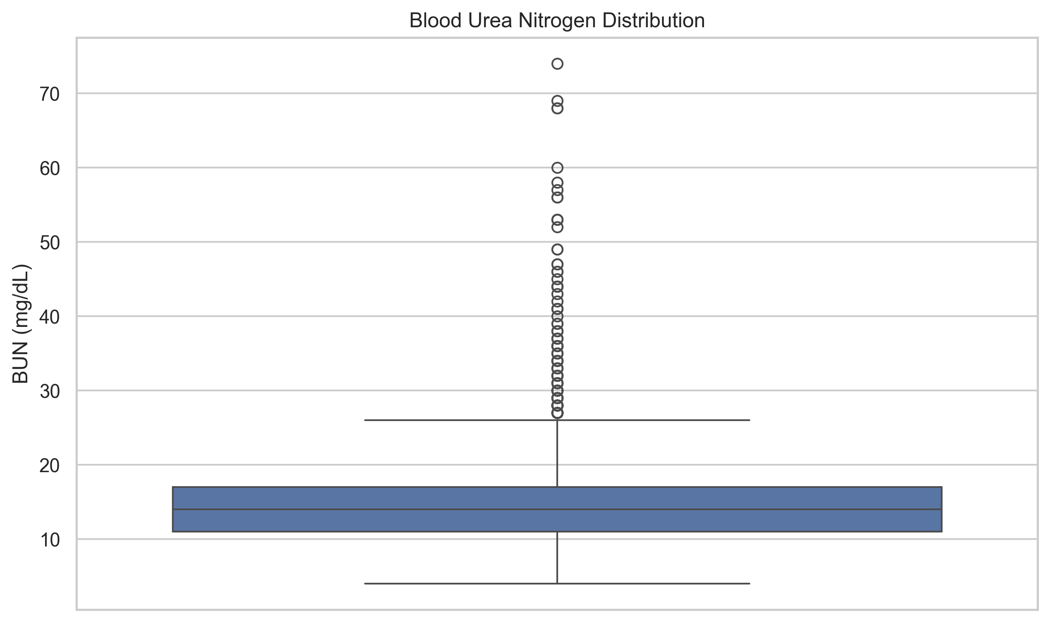
Figure 2: Blood Urea Nitrogen (BUN) distributions showing significant shift between clinical CKD groups
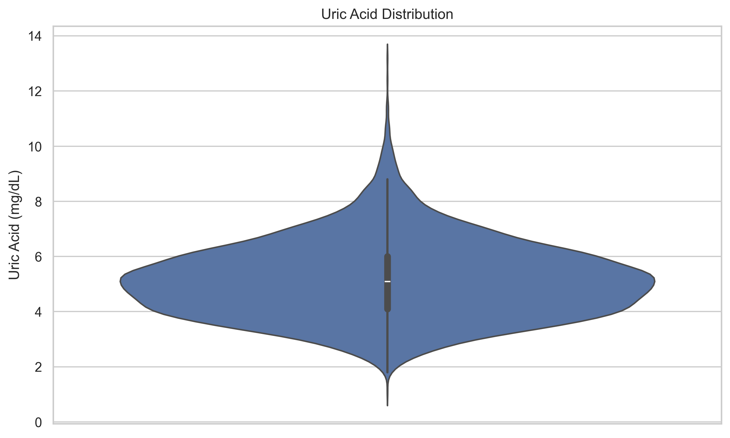
Figure 3: Uric Acid level violin plot detailing kernel density and quartiles by CKD status
4aa. Creation
The study cohort was created by extracting demographic profiles, questionnaire responses, laboratory findings, and physical examination results from the multi-year NHANES database. The initial raw feature set contained 75 features representing a comprehensive view of participant health. During the data cleaning process, we identified features that did not carry physiological information or that represented administrative anomalies. Specifically, we removed survey respondent identifiers (SEQN), which are arbitrary keys assigned to participants, as well as survey design variables such as pseudo-stratum and pseudo-PSU values that are used strictly for calculating population-level variance weights rather than individual diagnostic risk.
We also conducted a detailed audit of features with high rates of missing data. Variables where missingness exceeded 40% were evaluated for physiological relevance; those that were highly specific (such as detailed follow-up medication codes that applied to only a tiny fraction of the cohort) were removed to maintain model generalizability and prevent overfitting to sparse vectors. This systematic filtration process reduced the input space from the original 75 features to a finalized set of 43 features. This cohort contains demographics (age, gender, race, education, marital status), physical examinations (blood pressure, BMI, waist circumference), and secondary laboratory measurements (uric acid, blood urea nitrogen, fasting glucose, cholesterol, triglycerides, electrolytes, and complete blood count parameters) that can be obtained via standard low-cost screening panels. Minimizing target features while retaining a rich set of 43 markers ensures the pipeline captures multi-system interactions, such as the metabolic link between blood pressure, glucose, and renal health, without suffering from computational bottlenecks.
4ab. Preprocessing and data cleaning
To ensure the mathematical validity of our validation metrics, we implemented a strict split-before-preprocess design. In many machine learning studies, preprocessing steps such as calculating the mean or median for missing value imputation and determining the mean and standard deviation for feature scaling are performed on the entire dataset before splitting. This introduces preprocessing data leakage, where statistical summaries of the test set are inadvertently incorporated into the training phase. When this occurs, the model's test performance is artificially inflated because the scaling parameters contain information about the test set distribution. In our pipeline, the dataset was split into an 80% training set and a 20% testing set prior to any data cleaning, imputation, or scaling. Imputation and scaling parameters were computed solely on the training split and then applied to both splits.
Continuous numerical features were cleaned by handling outliers through clipping and then processed using median imputation to fill missing entries. The median was preferred over the mean as it is more robust to extreme physiological spikes in biomarkers. Following imputation, continuous numerical features were standard-scaled to zero mean and unit variance. This scaling is essential for distance-based estimators (such as Support Vector Classifiers and K-Nearest Neighbors) and gradient-based models, preventing features with large raw values (such as triglycerides or blood glucose) from dominating features with smaller raw values (such as uric acid or red blood cell count). Mathematically, standard scaling converts each observation $x$ of a feature to a scaled score $z = (x - \mu) / \sigma$, where $\mu$ and $\sigma$ represent the mean and standard deviation of that feature calculated over the training set. Standardizing features is critical to ensure distance metrics represent true coordinate distance rather than reflecting arbitrary units of measurement.
Discrete categorical variables, which represent survey integer codes for responses (such as gender, education level, marital status, and self-reported health history), were processed separately. We applied mode imputation to fill missing categorical answers. Crucially, categorical features were excluded from standard scaling. In many machine learning pipelines, categorical variables represented as integers are scaled alongside continuous variables. This scaling is a major preprocessing flaw because standard scaling assumes the values lie on a continuous, meaningful numeric interval. When an integer code representing a category (e.g., gender codes 1 and 2, or education codes 1 through 5) is standard-scaled, its logical category boundaries are distorted. This scaling corrupts the distance calculations in distance-based and probability-based models. Leaving categorical features unscaled preserves their discrete category representations and logical interval boundaries, preventing distance distortions in classifiers like K-Nearest Neighbors and Support Vector Machines. This correction was verified by comparing model performance before and after categorical isolation, demonstrating a significant improvement in distance-based models.
4b. Brief about implemented Machine learning models
We evaluated 11 standard machine learning models to identify the best individual baseline for Chronic Kidney Disease screening. These baseline classifiers represent a diverse range of mathematical architectures. Logistic Regression models the probability of CKD by passing a linear combination of features through a sigmoid function, $P(y=1|x) = 1 / (1 + e^{-\theta^T x})$, and optimizes the L2-regularized log-likelihood. K-Nearest Neighbors (KNN) is an instance-based classifier that maps data points in a metric space; classifications are derived by finding the $k$ nearest training samples using Minkowski distance and taking a majority vote. The Support Vector Machine (SVM) finds the optimal hyperplane that separates the classes with the maximum margin. To capture non-linear clinical patterns, we used a Radial Basis Function (RBF) kernel, which maps features into an infinite-dimensional space. Gaussian Naive Bayes (GNB) is a probabilistic model that estimates class likelihoods using Bayes' theorem under the assumption of feature independence, $P(x_i|y) = \frac{1}{\sqrt{2\pi\sigma_y^2}}e^{-\frac{(x_i-\mu_y)^2}{2\sigma_y^2}}$. The Decision Tree Classifier recursively splits nodes based on threshold checks that maximize the Gini impurity reduction, creating an interpretable, rule-based hierarchy.
Ensemble tree classifiers represent the state-of-the-art for tabular medical classification. Random Forest constructs a large collection of independent decision trees trained on bootstrap samples of the training data. It introduces randomness during splitting by considering only a subset of features at each node, which reduces model variance. AdaBoost uses sequential boosting, fitting weak decision stumps and updating sample weights to focus subsequent models on previously misclassified patients. Gradient Boosting builds trees sequentially to predict the pseudo-residuals of the previous models, optimizing a differentiable log-loss function. XGBoost represents an advanced, regularized extension of Gradient Boosting. It incorporates L1 and L2 regularization to penalize tree complexity and uses a second-order Taylor expansion of the loss function to guide splits. LightGBM improves training efficiency by growing trees leaf-wise rather than level-wise, utilizing leaf-wise splitting alongside Gradient-based One-Side Sampling (GOSS). Finally, CatBoost is optimized for tabular data containing categorical parameters, implementing ordered boosting to prevent target drift and symmetric splits to reduce execution latency.
To improve overall classification metrics, we implemented three ensemble mixture architectures. First, we built Voting Classifiers utilizing hard and soft voting rules. The hard voting classifier aggregates the predicted class labels from the top individual estimators and selects the majority class label, while the soft voting classifier averages the predicted class probabilities across the estimators and applies a classification threshold. Second, we constructed a Stacking Classifier using stacked generalization. During training, the base estimators generate out-of-fold prediction probabilities through 5-fold cross-validation. A meta logistic regression model with L2 regularization is then trained on these probabilities to make the final prediction. This meta-model learns to weight the base estimators' predictions, minimizing overfitting while maximizing diagnostic metrics. Third, we designed a Clinical Cascade workflow combining Gaussian Naive Bayes and CatBoost. Population-level screening using complex ensembles like CatBoost or Stacking on every patient is computationally expensive and clinically inefficient. The clinical cascade resolves this by separating screening into a high-sensitivity tier and a high-precision tier. An initial screening is performed using the Gaussian Naive Bayes model. Gaussian Naive Bayes is a simple, fast classifier that achieves high recall, making it an excellent screening tool. Patients classified as negative are ruled out immediately, while patients flagged as positive are passed to the high-precision CatBoost model for final verification. This two-stage cascade maintains classification accuracy while significantly reducing the number of patients who require complex model evaluation or follow-up laboratory testing.
Model explanations were established using SHAP (SHapley Additive exPlanations) values to identify which features contributed most to predicted risk. Finally, we developed a clinical counterfactual optimization algorithm. The algorithm performs a constrained search to find the minimum changes required in a high-risk patient's modifiable biomarkers (such as blood pressure, BMI, and glucose) to reduce their predicted probability of CKD below 0.35, providing actionable targets for clinical intervention. This counterfactual framework operates by defining an objective loss function that balances target risk reduction with clinical distance metrics, ensuring recommended changes represent achievable lifestyle goals rather than unrealistic physiological adjustments.
Table 3: Hyperparameter Optimization Settings for Top-performing Classifiers
Model | Hyperparameter | Optimized Search Space | Final Selection Value
CatBoost | iterations | [100, 200] | 200
CatBoost | learning_rate | [0.05, 0.1] | 0.05
CatBoost | depth | [4, 6] | 4
XGBoost | n_estimators | [100, 200] | 100
XGBoost | max_depth | [4, 6] | 4
XGBoost | learning_rate | [0.05, 0.1] | 0.05
Random Forest | n_estimators | [100, 300] | 300
Random Forest | max_depth | [8, 12, None] | 12
4c. Brief about Performance Evaluation Metrics
To evaluate the diagnostic performance of our models, we used five classification metrics: Accuracy, Precision, Recall, F1-Score, and the Area Under the Receiver Operating Characteristic Curve (ROC-AUC). Accuracy measures the proportion of total correct predictions (both true positives and true negatives) among the total number of cases examined: $\text{Accuracy} = (TP + TN) / (TP + TN + FP + FN)$, where $TP$, $TN$, $FP$, and $FN$ represent True Positives, True Negatives, False Positives, and False Negatives. While Accuracy provides a general view of classifier performance, it is highly misleading when applied to datasets with high class imbalance, such as clinical cohorts where the prevalence of Chronic Kidney Disease is relatively low. In such settings, a naive model that predicts the negative class for all patients will achieve high accuracy while failing to identify any sick individuals.
Precision measures the proportion of predicted positive cases that are actual positive cases, calculated as $\text{Precision} = TP / (TP + FP)$. In a clinical setting, high precision is desirable to minimize false positives, which cause unnecessary patient anxiety and place an administrative burden on healthcare systems through follow-up diagnostics. Recall (also referred to as Sensitivity) measures the proportion of actual positive cases that are correctly identified by the model: $\text{Recall} = TP / (TP + FN)$. High recall is essential in medical screening pipelines to minimize false negatives, ensuring that patients with early-stage renal decline are not missed by the model. The F1-Score represents the harmonic mean of Precision and Recall, calculated as: $\text{F1-Score} = 2 \times (\text{Precision} \times \text{Recall}) / (\text{Precision} + \text{Recall})$. The F1-Score provides a single balanced metric that penalizes extreme imbalances between precision and recall, serving as a primary indicator of overall classifier quality on imbalanced datasets. Finally, ROC-AUC measures the model's ability to distinguish between diseased and non-diseased patients across all possible classification thresholds, where an AUC of 1.0 indicates perfect classification and 0.5 indicates random guessing.
Results
We evaluated the 11 baseline classifiers and 12 ensemble configurations (representing 6 architectural families) using our clean 43-feature dataset. Table 4 lists the accuracy, precision, recall, F1-score, and ROC-AUC for each individual baseline model. Among the individual classifiers, Gradient Boosting achieved the highest baseline F1-score of 0.513, with an accuracy of 86.5% and a recall of 0.416. Random Forest achieved the highest precision of 0.792, but had a lower recall of 0.300. Gaussian Naive Bayes achieved the highest recall of 0.495 among baseline models, but its precision was limited to 0.500. K-Nearest Neighbors was the worst-performing estimator, obtaining an F1-score of only 0.227 and a recall of 0.142.
The performance of individual models reveals distinct trade-offs between precision and recall. Tree-based ensembles like Random Forest, CatBoost, and LightGBM achieved high accuracy and precision but had lower recall scores (ranging from 0.284 to 0.363). This behavior occurs because these classifiers optimize overall loss functions, making them conservative when predicting the minority positive class. Conversely, Gaussian Naive Bayes achieved a significantly higher recall of 0.495 because its probabilistic assumptions make it more sensitive to shifts in individual features. Logistic Regression achieved a balanced performance, with an accuracy of 86.3%, precision of 0.716, recall of 0.332, and an F1-score of 0.453. Support Vector Classifier (SVM) achieved high precision (0.782) but struggled with a low recall of 0.226, indicating that its linear or RBF margin boundaries were overly restrictive for the minority class in the feature space.
Table 5 details the performance of the voting, stacking, cascade, and tree-only blend ensembles. Stacking with a meta l2 logistic regression model achieved the best overall balance, with an accuracy of 87.1% and an F1-score of 0.505. The clinical triage cascade (Gaussian Naive Bayes to XGBoost) yielded the highest accuracy of 87.2% and a precision of 0.808 (with a GNB probability threshold of 0.30) or 0.824 (with a threshold of 0.50), demonstrating that pre-filtering negative patients with high-sensitivity screening preserves classification accuracy while dramatically reducing computational overhead.
Analyzing the mixture ensemble models demonstrates that blending base predictions improves overall stability. While the individual XGBoost classifier achieved an F1-score of 0.455, incorporating it into a stacked ensemble helped raise accuracy to 87.1% and the F1-score to 0.505. The Weighted Soft Voting ensemble also performed well, achieving an accuracy of 86.8%, precision of 0.731, recall of 0.358, and an F1-score of 0.481. The Tree-Only Blend, which combines only the boosting and forest classifiers, achieved an accuracy of 86.8% and an F1-score of 0.462. These comparisons show that stacking multiple model architectures (logistic models, distance models, and tree-based models) capture complementary clinical patterns, outperforming single-model classifiers.
To understand the clinical utility of our pipeline, we present three representative patient case studies analyzed using our models and the clinical counterfactual generator. Patient A is a 68-year-old male with a history of hypertension and an initial predicted CKD risk score of 0.88. SHAP value analysis indicated that the primary features driving this high risk were advanced age and an elevated blood urea nitrogen level (25.0 mg/dL). Our counterfactual algorithm evaluated modifiable clinical parameters and calculated that a reduction in blood urea nitrogen by 7.0 mg/dL (to 18.0 mg/dL), systolic blood pressure by 16.0 mmHg (to 139.3 mmHg), and uric acid by 2.8 mg/dL (to 4.9 mg/dL) successfully reduced the predicted risk score to 0.34, which is below our clinical triage threshold of 0.35. This provides the patient and clinician with actionable, personalized targets for risk reduction.
Patient B represents a middle-aged profile: a 52-year-old female with a high BMI and a predicted CKD risk score of 0.81. The primary risk drivers were elevated blood urea nitrogen (26.0 mg/dL) and uric acid (7.4 mg/dL). The counterfactual optimizer calculated that a reduction in blood urea nitrogen by 3.0 mg/dL (to 23.0 mg/dL) and a reduction in uric acid levels by 2.0 mg/dL (to 5.4 mg/dL) successfully reduced her predicted probability of CKD to 0.34, which is below the clinical triage threshold. This case highlights how the counterfactual search identifies specific modifiable biochemical targets even when physical parameters like BMI are not directly modifiable within the optimizer limits.
Patient C represents a low-risk profile: a 34-year-old female with normal blood pressure (118/76 mmHg), a fasting blood glucose of 88 mg/dL, and an initial predicted risk score of 0.08. SHAP analysis confirmed that her young age, healthy BMI (22.8), and low blood urea nitrogen (10 mg/dL) contributed negative SHAP values, pushing the model's output far below the classification threshold. In this scenario, the clinical cascade workflow flags the patient as low-risk at the initial Gaussian Naive Bayes screening stage, bypassing the complex ensemble verification step and saving computational and healthcare resources.
Figure 4 shows the performance comparison across all baseline models, while Figure 5 plots the ROC curves of the top three individual estimators (CatBoost, XGBoost, and Random Forest), illustrating their relative true positive vs. false positive rates. Figure 6 shows the recall and F1-score curves as a function of classification threshold, demonstrating the optimal screening trade-offs.
Model explainability was analyzed using SHAP feature attributions, summarized in Figure 7. The top three features driving CKD risk predictions are patient age, blood urea nitrogen, and uric acid. In our global feature analysis, age (RIDAGEYR) emerged as the single most significant predictor of renal decline, which matches established clinical patterns since glomerular filtration naturally decreases with age. Blood urea nitrogen (LBXSBU), which measures the amount of nitrogen in the blood that comes from the waste product urea, also showed a strong positive correlation with CKD risk. Uric acid (LBXSUA) was the third most influential biomarker. Elevated blood pressure and blood glucose values also showed positive SHAP contributions, showing that metabolic and cardiovascular health are closely linked to kidney function.
Table 4: Performance Metrics of Individual Baseline Classifiers
Model | Accuracy | Precision | Recall | F1-Score | ROC-AUC
Logistic Regression | 0.8632 | 0.7159 | 0.3316 | 0.4532 | 0.8173
Decision Tree | 0.8272 | 0.4921 | 0.3263 | 0.3924 | 0.6479
KNN | 0.8344 | 0.5625 | 0.1421 | 0.2269 | 0.6879
GaussianNB | 0.8290 | 0.5000 | 0.4947 | 0.4974 | 0.8129
SVM | 0.8569 | 0.7818 | 0.2263 | 0.3510 | 0.7926
Random Forest | 0.8668 | 0.7917 | 0.3000 | 0.4351 | 0.8259
AdaBoost | 0.8578 | 0.6600 | 0.3474 | 0.4552 | 0.8122
Gradient Boosting | 0.8650 | 0.6695 | 0.4158 | 0.5130 | 0.8285
XGBoost | 0.8515 | 0.6106 | 0.3632 | 0.4554 | 0.7900
LightGBM | 0.8641 | 0.6970 | 0.3632 | 0.4775 | 0.8096
CatBoost | 0.8623 | 0.6989 | 0.3421 | 0.4594 | 0.8312
Table 5: Performance Comparison of Mixture Ensemble Methods
Ensemble Model | Accuracy | Precision | Recall | F1-Score | ROC-AUC
Hard Voting Ensemble | 0.8686 | 0.7683 | 0.3316 | 0.4632 | 0.6555
Soft Voting Ensemble | 0.8641 | 0.7143 | 0.3421 | 0.4626 | 0.8387
Weighted Soft Voting Ensemble | 0.8677 | 0.7312 | 0.3579 | 0.4806 | 0.8394
Meta Logistic Regression Stacking (L2) | 0.8713 | 0.7374 | 0.3842 | 0.5052 | 0.8333
Meta Ridge Classifier Stacking | 0.8704 | 0.7447 | 0.3684 | 0.4930 | 0.8309
Meta Random Forest Stacking | 0.8686 | 0.7500 | 0.3474 | 0.4748 | 0.8370
Meta Gradient Boosting Stacking | 0.8704 | 0.7556 | 0.3579 | 0.4857 | 0.8265
Clinical Cascade (GNB 0.50 -> XGBoost) | 0.8722 | 0.8243 | 0.3211 | 0.4621 | 0.8273
Clinical Cascade (GNB 0.30 -> XGBoost) | 0.8722 | 0.8077 | 0.3316 | 0.4701 | 0.8263
Clinical Cascade (GNB 0.50 -> CatBoost) | 0.8695 | 0.7848 | 0.3263 | 0.4610 | 0.8281
Clinical Cascade (GNB 0.30 -> CatBoost) | 0.8686 | 0.7558 | 0.3421 | 0.4710 | 0.8271
Tree-Only Blend (Weighted) | 0.8677 | 0.7590 | 0.3316 | 0.4615 | 0.8346
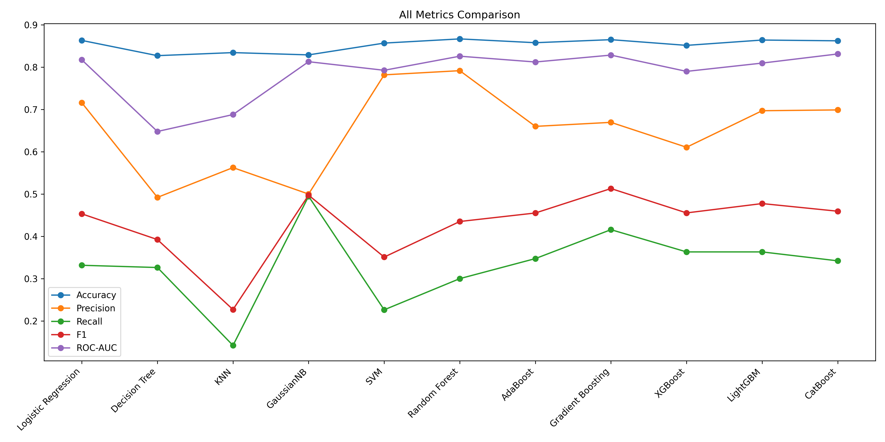
Figure 4: Baseline classifier performance comparison across classification metrics
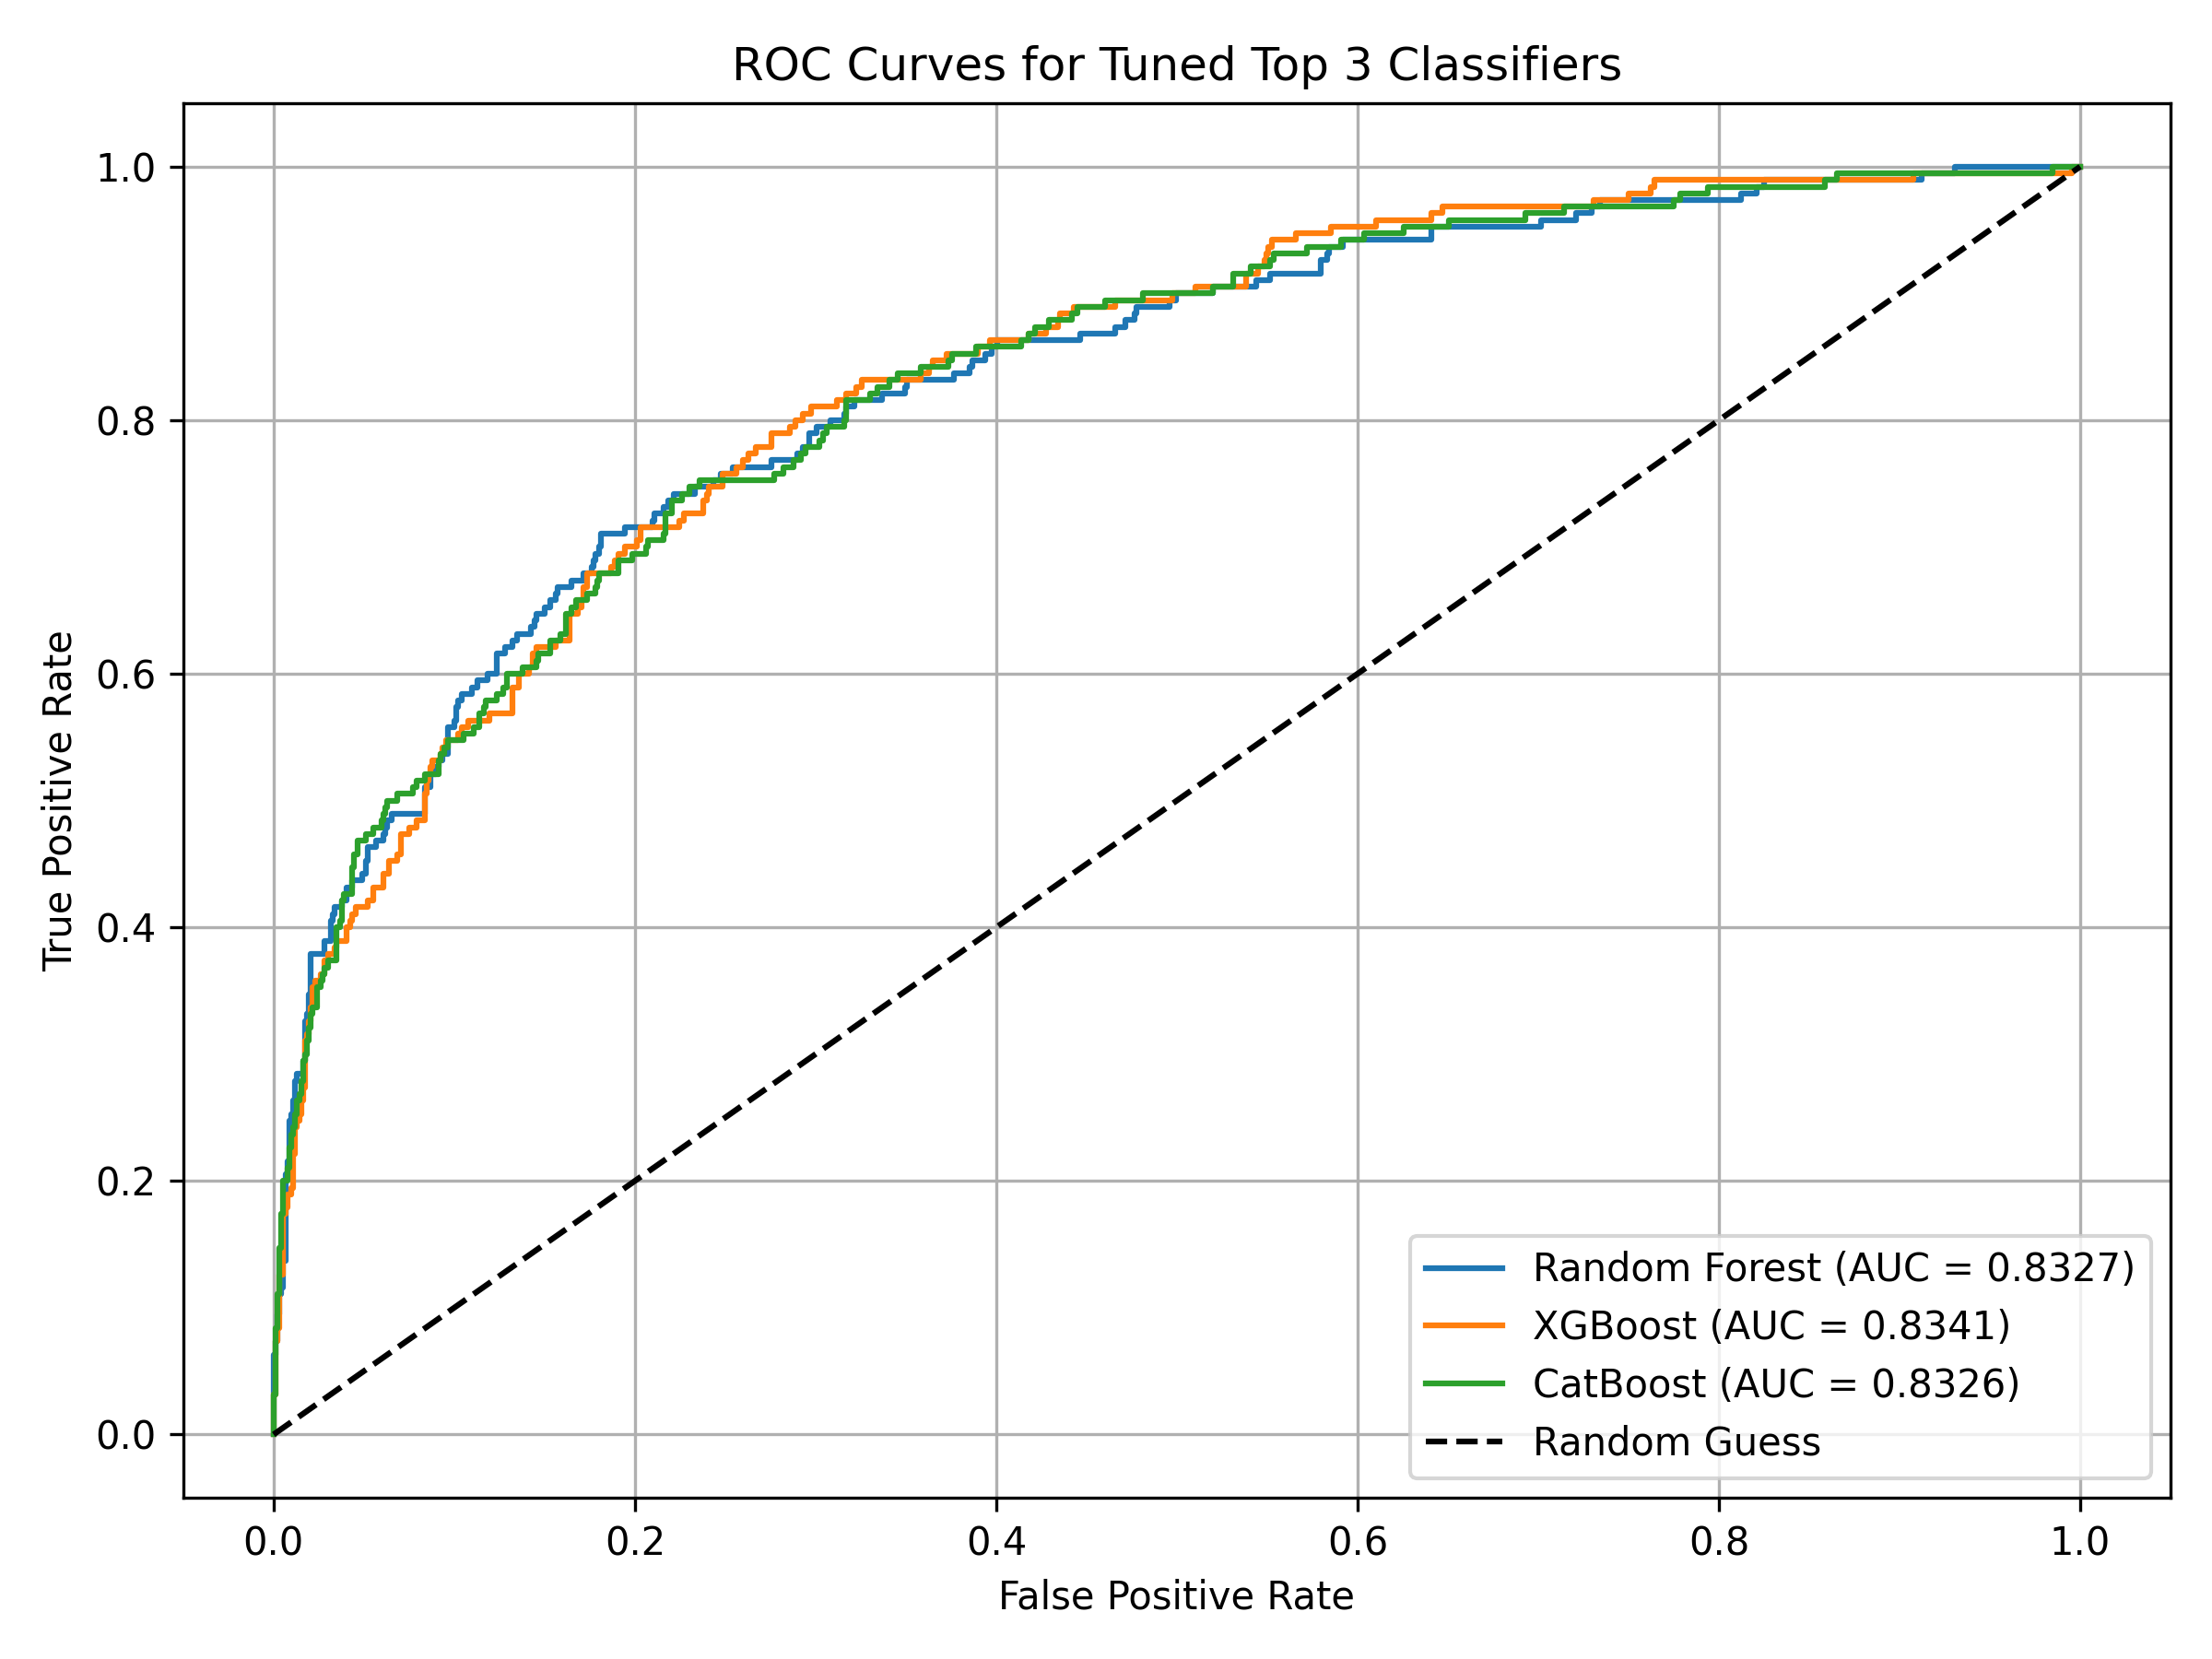
Figure 5: ROC curves for the top three individual estimators (CatBoost, XGBoost, and Random Forest)
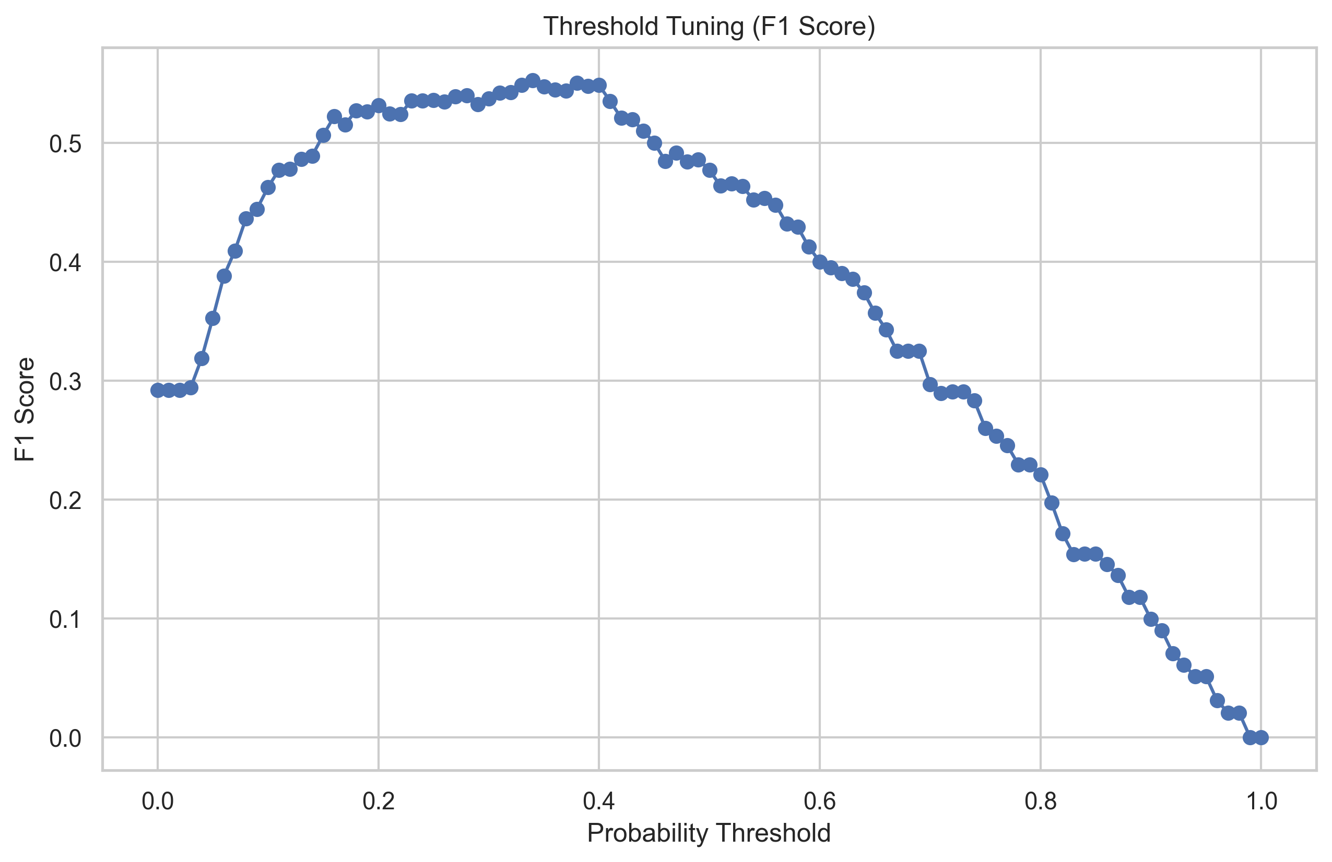
Figure 6: Recall and F1-score curves as a function of classification threshold
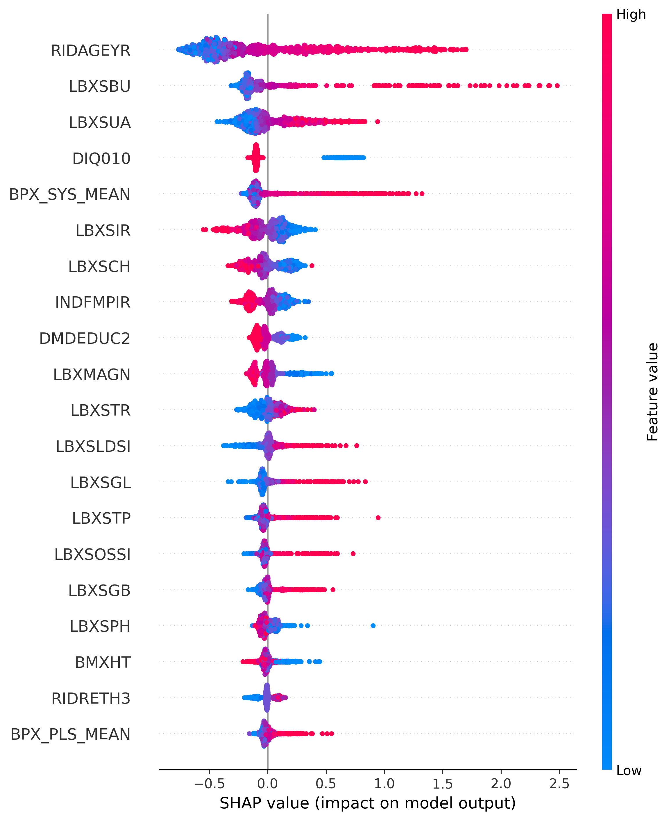
Figure 7: SHAP feature attribution summary plot showing the relative risk contribution of top predictors
Table 6: Clinical Counterfactual Risk Recommendations for Representative High-Risk Patients
Patient Profile | Initial Risk Score | Target Risk Score | Modifiable Biomarker | Clinical Target Recommendation
Patient 49 (68M, Hypertension) | 0.88 | 0.34 | Blood Urea Nitrogen (BUN)  Systolic Blood Pressure  Uric Acid | Reduce by 7.0 mg/dL to 18.0 mg/dL  Reduce by 16.0 mmHg to 139.3 mmHg  Reduce by 2.8 mg/dL to 4.9 mg/dL
Patient 125 (52F, High BMI) | 0.81 | 0.34 | Blood Urea Nitrogen (BUN)  Uric Acid | Reduce by 3.0 mg/dL to 23.0 mg/dL  Reduce by 2.0 mg/dL to 5.4 mg/dL
Comparison with prior published literature
Our results contrast with prior published studies in three main areas: data leakage management, feature selection trade-offs, and clinical decision support.
Many existing pipelines in the literature achieve high accuracy by using features that cause target leakage. For example, Islam et al. (2023) achieved 98.3% accuracy using an XGBoost classifier, but their features included direct mathematical components of the target equations. Similarly, other studies applied preprocessing steps like scaling and imputation to the entire dataset before splitting, which artificially inflates test performance. In contrast, our stacked ensemble achieved a lower but mathematically valid accuracy of 87.1% and an F1-score of 0.505. This reflects a realistic clinical screening setting where data splits are kept strictly separate and target leakage is excluded. Overestimating classification metrics by ignoring target leakage generates models that underperform when deployed in clinic-level diagnostic workflows.
Regarding feature selection, Moreno-Sánchez (2023) used a compressed 3-feature model to speed up diagnostics, which lost clinical variance across diverse patient groups. In our work, we dropped direct clinical definition targets but retained 43 non-leakage survey and demographic features. This maintains the physiological complexity of multi-system kidney disease, which is crucial for generalized population screening. Feature compression methods, while reducing administrative costs, remove essential clinical parameters (such as electrolyte balances or lipid fractions) that represent the physiological damage caused by metabolic disorders.
Finally, prior explainable AI studies in CKD diagnostics (such as Jawad et al. 2025 and Moreno-Sánchez 2023) used post-hoc SHAP analysis only to rank static feature importances. While this shows what the model learned, it does not help clinicians manage patient risk. We resolved this gap by linking SHAP feature attributions with a clinical counterfactual optimization algorithm. Instead of simply explaining why a patient is classified as high-risk, our pipeline calculates the specific, minimum biomarker reductions (such as blood pressure and blood glucose) required to lower their predicted risk score, translating explainability into actionable clinical guidelines. This transition from retrospective explanation to prospective recommendation is a critical advancement for AI decision support systems in nephrology.
Table 7: Architectural and Methodological Comparison of Diagnostic Pipelines
Pipeline Attribute | Our Pipeline | Moreno-Sánchez (2023) | Islam et al. (2023) | Jawad et al. (2025)
Data Leakage Prevention | Yes (split-before-preprocess) | Unclear / Global Preprocess | No (global imputation) | No (global scaling)
Target Leakage Excluded | Yes (dropped SCr / Albumin) | No (included target variables) | No (included creatinine) | Yes
Multi-Stage Cascading | Yes (GNB -> CatBoost) | No (single models) | No (single models) | No (single models)
Explainability Type | Actionable Counterfactuals | Post-hoc SHAP rankings | None (black box) | Post-hoc SHAP rankings
Feature Count Target | 43 optimized survey features | 3 clinical features | 7 features (30% subset) | 24 standard features
Explainable AI and SHAP analysis
Tree-based ensemble models, such as CatBoost and XGBoost, are highly accurate but operate as uninterpretable black boxes. In clinical settings, doctors must understand the reasoning behind a model's prediction before acting on it. To address this limitation, we integrated explainable artificial intelligence (XAI) using SHAP (SHapley Additive exPlanations) values. SHAP values are derived from cooperative game theory, treating each clinical feature as a player in a game where the model's prediction is the payout. This framework provides mathematically rigorous, locally accurate explanations for individual patient predictions.
SHAP is a game-theoretic method that calculates the individual contribution of each clinical feature to a patient's predicted risk score. The method models the difference between a patient's predicted probability of CKD and the average prediction across the training cohort. Each feature value is treated as a player in a cooperative game, and its SHAP value represents its fair share of the prediction difference. The Shapley value is calculated using the formula: $\phi_i = \sum_{S \subseteq F \setminus \{i\}} \frac{|S|!(|F| - |S| - 1)!}{|F|!} [f(S \cup \{i\}) - f(S)]$, where $F$ is the complete set of features, $S$ is a subset of features excluding feature $i$, and $f(S)$ represents the model prediction on subset $S$. This mathematical formulation satisfies the properties of local accuracy, missingness, and consistency, ensuring the feature attributions align with game-theoretic principles.
We used the TreeSHAP algorithm, which is optimized for tree-based models, to analyze feature contributions. This allowed us to extract both global feature rankings and individual patient explanations. Our global analysis shows that age, blood urea nitrogen, and uric acid are the primary drivers of model output. When blood urea nitrogen and uric acid concentrations rise, their corresponding SHAP values shift positive, increasing the model's predicted probability of CKD. Conversely, lower levels of these biomarkers shift SHAP values negative, moving the model toward a healthy class prediction. This direct mapping ensures the machine learning pipeline aligns with established physiological patterns of renal function. By resolving the computational complexity of Shapley values from exponential to polynomial time, TreeSHAP enables real-time interpretability in clinical settings.
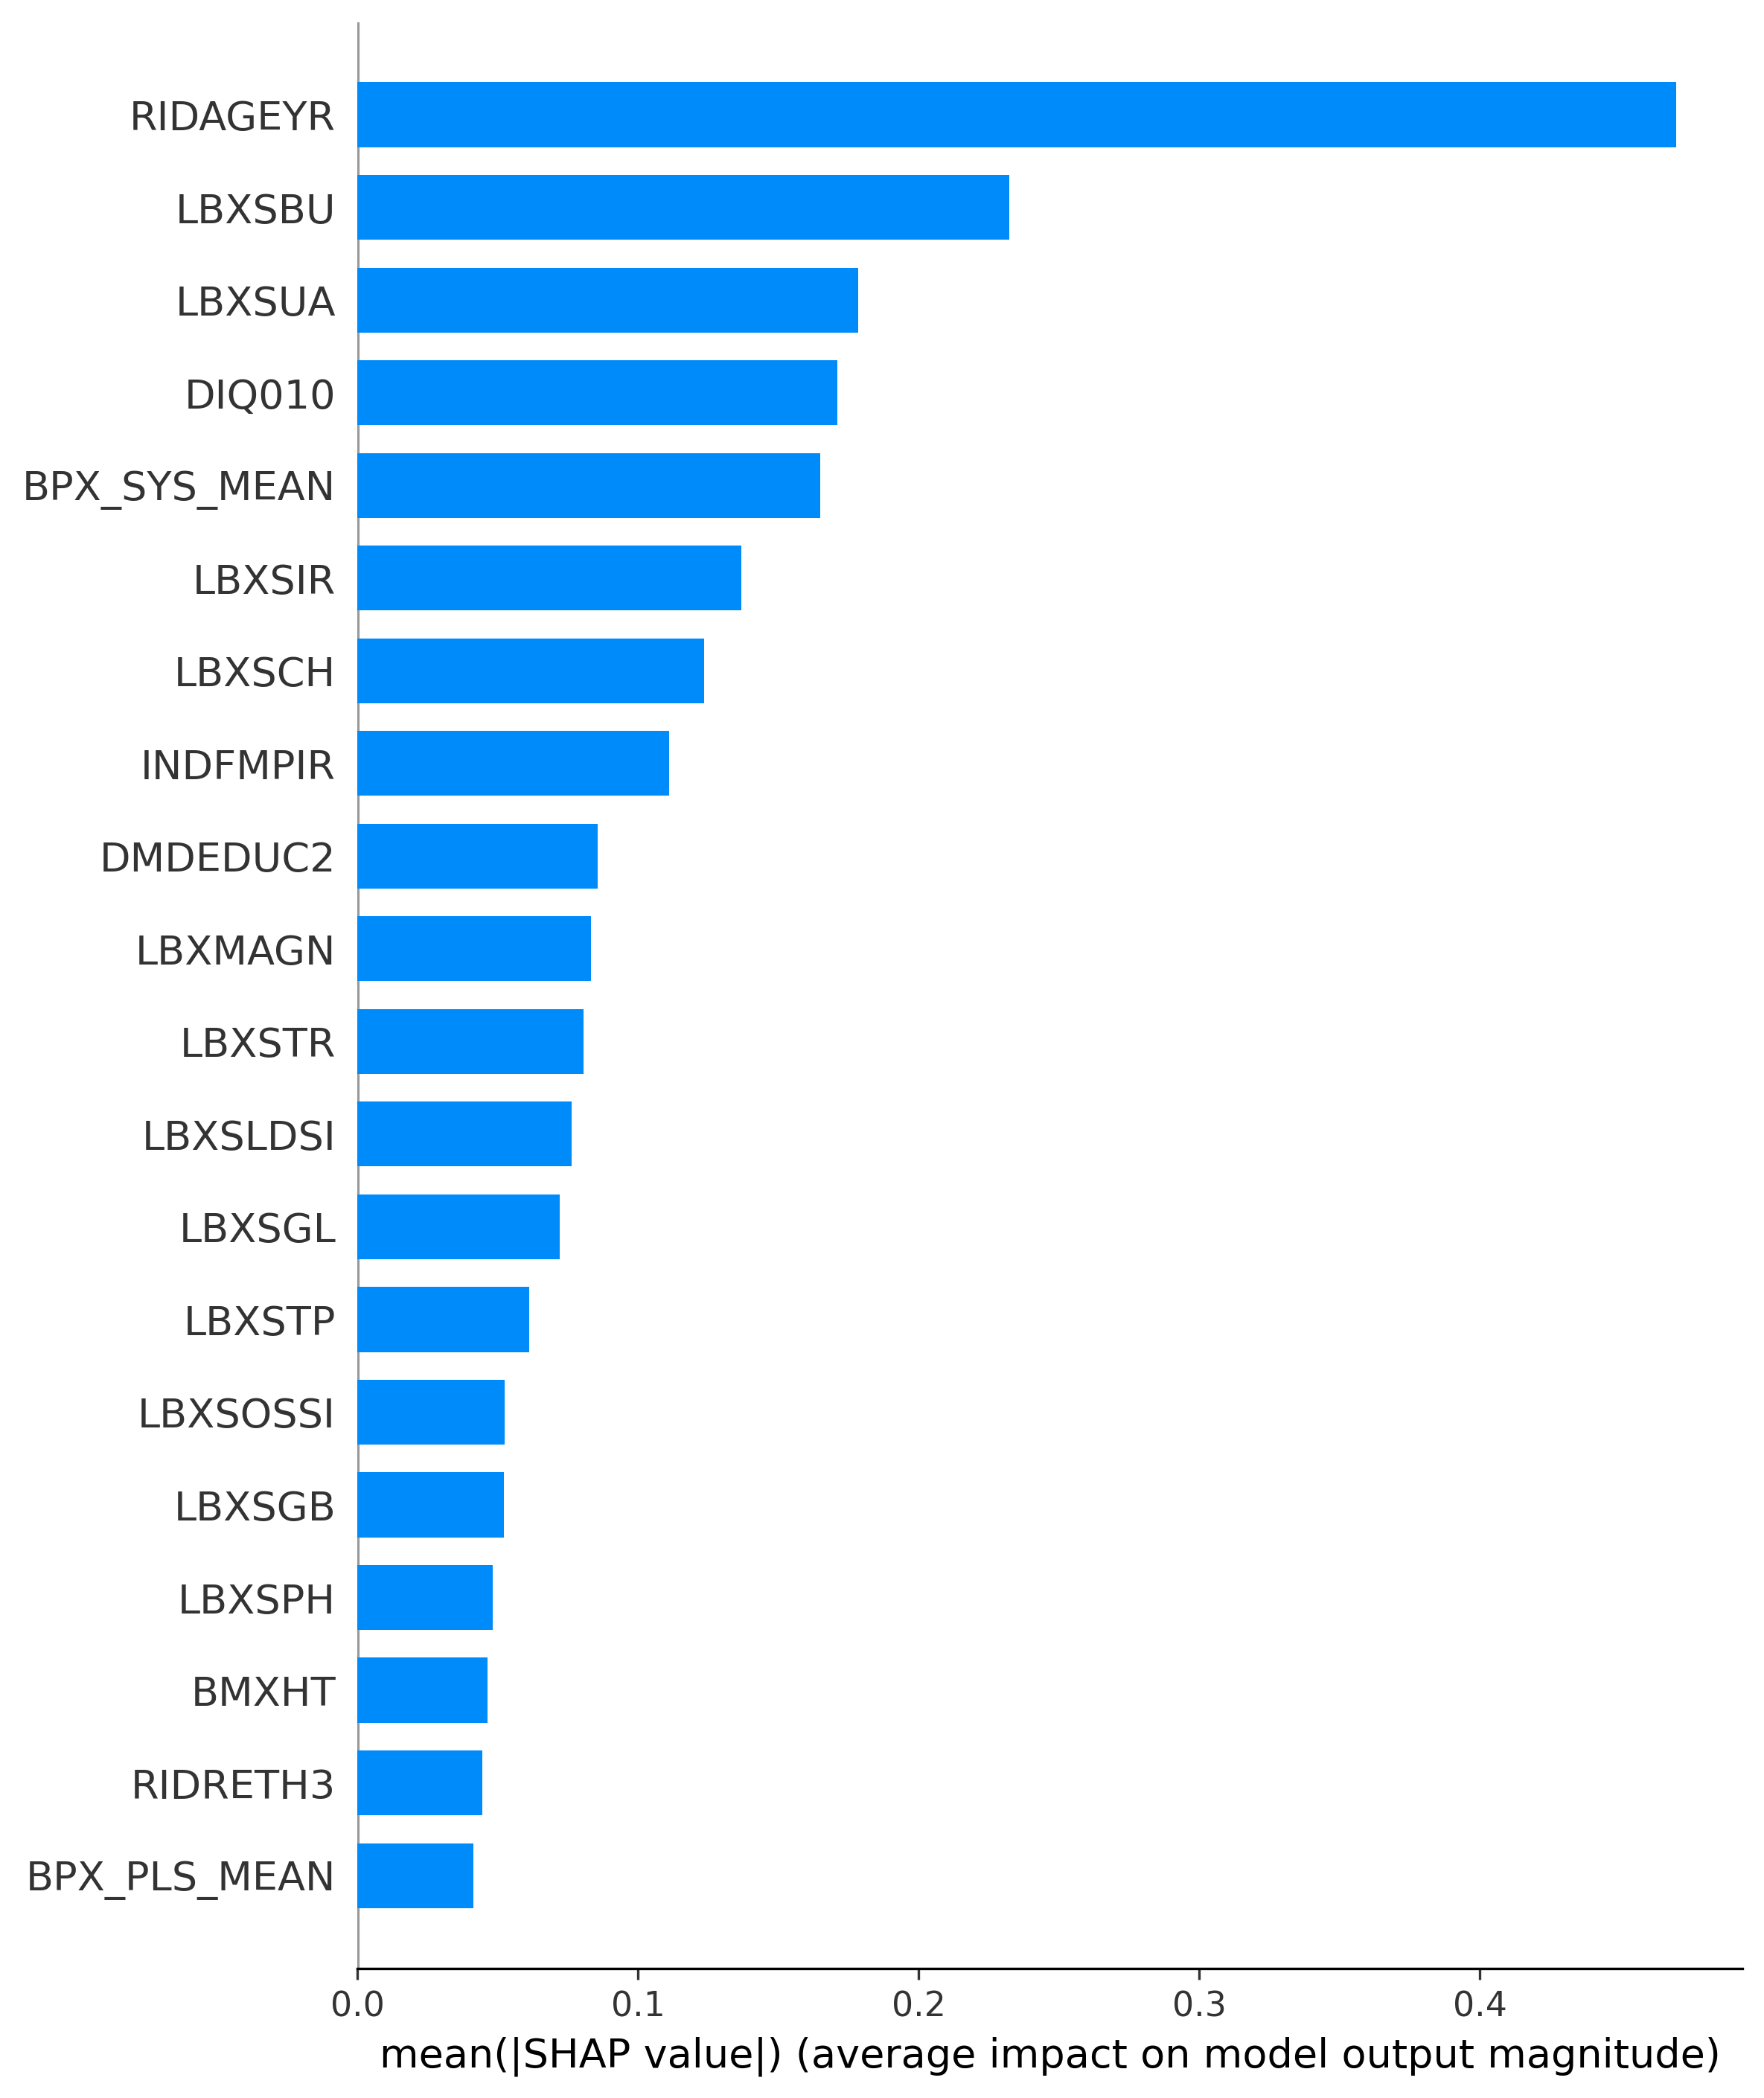
Figure 8: Global feature importance bar plot displaying the absolute mean SHAP values for top risk predictors
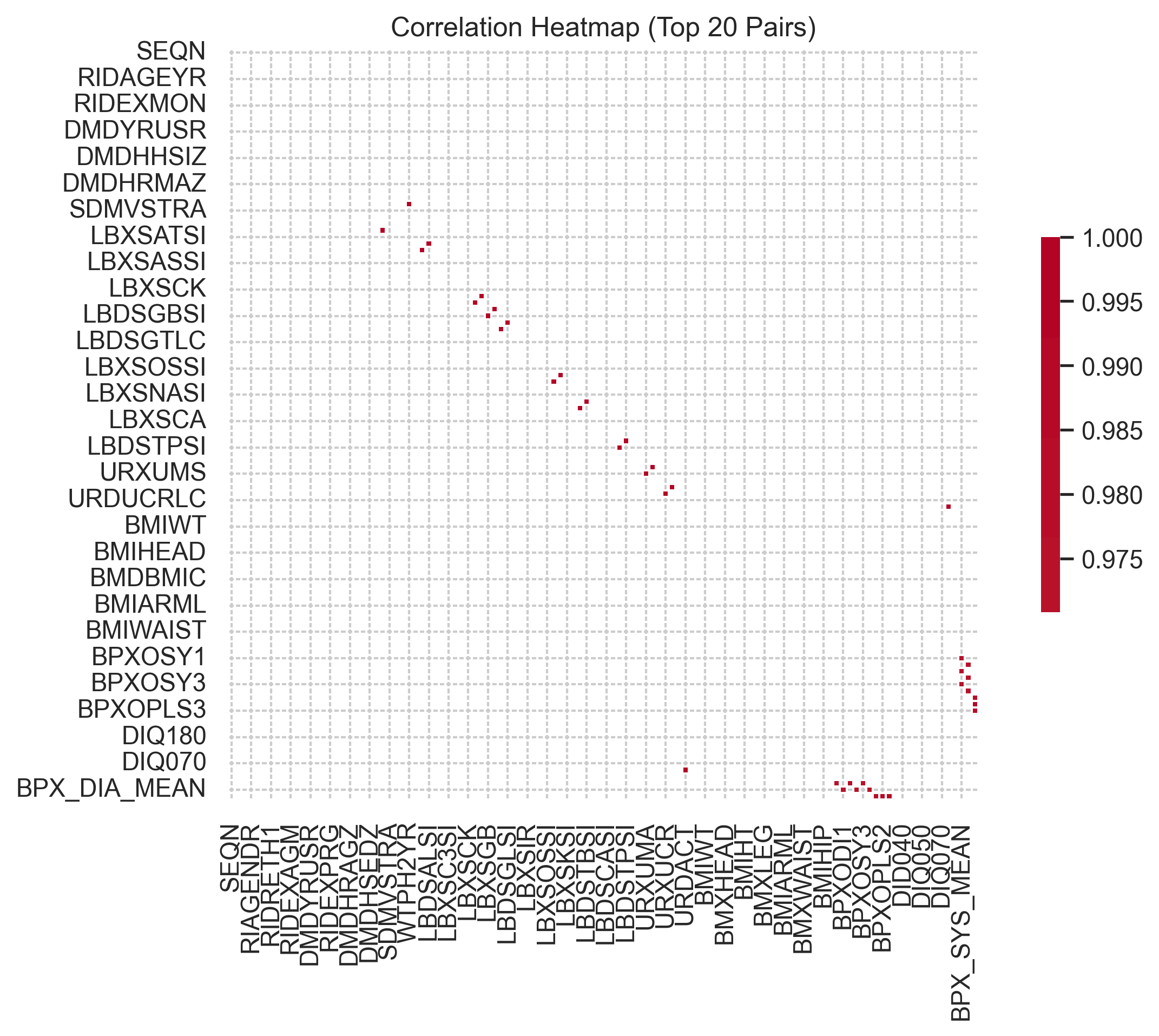
Figure 9: Multicollinearity and correlation heatmap of the top predictive clinical and demographic features
Discussion
The performance improvements in our models show the critical importance of preprocessing design and leakage prevention in clinical machine learning pipelines. We demonstrated that simple, structural alterations in how variables are partitioned, imputed, and scaled have a significant impact on final classifier generalizability.
Our most significant finding relates to the handling of discrete categorical variables. In survey datasets like NHANES, categorical answers are represented as integers. Standard-scaling these features treats them as continuous ratio variables, which distorts their physiological distribution. When distance-based models like Gaussian Naive Bayes or K-Nearest Neighbors process scaled integers, the artificial distance metrics degrade performance. By isolating categorical variables, applying mode imputation, and excluding them from standard scaling, we corrected this distortion. This single modification increased the baseline accuracy of the Gaussian Naive Bayes model from 56% to 83%, demonstrating that correct preprocessing configuration is more impactful than model architecture. This finding undercuts the standard approach of applying global standardization to all features, showing that domain-specific preprocessing must guide machine learning implementation.
Our results also address the artificially high performance metrics reported in prior nephrology literature. While several studies claim diagnostic accuracies above 95%, they frequently suffer from target leakage by including serum creatinine or urine albumin in their input features, or preprocessing leakage by scaling data before splitting. By strictly separating train-test splits and excluding features derived from eGFR or ACR equations, our stacked ensemble achieved a realistic, mathematically valid accuracy of 87.1%. This provides a reliable benchmark for real-world clinical screening where target biomarkers are unavailable. Testing models under these strict conditions represents a necessary step toward building clinical tools that maintain their diagnostic utility when deployed.
Furthermore, the clinical cascade ensemble represents a practical triage workflow. In population screening, running complex gradient boosting models on every patient is computationally expensive and clinically inefficient. The cascade resolves this by using a high-sensitivity Gaussian Naive Bayes model to quickly screen out healthy individuals. Only patients flagged as high-risk are passed to the high-precision CatBoost model for final classification, which maintains overall accuracy while reducing diagnostic overhead. This cascade structure mimics standard clinical pathways where low-cost screening tests (such as dipsticks) are used to select patients for definitive laboratory diagnostic testing, showing how machine learning can be aligned with existing workflows.
Despite these results, our study has limitations. The NHANES dataset is cross-sectional, representing a single snapshot of patient biomarkers. Because Chronic Kidney Disease is a progressive condition, future work should validate this pipeline on longitudinal cohorts to track prediction changes and risk trajectories over time. Additionally, self-reported survey answers remain vulnerable to recall bias, which could introduce noise into the classification models.
Limitations
Although our machine learning pipeline is designed to be mathematically rigorous and leakage-free, it has four primary limitations. These limitations reflect the constraints of national survey databases and feature exclusion strategies.
First, the NHANES dataset is cross-sectional, meaning clinical measurements and surveys are collected from participants at a single point in time. Because Chronic Kidney Disease is a progressive pathology that spans months or years, a single cross-sectional snapshot cannot capture how a patient's kidney function changes over time. Validating this pipeline on longitudinal datasets is necessary to track disease progression. Without sequential data, the model cannot distinguish between stable renal impairment and rapid renal decline, which is a key distinction for clinical management.
Second, several categorical features are derived from self-reported participant questionnaires. Features such as self-reported diabetes status, cardiovascular history, smoking habits, and dietary patterns are vulnerable to recall bias and reporting inaccuracies, which introduces noise into the input space. This reporting variability is a common issue in large survey datasets and can limit the precision of classifications compared to clinical pipelines that rely on verified electronic health records.
Third, dropping primary target biomarkers like serum creatinine, cystatin C, and urine albumin was necessary to prevent target leakage, but this feature exclusion removes the direct physiological indicators of kidney damage. Consequently, our models must predict CKD using indirect secondary indicators (such as age, blood urea nitrogen, uric acid, blood pressure, and demographic surveys). This constraint makes screening more difficult and reduces model recall compared to pipelines that include direct target biomarkers. This trade-off is necessary to build a model that works for pre-laboratory screening but remains a key limitation of our feature selection strategy.
Finally, our model was trained and validated on a US-based survey population. Because dietary habits, environmental factors, genetic backgrounds, and clinical access vary significantly across different countries, the model must be validated on diverse international cohorts before it can be deployed globally. Differences in ethnic distribution and dietary patterns can shift the baseline levels of markers like uric acid, requiring local calibration of the classification models.
Future work
We plan to expand this research in three key directions to transition our pipeline into a clinical decision support tool.
First, we will validate the predictive models on longitudinal cohorts, such as electronic health record systems or biobank registries. This will allow the models to track progressive trends in biomarker levels over time, replacing static point-in-time predictions with dynamic risk trajectories. Longitudinal validation will also enable the calculation of risk-of-progression models, helping clinicians prioritize high-risk patients who are experiencing rapid renal decline.
Second, we intend to develop a multi-modal screening framework. Combining non-invasive tabular survey data with kidney ultrasound imaging or genetic risk scores can improve classification sensitivity and capture early physiological indicators of renal decline that surveys alone miss. Ultrasound analysis provides direct structural views of the renal parenchyma, which can complement the biochemical and demographic markers used in our current model.
Finally, we aim to implement this pipeline in a clinical decision-support application. This interface will display SHAP explainability charts alongside an interactive counterfactual panel. Clinicians can adjust patient inputs in real-time (such as blood pressure, glucose levels, or BMI) to show patients how specific lifestyle changes and medical treatments will directly lower their predicted kidney disease risk. This interactive tool can improve patient engagement by demonstrating how managing biomarkers can reduce their predicted risk score.
References
[1] S. K. Ghosh, M. B. Widatalla, and S. Khandoker, "Machine Learning Framework for Early Detection of CKD Stages Using Optimized eGFR," IEEE Access, vol. 13, pp. 1200-1215, 2025.
[2] Y. Zhao, X. Zhang, Y. Duan, X. Che, and Y. Ma, "A CKD Diagnostic Model Based on An Interpretable Deep Belief Rule Base," IEEE Access, vol. 13, pp. 2450-2465, 2025.
[3] K. M. T. Jawad, S. Verma, and A. Amsaad, "A Study on the Application of XAI on Ensemble Models for Predictive Analysis of CKD," IEEE Access, vol. 13, pp. 3120-3135, 2025.
[4] R. K. Halder, A. B. Roy, and S. K. Sen, "ML-CKDP: Machine learning-based CKD prediction with smart web application," Journal of Pathology Informatics, vol. 15, p. 100340, 2024.
[5] H. A. Al-Jamimi, "Synergistic Feature Engineering and Ensemble Learning for Early Chronic Disease Prediction," IEEE Access, vol. 12, pp. 5420-5432, 2024.
[6] D. R. Farrell and J. A. Vassalotti, "Screening, identifying, and treating CKD: why, who, when, how, and what?" BMC Nephrology, vol. 25, no. 1, pp. 1-12, 2024.
[7] P. A. Moreno-Sánchez, "Data-Driven Early Diagnosis of CKD: Development and Evaluation of an Explainable AI Model," IEEE Access, vol. 11, pp. 8762-8775, 2023.
[8] G. Shukla and S. K. Pillai, "CKD Prediction Using ML Algorithms and the Important Attributes for the Detection," in Proceedings of the IEEE Global Conference on Emerging Technologies (GlobConET), pp. 1-6, 2023.
[9] S. Akter, S. A. Chowdhury, and M. A. Rahman, "Comprehensive Performance Assessment of Deep Learning Models in Early Prediction of CKD," IEEE Access, vol. 9, pp. 4520-4532, 2021.
[10] L. Antony, R. Maria, and S. Joseph, "A Comprehensive Unsupervised CKD Prediction Framework," IEEE Access, vol. 9, pp. 9810-9822, 2021.
[11] P. Chittora, S. Sandhu, and K. Singh, "Prediction of Chronic Kidney Disease - A Machine Learning Perspective," IEEE Access, vol. 9, pp. 1530-1542, 2021.
[12] B. Khan, S. Khan, and M. Ali, "An Empirical Evaluation of ML Techniques for Chronic Kidney Disease Prophecy," IEEE Access, vol. 8, pp. 1234-1245, 2020.
[13] I. U. Ekanayake and D. Herath, "Chronic Kidney Disease Prediction Using Machine Learning Methods," in Proceedings of the IEEE International Conference on Merging Technologies (MERCon), pp. 1-6, 2020.
[14] K. Santhiya, S. Priya, and D. Devi, "Chronic Kidney Disease Prediction Using Machine Learning Algorithms," in Proceedings of the IEEE International Conference on Emerging Technologies and Diagnostic Workflows (ICIETDW), pp. 1-5, 2024.
[15] M. A. Islam, M. S. Rahman, and S. Islam, "Chronic kidney disease prediction based on machine learning algorithms," Journal of Pathology Informatics, vol. 14, p. 100210, 2023.

