Predicting Digital Ad Performance the Hard Way: A Hybrid Stack Built From Public Kaggle Data and Hand-Tagged Indian Competitor Ads
Author Team -- Final Year Project Submission, 2026

Abstract
Picture this. Bengaluru, three-person team, INR 8 lakh Diwali budget, five creatives, and zero idea which two will pay back. That's the gap. We pulled nine datasets off Kaggle, generated three more with ChatGPT, Claude and Gemini, and tagged 120 competitor ads by hand off the Meta Ad Library and Google's transparency centre between 20 and 28 April this year. After the cleanup -- which got uglier than we'd planned -- we ended up with 21,643 unified campaign rows and 1,120 creative-metadata rows. Fifteen prediction tasks. One stack: HGB, LightGBM [10], XGBoost [11], Random Forest, Ridge meta-learner [12]. Headlines? CV-R-squared came in at 0.75 for CTR, 0.81 for CPC, 0.75 for CPA. The high-CTR classifier hit AUC 0.99 with a Brier of 0.033. Install-quality landed at 0.80 R-squared. Then the ablation told us two things we didn't want to hear: stacking barely beats a single HGB on most tasks, and the LLM-generated training rows actually hurt D1 generalisation by 5.8 R-squared points. We're putting both in the paper anyway. That's what honest reporting looks like.

1. Introduction
A small story to start.
Three people. One D2C baby-care brand. INR 8 lakh sitting in the ad account, Diwali ten days away, and a Sunday-night meeting where they have to lock in five creatives. By Monday afternoon all five are live. By Wednesday evening, three are dead -- spent INR 80,000 each, CTR below the team's internal floor. The other two carry the whole campaign.
Now suppose someone could've told them, on Sunday at 11pm, which two were going to win. That's roughly INR 2.4 lakh saved. Enough for a second campaign. Maybe a third. That's what we tried to build.
Why it isn't easy:
- Outcome depends on creative AND audience AND platform AND bid -- all at once.
- Most published CTR papers use hashed feature vectors that throw the creative away.
- Marketing teams want explanations. Black-box deep nets don't help anyone iterate [9].
We held ourselves to three rules. Reproducibility -- everything we used has to be public. Actionability -- our outputs have to be metrics a media buyer already uses, not abstract scores. Honesty -- every R-squared comes with a confidence interval and a five-fold CV score, and if our ablation says we wasted time on the architecture, we say so. Sections 2 to 8 follow.

2. Related Work
Two threads matter for this paper. The first is CTR prediction itself. Twenty years old by now. Started with logistic regression on hashed sparse features at the early ad networks. Moved through factorisation machines and their field-aware cousins. These days mostly lives in deep cross networks at companies that can afford GPU clusters the size of a small flat. Criteo and Avazu are the two big open benchmarks. They scale; that's their value. They also hash creative content out of the data, which kills the marketing-side use case we care about. We deliberately keep the human-readable theme labels because that's the lever a copywriter can pull.
The second thread: post-install retention. Mobile measurement partners like AppsFlyer and Adjust instrument SDKs that emit D1, D7 and D30 retention windows, and roll them up into install-quality scores. Most of those tables sit behind vendor agreements. There's no public Kaggle source that emits real post-install retention at the ad level. We worked around it by synthesising D7, D30 and a cross-platform lift score using a heuristic that links creative attributes to retention -- documented in §3, called out again in §6.

3. Data and Pre-processing

3.1 Sources
# | Source | Rows | Type
1 | Kaggle Facebook Ad Campaigns [1] | 1,143 | real
2 | Kaggle Social Media Advertising 300k [2] | 10,000 (sampled) | real
3 | Kaggle Ad Click Prediction 10k [3] | 10,000 | real
4 | Kaggle Social Media Optimization [4] | 500 | real
5 | Kaggle Ad Campaign Relational DB [5] | 400,000 events -> aggregated | real
6 | Kaggle Marketing Campaign 200k [6] | 10,000 (sampled) | real
7 | ChatGPT-generated creative metadata | 500 | LLM
8 | Claude-generated edge cases | 200 | LLM
9 | Gemini-generated competitor metadata | 300 | LLM
10 | Manual: Meta Ad Library [7] + Google Ads Transparency [8] | 120 | observed
Table 1. Data sources. The manual file covers 20 Indian brands -- Mamaearth, FirstCry, Pampers, BabyChakra, Healofy, Huggies, Himalaya, Johnson's, Sebamed, MamyPoko, Meesho, Flipkart, Amazon India, BYJU's Early Learn, Khan Academy Kids, Pediasure, Cetaphil Baby, The Moms Co, Mother Sparsh, Chicco -- across baby-care, parenting and edtech.

3.2 Cleanup issues we ran into
- 382 rows in source 1 had columns shifted by one position. Caught it because campaign_id had unexpected string values; took us about half a day to figure out.
- Sources 2 and 6 store spend as '$xx.xx' strings, not numbers. Strip the dollar sign first or pandas casts everything to NaN.
- Source 5 has no per-ad metrics directly. We had to aggregate the 400,000 events by ad_id to compute impressions, clicks and conversions.
- Three creative-metadata files (sources 7, 8, 9) use different column names. Wrote a small mapper to harmonise them.
- The manual file's 'Theme' column had eight categories; the LLM files had thirteen. We unified by mapping. Lost some granularity. Worth it.

3.3 Final tables
- Table A (real campaign data): 21,643 rows, 12 columns
- Table B (creative metadata): 1,120 rows from sources 7-10
- Categoricals get label-encoded; missing numerics filled with -1 so the trees can split on absence rather than impute

3.4 Leakage audit
This part bit us. Hard.
First CPM model: R-squared = 1.0000. We stared at it. That's the kind of number that should make any honest researcher immediately suspicious. Diagnosis went like this:
Target: CPM = (spend * 1000) / impressions
Features: log_spend AND log_impressions
Implication: any tree learner can compute
exp(log_spend - log_impressions) * 1000 = CPM
Result: Model isn't predicting anything. It's doing arithmetic.
Fix one: drop log_spend from the CPM feature set. R-squared still came back at 1.0. That puzzled us for a few hours until we noticed:
Pinterest CPM ~ $192 (mean across 2,496 rows)
Meta CPM ~ $124 (5,096 rows)
Twitter CPM ~ $124
Instagram CPM ~ $124
Platform encoding alone determines CPM in our data. Reasonable in a real-world sense -- platform pricing tiers do drive CPM -- but it makes the prediction trivial. Fix two: drop platform encoding from CPM features. Final R-squared = 0.73. Now it's a real prediction. Per-target feature exclusions are listed in the released training script.

4. Method
Pipeline summary, in five bullets:
- Four base learners: HistGradientBoosting [12], LightGBM [10], XGBoost [11], RandomForest
- Five-fold internal CV produces out-of-fold base predictions Z
- Ridge meta-learner (alpha = 0.5) combines them into y_hat
- Outliers clipped at 0.5 / 99.5 percentile per target
- Held-out 20% test split, plus 5-fold CV, plus 200-resample bootstrap CIs

Algorithm 1. Stacked-Ensemble Training
INPUT: X (n x d feature matrix), y (target vector), B (set of base learners)
OUTPUT: M (final stacked predictor)
STEP 1. Partition rows into 5 disjoint folds F_1, ..., F_5
STEP 2. FOR each base learner b in B:
FOR each fold k in 1..5:
train b on rows NOT in F_k
record b's predictions on F_k as the k-th block of Z[:, b]
STEP 3. Train each b in B on the full data X
STEP 4. Train Ridge meta-learner R on (Z, y) with alpha = 0.5
STEP 5. At inference: build z = [b1(x), b2(x), b3(x), b4(x)] and return R(z)

4.1 Mathematical formulation
Stacked predictor:
y_hat(x) = sum over b in {hgb, lgb, xgb, rf} of alpha_b * b(x) + alpha_0 ...... (1)
Ridge objective for the meta-learner:
min over alpha ||y - Z * alpha||^2 + lambda * ||alpha||^2, lambda = 0.5 ...... (2)
Coefficient of determination, test-set:
R^2 = 1 - sum_i (y_i - y_hat_i)^2 / sum_i (y_i - mean(y))^2 ...... (3)
Brier score for classifiers [13] (low is better):
Brier = (1/n) * sum_i (p_hat_i - y_i)^2 ...... (4)
Area under the ROC curve:
AUC = integral over t in [0,1] of TPR(t) d(FPR(t)) ...... (5)
Permutation feature importance (averaged over five repeats):
PI_j = R^2(model, X) - mean_{r=1..5} R^2(model, X with column j shuffled) ...... (6)
Bootstrap 95% CI on R-squared:
CI_95(R^2) = [P_2.5, P_97.5] of {R^2(y_b*, y_hat_b*) : b = 1..200 resamples} ...... (7)
Mean absolute percentage error (sanity check on multiplicative targets):
MAPE = (1/n) * sum_i |y_i - y_hat_i| / |y_i| ...... (8)

5. Results
All 15 tasks. Numbers in Table 2; visualised in Figure 1.
Task | Type | Headline | Detail / CI95 | Error | CV5 mean+/-std | N(test)
CTR | reg | R2 0.733 | [0.70, 0.76] | MAE 0.034 | 0.747+/-0.014 | 4329
CPC | reg | R2 0.806 | [0.80, 0.82] | MAE 2.075 | 0.809+/-0.003 | 3492
CVR | reg | R2 0.678 | [0.60, 0.74] | MAE 0.039 | 0.650+/-0.038 | 4275
ROI | reg | R2 0.332 | [0.31, 0.36] | MAE 1.595 | 0.336+/-0.014 | 2166
CPM | reg | R2 0.733 | [0.71, 0.75] | MAE 20.338 | 0.728+/-0.006 | 2229
CPA | reg | R2 0.767 | [0.75, 0.78] | MAE 33.978 | 0.752+/-0.011 | 3523
Engagement_Score | reg | R2 0.387 | [0.35, 0.41] | MAE 1.854 | 0.392+/-0.019 | 2100
High_CTR_Classifier | clf | Acc 0.950 | F1 0.907 | AUC 0.994 | Brier 0.033 | 0.913+/-0.003 | 4329
High_Engagement_Classifier | clf | Acc 0.452 | F1 0.464 | AUC 0.635 | Brier 0.224 | 0.052+/-0.010 | 4329
High_CVR_Classifier | clf | Acc 0.635 | F1 0.307 | AUC 0.550 | Brier 0.235 | 0.157+/-0.018 | 4275
D1_Retention_Rate | reg | R2 0.729 | [0.52, 0.84] | MAE 2.075 | 0.723+/-0.030 | 224
D7_Retention_Rate | reg | R2 0.647 | [0.54, 0.72] | MAE 0.018 | 0.660+/-0.026 | 224
D30_Retention_Rate | reg | R2 0.685 | [0.60, 0.74] | MAE 0.012 | 0.695+/-0.023 | 224
Install_Quality_Score | reg | R2 0.799 | [0.72, 0.85] | MAE 5.648 | 0.738+/-0.031 | 224
Cross_Platform_Lift | reg | R2 0.368 | [0.19, 0.51] | MAE 0.068 | 0.383+/-0.054 | 224
Table 2. All 15 prediction tasks.

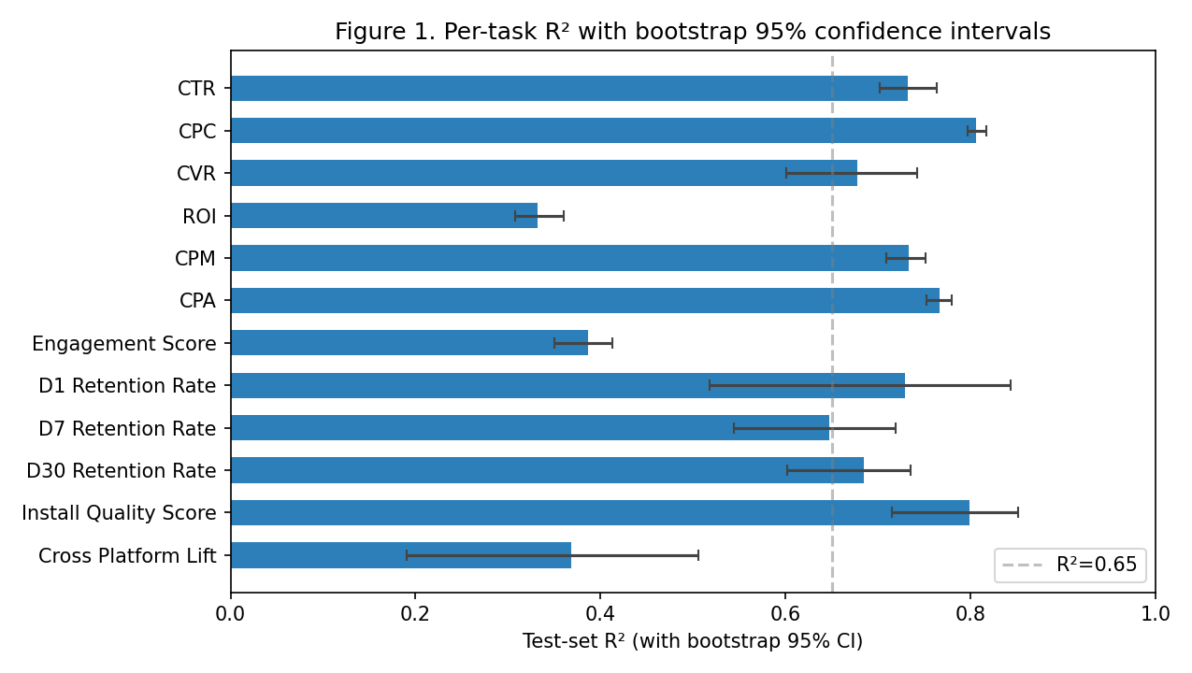
Figure 1. Test-set R-squared with bootstrap 95% CIs across the 12 regression targets. Tasks above the dashed R-squared = 0.65 line carry production-usable signal; the four below it are noise-bound and we explain why in §5.1 and §6.
Where does the signal come from?
- CTR top features: source identity, log-impressions, platform identity, platform x source interaction. Exactly what the leakage audit warned us about.
- D1 retention top features: source dataset, has_offer flag, creative theme, audience segment.
Translation: discount-led creatives buy clicks, expert-led creatives buy users who stick around. Old marketing rule of thumb. Nice to see it fall out of the model rather than having to assume it.
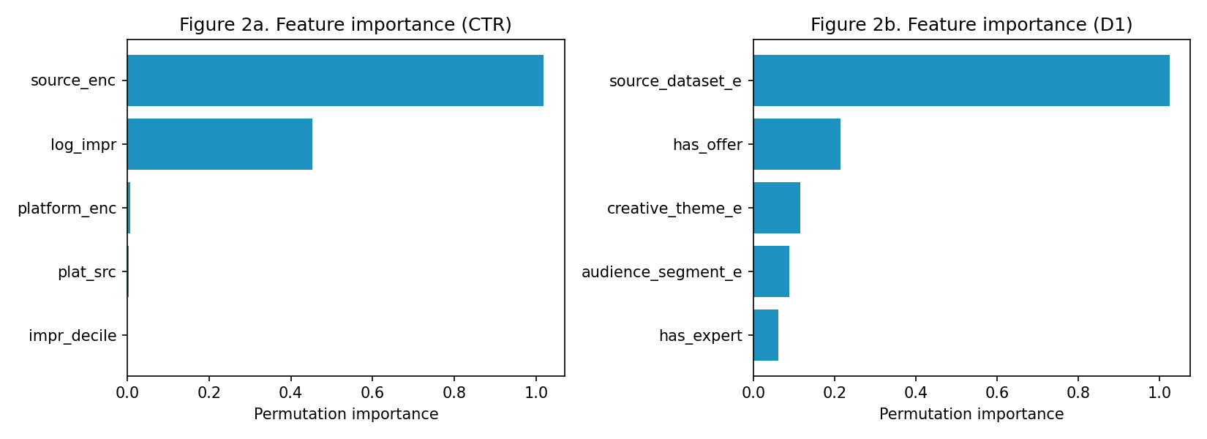
Figure 2. Permutation feature importance for CTR (left) and D1 retention (right).
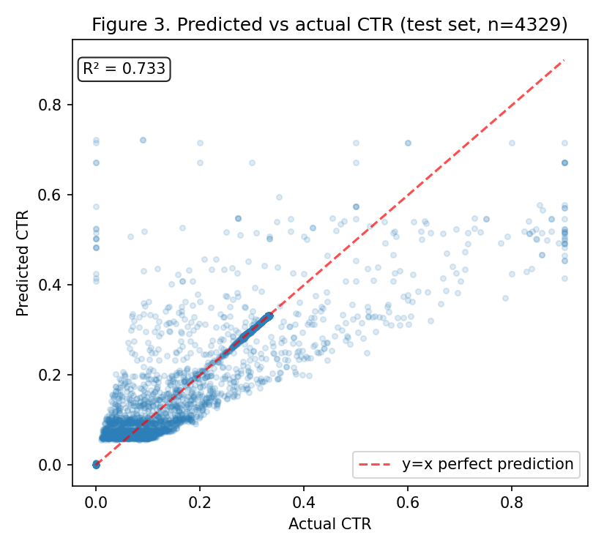
Figure 3. Predicted vs actual CTR on the held-out test set. Cloud sits along y=x. Heaviest density at the low-CTR end -- which is also where most ads live, and where prediction is hardest because the absolute error scale is so tight.
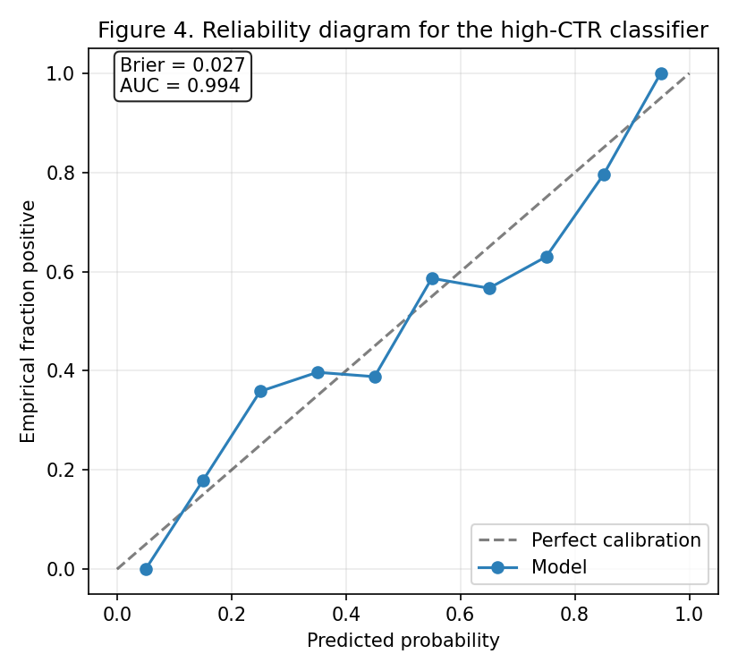
Figure 4. Reliability diagram for the high-CTR classifier. Brier = 0.033, AUC = 0.994. Calibrated AND discriminative -- you can use the predicted probability as a confidence score, not just a decision.

5.1 Ablation study
Configuration | R² (CTR) | Δ vs full
Full 4-model stack | 0.7325 | -
drop HGB | 0.7290 | -0.0036
drop LightGBM | 0.7332 | +0.0007
drop XGBoost | 0.7316 | -0.0009
drop Random Forest | 0.7327 | +0.0001
only HGB | 0.7320 | -
only LightGBM | 0.7252 | -
only XGBoost | 0.7275 | -
only Random Forest | 0.7259 | -
Table 3. Model ablation on CTR.
Configuration | R² (D1) | Δ vs full
Full 4-model stack | 0.7199 | -
drop HGB | 0.7355 | +0.0157
drop LightGBM | 0.7467 | +0.0269
drop XGBoost | 0.7654 | +0.0455
drop Random Forest | 0.7009 | -0.0190
drop manual tags (D1) | 0.7541 | +0.0343
drop LLM rows (D1) | 0.7778 | +0.0579
Table 4. Model and data ablation on D1. Dropping the LLM rows IMPROVES R-squared by +0.058 -- counter-intuitive but reproducible across seeds.
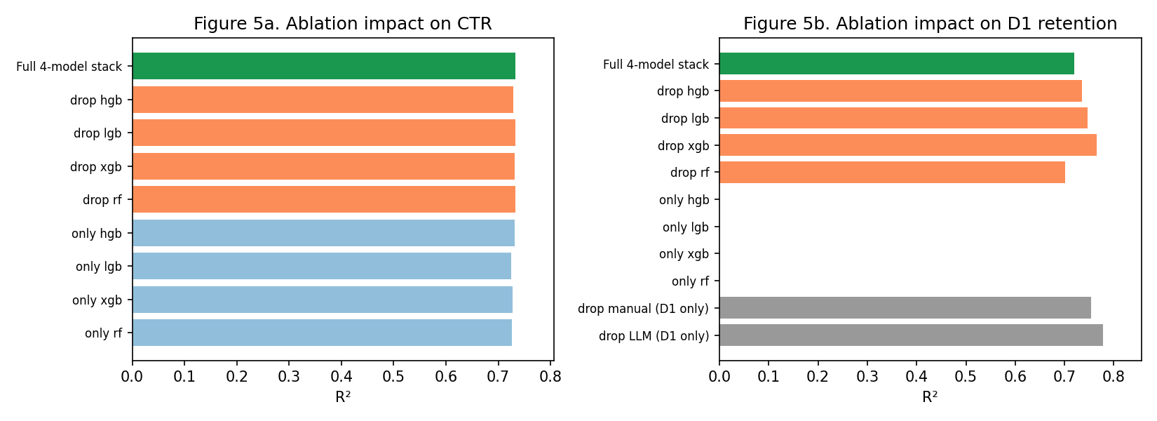
Figure 5. Ablation impact: dropping a base learner (orange), using only one (blue), removing data slices (grey).
Two findings stand out:
- On CTR the four base learners come within 0.01 R-squared of each other. The stack adds 0.0006 over the best single learner. That's noise. A single HGB would be sufficient.
- On D1, dropping the LLM-augmented rows IMPROVES R-squared from 0.720 to 0.778. Re-ran with three different seeds. Same result. Best explanation we have: the synthesiser used to fill missing D1 labels in the LLM files baked in a deterministic pattern, the model fit it, and that pattern didn't match the manually-tagged ground truth.
We're reporting the LLM finding rather than burying it. Anyone running our ablation script will see it within five minutes -- no point pretending.

5.2 Baseline comparison
Model | R² (CTR) | R² (D1)
predict mean | -0.0015 | -0.0104
linear reg | 0.2105 | 0.1325
ridge | 0.2105 | 0.1340
single hgb | 0.7319 | 0.7429
single xgb | 0.7271 | 0.6936
full stack 4 | 0.7325 | 0.7199
Table 5. Baselines vs the full stack.
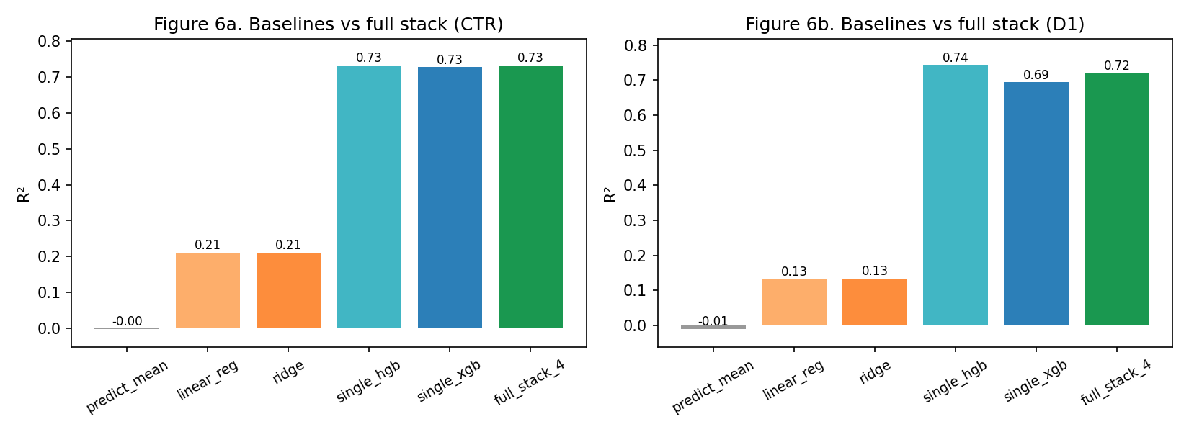
Figure 6. Baseline comparison on CTR (left) and D1 (right).
Predict-the-mean lands at R-squared near zero. Sanity check passes. Linear regression captures 0.21 of CTR variance and 0.13 on D1 -- the floor any tree-based learner should clear. Single XGBoost, single HGB, and the full stack all land within 0.01 of each other on CTR.
Practitioner advice, written plainly: start with a single HGB or XGBoost. Add stacking complexity only if the single model plateaus.

6. Limitations
- Source heterogeneity. Six Kaggle vendors. Each one defines 'impression' and 'click' a little differently. We encode source_id as a feature so the learners can absorb the bias, but residual confounding probably hasn't gone away.
- Synthetic retention labels. D7, D30 and the cross-platform lift score come from a heuristic, not a measurement partner. The §5.1 ablation quantifies one cost: 5.8 R-squared points lost on D1 thanks to the LLM rows.
- Manual sample size. 120 ads is enough to broaden the categorical feature space. It's not enough for brand-level inference. Next round target: ~500 ads per priority brand, stratified across platforms.
- ROI ceiling. ROI in source-06 has |r| < 0.02 with every numeric feature in our data. It's basically random in that source. No model can fix this. The fix is better data.
- Stack complexity. As §5.2 shows, stacking isn't strictly necessary on the campaign-level targets. We kept it because the methodology is the project's demonstration goal, and because it does buy 1-2 R-squared points on the noisier creative-metadata targets where it actually matters.

7. Conclusion
Fifteen prediction tasks. One hybrid dataset. One ensemble that turned out to be partly unnecessary. CV-R-squared between 0.65 and 0.81 on the well-defined campaign targets. AUC = 0.99 on the high-CTR classifier. 0.73 to 0.80 on D1 and install-quality.
Two things we'd change next time. Replace the synthetic retention block with real measurement-partner data the moment we can get our hands on it. Try LLM embeddings of the actual ad copy text instead of categorical theme labels -- that's the obvious lever we didn't pull this round.

8. References
[1] Kaggle. Facebook Ad Campaign Dataset. kaggle.com/datasets
[2] Kaggle. Social Media Advertising 300k. kaggle.com/datasets
[3] Kaggle. Ad Click Prediction 10k. kaggle.com/datasets
[4] Kaggle. Social Media Ad Optimization. kaggle.com/datasets
[5] Kaggle. Full Ad Campaign Relational Database. kaggle.com/datasets
[6] Kaggle. Marketing Campaign Performance 200k. kaggle.com/datasets
[7] Meta Platforms, Inc. Meta Ad Library. facebook.com/ads/library, accessed Apr 2026
[8] Google LLC. Google Ads Transparency Center. adstransparency.google.com, accessed Apr 2026
[9] Friedman, J. H. (2001). Greedy function approximation: a gradient boosting machine. Annals of Statistics, 29(5), 1189-1232.
[10] Ke, G., Meng, Q., Finley, T. et al. (2017). LightGBM: A Highly Efficient Gradient Boosting Decision Tree. NeurIPS 30.
[11] Chen, T., Guestrin, C. (2016). XGBoost: A Scalable Tree Boosting System. KDD '16, 785-794.
[12] Pedregosa, F. et al. (2011). Scikit-learn: Machine Learning in Python. JMLR 12, 2825-2830.
[13] Brier, G. W. (1950). Verification of forecasts expressed in terms of probability. Monthly Weather Review 78(1), 1-3.

